**NAME: BHOOMIKA.M**

**USN: 1BM23CS068**

**LAB -09**

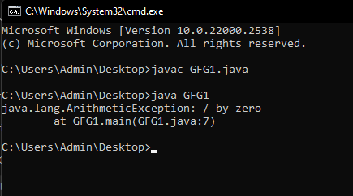

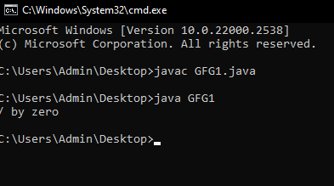 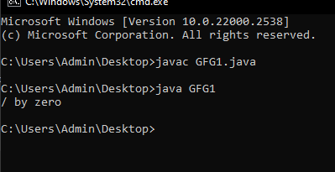

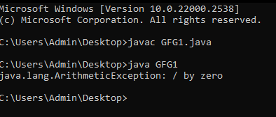

1. 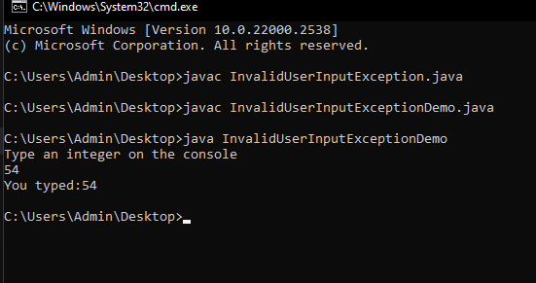
2. 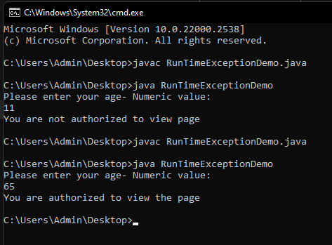
3. 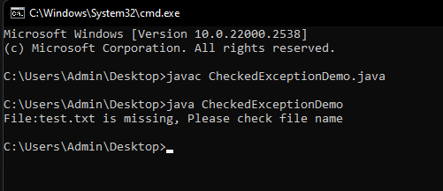
4. 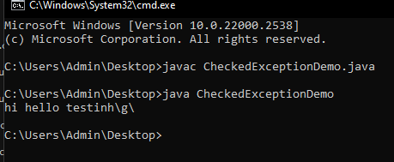

Write a program that demonstrates handling of exceptions in inheritance tree. Create a base class called "Father" and derived class called "Son" which extends the base class. In Father class, implement a constructor which takes the age and throws the exception WrongAge() when the input age<0. In Son class, implement a constructor that uses both father and son's age and throws an exception if son's age is >=father's age

