LAB-01

1. **Write a C program to simulate the following non-pre-emptive CPU scheduling algorithm to find turnaround time and waiting time.**

**(a) FCFS**

#include<stdio.h>

int n, i, j, pos, temp, choice, Burst_time[20], Waiting_time[20], Turn_around_time[20], process[20], total=0;

float avg_Turn_around_time=0, avg_Waiting_time=0;

void FCFS(){

Waiting_time[0]=0;

for(i=1;i<n;i++) {

Waiting_time[i]=0;

for(j=0;j<i;j++)

Waiting_time[i]+=Burst_time[j];

}

printf("\nProcess\t\tBurst Time\t\tWaiting Time\t\tTurnaround Time");

for(i=0;i<n;i++)

{

Turn_around_time[i]=Burst_time[i]+Waiting_time[i];

avg_Waiting_time+=Waiting_time[i];

avg_Turn_around_time+=Turn_around_time[i];

printf("\nP[%d]\t\t%d\t\t\t%d\t\t\t\t%d",i+1,Burst_time[i],Waiting_time[i],Turn_around_time[i]);

}

avg_Waiting_time =(float)(avg_Waiting_time)/(float)i;

avg_Turn_around_time=(float)(avg_Turn_around_time)/(float)i;

printf("\nAverage Waiting Time:%.2f",avg_Waiting_time);

printf("\nAverage Turnaround Time:%.2f\n",avg_Turn_around_time);

}

void main()

{

printf("Enter the total number of processes:");

scanf("%d",&n);

printf("\nEnter Burst Time:\n");

for(i=0;i<n;i++) {

printf("P[%d]:",i+1);

scanf("%d",&Burst_time[i]);

process[i]=i+1;

}

FCFS();

}

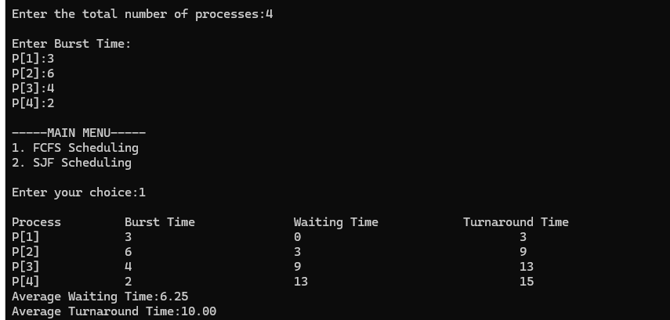

**b. SJF**

#include<stdio.h>

int n, i, j, pos, temp, choice, Burst_time[20], Waiting_time[20], Turn_around_time[20], process[20], total=0;

float avg_Turn_around_time=0, avg_Waiting_time=0;

void SJF(){

for(i=0;i<n;i++)

{

pos=i;

for(j=i+1;j<n;j++)

{

if(Burst_time[j]<Burst_time[pos])

pos=j;

}

temp=Burst_time[i];

Burst_time[i]=Burst_time[pos];

Burst_time[pos]=temp;

temp=process[i];

process[i]=process[pos];

process[pos]=temp;

}

Waiting_time[0]=0;

for(i=1;i<n;i++)

{

Waiting_time[i]=0;

for(j=0;j<i;j++)

Waiting_time[i]+=Burst_time[j];

total+=Waiting_time[i];

}

avg_Waiting_time=(float)total/n;

total=0;

printf("\nProcess\t\tBurst Time\t\tWaiting Time\t\tTurnaround Time");

for(i=0;i<n;i++)

{

Turn_around_time[i]=Burst_time[i]+Waiting_time[i];

total+=Turn_around_time[i];

printf("\nP[%d]\t\t%d\t\t\t%d\t\t\t\t%d",process[i],Burst_time[i],Waiting_time[i],Turn_around_time[i]);

}

avg_Turn_around_time=(float)total/n;

printf("\n\nAverage Waiting Time=%f",avg_Waiting_time);

printf("\nAverage Turnaround Time=%f\n",avg_Turn_around_time);

}

void main(){

printf("Enter the total number of processes:");

scanf("%d",&n);

printf("\nEnter Burst Time:\n");

for(i=0;i<n;i++) {

printf("P[%d]:",i+1);

scanf("%d",&Burst_time[i]);

process[i]=i+1;

}

SJF();

}

