**Lab-02**

1. To simulate the CPU scheduling algorithm round-robin.

#include<stdio.h>

void main()

{

Int i,j,n,bu[10],wa[10],tat[10],t,ct[10],max;

float awt=0,att=0,temp=0;

printf("Enter the no of processes -- ");

scanf("%d",&n);

for(i=0;i<n;i++)

{

printf("\nEnter Burst Time for process %d -- ", i+1);

scanf("%d",&bu[i]);

ct[i]=bu[i];

}

printf("\nEnter the size of time slice -- ");

scanf("%d",&t);

max=bu[0];

for(i=1;i<n;i++){

if(max<bu[i])

max=bu[i];

}

for(j=0;j<(max/t)+1;j++) {

for(i=0;i<n;i++) {

if(bu[i]>0){

if(bu[i]<=t){

temp=temp+bu[i];

tat[i]=temp;

bu[i]=0;

}

else {

bu[i]=bu[i]-t;

temp=temp+t;

}

}}}

for(i=0;i<n;i++){

wa[i]=tat[i]-ct[i];

att+=tat[i];

awt+=wa[i];}

printf("\nThe Average Turnaround time is -- %f",att/n);

printf("\nThe Average Waiting time is -- %f ",awt/n);

printf("\n\tPROCESS\t BURST TIME \t WAITING TIME\tTURNAROUND TIME\n");

for(i=0;i<n;i++)

printf("\t%d \t %d \t\t %d \t\t %d \n",i+1,ct[i],wa[i],tat[i]); }

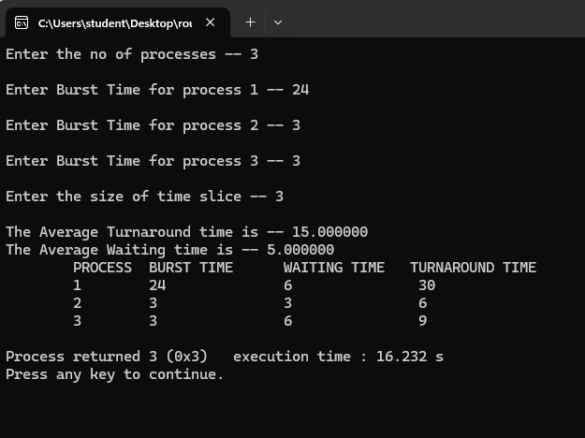

2. To write a c program to simulate the CPU scheduling priorityalgorithm.

#include<stdio.h>

void main()

{

int p[20],bt[20],pri[20], wt[20],tat[20],i, k, n, temp;

float wtavg, tatavg;

printf("Enter the number of processes --- ");

scanf("%d",&n);

for(i=0;i<n;i++){

p[i] = i;

printf("Enter the Burst Time & Priority of Process %d --- ",i);

scanf("%d%d",&bt[i], &pri[i]);

}

for(i=0;i<n;i++){

for(k=i+1;k<n;k++) {

if(pri[i] < pri[k]){

temp=p[i];

p[i]=p[k];

p[k]=temp;

temp=bt[i];

bt[i]=bt[k];

bt[k]=temp;

temp=pri[i];

pri[i]=pri[k];

pri[k]=temp;

}}}

tat[0] = bt[0];

for(i = 0; i < n; i++) {

if(i == 0) {

wt[i] = 0;

} else {

wt[i] = tat[i - 1];

}

tat[i] = wt[i] + bt[i];

wtavg += wt[i];

tatavg += tat[i];

}

printf("\nPROCESS\t\tPRIORITY\tBURST TIME\tWAITING TIME\tTURNAROUND TIME");

for(i=0;i<n;i++)

printf("\n%d \t\t %d \t\t %d \t\t %d \t\t %d ",p[i],pri[i],bt[i],wt[i],tat[i]);

printf("\nAverage Waiting Time is --- %f",wtavg/n);

printf("\nAverage Turnaround Time is --- %f",tatavg/n);

}

