**Lab-03**

**Write a C program to simulate Real-Time CPU Scheduling algorithms:**

1. **Rate- Monotonic**

#include <stdio.h>

#include <stdlib.h>

#include <math.h>

#include <stdbool.h>

#define MAX_PROCESS 10

typedef struct {

    int id;

    int burst_time;

    float priority;

} Task;

int num_of_process, execution_time[MAX_PROCESS],,period[MAX_PROCESS], remain_time[MAX_PROCESS], deadline[MAX_PROCESS], remain_deadline[MAX_PROCESS];

void get_process_info(){

    printf("Enter total number of processes (maximum %d): ", MAX_PROCESS);

    scanf("%d", &num_of_process);

    if (num_of_process < 1) exit(0);

    for (int i = 0; i < num_of_process; i++) {

        printf("\nProcess %d:\n", i + 1);

        printf("==> Execution time: ");

        scanf("%d", &execution_time[i]);

        remain_time[i] = execution_time[i];

            printf("==> Period: ");

            scanf("%d", &period[i]);

    }

}

int max(int a, int b, int c){

    int max;

    if (a >= b && a >= c)

        max = a;

    else if (b >= a && b >= c)

        max = b;

    else if (c >= a && c >= b)

        max = c;

    return max;

}

int get_observation_time(){

        return max(period[0], period[1], period[2]);

}

void print_schedule(int process_list[], int cycles)

{

    printf("\nScheduling:\n\n");

    printf("Time: ");

    for (int i = 0; i < cycles; i++)

    {

        if (i < 10)

            printf("| 0%d ", i);

        else

            printf("| %d ", i);

    }

    printf("|\n");

    for (int i = 0; i < num_of_process; i++)

    {

        printf("P[%d]: ", i + 1);

        for (int j = 0; j < cycles; j++)

        {

            if (process_list[j] == i + 1)

                printf("|####");

            else

                printf("|    ");

        }

        printf("|\n");

    }

}

void rate_monotonic(int time)

{

    int process_list[100] = {0}, min = 999, next_process = 0;

    float utilization = 0;

    for (int i = 0; i < num_of_process; i++)

    {

        utilization += (1.0 * execution_time[i]) / period[i];

    }

    int n = num_of_process;

    int m = (float) (n * (pow(2, 1.0 / n) - 1));

    if (utilization > m)

    {

        printf("\nGiven problem is not schedulable under the said scheduling algorithm.\n");

    }

    for (int i = 0; i < time; i++)

    {

        min = 1000;

        for (int j = 0; j < num_of_process; j++)

        {

            if (remain_time[j] > 0)

            {

                if (min > period[j])

                {

                    min = period[j];

                    next_process = j;

                }

            }

        }

        if (remain_time[next_process] > 0)

        {

            process_list[i] = next_process + 1;

            remain_time[next_process] -= 1;

        }

        for (int k = 0; k < num_of_process; k++)

        {

            if ((i + 1) % period[k] == 0)

            {

                remain_time[k] = execution_time[k];

                next_process = k;

            }

        }

    }

    print_schedule(process_list, time);

}

void main()

{

    int observation_time;

get_process_info();

    observation_time = get_observation_time();

     rate_monotonic(observation_time);

               }

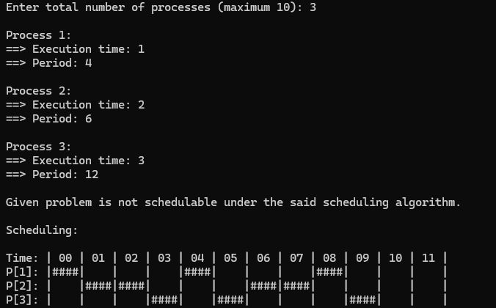

1. **Earliest-deadline First**

#include <stdio.h>

#include <stdlib.h>

#include <math.h>

#include <stdbool.h>

#define MAX_PROCESS 10

typedef struct {

    int id;

    int burst_time;

    float priority;

} Task;

int num_of_process, execution_time[MAX_PROCESS],,period[MAX_PROCESS], remain_time[MAX_PROCESS], deadline[MAX_PROCESS], remain_deadline[MAX_PROCESS];

void get_process_info(){

    printf("Enter total number of processes (maximum %d): ", MAX_PROCESS);

    scanf("%d", &num_of_process);

    if (num_of_process < 1) exit(0);

    for (int i = 0; i < num_of_process; i++) {

        printf("\nProcess %d:\n", i + 1);

        printf("==> Execution time: ");

        scanf("%d", &execution_time[i]);

        remain_time[i] = execution_time[i];

            printf("==> Deadline: ");

            scanf("%d", &deadline[i]);

    }

}

int max(int a, int b, int c){

    int max;

    if (a >= b && a >= c)

        max = a;

    else if (b >= a && b >= c)

        max = b;

    else if (c >= a && c >= b)

        max = c;

    return max;

}

int get_observation_time(){

        return max(deadline[0], deadline[1], deadline[2]);

    }

void print_schedule(int process_list[], int cycles)

{

    printf("\nScheduling:\n\n");

    printf("Time: ");

    for (int i = 0; i < cycles; i++)

    {

        if (i < 10)

            printf("| 0%d ", i);

        else

            printf("| %d ", i);

    }

    printf("|\n");

    for (int i = 0; i < num_of_process; i++)

    {

        printf("P[%d]: ", i + 1);

        for (int j = 0; j < cycles; j++)

        {

            if (process_list[j] == i + 1)

                printf("|####");

            else

                printf("|    ");

        }

        printf("|\n");

    }

}

void earliest_deadline_first(int time){

    float utilization = 0;

    for (int i = 0; i < num_of_process; i++){

        utilization += (1.0*execution_time[i])/deadline[i];

    }

    int n = num_of_process;

    int process[num_of_process];

    int max_deadline, current_process=0, min_deadline,process_list[time];

    bool is_ready[num_of_process];

    for(int i=0; i<num_of_process; i++){

        is_ready[i] = true;

        process[i] = i+1;

    }

    max_deadline=deadline[0];

    for(int i=1; i<num_of_process; i++){

        if(deadline[i] > max_deadline)

            max_deadline = deadline[i];

    }

    for(int i=0; i<num_of_process; i++){

        for(int j=i+1; j<num_of_process; j++){

            if(deadline[j] < deadline[i]){

                int temp = execution_time[j];

                execution_time[j] = execution_time[i];

                execution_time[i] = temp;

                temp = deadline[j];

                deadline[j] = deadline[i];

                deadline[i] = temp;

                temp = process[j];

                process[j] = process[i];

                process[i] = temp;

            }

        }

    }

    for(int i=0; i<num_of_process; i++){

        remain_time[i] = execution_time[i];

        remain_deadline[i] = deadline[i];

    }

    for (int t = 0; t < time; t++){

        if(current_process != -1){

            --execution_time[current_process];

            process_list[t] = process[current_process];

        }

        else

            process_list[t] = 0;

        for(int i=0;i<num_of_process;i++){

            --deadline[i];

            if((execution_time[i] == 0) && is_ready[i]){

                deadline[i] += remain_deadline[i];

                is_ready[i] = false;

            }

            if((deadline[i] <= remain_deadline[i]) && (is_ready[i] == false)){

                execution_time[i] = remain_time[i];

                is_ready[i] = true;

            }

        }

        min_deadline = max_deadline;

        current_process = -1;

        for(int i=0;i<num_of_process;i++){

            if((deadline[i] <= min_deadline) && (execution_time[i] > 0)){

                current_process = i;

                min_deadline = deadline[i];

            }

        }

    }

    print_schedule(process_list, time);

}

void main()

{

    int observation_time;

get_process_info();

   observation_time = get_observation_time();

    earliest_deadline_first(observation_time);

}

