# AWS Highly Available Web Application Infrastructure

## 📌 Project Overview

This project demonstrates the design and deployment of a **highly available static web application infrastructure on AWS using Terraform**.

The application is deployed on Amazon EC2 instances running in **private subnets across multiple Availability Zones**. An **Application Load Balancer (ALB)** distributes incoming HTTP traffic across the EC2 instances, while an **Auto Scaling Group (ASG)** maintains application availability and automatically replaces unhealthy instances.

The entire AWS infrastructure is provisioned and managed using **Terraform Infrastructure as Code (IaC)**.

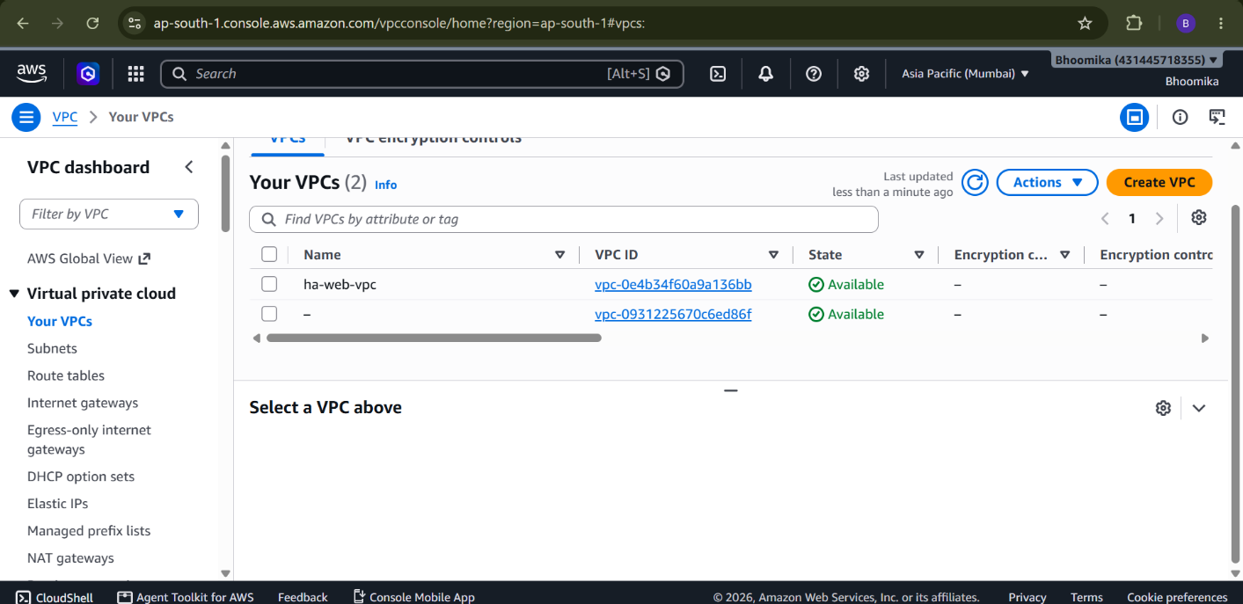
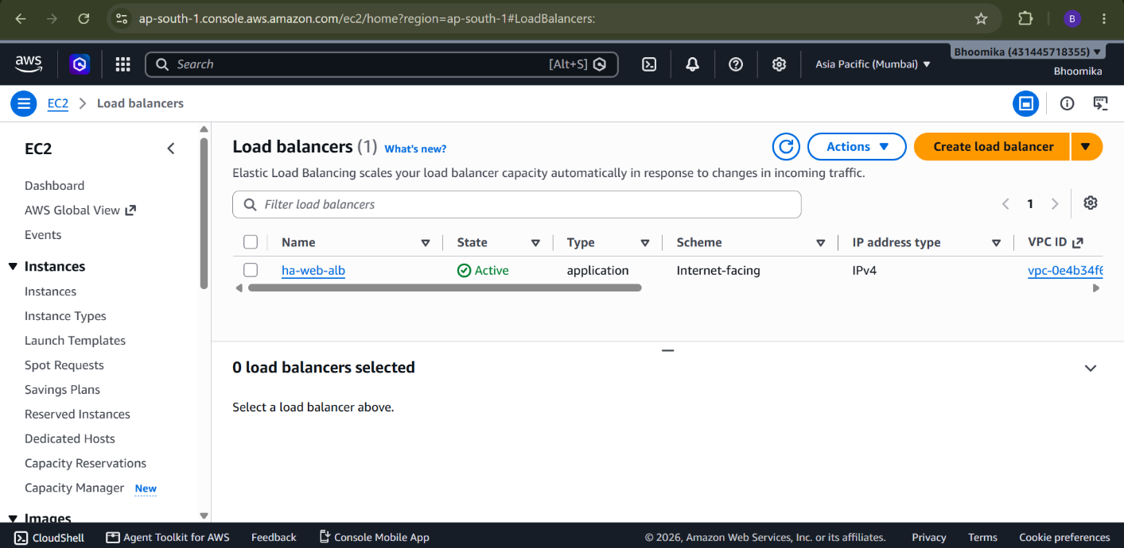

---

## 🏗️ Architecture

```text
INTERNET
│
▼
┌─────────────────────┐
│ Application Load │
│ Balancer (ALB) │
│ Port 80 │
└──────────┬──────────┘
│
┌─────────────┴─────────────┐
│ │
▼ ▼
┌────────────────┐ ┌────────────────┐
│ Private Subnet │ │ Private Subnet │
│ AZ-1 │ │ AZ-2 │
│ │ │ │
│ EC2 + Nginx │ │ EC2 + Nginx │
│ Web Server │ │ Web Server │
└───────┬────────┘ └────────┬───────┘
│ │
▼ ▼
NAT Gateway NAT Gateway
│ │
└─────────────┬─────────────┘
│
▼
Internet
```
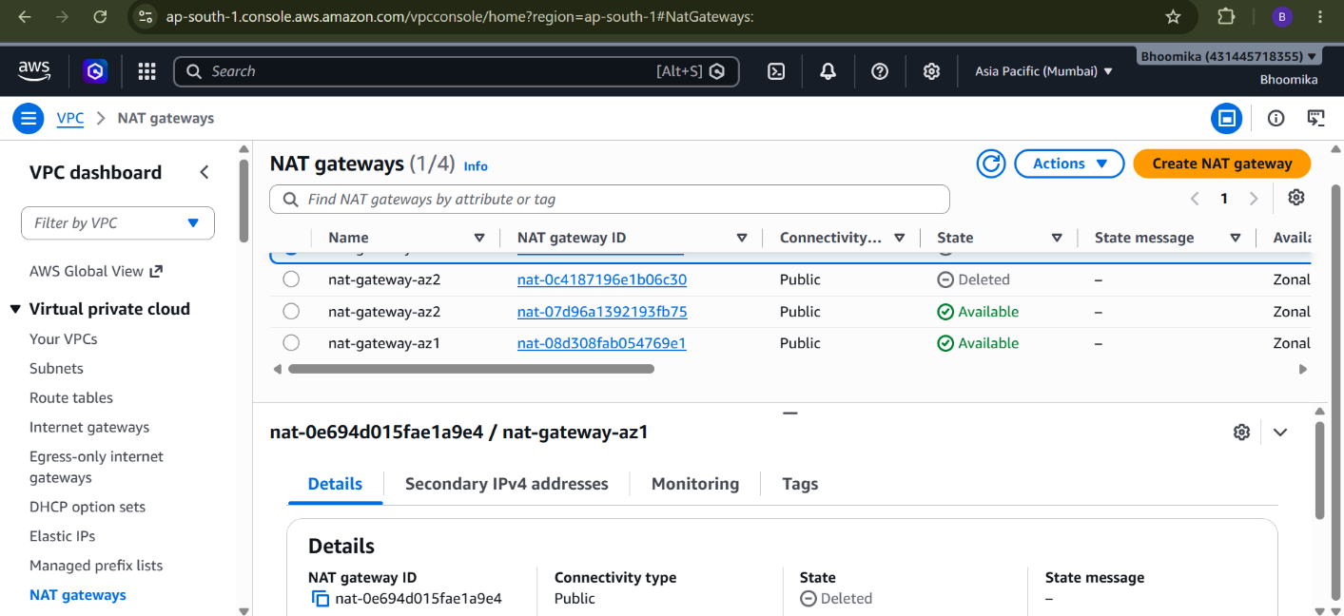

---

## 🚀 Application

A static web template from **Tooplate – Orbital** is deployed on the EC2 instances.

The template is automatically downloaded and configured during EC2 instance initialization using Terraform `user_data`.

The web application is served using **Nginx** and accessed through the Application Load Balancer DNS endpoint.



---

## 🛠️ Technologies Used

### Cloud

* Amazon Web Services (AWS)
* Amazon EC2
* Amazon VPC
* Application Load Balancer
* Auto Scaling Group
* NAT Gateway
* Internet Gateway
* Elastic IP
* IAM
* AWS Systems Manager

### Infrastructure as Code

* Terraform

### Networking

* VPC
* Public Subnets
* Private Subnets
* Route Tables
* Security Groups
* Availability Zones

### Web Server

* Nginx
* HTML
* CSS
* JavaScript

### Version Control

* Git
* GitHub

---

## ✨ Key Features

* Highly available multi-AZ architecture
* Public and private subnet separation
* Internet-facing Application Load Balancer
* EC2 instances deployed in private subnets
* Auto Scaling Group with minimum, desired, and maximum capacity
* CPU-based Auto Scaling policy
* ALB health checks
* Automatic replacement of unhealthy instances
* NAT Gateway for private subnet internet access
* Security Group based traffic control
* Automated Nginx installation
* Automated static website deployment
* Infrastructure fully provisioned using Terraform
* AWS Systems Manager access without requiring an EC2 key pair

---

## 📁 Project Structure

```text
aws-highly-available-web-infrastructure/
│
├── .gitignore
├── README.md
│
├── screenshots/
│ ├── architecture.png
│ ├── vpc.png
│ ├── subnets.png
│ ├── alb.png
│ ├── target-group.png
│ ├── autoscaling.png
│ └── website.png
│
└── terraform/
│
├── provider.tf
├── variables.tf
├── terraform.tfvars
├── vpc.tf
├── subnet.tf
├── internet-gateway.tf
├── nat-gateway.tf
├── route-table.tf
├── security-groups.tf
├── iam.tf
├── alb.tf
├── launch-template.tf
├── autoscaling.tf
├── outputs.tf
└── .terraform.lock.hcl
```

---

## 🔧 Infrastructure Components

### 1. VPC

A custom VPC is created with the CIDR:

```text
10.0.0.0/16
```

---

### 2. Public Subnets

Two public subnets are created across different Availability Zones.

```text
Public Subnet AZ-1 → 10.0.1.0/24
Public Subnet AZ-2 → 10.0.2.0/24
```

The Application Load Balancer is deployed in these public subnets.

---

### 3. Private Subnets

Two private subnets are created across different Availability Zones.

```text
Private Subnet AZ-1 → 10.0.3.0/24
Private Subnet AZ-2 → 10.0.4.0/24
```

The EC2 web servers are deployed in these private subnets.

---

### 4. Internet Gateway

The Internet Gateway provides internet connectivity to resources in the public subnets.

```text
Public Subnet
↓
Internet Gateway
↓
Internet
```

---

### 5. NAT Gateway

NAT Gateways allow EC2 instances in private subnets to access the internet for outbound communication.

```text
Private EC2
↓
Private Route Table
↓
NAT Gateway
↓
Internet Gateway
↓
Internet
```

This allows the EC2 instances to download packages and the web template without exposing them directly to the internet.

---

### 6. Application Load Balancer

The Application Load Balancer is deployed across the two public subnets.

It:

* Accepts HTTP traffic on port 80
* Performs health checks
* Routes requests to healthy EC2 instances
* Distributes traffic across Availability Zones

---

### 7. Auto Scaling Group

The Auto Scaling Group maintains the desired number of web servers.

Configuration:

```text
Minimum Instances: 2
Desired Instances: 2
Maximum Instances: 4
```

The ASG uses the EC2 Launch Template to create new instances.

---

### 8. Auto Scaling Policy

A target tracking policy is configured based on average CPU utilization.

```text
Target CPU Utilization: 60%
```

When the workload increases, the Auto Scaling Group can launch additional instances.

---

### 9. Security Groups

Two security groups are used.

#### ALB Security Group

Allows:

```text
HTTP - Port 80
Source: 0.0.0.0/0
```

#### EC2 Security Group

Allows:

```text
HTTP - Port 80
Source: ALB Security Group
```

The EC2 instances are therefore not directly exposed to internet traffic.

---

## 🔐 Security Design

The architecture follows a basic layered security model:

```text
Internet
↓
ALB Security Group
↓
Application Load Balancer
↓
EC2 Security Group
↓
Private EC2 Instances
```

The web servers are placed in private subnets and receive traffic only through the Application Load Balancer.

---

## ⚙️ EC2 Initialization

The EC2 Launch Template uses `user_data` to automatically:

1. Update the operating system
2. Install Nginx
3. Install required download utilities
4. Download the Tooplate Orbital template
5. Extract the template
6. Copy the website files to the Nginx document root
7. Configure file permissions
8. Restart Nginx

This eliminates the need for manual application configuration after EC2 instances are launched.

---

## 🚀 Deployment

### Prerequisites

Install:

* Terraform
* AWS CLI
* Git

Verify:

```bash
terraform --version
aws --version
git --version
```

---

## 🔑 Configure AWS Credentials

Configure AWS CLI:

```bash
aws configure
```

Verify authentication:

```bash
aws sts get-caller-identity
```

Do not store AWS credentials inside the Terraform files or GitHub repository.

---

## 🏗️ Initialize Terraform

Navigate to the Terraform directory:

```bash
cd terraform
```

Initialize Terraform:

```bash
terraform init
```

---

## 🔍 Validate Configuration

```bash
terraform fmt
terraform validate
```

---

## 📋 Review Infrastructure

```bash
terraform plan
```

Review the resources Terraform plans to create.

---

## 🚀 Create Infrastructure

```bash
terraform apply
```

Enter:

```text
yes
```

Terraform will provision the AWS infrastructure.

---

## 🌐 Access the Application

After deployment, retrieve the Application Load Balancer DNS name:

```bash
terraform output alb_dns_name
```

Open the returned DNS name in a web browser:

```text
http://<ALB-DNS-NAME>
```

The Tooplate Orbital static website should be displayed.

---

## 📊 Testing

### Load Balancing

The application is deployed on multiple EC2 instances.

Refreshing the application demonstrates that requests can be served by different instances through the Application Load Balancer.

---

### Health Checks

The ALB continuously checks the health of the EC2 targets.

If an instance becomes unhealthy, traffic is directed to healthy instances.

---

### Auto Scaling

The Auto Scaling Group can scale the number of EC2 instances based on CPU utilization.

```text
CPU increases
↓
Auto Scaling
↓
Additional EC2 instance
↓
Instance registered with ALB
```

---

### High Availability

The web servers are deployed across multiple Availability Zones.

If an instance or Availability Zone experiences a failure, the remaining healthy infrastructure can continue serving the application.

---

## 🔧 Troubleshooting

### Check Nginx

```bash
sudo systemctl status nginx
```

Restart Nginx:

```bash
sudo systemctl restart nginx
```

---

### Check Website Files

```bash
ls -la /usr/share/nginx/html/
```

---

### Check EC2 Initialization Logs

```bash
sudo tail -100 /var/log/cloud-init-output.log
```

---

### Check ALB Target Health

AWS Console:

```text
EC2
→ Load Balancing
→ Target Groups
→ Targets
```

Targets should show:

```text
healthy
```

---

## 🧹 Destroy Infrastructure

When the project is no longer required, destroy the resources to avoid unnecessary AWS charges:

```bash
terraform destroy
```

Enter:

```text
yes
```

---

## 📸 Screenshots

The repository contains screenshots demonstrating:

* AWS VPC
* Public and private subnets
* Route tables
* NAT Gateway
* Application Load Balancer
* Target Group
* Auto Scaling Group
* Running EC2 instances
* Deployed web application

---

## 🎯 Learning Outcomes

Through this project, I gained hands-on experience with:

* AWS VPC architecture
* Public and private subnet design
* AWS networking
* Internet Gateway and NAT Gateway
* Route tables
* Security Groups
* EC2 deployment
* Application Load Balancer
* Auto Scaling Groups
* Health checks
* IAM roles
* AWS Systems Manager
* Nginx configuration
* Terraform Infrastructure as Code
* Git and GitHub
* Automated application deployment

---

## 👩‍💻 Author

**Bhoomika K R**

Computer Science Engineering Graduate
Cloud & DevOps Enthusiast

---

## ⭐ Project Highlights

```text
✓ Multi-AZ AWS Architecture
✓ Private EC2 Web Servers
✓ Application Load Balancer
✓ Auto Scaling
✓ NAT Gateway
✓ Security Groups
✓ Nginx
✓ Terraform IaC
✓ Automated Deployment
✓ AWS Systems Manager
```

