MEDTRACK
Hospital Operations & Patient Analytics Dashboard
Milestone 3 – Dashboard Development

Project Documentation

1. Introduction
MedTrack is a hospital operations and patient analytics dashboard developed with Python and Streamlit. It presents hospital-related data through summary indicators and interactive visualizations. The dashboard is organized into four sections: Hospital Overview, Patient Flow, Department & Clinical Analytics, and Resource Utilization.

2. Objectives
- Present important hospital admission and patient-flow indicators in one dashboard.
- Explore admission patterns across medical conditions and admission types.
- Summarize patient outcomes and length-of-stay patterns.
- Provide doctor-wise and clinical-condition analysis where the available dataset supports it.
- Visualize recorded room assignments and ICU/hospital stay durations.

3. Tools and Technologies
Technology | Purpose
Python | Application and data-processing language
Streamlit | Dashboard interface and navigation
Pandas | Loading, preparing and analyzing tabular data
Plotly | Interactive charts and visualizations
CSV datasets | Input data for dashboard analysis

4. Dataset and Data Preparation
The project workspace contains hospital-related CSV datasets, including the HDHI Admission dataset and healthcare dataset. The workspace also contains cleaned data and KPI output files. The dashboard uses the prepared data files available in the project.
The project scripts visible in the workspace include:
- inspect_data.py – used to inspect the input data.
- clean_data.py – used for data-cleaning operations.
- generate_kpis.py – used to generate KPI outputs.
The documentation reflects the project structure and dashboard screens provided. Exact cleaning rules, column-level transformations and formulas should be documented from the corresponding source scripts.

5. Dashboard Modules

5.1 Hospital Overview
This section provides a high-level summary of hospital activity. The supplied dashboard screen shows KPI cards for total admissions, average stay, number of medical conditions and unique hospital names. It also includes visualizations such as admissions by medical condition and admission-type distribution.

5.2 Patient Flow Analysis
This section focuses on admissions, length of stay and patient outcomes. The supplied screens show total admissions, average stay, average ICU stay, monthly admission trends, patient outcome analysis and an Emergency-versus-OPD admission comparison.

5.3 Department & Clinical Analytics
This section presents clinical-condition and doctor-wise analysis. The supplied screens include admissions by medical condition, top doctors by patient admissions and average length of stay by medical condition. The dashboard also displays a note explaining that department-wise performance cannot be calculated reliably because the dataset does not contain a Department column.

5.4 Resource Utilization Analysis
This section visualizes recorded room assignments, ICU stay duration and hospital stay duration. The supplied dashboard screens include room assignment frequency and distributions of ICU and hospital stays. A note in the dashboard clarifies that room assignment frequency is not the same as bed occupancy.

6. Screenshots of the Dashboard
The following screenshots are included as visual evidence of the dashboard sections. They show the locally running MedTrack Streamlit application.
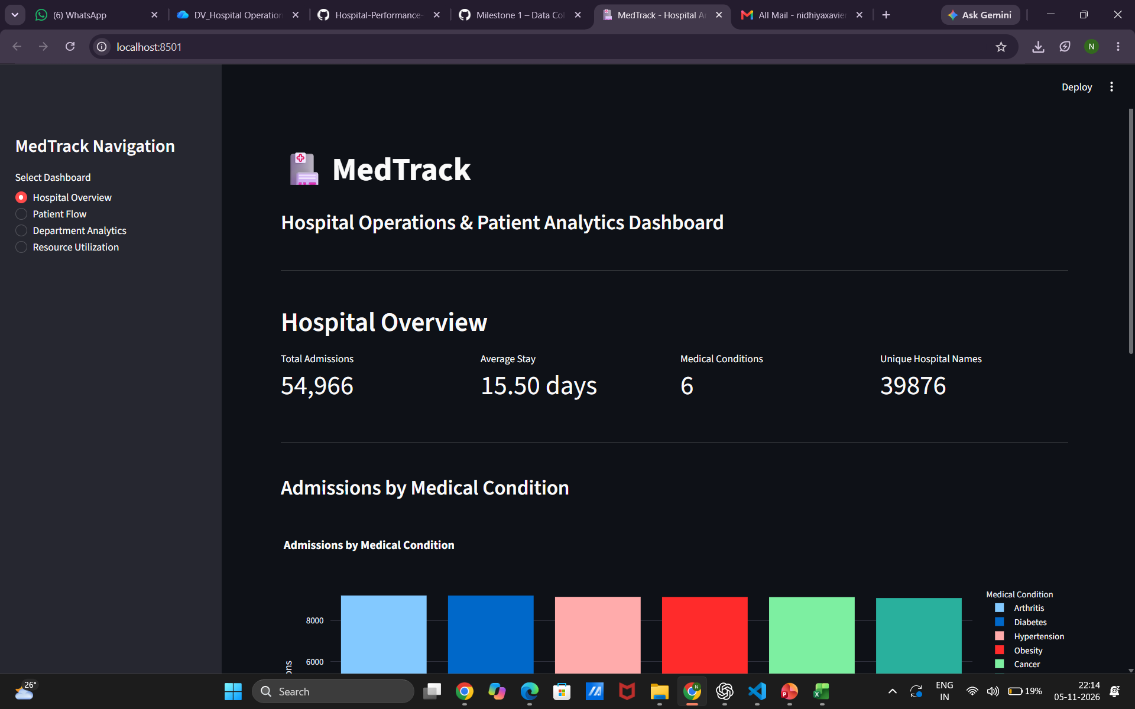
Hospital Overview – summary KPIs and admission visualization
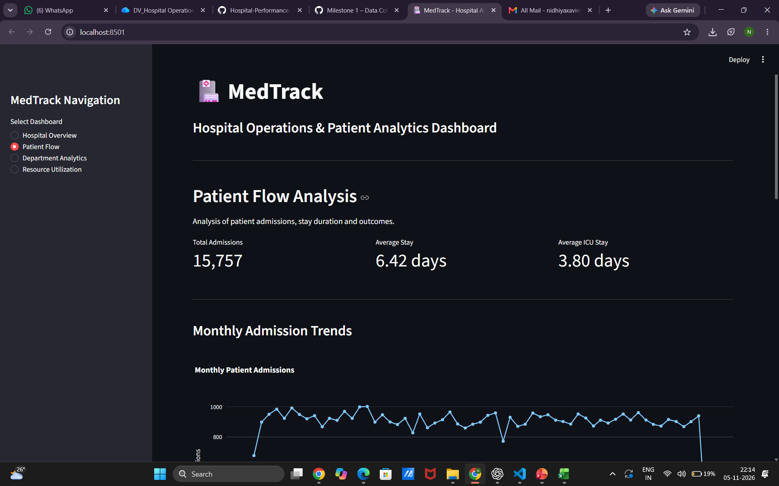
Patient Flow – patient-flow KPIs and monthly admission trend
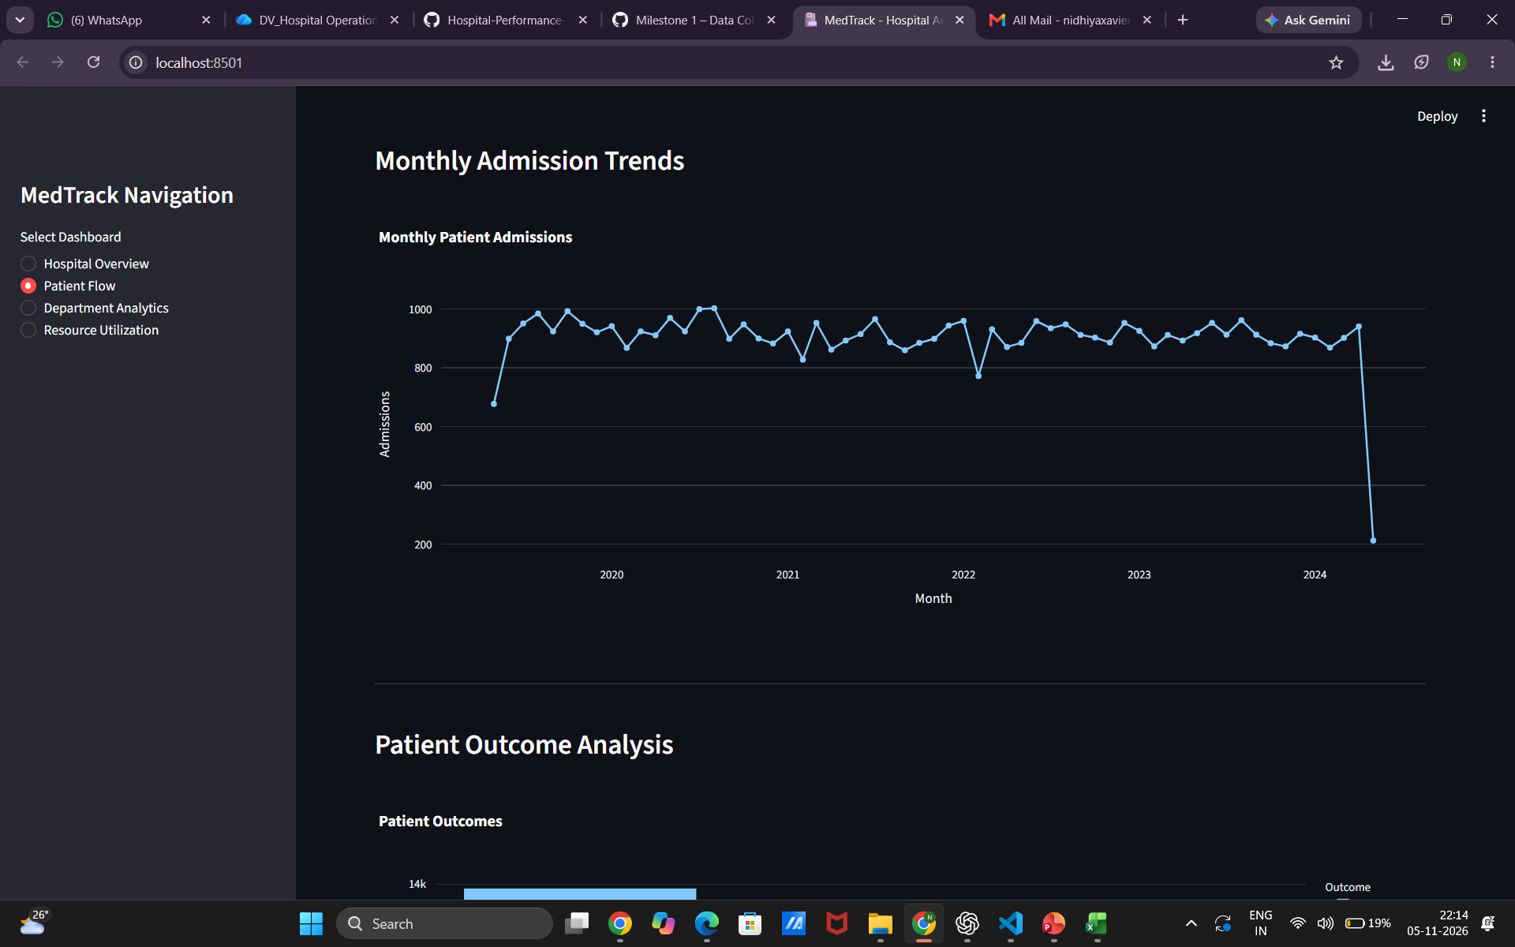
Patient Flow – monthly admission trend and patient outcome analysis
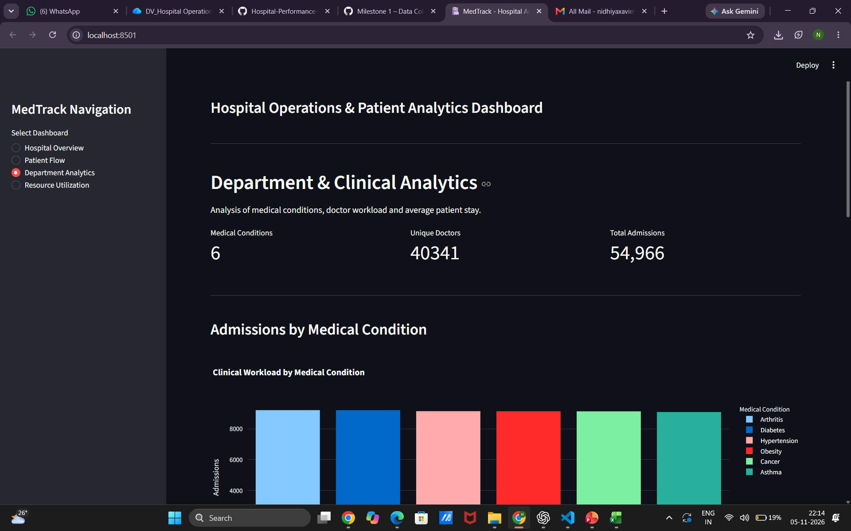
Department & Clinical Analytics – admissions by medical condition
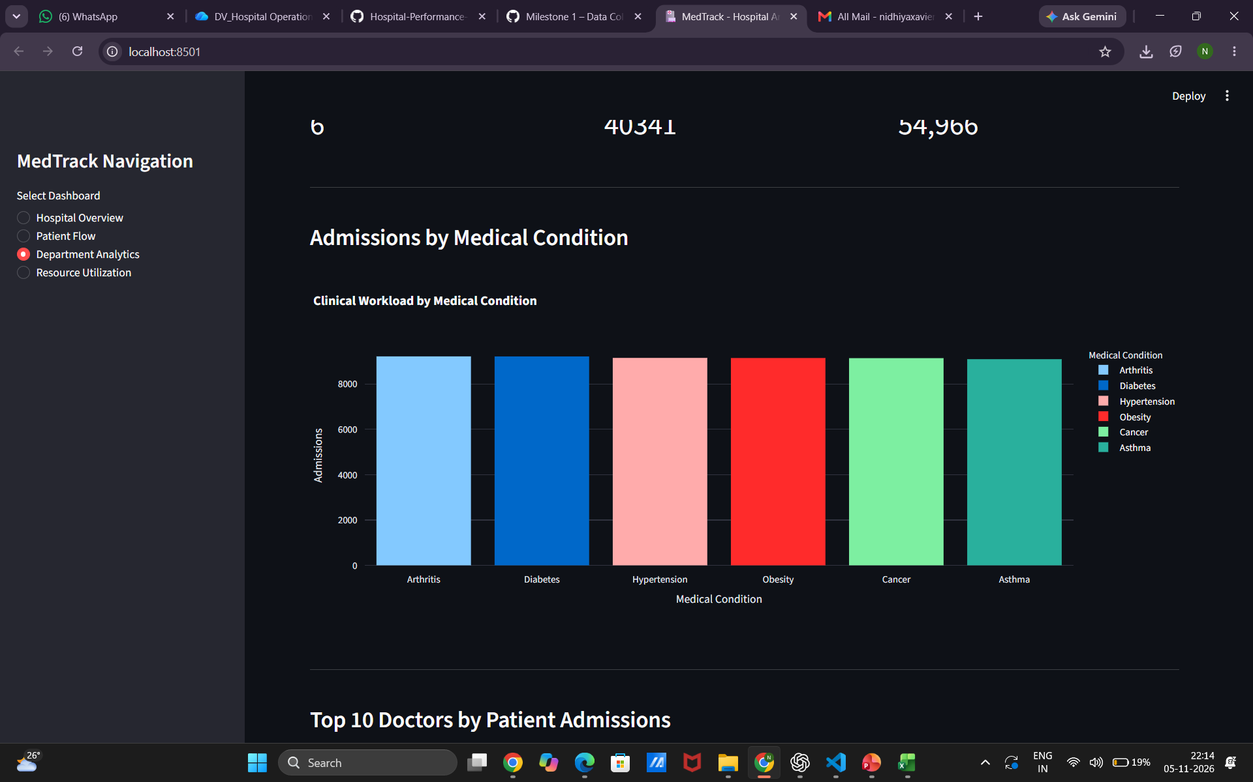
Department & Clinical Analytics – clinical charts and doctor analysis
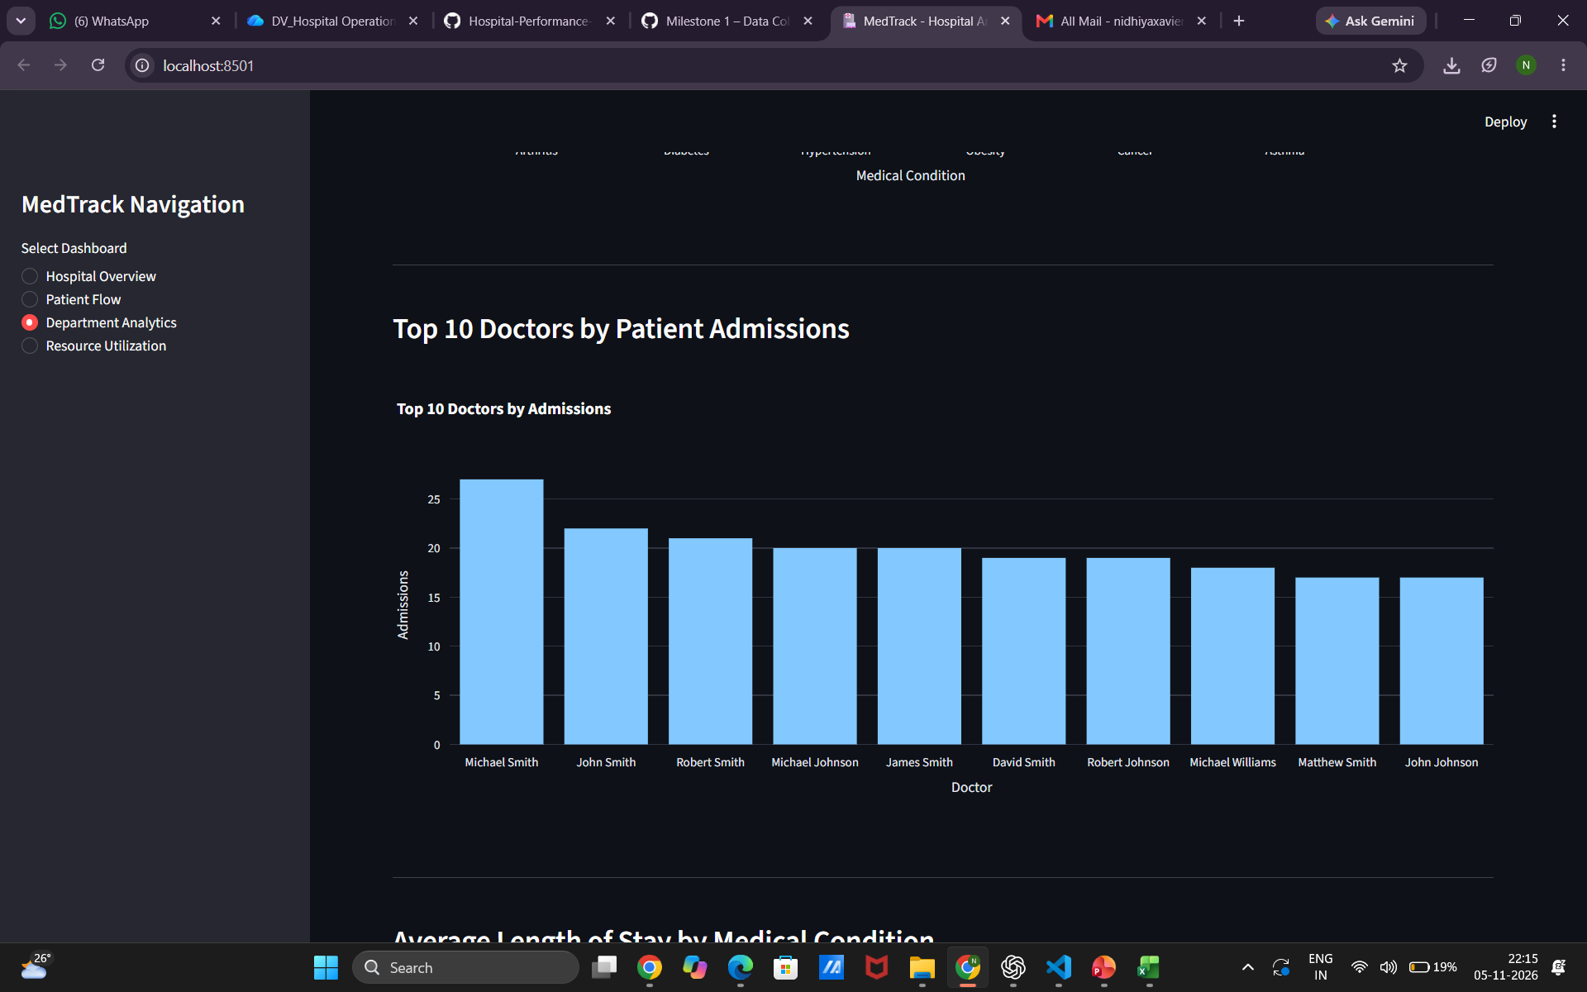
Top 10 doctors by patient admissions
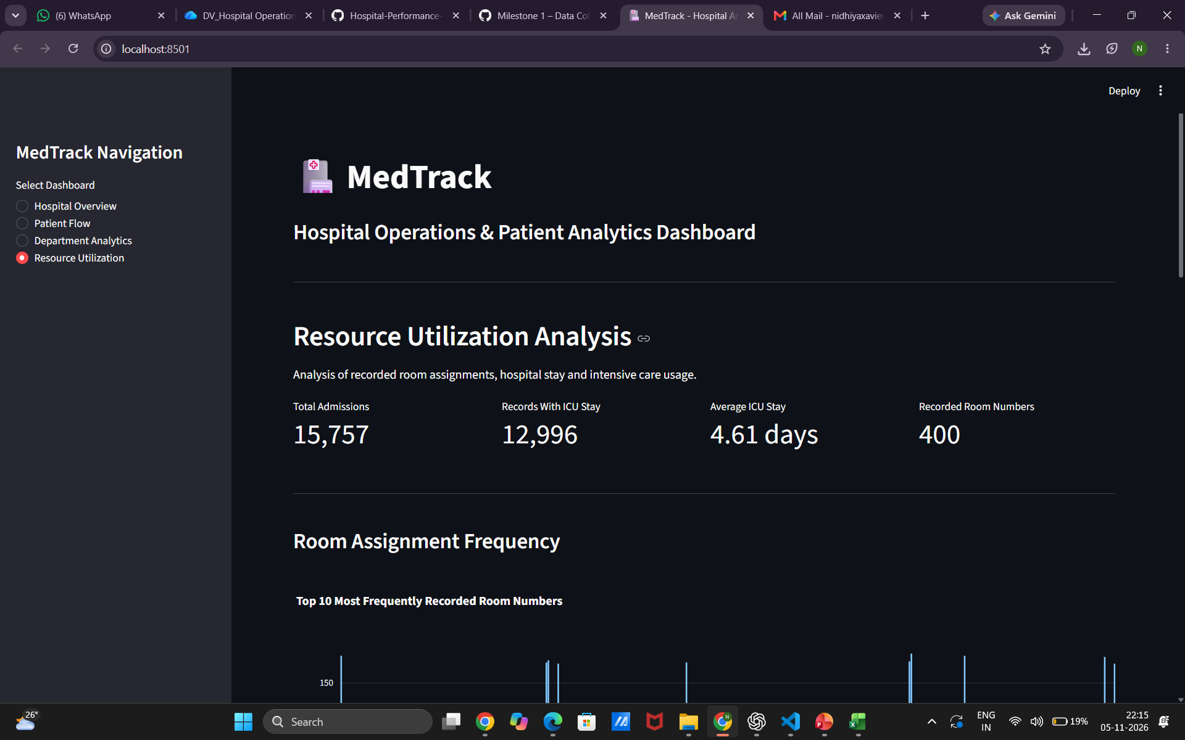
Resource Utilization – overview and room assignment frequency
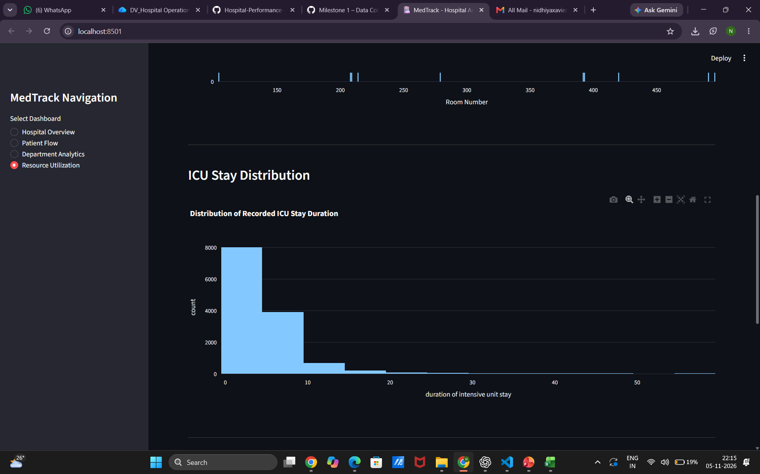
Resource Utilization – ICU stay distribution
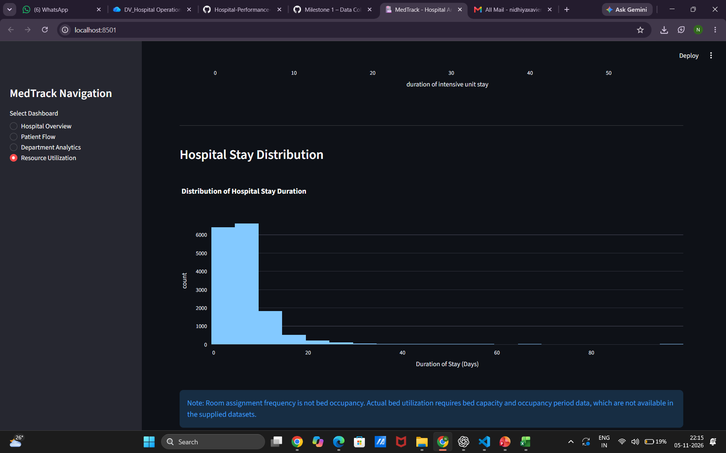
Resource Utilization – hospital stay distribution and data limitation note

7. How to Run the Dashboard
From the dashboard project directory, open a terminal and run:
python -m streamlit run app.py
If Streamlit or other dependencies are not installed in the active Python environment, install the packages listed by the project before running the command. The terminal displays the local address to open in a browser.

8. Observations and Data Limitations
- The dashboard includes a note that department-wise performance cannot be calculated because the dataset does not contain a Department column.
- The dashboard states that room assignment frequency should not be interpreted as bed occupancy.
- Actual bed utilization requires bed-capacity and occupancy-period information, which is not available in the supplied datasets.
- The dashboard presents recorded ICU stay and hospital stay durations; interpretation depends on the completeness and meaning of the source fields.

9. Conclusion
Milestone 3 brings the prepared hospital data into a Streamlit dashboard with four navigable analytical sections. The screens demonstrate summary KPIs, admission trends, clinical-condition analysis, patient outcomes and resource-related duration distributions. The dashboard also identifies important data limitations so that unsupported measures, such as actual bed occupancy or department-wise efficiency, are not presented as confirmed results.

10. Suggested Milestone 3 Folder Structure
Milestone_3/
├── dashboard/
│ ├── app.py
│ └── cleaned_data/
├── screenshots/
├── documentation/
│ └── Milestone3_Dashboard_Documentation.docx
└── README.md

