Hospital Performance Intelligence System

Milestone 3 – Interactive Dashboard

1. Introduction
The Hospital Performance Intelligence System is an interactive healthcare analytics solution developed to analyze hospital operations, patient flow, departmental performance, and resource utilization.
Milestone 3 focuses on converting the previously engineered hospital data and KPI calculations into an interactive Streamlit dashboard. The dashboard provides multiple analytical views that allow users to explore hospital performance and compare departments using interactive visualizations and filters.
The system uses Python, Pandas, Plotly, and Streamlit to provide a user-friendly dashboard for hospital performance monitoring and decision support.

2. Objectives
The main objectives of the dashboard are:
- To provide an overview of important hospital performance indicators.
- To analyze patient admission and discharge patterns.
- To compare patient volume and performance across departments.
- To monitor average length of stay and readmission rates.
- To analyze hospital resource availability and staff allocation.
- To provide interactive dashboard navigation.
- To allow users to filter admission-level analysis by department.
- To present hospital analytics through interactive visualizations.

3. Technologies Used
The following technologies were used to develop the dashboard:
Technology | Purpose
Python | Dashboard development and data processing
Pandas | Data loading, cleaning and analysis
Plotly | Interactive charts and visualizations
Streamlit | Interactive web dashboard
CSV | Storage of cleaned datasets
Git / GitHub | Version control and project management

4. Dataset Description
Two cleaned datasets were used for the dashboard.

4.1 Hospital Weekly Operational Dataset
The weekly operational dataset contains information related to hospital services and operational activity, including:
- Available beds
- Patient requests
- Patients admitted
- Patients refused
- Patient satisfaction
- Staff morale
- Patient count
- Average age
- Average length of stay
- Staff present
- Staff count
- Service and weekly/monthly information
This dataset is mainly used for hospital-level operational trends and resource utilization analysis.

4.2 Hospital Admissions Dataset
The admission-level dataset contains individual patient admission records, including:
- Admission ID
- Patient ID
- Admission date
- Department
- Diagnosis
- Age
- Gender
- Insurance type
- Admission type
- Length of stay
- Billing amount
- Discharge status
- 30-day readmission status
- Patient satisfaction
This dataset is used for patient flow, department-level analysis, readmission analysis, length-of-stay analysis, and patient satisfaction analysis.

5. Dashboard Modules
The Streamlit dashboard is divided into four main analytical modules.

5.1 Hospital Overview
The Hospital Overview dashboard provides a high-level summary of hospital performance.
It includes:
- Total admissions
- Average length of stay
- 30-day readmission rate
- Patient satisfaction
- Monthly admission trends
- Patient volume by department
This module provides an overall view of hospital activity and key performance indicators.
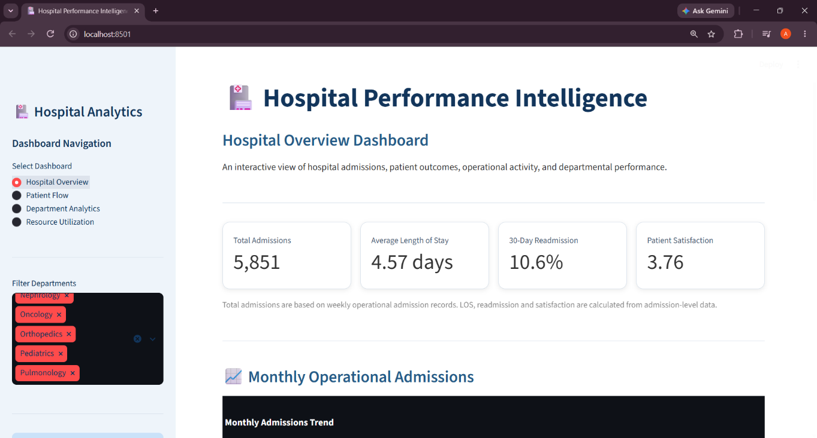

Figure 1 – Hospital Overview Dashboard: Displays key hospital performance indicators, providing a summary of overall hospital operations.

5.2 Patient Flow
The Patient Flow dashboard focuses on the movement of patients through the hospital.
It includes:
- Monthly admission trends
- Discharge outcomes
- Average length of stay by department
- Weekly patient load
This module helps identify changes in patient volume and understand patient movement and stay patterns.
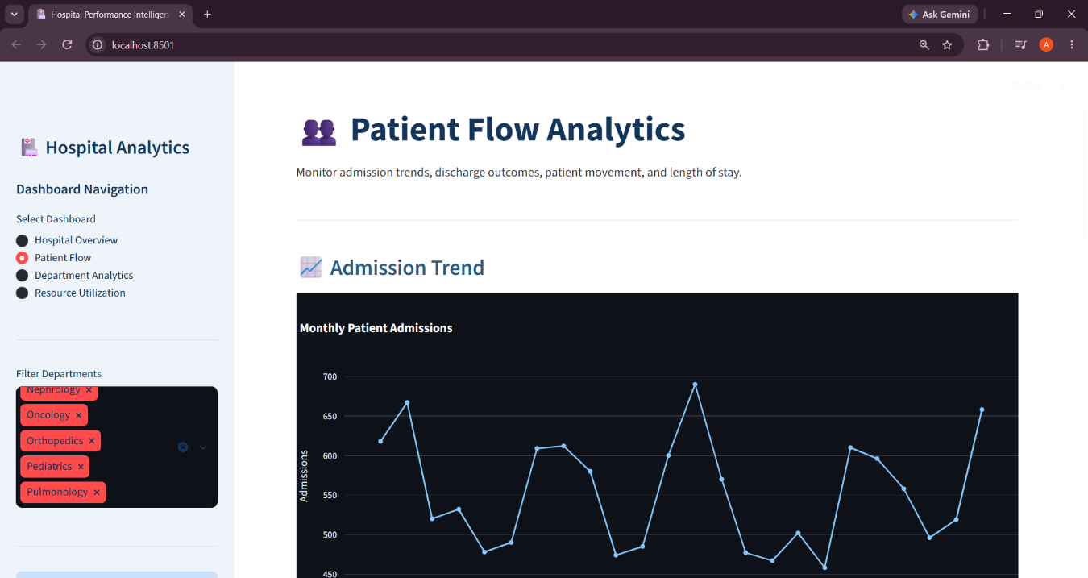
Figure 2 – Patient Flow Dashboard: Presents patient admission and discharge patterns

5.3 Department Analytics
The Department Analytics dashboard allows users to compare different hospital departments.
It includes:
- Patient volume by department
- 30-day readmission rate by department
- Patient satisfaction by department
- Department performance summary
The department filter allows users to select or remove departments and dynamically update admission-level analysis.
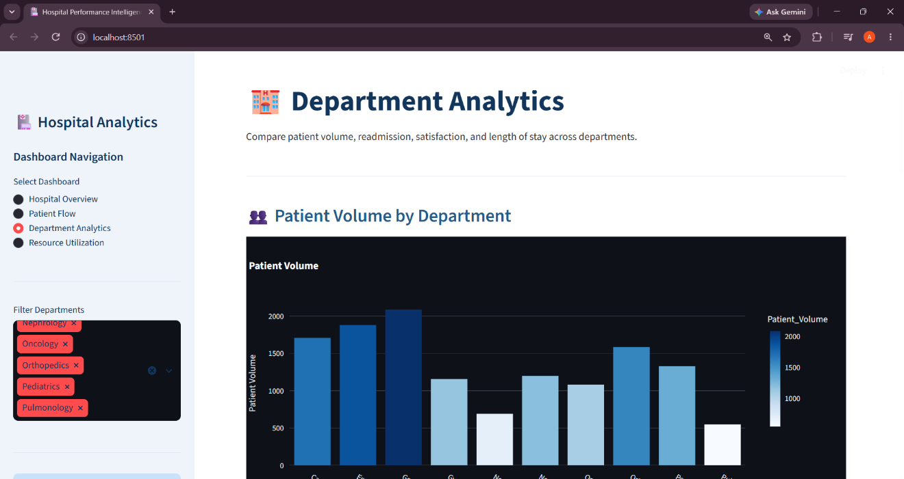
Figure 3 – Department Analytics Dashboard: Compares department-wise performance using admission-related metrics and visualizations.

5.4 Resource Utilization
The Resource Utilization dashboard focuses on hospital capacity and staffing.It includes:
- Average available beds by service
- Staff allocation
- Staff present compared with total staff
- Staff coverage
- Estimated bed utilization
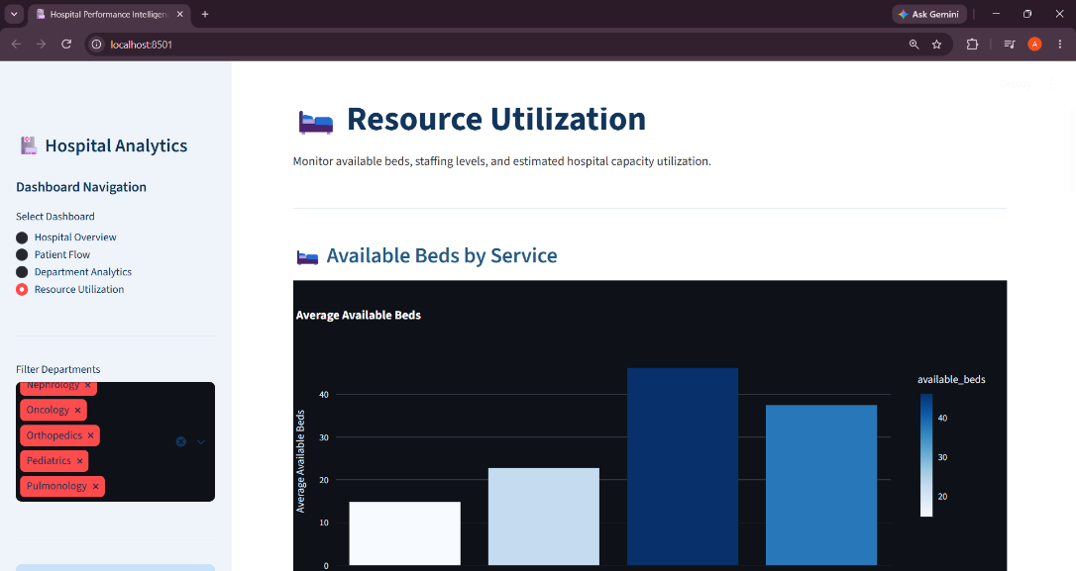
Equipment utilization was not calculated because equipment-level usage data was not available in the supplied datasets.The bed utilization measure is presented as an estimated operational indicator rather than a direct occupied-bed measurement.

Figure 4 – Resource Utilization Dashboard: Shows weekly resource-related metrics, including bed availability, staff allocation, staff coverage, and estimated bed utilization.

6. KPI Calculation and Methodology
The dashboard uses calculated performance indicators to summarize hospital operations.

Total Admissions
Total admissions are calculated from the weekly operational dataset by summing the patients_admitted values.
The resulting overall value is approximately 5,851 admissions.

Average Length of Stay
Average length of stay is calculated from the admission-level dataset using the mean of length_of_stay_days.
The resulting average is approximately 4.57 days.

30-Day Readmission Rate
The readmission rate is calculated using the is_readmission_30d field.
It represents the percentage of admission records marked as readmissions within 30 days.
The overall rate is approximately 10.6%.

Patient Satisfaction
Patient satisfaction is calculated as the average of the available patient_satisfaction values in the admission-level dataset.
Missing satisfaction values are excluded from the calculation.
The overall value displayed by the dashboard is approximately 3.76.

Estimated Bed Utilization
Bed utilization is estimated using patient count, average length of stay, available beds, and a seven-day operational period.
This is an estimated utilization indicator because the dataset does not contain direct daily occupied-bed measurements.

Staff Coverage
Staff coverage is calculated by comparing the number of staff present with the total staff count for each service in the weekly operational dataset.
The resource utilization analysis is based on the weekly service-level operational data, while the department filter is based on the admission-level department field. Therefore, the staff/resource charts represent the available weekly service data independently of the admission-level department selection.

7. Interactive Features
The dashboard provides several interactive features to make hospital performance analysis easier and more flexible.
7.1 Dashboard Navigation
A sidebar navigation panel allows users to switch between the four dashboard modules:
- Hospital Overview
- Patient Flow
- Department Analytics
- Resource Utilization
7.2 Department Filtering
A department multiselect filter is provided in the sidebar. Users can select or deselect departments to dynamically update admission-level KPIs, patient volume, readmission analysis, satisfaction analysis, and other department-related visualizations.
7.3 Interactive Visualizations
Plotly charts allow users to interact with visualizations through hovering, zooming, and exploring individual data points.
7.4 Dynamic Dashboard Updates
When users change the department selection, the relevant admission-level calculations and visualizations are automatically updated based on the selected departments.
Weekly operational resource visualizations remain independent of the department filter because they use a separate service-level dataset.

8. Testing and Validation
The Hospital Performance Intelligence dashboard was tested to ensure that its visualizations, interactive features, filters, and KPI calculations function correctly.

8.1 Dashboard Navigation
All four dashboard modules were tested to verify that users could navigate between Hospital Overview, Patient Flow, Department Analytics, and Resource Utilization.

8.2 Department Filter Testing
The department multiselect filter was tested to verify that admission-level metrics and visualizations update according to the selected departments. Selecting different departments was checked to ensure that the displayed results changed appropriately.

8.3 KPI Validation
The calculated KPIs, including total admissions, average length of stay, readmission rate, and patient satisfaction, were checked against the corresponding dataset values to ensure calculation accuracy.

8.4 Visualization Testing
All charts and graphs were checked to ensure that they displayed the correct information and supported interactive features such as hovering over data points and zooming.

8.5 Resource Utilization Validation
Weekly resource visualizations, including staff coverage and estimated bed utilization, were checked against the hospital's weekly operational dataset. These visualizations remain independent of the department filter because they use a separate service-level dataset.

9. Limitations
Although the Hospital Performance Intelligence System provides useful insights into hospital performance, it has certain limitations:
- Dataset Dependency: The accuracy of the dashboard depends on the quality, completeness, and availability of the input datasets.
- Estimated Bed Utilization: Bed utilization is estimated using patient count, average length of stay, and available beds rather than actual daily occupied-bed records.
- Limited Equipment Information: Equipment utilization could not be analyzed because detailed equipment-related data was not available.
- Separate Data Sources: Admission-level analytics and weekly operational resource analytics use separate datasets. Therefore, the department filter does not affect the weekly resource utilization charts.
- Historical Analysis: The dashboard analyzes the available historical data and does not currently provide real-time hospital monitoring or future predictions.

10. Conclusion
The Hospital Performance Intelligence System was developed to analyze hospital operations and present important performance indicators through an interactive dashboard.
The system integrates hospital admission and weekly operational data to evaluate patient flow, department-wise performance, and resource utilization. Key Performance Indicators such as total admissions, average length of stay, readmission rate, patient satisfaction, and estimated bed utilization provide useful insights into hospital operations.
The interactive Streamlit dashboard allows users to explore hospital performance through different modules, visualizations, and department-based filtering. Overall, the project demonstrates how data analytics and visualization can support better understanding of hospital operations and assist in data-driven decision-making.

