ClimateScope: Visualizing Global Weather Trends and Extreme Events

Intern: Bhagyalaxmi Kali
Program: Infosys Springboard Virtual Internship 6.0
Duration: 8 Weeks
Tech Stack: Python, Streamlit, Plotly, Pandas, NumPy, ReportLab
Dataset: Global Weather Repository (Kaggle)

Abstract
ClimateScope is an interactive data-driven dashboard designed to analyze and visualize global weather patterns using the Global Weather Repository dataset.
The project enables users to explore climatic behavior over time, identify extreme events, and compare regional variations through engaging and interactive visualizations.
By transforming vast weather data into clear, interpretable insights, ClimateScope supports climate awareness, research, and data-based decision-making.
The final deliverables include a robust, fully functional Streamlit dashboard and a comprehensive report detailing the methodology, visualizations, insights, and testing process.

1. Introduction
Climate change and extreme weather events have become urgent global challenges. Understanding and visualizing large-scale climatic data can provide valuable insights into temperature variations, air quality trends, and changing seasonal behaviors.
The ClimateScope project was developed as part of the Infosys Springboard Virtual Internship 6.0 to visualize, analyze, and interpret worldwide weather data in an accessible, interactive format.
It empowers users to explore trends across time, detect anomalies, and derive insights into regional and seasonal dynamics of global weather.

2. Objectives
The key objectives of the ClimateScope project were:
- To analyze global weather data from the Global Weather Repository and identify regional and temporal trends.
- To visualize seasonal patterns and extreme weather events interactively.
- To compare weather conditions across countries and climatic zones.
- To build an intuitive Streamlit dashboard integrating multiple analytical perspectives.
- To summarize key insights that support research and awareness regarding global weather behavior.

3. Methodology
The development of ClimateScope followed a structured workflow consisting of data acquisition, cleaning, analysis, visualization, and deployment.
3.1 Data Acquisition
- The Global Weather Repository dataset was sourced from Kaggle:
https://www.kaggle.com/datasets/nelgiriyewithana/global-weather-repository
- The dataset provides daily-updated weather observations across multiple countries, including variables such as temperature, humidity, wind speed, precipitation, and air quality.
3.2 Data Understanding
- Each dataset was examined for structure, coverage, and types.
- Primary attributes included:
temperature_celsius, humidity, wind_kph, precip_mm, air_quality_PM2.5, air_quality_PM10, air_quality_Carbon_Monoxide.
- Missing values, outliers, and inconsistencies were identified and recorded.
3.3 Data Cleaning and Pre-processing
- Dates were standardized using pd.to_datetime(); inconsistent entries were dropped or interpolated.
- Derived columns such as year, year_month, and season were created.
- Air quality composite scores were generated using average normalization across available pollutants.
- Categorical and numerical columns were validated for consistent units.
- Final cleaned datasets were cached using Streamlit’s @st.cache_data for faster dashboard load time.
- For faster processing, aggregated the data into four CSVs:
  - daily_cleaned.csv – daily level observations
  - weather_data_monthly.csv – monthly aggregated values
  - weather_seasonal_avg.csv – seasonal summaries
  - weather_yearly_avg.csv – yearly statistics

3.4 Data Analysis
- Statistical summaries (mean, median, quantiles) were computed to understand global distributions.
- Correlations between temperature, humidity, and wind were analyzed using pairwise correlation plots.
- Extreme events were identified using 95th and 99th percentile thresholds.
- Seasonal and regional comparisons were conducted using grouped aggregations.
3.5 Visualization Design
- Visualization types were selected based on insight needs:
  - Choropleth Maps – global temperature or air quality patterns by country.
  - Line Charts – temporal trends in temperature, wind speed, and air quality.
  - Scatterplots – relationship between temperature and pollution levels.
  - Boxplots / Heatmaps – seasonal variation across regions.
- A color scheme and consistent layout were designed for clarity and accessibility.
3.6 Dashboard Development
The entire dashboard was implemented in Streamlit, combining interactivity and responsiveness.
Key libraries:
- plotly.express and plotly.graph_objects for visualizations
- pandas and numpy for computation
- reportlab and kaleido for PDF report generation
- scikit-learn for normalization (Min-Max scaling)
Caching, filtering widgets, and data downloads were implemented to ensure performance and usability.

4. Dashboard Architecture and Workflow
4.1 Overall Architecture
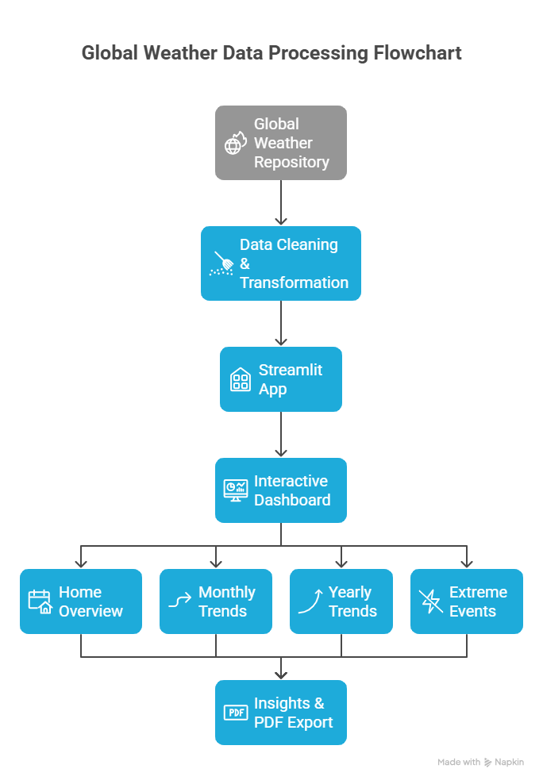
4.2 Functional Modules
- Home Overview
  - Displays global KPIs and temperature trends.
  - Includes 3-year rolling averages and scatter analysis (Temperature vs Air Quality).
- Monthly Trends
  - Shows country-wise monthly averages for temperature, wind, and air quality.
  - Allows selection of countries and visualization type (line/bar/box).
- Yearly Analysis
  - Compares multi-year climate indicators.
  - Displays country-level PM2.5 boxplots and correlation scatterplots.
- Extreme Events
  - Detects 95th/99th percentile temperature days.
  - Highlights top extreme countries (hottest, coldest, polluted).
- Seasonal Patterns
  - Compares seasonal averages for multiple years.
  - Highlights transitions and weather consistency.
- Download Reports
  - Exports summarized charts and findings as a professional PDF.

5. Key Visualizations and Insights
5.1 Choropleth Map
Displays temperature distribution across countries for a selected year.
Insight: Regions near the equator consistently exhibit higher mean temperatures. Northern and Southern extremes show stronger annual fluctuations.
5.2 Rolling Trend Lines
3-year rolling averages for temperature and air quality show upward and downward shifts respectively, hinting at worsening heat and pollution cycles.
5.3 Temperature vs Air Quality Scatter
Visualizes the relationship between heat and pollution.
Insight: High-temperature regions often overlap with poor air-quality areas, suggesting urban heat–pollution coupling.
5.4 Seasonal Patterns
Boxplots and line charts compare average temperature and PM2.5 across seasons.
Insight: Summer seasons show the widest range of temperature variance; monsoon periods exhibit improved air quality.
5.5 Extreme Event Detection
Using percentile thresholds, outliers in temperature are flagged.
Insight: The top 5 hottest countries align with major desert and equatorial zones, while cold extremes cluster around polar regions.

6. Results and Discussion
- Global warming signal: Average global temperature shows a rising trend between 2010–2024.
- Wind–pollution correlation: Lower wind speed regions tend to record higher PM2.5 levels.
- Regional contrasts: South-Asian countries display strong seasonal air-quality variation, while Western Europe remains comparatively stable.
- Extreme events: Number of temperature extremes per year has increased, aligning with reports of heatwaves worldwide.
- Climate Index: Derived composite index confirms that overall environmental stress (heat + wind + AQ) has gradually intensified.

7. Testing and Evaluation
7.1 Functional Testing
- All five dashboard pages tested independently.
- Input filters, sliders, and dropdowns verified for valid responses.
- CSV file load failure handled gracefully with warnings instead of crashes.
7.2 Performance Testing
- Cached datasets ensure sub-second loading after first execution.
- Large CSV handling tested up to 1 million rows.
7.3 Accuracy Validation
- Cross-checked KPI values with manual calculations on sample subsets.
- Verified correctness of extreme detection quantiles (95th, 99th).
7.4 Robustness
- Error handling added for missing columns, invalid dates, and null entries.
- Dashboard remains operational even with partial data availability.

8. Challenges and Learnings
Challenges Faced:
- Handling very large CSV files efficiently in Streamlit.
- Maintaining consistent interactivity across multiple pages.
- Managing date formats across global sources.
- Avoiding duplicate code and ensuring clean modular structure.
Learnings:
- Improved understanding of climate data structures.
- Hands-on experience with Plotly for advanced data visualization.
- Strengthened Python data-handling and Streamlit app-deployment skills.
- Gained practical experience in testing and report documentation.

9. Future Enhancements
- Integrate live weather API updates for real-time visualization.
- Include forecast modeling using ARIMA or Prophet for trend prediction.
- Expand dashboard scope to include greenhouse gas data.
- Deploy the dashboard publicly using Streamlit Cloud or AWS.
- Add automated anomaly detection alerts for extreme weather.

10. Conclusion
The ClimateScope project successfully met all the objectives defined in its agenda.
It transformed complex global weather data into a clear, interactive dashboard that uncovers seasonal variations, regional trends, and extreme events.
Through data-driven visualizations, the platform enhances understanding of global climate behavior and serves as a foundation for research, awareness, and decision support.
The project demonstrates how open data, combined with visualization technologies, can communicate large-scale environmental patterns effectively.

References
- Kaggle Dataset: Global Weather Repository — https://www.kaggle.com/datasets/nelgiriyewithana/global-weather-repository
- Streamlit Documentation — https://docs.streamlit.io/
- Plotly Express Documentation — https://plotly.com/python/plotly-express/
- Pandas User Guide — https://pandas.pydata.org/

