FINANCIAL MARKET ANALYSIS
Week 4: Predictive Modeling & Performance Evaluation
Infosys | Reliance Industries | Tata Consultancy Services

Python | pandas | NumPy | scikit-learn | Matplotlib
Data source: Yahoo Finance | Period: 1 November 2023 to 30 October 2026
Internship Project Report
Prepared by: Bhoomika Jain
November 2026

Contents
1. Executive Summary 2
2. Introduction 2
3. Project Objectives 3
4. Dataset Description and Data Source 3
5. Problem Definition and Target Variable 4
6. Methodology 4
7. Model Selection and Implementation 6
8. Evaluation Metrics 6
9. Results and Performance Comparison 7
10. Actual vs. Predicted Analysis 8
11. Residual Analysis 10
12. Company-wise Findings 12
13. Challenges and Limitations 13
14. Possible Improvements and Future Scope 14
15. Conclusion 14
16. References and Data Source 15
Appendix A: Code Annotations for Modeling 16
Appendix B: Code Annotations for Evaluation 18
List of Figures
Figure 1. Infosys: Actual vs Predicted Adjusted Closing Price 9
Figure 2. Reliance Industries: Actual vs Predicted Adjusted Closing Price 9
Figure 3. Tata Consultancy Services: Actual vs Predicted Adjusted Closing Price 10
Figure 4. Infosys: Residual Plot 11
Figure 5. Reliance Industries: Residual Plot 11
Figure 6. Tata Consultancy Services: Residual Plot 11

1. Executive Summary
This report documents the design, implementation and evaluation of a supervised regression model that predicts the next trading day's adjusted closing price of Infosys, Reliance Industries and Tata Consultancy Services (TCS). A separate Linear Regression model was trained for each company on ten price, volume, return and volatility features, using a chronological 80:20 split (574 training and 144 test observations per company) and a StandardScaler + Linear Regression scikit-learn pipeline. Performance was compared with a naive persistence baseline that predicts tomorrow's price as today's price.
Key findings
- Linear Regression tracks the broad price movement of all three stocks, with test R² of 0.888 (Infosys), 0.917 (Reliance) and 0.892 (TCS).
- The naive baseline is marginally better than Linear Regression on MAE, MSE and RMSE for every company. For example, the Infosys MAE is 19.099 for Linear Regression against 18.220 for the baseline, and the TCS MAE is 36.445 against 34.983.
- Reliance is a near tie. MAE is 14.114 vs 14.024 and R² is 0.917 for both. Linear Regression was closer to the actual price on only 71 of 144 test days (49.3%).
- Error size differs by stock. Reliance has the lowest errors in absolute terms and relative to price level (MAE about 1.09% of its mean test price). TCS has the largest absolute errors and residual variability (residual standard deviation 48.866).
- Residuals are centred near zero but include sizeable outliers, such as −157.370 and +154.898 for TCS.
Conclusion. Linear Regression does not demonstrate a consistent advantage over the persistence baseline on this test period. A high R² reflects the strong autocorrelation of price levels rather than forecasting skill. The model is therefore best viewed as a documented, reproducible benchmark, not as a tool for trading decisions.
Scope of inference: results come from one chronological test window of 144 observations per company. Hyperparameter tuning, cross-validation and additional algorithms were not performed; they are discussed only as future work (Section 14).

2. Introduction

2.1 Background
Forecasting asset prices is a central task in quantitative finance, and next-day price prediction is a common entry point because it can be posed as a simple supervised regression problem. It is also a demanding one: a forecaster must outperform the information already contained in the current market price.
The weak form of the efficient market hypothesis (Fama, 1970) holds that past prices cannot be used to systematically earn abnormal returns, because current prices already reflect that information. Under this view, price levels behave approximately like a random walk, for which the best one-step-ahead forecast is the latest observed price. In forecasting practice, the corresponding “naïve” method is used as a standard benchmark that any more sophisticated model should beat before it is considered useful (Hyndman and Athanasopoulos, Forecasting: Principles and Practice). This report adopts that approach: Linear Regression is evaluated against a persistence baseline rather than in isolation. This background is context only; every quantitative statement in the report comes from the project's own notebook outputs.
This report builds on the cleaned dataset prepared in Weeks 2 and 3: daily Yahoo Finance data for Infosys (INFY.NS), Reliance Industries (RELIANCE.NS) and Tata Consultancy Services (TCS.NS), with 2,220 observations from 1 November 2023 to 30 October 2026.

2.2 Scope
The report covers the complete Week 4 workflow: feature engineering, target definition, chronological splitting, model training, baseline construction, evaluation, and residual analysis for three stocks. It is accompanied by the notebook week-4.ipynb, which regenerates every number, table and chart presented here.

2.3 Cross-reference to the Week 4 Task Requirements
The table below maps each deliverable and key step of the official Week 4 task to the section of this report that addresses it.
Table 1. Task requirement cross-reference
Task requirement | Where addressed
Comprehensive report on model development and performance evaluation as a DOC file | This document (editable .docx)
Model planning: financial metric to predict, rationale and short background | Sections 2.1 and 5
Data splitting strategy and reasoning for the split ratio | Section 6.6
Model building: preprocessing, feature selection, parameter tuning | Sections 6.2 to 6.5 and 7 (no parameter tuning performed; see Sections 7.1 and 13)
Training and testing procedures | Sections 7.3, 7.4 and 9
Performance metrics used for evaluation | Section 8
Analysis of model performance | Sections 9 to 12
Limitations and suggested improvements | Sections 13 and 14
Annotated Python code segments | Appendices A and B

3. Project Objectives
- Predict the next trading day's adjusted closing price for Infosys, Reliance Industries and TCS (supervised regression).
- Engineer lagged price, volume, return and volatility features separately for each company, without look-ahead leakage.
- Evaluate models on a chronological hold-out set that respects time order.
- Train a separate Linear Regression pipeline (StandardScaler + Linear Regression) for each company.
- Compare Linear Regression with a naive persistence baseline using MAE, MSE, RMSE and R².
- Diagnose model behaviour through actual-versus-predicted charts and residual analysis, and document limitations honestly.

4. Dataset Description and Data Source
The data are daily Yahoo Finance records for three NSE-listed companies, prepared and cleaned in the earlier weeks of the project and stored in combined_cleaned_data.csv. The file contains 2,220 observations (740 per company) from 1 November 2023 to 30 October 2026 and 18 columns. The data were sorted by ticker and date, and no duplicate company-date records were found.
Table 2. Dataset summary
Company | Ticker | Observations | Date range
Infosys | INFY.NS | 740 | 1 Nov 2023 – 30 Oct 2026
Reliance Industries | RELIANCE.NS | 740 | 1 Nov 2023 – 30 Oct 2026
Tata Consultancy Services | TCS.NS | 740 | 1 Nov 2023 – 30 Oct 2026
Total |  | 2,220

The columns used by the model are the adjusted closing price (adj_close), volume, daily_return (percentage return) and rolling_volatility (verified to be the 20-day rolling standard deviation of daily returns). Open, high, low, dividends and outlier-flag columns from earlier weeks are retained in the file but are not model inputs.
The only missing values in the raw file are in daily_return (one per company, 3 in total) and rolling_volatility (20 per company, 60 in total); both arise from the calculation windows and are handled in Section 6.5. All price-based variables in this report are based on the adjusted close; the feature names current_close and close_lag_k refer to adjusted values.

5. Problem Definition and Target Variable
The task is to predict, for each company, the adjusted closing price on the next trading day using only information available at the close of the current trading day. The target variable is target_next_close, defined as adj_close shifted by −1 within each company, so each row pairs the features observed on day t with the adjusted close on the next trading day, t+1. The next trading day's date is stored as target_date so that predictions can be plotted against the date they refer to.
Predicting the price level (rather than the return) makes the task look easier than it is: because prices change slowly from day to day, almost any model that uses the current price will explain most of the variance in tomorrow's price. This is why the evaluation includes a baseline and why R² alone is not a sufficient measure of success.

6. Methodology
The modelling followed a fixed sequence of steps, each documented in the notebook and in Appendices A and B.
- Load and sort. The cleaned dataset was loaded and sorted by ticker and date (Appendix A.1).
- Engineer features and target. Per-company lags were created and the next-day adjusted close defined as the target (Appendix A.2).
- Remove incomplete rows. Rows lacking any feature or target were dropped (Appendix A.3).
- Split chronologically. The first 80% of each company's observations were used for training and the last 20% for testing (Appendix A.4).
- Train and predict. A StandardScaler + Linear Regression pipeline was fitted per company and used to predict the test set; the persistence baseline was built on the same rows (Appendix A.5).
- Evaluate and diagnose. MAE, MSE, RMSE and R² were computed, followed by actual-versus-predicted charts, residual analysis and largest-error review (Appendix B).

6.1 Data Preparation
Data were loaded with parsed dates and sorted by ticker and date, so every lag or lead operation respects time order within each company. All feature and target construction was performed with groupby("ticker") so that no value from one company can leak into another.

6.2 Feature Engineering
Ten features were created from the adjusted close, volume, daily return and rolling volatility. Short lags (1 and 2 days) capture immediate momentum and the 5-day lag captures roughly one trading week of history.
Table 3. Model features
Feature | Definition
current_close | Adjusted close on day t
close_lag_1, close_lag_2, close_lag_5 | Adjusted close 1, 2 and 5 trading days earlier
current_volume, volume_lag_1 | Trading volume on day t and t − 1
current_return, return_lag_1 | Daily percentage return on day t and t − 1
current_volatility, volatility_lag_1 | 20-day rolling volatility on day t and t − 1

6.3 Feature Selection
The ten features were chosen by design to combine recent price history with trading activity, short-term return and volatility. No automated feature-selection procedure or feature-importance analysis was carried out. Adjacent price lags are expected to be strongly correlated, which is revisited in Section 13.

6.4 Target Creation
The target is the next trading day's adjusted close, as described in Section 5. The final row of each company has no next-day value and therefore no target; it is removed in the next step.

6.5 Handling Missing Values
Rows with a missing feature, target or target date were removed; no imputation was used, so no artificial values entered the data. For each company this removes the first 21 rows (the 20-day volatility window plus the one-day volatility lag) and the last row (no next-day target), which is 22 rows per company.
Table 4. Observations before and after preparation
Stage | Total | Per company
Original observations | 2,220 | 740
Removed (missing features / target) | 66 | 22
Usable observations | 2,154 | 718

After preparation, the ten features and the target contain zero missing values.

6.6 Chronological Train-Test Split
For each company, the usable observations were ordered by date and split 80:20: the earliest 80% for training and the most recent 20% for testing. No shuffling was applied. Shuffling would let the model learn from future prices and be tested on the past, which would not reflect real forecasting and would overstate performance. An 80:20 split is a conventional compromise that gives the model enough history (574 observations, about 2.3 years) while leaving about seven months of unseen data for evaluation.
Table 5. Train-test split (per company unless stated)
Item | Training | Testing
Observations per company | 574 | 144
Observations, all three companies | 1,722 | 432
Prediction-origin dates | 4 Dec 2023 – 30 Mar 2026 | 1 Apr 2026 – 29 Oct 2026
Target dates | — | 2 Apr 2026 – 30 Oct 2026

Prediction-origin dates are the days on which the features are observed; target dates are the following trading days whose prices are being predicted.

7. Model Selection and Implementation

7.1 Linear Regression
Linear Regression was chosen as the basic model suggested in the task brief. It is fast, transparent and has no hyperparameters to tune, which makes it a clear reference point. It models the next-day price as a weighted sum of the ten features plus an intercept, with the weights estimated by ordinary least squares on the training set. Because the model has no tuning parameters, no parameter tuning was performed.

7.2 StandardScaler and Preprocessing Pipeline
A ColumnTransformer applies StandardScaler to all ten features, and the transformer and regressor are chained in a scikit-learn Pipeline (Appendix A.5). Because the scaler is part of the pipeline, its mean and standard deviation are estimated on the training data only and then reused to transform the test data, preventing leakage of test-set information into preprocessing. Scaling places features of very different magnitude (volume in millions, returns in percent, prices in the thousands) on a common scale. For ordinary least-squares regression it does not materially change the predictions, and it neither removes multicollinearity nor makes the model inherently more accurate; it is included as a standard, leak-safe step.

7.3 Separate Model for Each Company
Each company has a different price level and dynamics. Over the test period the mean target price was 1,097.822 for Infosys, 1,294.244 for Reliance and 2,268.809 for TCS, so a separate pipeline was fitted on each company's training set. This avoids forcing a single set of coefficients to fit stocks on different scales. Each pipeline then generated predictions for its own company's test set.

7.4 Naive Persistence Baseline
The baseline predicts that tomorrow's adjusted close equals today's: baseline = current_close. It requires no training and is evaluated on exactly the same 144 test observations as Linear Regression. It is a meaningful benchmark because short-term stock prices show strong persistence, so the current price is already a very good one-day-ahead forecast and is difficult to outperform. A useful property follows directly from its definition: the baseline's mean absolute error equals the average absolute one-day price change over the test period (18.220 for Infosys, 14.024 for Reliance and 34.983 for TCS). A model that cannot do better than this has not learned anything beyond “prices move a little each day.”

8. Evaluation Metrics
Both models were scored on the same test targets using four metrics. Residual is defined as Actual − Predicted.
Table 6. Evaluation metrics
Metric | Definition | Interpretation
MAE | mean(|actual − predicted|) | Average error in price units (INR); easy to interpret and robust to occasional large misses.
MSE | mean((actual − predicted)²) | Average squared error; penalises large errors heavily. Units are squared.
RMSE | √MSE | Error in price units, but more sensitive to large errors than MAE. A large RMSE−MAE gap signals outliers.
R² | 1 − SSE / SST | Share of the variance of actual prices explained. Because price levels are highly autocorrelated, even a naive forecast scores a high R².

A high R² does not by itself show that a model is better than the baseline. Here, the naive baseline reaches R² between 0.892 and 0.917 without any learning. The relevant comparison is therefore between the model's error and the baseline's error on the same observations. MAE, MSE and RMSE are in price units (INR) and depend on each stock's price level, so they should not be compared across companies as though prices were on one scale; Section 9.3 provides scale-adjusted figures.

9. Results and Performance Comparison

9.1 Model Evaluation Results
Table 7. Test-set performance (144 observations per company; lower error and higher R² in bold)
Company | Model | MAE | MSE | RMSE | R²
Infosys | Linear Regression | 19.099 | 594.661 | 24.386 | 0.888
 | Naive Baseline | 18.220 | 574.146 | 23.961 | 0.892
Reliance Industries | Linear Regression | 14.114 | 321.298 | 17.925 | 0.917
 | Naive Baseline | 14.024 | 321.026 | 17.917 | 0.917
Tata Consultancy Services | Linear Regression | 36.445 | 2,391.187 | 48.900 | 0.892
 | Naive Baseline | 34.983 | 2,332.648 | 48.297 | 0.894

The baseline records the lower MAE, MSE and RMSE for all three companies. Linear Regression therefore does not outperform the persistence benchmark in this evaluation. The Reliance R² is identical at the reported precision (0.917), and the baseline's R² is slightly higher for Infosys and TCS. Values are shown to three decimal places, as produced by the notebook.

9.2 How Large Is the Gap?
Table 8. Linear Regression compared with the naive baseline
Company | MAE gap (INR) | MAE gap (%) | RMSE gap (%) | Days LR closer | LR closer (%)
Infosys | +0.878 | +4.82% | +1.77% | 61 of 144 | 42.4%
Reliance Industries | +0.090 | +0.64% | +0.04% | 71 of 144 | 49.3%
Tata Consultancy Services | +1.461 | +4.18% | +1.25% | 60 of 144 | 41.7%
Gap = Linear Regression minus baseline (positive means Linear Regression has the larger error). “Days LR closer” counts test days on which Linear Regression's absolute error was smaller than the baseline's. Percentages are computed from unrounded values.
The differences are small in absolute terms. For Infosys and TCS, Linear Regression's MAE is roughly 4–5% higher than the baseline's, and it was the closer forecast on fewer than half the days (61 and 60 of 144). For Reliance the gap is under 1% and the model was closer on 71 of 144 days (49.3%), so the two methods are effectively tied. No formal significance test was run, so these gaps should be read as descriptive rather than statistically established.
Worked example. For the first test target date, 2 April 2026, the actual adjusted closes were 1,244.734 (Infosys), 1,344.285 (Reliance) and 2,392.014 (TCS). Linear Regression predicted 1,223.028, 1,362.733 and 2,339.415, giving absolute errors of 21.706, 18.449 and 52.600. The baseline predicted 1,220.716, 1,362.898 and 2,350.532, giving absolute errors of 24.018, 18.614 and 41.483. The model was marginally closer for Infosys and Reliance and the baseline was closer for TCS, a small illustration of the mixed picture in the aggregate results.

9.3 Scale-Adjusted Comparison
The three stocks trade at different price levels, so raw MAE cannot be compared across them directly. Expressing MAE as a percentage of each stock's mean test price gives a more comparable view.
Table 9. MAE relative to mean test price
Company | Mean test price | Test price range | LR MAE (% of price) | Baseline MAE (% of price) | Baseline MAE (INR)
Infosys | 1,097.822 | 963.235 – 1,288.177 | 1.740% | 1.660% | 18.220
Reliance Industries | 1,294.244 | 1,158.000 – 1,456.864 | 1.091% | 1.084% | 14.024
Tata Consultancy Services | 2,268.809 | 1,961.362 – 2,547.988 | 1.606% | 1.542% | 34.983

In relative terms, Reliance is predicted most accurately (about 1.09% of price). TCS has the largest rupee errors, but relative to its price level its error (1.606%) is lower than Infosys's (1.740%); much of TCS's larger raw MAE therefore reflects its higher price level rather than purely worse forecasting. Because the baseline error equals the average absolute daily move, Table 9 also shows that the stocks' typical one-day moves are about 1.1% to 1.7% of price, which is the size of the signal any model must improve upon.

10. Actual vs. Predicted Analysis
Figures 1 to 3 plot, for each company's test period, the actual next-day adjusted close, the Linear Regression prediction and the naive baseline, indexed by target date (2 April 2026 to 30 October 2026). The charts are generated by the notebook code (Appendix B.3). Each uses a line chart because the question is how closely two forecasts follow one series through time.

10.1 Figure 1: Infosys
Why this visualization. A time-indexed line chart shows both when and by how much the forecasts depart from the actual price, which summary metrics cannot show.
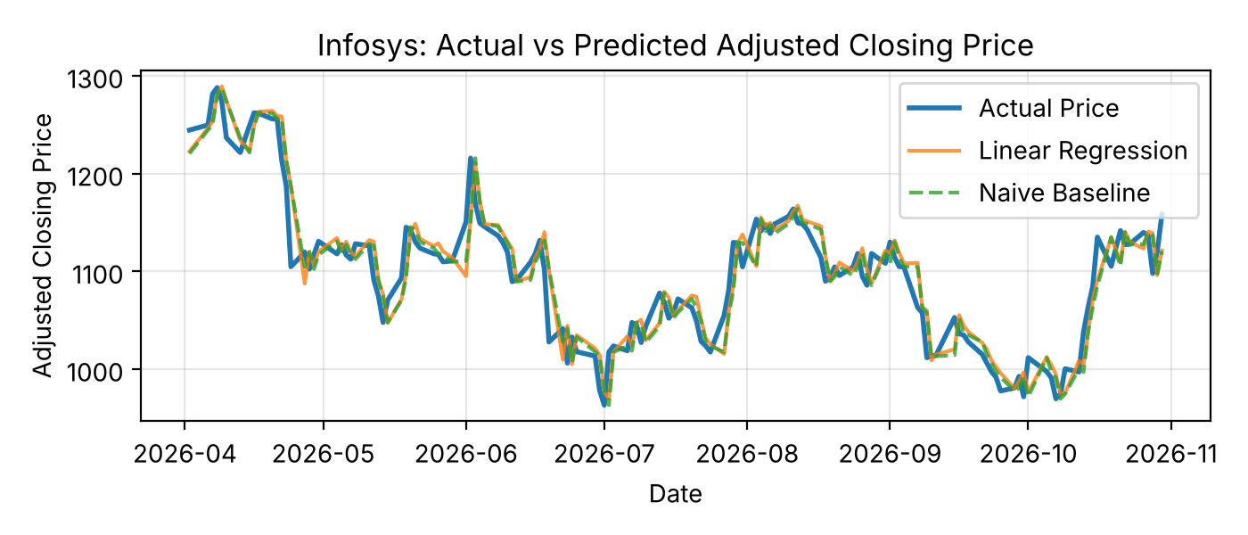
Figure 1. Infosys: Actual vs Predicted Adjusted Closing Price
What the chart shows. Infosys fell from about 1,290 in April 2026 to a low in early July, recovered above 1,150 in August, declined again to about 970 in early October and then rebounded toward 1,160 at the end of October. Both forecasts follow these swings closely, and the Linear Regression and baseline lines are almost indistinguishable at this scale.
Numerical evidence. The test-period price ranged from 963.235 to 1,288.177 (mean 1,097.822). Linear Regression's MAE was 19.099 (1.740% of the mean price) against 18.220 (1.660%) for the baseline, and the model was closer on 61 of 144 days. The two largest misses occurred at turning points: on 24 April 2026 the actual price was 1,104.835 against a prediction of 1,187.597, and on 2 June 2026 it was 1,216.027 against 1,157.074.
Interpretation. Close visual agreement reflects price persistence rather than forecasting skill: the dashed baseline tracks the series just as well. The visible differences arise at sharp reversals, where both forecasts, built from information up to the previous close, lag the move by about a day.

10.2 Figure 2: Reliance Industries
Why this visualization. The same layout is used for each company so that the three charts can be compared directly.
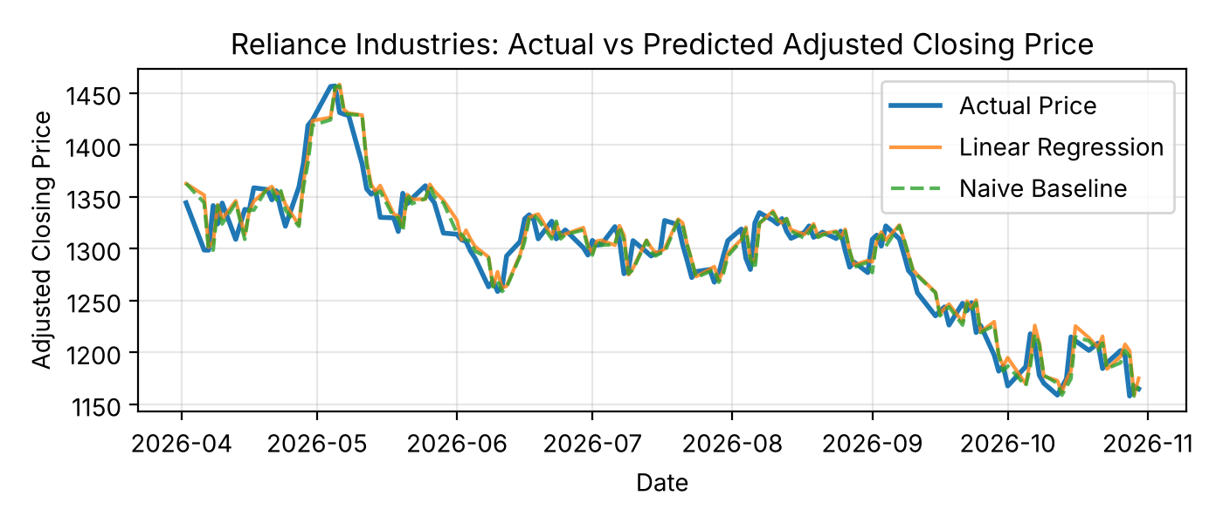
Figure 2. Reliance Industries: Actual vs Predicted Adjusted Closing Price
What the chart shows. Reliance peaked near 1,457 in early May 2026, drifted lower, traded in a comparatively narrow band of roughly 1,280 to 1,340 through the summer, and then declined to about 1,160 by late October. The model and baseline lines nearly coincide and closely shadow the actual series.
Numerical evidence. The test-period price ranged from 1,158.000 to 1,456.864 (mean 1,294.244). Linear Regression's MAE was 14.114 (1.091% of the mean price) against 14.024 (1.084%) for the baseline, and the model was closer on 71 of 144 days (49.3%). The largest misses were on 6 April 2026 (actual 1,298.695, predicted 1,351.689) and 6 August 2026 (actual 1,325.000, predicted 1,287.281).
Interpretation. Reliance is the stock for which the model and the benchmark are hardest to tell apart, and the one with the smallest errors. Its calmer, narrower trading range leaves less room for large misses.

10.3 Figure 3: Tata Consultancy Services
Why this visualization. TCS has the highest price level and the widest swings, so a chart is the quickest way to see where its larger errors arise.
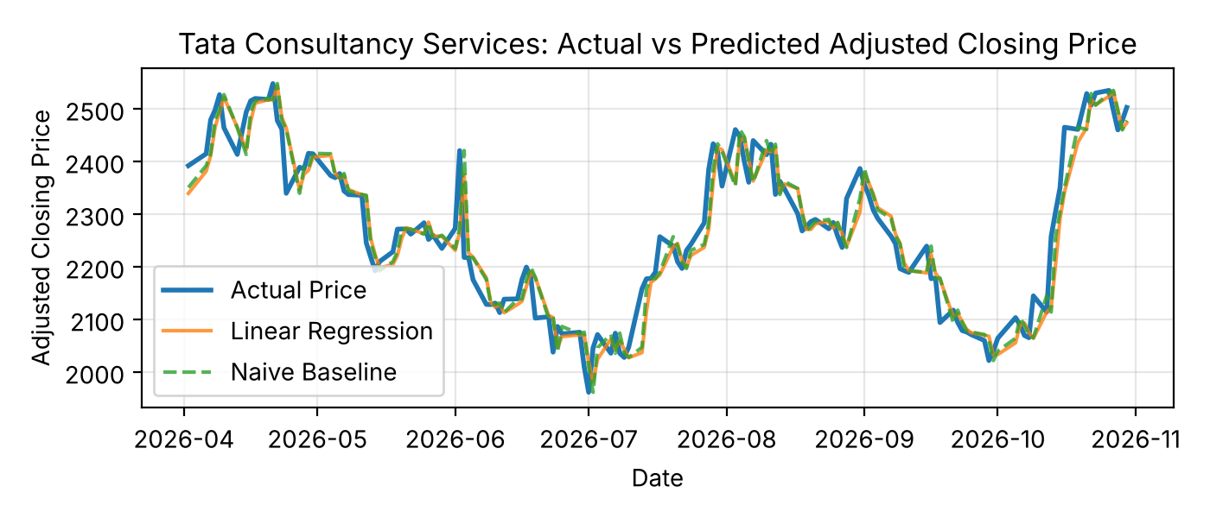
Figure 3. Tata Consultancy Services: Actual vs Predicted Adjusted Closing Price
What the chart shows. TCS shows the widest swings of the three, from a low in early July to a high in April and again about 2,530 in late October. The predicted lines trace the actual price but with visibly larger gaps at reversals, such as the spike of 2 June 2026 followed by a fall the next day.
Numerical evidence. The test-period price ranged from 1,961.362 to 2,547.988 (mean 2,268.809). Linear Regression's MAE was 36.445 (1.606% of the mean price) against 34.983 (1.542%) for the baseline, and the model was closer on 60 of 144 days (41.7%). On 2 June 2026 the actual price reached 2,420.688 (predicted 2,265.791) and on 3 June it fell to 2,217.687 (predicted 2,375.057).
Interpretation. TCS's larger rupee errors partly reflect its higher price level, but its sharp one-day reversals also drive the largest residuals. As with the other stocks, a model that follows the price closely is not necessarily a better forecaster than a model that simply repeats it.
Reading the charts: close visual agreement between predicted and actual price should not be mistaken for forecasting skill. The informative test is the numerical comparison against the baseline in Section 9.

11. Residual Analysis
Residuals (Actual − Predicted) for Linear Regression are plotted against the predicted price in Figures 4 to 6 (Appendix B.4). Scatter plots with a zero reference line are used because a well-behaved model produces residuals scattered randomly around zero with a roughly constant spread and no visible curve.

11.1 Figures 4 to 6: Residuals by Company
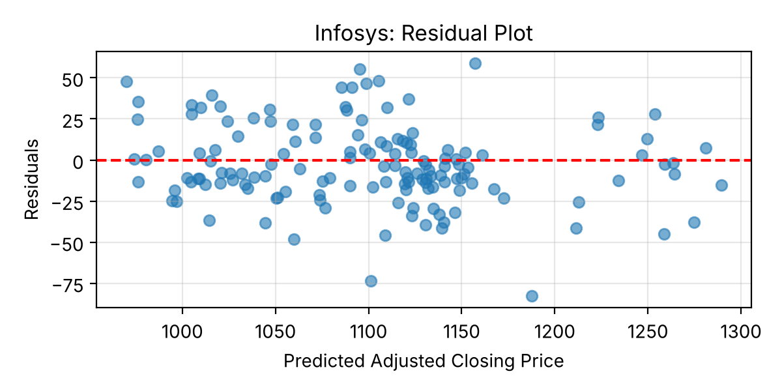
Figure 4. Infosys: Residual Plot
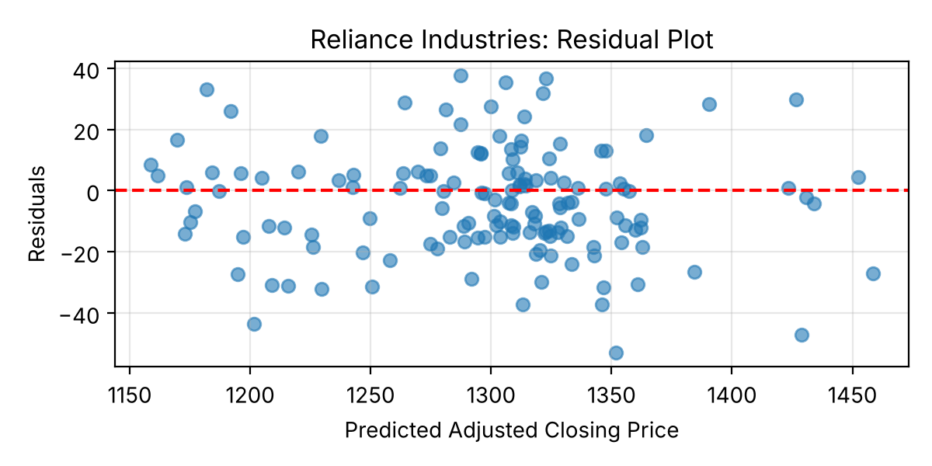
Figure 5. Reliance Industries: Residual Plot
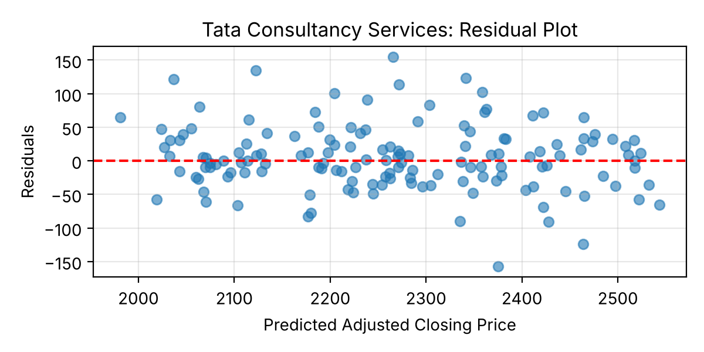
Figure 6. Tata Consultancy Services: Residual Plot
What the charts show. In all three plots the residuals are distributed on both sides of the zero line with no strong systematic pattern against the predicted value, but each contains outliers. The vertical spread is smallest for Reliance, larger for Infosys and largest for TCS, mirroring the ordering of price levels and error metrics.
Numerical evidence. Table 10 summarises the residuals. Reliance residuals range from −52.993 to 37.719, Infosys from −82.762 to 58.953 and TCS from −157.370 to 154.898.
Table 10. Residual summary for Linear Regression (Residual = Actual − Predicted)
Company | Mean | Std Dev | Minimum | Maximum
Infosys | −2.880 | 24.300 | −82.762 | 58.953
Reliance Industries | −3.977 | 17.539 | −52.993 | 37.719
Tata Consultancy Services | 4.463 | 48.866 | −157.370 | 154.898

Interpretation. A negative mean residual indicates slight average over-prediction (Infosys and Reliance); a positive mean residual indicates slight average under-prediction (TCS). In each case the mean is small relative to the standard deviation (about 12%, 23% and 9% of it respectively), so the bias is minor compared with the day-to-day scatter. The over-prediction for Infosys and Reliance is consistent with their declining prices over parts of the test window, though this report does not formally test that explanation. Because the plots are against predicted value rather than time, they do not show whether residuals are correlated from one day to the next; this was not tested.

11.2 The Largest Errors
Table 11. Dates of the largest Linear Regression residuals
Company and case | Target date | Actual | LR prediction | Baseline prediction | Residual
Infosys: over-prediction | 24 Apr 2026 | 1,104.835 | 1,187.597 | 1,187.129 | −82.762
Infosys: under-prediction | 2 Jun 2026 | 1,216.027 | 1,157.074 | 1,150.671 | 58.953
Reliance: over-prediction | 6 Apr 2026 | 1,298.695 | 1,351.689 | 1,344.285 | −52.993
Reliance: under-prediction | 6 Aug 2026 | 1,325.000 | 1,287.281 | 1,280.000 | 37.719
TCS: over-prediction | 3 Jun 2026 | 2,217.687 | 2,375.057 | 2,420.688 | −157.370
TCS: under-prediction | 2 Jun 2026 | 2,420.688 | 2,265.791 | 2,272.790 | 154.898

The largest errors occur on days with abrupt price moves, and the baseline misses those days by similar amounts (for example, Infosys on 24 April 2026: Linear Regression −82.762 against a baseline error of 82.294 in magnitude). Infosys and TCS both jumped on 2 June 2026 and TCS reversed sharply the next day, which suggests a common sector-level or market-wide driver. The dataset does not identify the cause, and price-and-volume lags cannot anticipate such events. The outliers explain much of the gap between RMSE and MAE for each stock (for TCS, RMSE 48.900 against MAE 36.445).

12. Company-wise Findings

12.1 Infosys
- Linear Regression: MAE 19.099, RMSE 24.386, R² 0.888. Baseline: MAE 18.220, RMSE 23.961, R² 0.892.
- Linear Regression's MAE is about 4.8% higher than the baseline's and it was the closer forecast on 61 of 144 days (42.4%).
- Relative error is the highest of the three (MAE about 1.74% of the mean test price). Residuals are modestly biased towards over-prediction (mean −2.880) with a standard deviation of 24.300.
- The test period includes the lowest adjusted close in the entire dataset (963.235), a price region the training data did not cover (see Section 13).

12.2 Reliance Industries
- Linear Regression: MAE 14.114, RMSE 17.925, R² 0.917. Baseline: MAE 14.024, RMSE 17.917, R² 0.917.
- Lowest errors in absolute terms and relative to price (MAE about 1.09% of mean test price) and the highest R² of the three.
- The model and baseline are practically indistinguishable (MAE gap 0.090, or 0.64%; Linear Regression closer on 49.3% of days).
- Residuals have the smallest spread (standard deviation 17.539; range −52.993 to 37.719) with a mean of −3.977, indicating slight over-prediction.

12.3 Tata Consultancy Services
- Linear Regression: MAE 36.445, RMSE 48.900, R² 0.892. Baseline: MAE 34.983, RMSE 48.297, R² 0.894.
- Highest absolute errors and the most variable residuals (standard deviation 48.866; range −157.370 to 154.898), partly reflecting TCS's higher price level. Relative to price the MAE is about 1.61%.
- Linear Regression's MAE is about 4.2% higher than the baseline's and it was closer on 60 of 144 days (41.7%). The mean residual is +4.463, indicating slight under-prediction.
- As with Infosys, the dataset's lowest adjusted close for TCS (1,961.362) occurs during the test period.

12.4 Practical Implications
- Use the baseline as the minimum hurdle. Any future model for these stocks should be reported alongside the persistence benchmark; a model that does not beat it adds complexity without adding value.
- Do not base trading decisions on this model. Its typical error (about 1.1% to 1.7% of price) is the same size as a typical one-day price move, so it offers no demonstrated edge over simply using today's price.
- Judge models on errors, not R². R² values of 0.89 to 0.92 look strong but are matched by the baseline; the decision should rest on error comparison on identical test observations.
- Scale expectations by stock. Tolerances based on raw rupee errors would need to be more than twice as wide for TCS as for Reliance (MAE 36.445 vs 14.114) because of price level, and should be set in percentage terms for comparability.
- Treat event days separately. The largest misses cluster around abrupt moves (such as 2 and 3 June 2026); error analysis around such dates is more informative than average metrics.
These observations describe results on one historical test period and are not investment advice or forecasts.

13. Challenges and Limitations
- Unpredictable market events. Stock prices respond to earnings, policy changes and global shocks. Historical price and volume features cannot capture these external influences, and the largest residuals occur on abrupt-move days.
- Correlated features. The adjacent price-lag features (current_close, close_lag_1, close_lag_2) are likely to be highly correlated with one another, which can make individual regression coefficients unstable. StandardScaler does not eliminate this multicollinearity or make the model inherently more accurate. Correlations and coefficient stability were not examined in this project.
- Linearity assumption. Linear Regression assumes a linear relationship between the features and the next-day price; nonlinear relationships were not tested.
- Extrapolation outside the training range. The lowest adjusted closes in the whole dataset for Infosys (963.235) and TCS (1,961.362) occur within the test targets, so the model partly had to predict prices below what it saw in training. Linear models extrapolate by construction and cannot adapt to such regimes.
- Single test period. All conclusions come from one chronological test window of about seven months. Performance may differ under other market conditions, so the small differences between model and baseline may not hold elsewhere.
- Strong benchmark. The persistence baseline is a hard benchmark for one-day-ahead prices; beating it consistently is difficult for any model that relies solely on past prices.
- No statistical testing or tuning. No significance test, hyperparameter tuning or cross-validation was performed, and the model was trained once on a fixed window.

14. Possible Improvements and Future Scope
The table below separates what was carried out in this project from what is proposed. Proposed items have not been implemented, and no results are claimed for them.
Table 12. Implemented work versus proposed improvements
Implemented in this project | Proposed (not performed)
Per-company lag features for price, volume, return and volatility | Ridge or Lasso regression to handle correlated lag features
Chronological 80:20 train-test split (no shuffling) | Walk-forward (rolling-origin) validation
StandardScaler + Linear Regression pipeline, one model per company | Additional indicators (e.g., moving averages, RSI)
Naive persistence baseline on the same test observations | Nonlinear models compared against the same baseline
MAE, MSE, RMSE and R² evaluation; scale-adjusted MAE | Evaluation across multiple time periods and market regimes
Actual-vs-predicted charts, residual plots and largest-error analysis | Feature-importance analysis, correlation checks and further error analysis
 | Modelling returns or direction rather than price levels
 | Statistical test of the model-versus-baseline difference

If extended, the most valuable next step would be walk-forward validation, because it would show whether the small and mixed differences between Linear Regression and the baseline are stable across periods. Regularised or nonlinear models would then be worth trying, but only if they beat the persistence baseline on the same walk-forward folds.

15. Conclusion
This project built a reproducible workflow for forecasting the next trading day's adjusted close of Infosys, Reliance Industries and TCS. Leak-safe, per-company lag features were created, data were split chronologically (574 training and 144 test observations per company), and a StandardScaler + Linear Regression pipeline was trained for each stock and evaluated against a naive persistence baseline.
Linear Regression captures the broad price trajectory (R² of 0.888, 0.917 and 0.892), but the persistence baseline is marginally better on MAE, MSE and RMSE for all three companies, by 0.878 MAE for Infosys, 0.090 for Reliance and 1.461 for TCS. Reliance is forecast most accurately, and TCS has the largest absolute errors and residual spread. Residuals are centred near zero with notable outliers on days of abrupt price movement. The model therefore does not consistently outperform the baseline, and the evidence does not support using it for trading decisions.
The main lessons are methodological: always benchmark against persistence, interpret R² cautiously for price-level targets, and evaluate in percentage terms when comparing stocks. Walk-forward validation, regularised and nonlinear models, and richer indicators are logical next steps, but they remain proposals and have not been tested here.

16. References and Data Source
- Market data: Yahoo Finance daily price data for INFY.NS, RELIANCE.NS and TCS.NS, cleaned in Weeks 2 and 3 of the project.
- Dataset used: combined_cleaned_data.csv (2,220 observations across 18 columns).
- Software: Python with pandas, NumPy, scikit-learn and Matplotlib (notebook week-4.ipynb).
- Task specification: Week 4 Task: Predictive Modeling & Performance Evaluation.
- Fama, E. F. (1970). Efficient capital markets: A review of theory and empirical work. The Journal of Finance, 25(2), 383–417.
- Hyndman, R. J., & Athanasopoulos, G. Forecasting: Principles and Practice (naïve forecasting method). OTexts.
- Pedregosa, F. et al. (2011). Scikit-learn: Machine learning in Python. Journal of Machine Learning Research, 12, 2825–2830.

Appendix A: Code Annotations for Modeling
The snippets below are taken from the project notebook (week-4.ipynb), shortened where a cell was long. Each is followed by a short explanation of what it does.

A.1 Loading and Inspecting the Dataset
import numpy as np
import pandas as pd
from sklearn.compose import ColumnTransformer
from sklearn.preprocessing import StandardScaler
from sklearn.pipeline import Pipeline
from sklearn.linear_model import LinearRegression
from sklearn.metrics import mean_absolute_error, mean_squared_error, r2_score

df = pd.read_csv("combined_cleaned_data.csv", parse_dates=["date"])
df = df.sort_values(["ticker", "date"]).reset_index(drop=True)

print("Dataset shape:", df.shape) # (2220, 18)
print("Duplicate company-date records:",
df.duplicated(subset=["ticker", "date"]).sum()) # 0
The data are loaded with parsed dates and sorted by ticker and date so that every lag and lead below respects time order within each company. The checks confirm 2,220 rows and 18 columns and that no company-date record is duplicated.

A.2 Feature Engineering and Target Creation
model_df = df.copy()
grouped = model_df.groupby("ticker") # lags are computed per company

model_df["current_close"] = grouped["adj_close"].shift(0)
model_df["close_lag_1"] = grouped["adj_close"].shift(1)
model_df["close_lag_2"] = grouped["adj_close"].shift(2)
model_df["close_lag_5"] = grouped["adj_close"].shift(5)
model_df["current_volume"] = grouped["volume"].shift(0)
model_df["volume_lag_1"] = grouped["volume"].shift(1)
model_df["current_return"] = grouped["daily_return"].shift(0)
model_df["return_lag_1"] = grouped["daily_return"].shift(1)
model_df["current_volatility"] = grouped["rolling_volatility"].shift(0)
model_df["volatility_lag_1"] = grouped["rolling_volatility"].shift(1)

model_df["target_next_close"] = grouped["adj_close"].shift(-1) # next day's price
model_df["target_date"] = grouped["date"].shift(-1)
Grouping by ticker before shifting guarantees that a lag never pulls a value from a different company. shift(k) moves a series k trading days forward, so shift(1) is yesterday's value, while shift(-1) pulls tomorrow's adjusted close into the current row to serve as the target.

A.3 Selecting Features and Removing Incomplete Rows
features = ["current_close", "close_lag_1", "close_lag_2", "close_lag_5",
"current_volume", "volume_lag_1", "current_return", "return_lag_1",
"current_volatility", "volatility_lag_1"]
target = "target_next_close"

model_data = model_df.dropna(subset=features + [target, "target_date"]).copy()

print("Original observations:", len(model_df)) # 2220
print("Usable observations:", len(model_data)) # 2154
print("Removed observations:", len(model_df) - len(model_data)) # 66
dropna removes rows in which any feature, the target or the target date is missing: the first 21 rows of each company (rolling-volatility window and its lag) and the last row (no next-day price). No imputation is used.

A.4 Chronological Train-Test Split
train_test_data = {}
for company in model_data["company"].unique():
company_data = (model_data[model_data["company"] == company]
.sort_values("date").reset_index(drop=True))

split_index = int(len(company_data) * 0.80) # chronological 80:20, no shuffling
train = company_data.iloc[:split_index] # earliest 80%
test = company_data.iloc[split_index:] # most recent 20%

train_test_data[company] = {
"X_train": train[features], "X_test": test[features],
"y_train": train[target], "y_test": test[target],
"test_dates": test["target_date"]
}
Each company is split on its own, so each gets 574 training and 144 test rows. Using iloc positions on date-sorted data keeps the split strictly chronological: every test row is later than every training row.

A.5 Pipeline, Training, Predictions and Baseline
def build_pipeline():
preprocessor = ColumnTransformer(
transformers=[("num", StandardScaler(), features)], # scale all 10 features
remainder="drop")
return Pipeline([("preprocessor", preprocessor), # fitted on training data only
("regressor", LinearRegression())])

models = {}
for company, data in train_test_data.items():
pipeline = build_pipeline()
pipeline.fit(data["X_train"], data["y_train"]) # one model per company
models[company] = {"pipeline": pipeline}
models[company]["predictions"] = pipeline.predict(data["X_test"])
data["baseline"] = data["X_test"]["current_close"] # naive persistence baseline
Placing StandardScaler inside the Pipeline means fit() learns the scaling from the training rows only, and predict() reuses those statistics on the test rows. The baseline needs no fitting: it is simply today's adjusted close, taken from the same test rows that the model predicts.

Appendix B: Code Annotations for Evaluation
All figures were saved at 200 dpi by the notebook (the figures/ folder). Matplotlib and pandas are imported as in Appendix A.1.

B.1 Evaluation Metrics
evaluation_results = []
for company, data in train_test_data.items():
actual = data["y_test"]
predicted = models[company]["predictions"]
baseline = data["baseline"]

for name, forecast in [("Linear Regression", predicted), ("Naive Baseline", baseline)]:
evaluation_results.append({
"Company": company, "Model": name,
"MAE": mean_absolute_error(actual, forecast),
"MSE": mean_squared_error(actual, forecast),
"RMSE": np.sqrt(mean_squared_error(actual, forecast)),
"R2": r2_score(actual, forecast)})

evaluation_df = pd.DataFrame(evaluation_results)
The notebook computes each metric with its scikit-learn function for both forecasts against the same actual values (written here as a loop over the two forecasts; the notebook lists the two cases separately). RMSE is the square root of MSE. A final assertion cell in the notebook checks that all values match the verified results to three decimals.

B.2 Scale-Adjusted Comparison and Day-by-Day Count
for company, data in train_test_data.items():
actual = data["y_test"].values
lr_err = np.abs(actual - models[company]["predictions"])
base_err = np.abs(actual - data["baseline"].values)

mae_pct_lr = 100 * lr_err.mean() / actual.mean() # MAE as % of mean test price
mae_pct_base = 100 * base_err.mean() / actual.mean()
days_lr_closer = int((lr_err < base_err).sum()) # days LR beat the baseline
Dividing MAE by the mean test price puts the three stocks on a comparable percentage scale (Table 9). Comparing the two absolute errors day by day gives the “days LR closer” counts in Table 8.

B.3 Actual vs. Predicted Chart
for company, data in train_test_data.items():
plt.figure(figsize=(7, 3))
plt.plot(data["test_dates"], data["y_test"].values, label="Actual Price", linewidth=2)
plt.plot(data["test_dates"], models[company]["predictions"],
label="Linear Regression", alpha=0.8)
plt.plot(data["test_dates"], data["baseline"].values,
label="Naive Baseline", alpha=0.8, linestyle="--")
plt.title(f"{company}: Actual vs Predicted Adjusted Closing Price")
plt.xlabel("Date"); plt.ylabel("Adjusted Closing Price")
plt.legend(); plt.grid(alpha=0.3); plt.tight_layout()
plt.savefig(FIG_DIR / f"actual_vs_predicted_{company.replace(' ', '_')}.png", dpi=200)
plt.show()
One chart is drawn per company. The actual price is a thicker solid line, the model forecast a thinner line and the baseline a dashed line, so the three series can be separated by eye. Dates on the x-axis are target dates.

B.4 Residual Plots and Summary
for company, data in train_test_data.items():
actual = data["y_test"].values
predicted = models[company]["predictions"]
residuals = actual - predicted # residual = actual - predicted

plt.figure(figsize=(6, 3))
plt.scatter(predicted, residuals, alpha=0.6)
plt.axhline(y=0, color="red", linestyle="--") # zero-error reference line
plt.title(f"{company}: Residual Plot")
plt.xlabel("Predicted Adjusted Closing Price"); plt.ylabel("Residuals")
plt.grid(alpha=0.3); plt.tight_layout(); plt.show()

# summary: residuals.mean(), residuals.std(), residuals.min(), residuals.max()
Residuals are plotted against the predicted price so that any curvature or funnel shape would be visible; the red dashed line marks zero error. The summary statistics feed Table 10.

B.5 Largest Errors
detail = pd.DataFrame({"Target date": data["test_dates"].values,
"Actual": data["y_test"].values,
"LR prediction": models[company]["predictions"],
"Baseline prediction": data["baseline"].values})
detail["Residual"] = detail["Actual"] - detail["LR prediction"]

worst_over = detail.loc[detail["Residual"].idxmin()] # largest over-prediction
worst_under = detail.loc[detail["Residual"].idxmax()] # largest under-prediction
idxmin and idxmax locate the days with the most negative and most positive residuals, giving the dates in Table 11 together with the baseline's prediction for the same day.

