FINANCIAL MARKET ANALYSIS

Week 3: Exploratory Data Analysis & Visualization
Infosys | Reliance Industries | Tata Consultancy Services
Python | pandas | NumPy | Matplotlib | Seaborn
Data source: Yahoo Finance | Period: 1 November 2023 to 30 October 2026
Internship Project Report
Prepared by: Bhoomika Jain
November 2026

Contents
1. Introduction and Objectives 2
2. Dataset Overview and Variables 3
3. Approach to Data Exploration 3
4. Data Quality Assessment 4
5. Descriptive Statistics 5
6. Exploratory Analysis: Distributions, Trends and Anomalies 7
7. Visualizations and Interpretation 8
8. Initial Hypotheses and Evaluation 14
9. Key Findings and Practical Implications 15
10. Limitations of the Analysis 16
11. Conclusion 16
12. References and Data Source 17
Appendix A: Code Annotations for Analysis 18
Appendix B: Code Annotations for Visualizations 20
List of Figures
Figure 1. Normalized Stock Price Trends (Base = 100) 9
Figure 2. Distribution of Daily Stock Returns 9
Figure 3. Daily Return Distribution and Outliers (Box Plot) 10
Figure 4. Correlation Between Daily Stock Returns 11
Figure 5. Rolling 20-Day Volatility Across Companies 12
Figure 6. Daily Return Scatter Plots with Regression Lines 13
Figure 7. Monthly Average Daily Returns 13

1. Introduction and Objectives

1.1 Background
Financial markets generate large volumes of numerical data, but raw tables of prices and volumes rarely reveal how an asset behaves. Exploratory data analysis (EDA) is the stage at which a dataset is examined systematically, through summary statistics and visualizations, before any formal modelling is attempted. It shows where values concentrate, how widely they vary, which observations are unusual and whether different series move together.
This report documents the Week 3 EDA of daily stock-market data for three large Indian listed companies: Infosys (INFY.NS), Reliance Industries (RELIANCE.NS) and Tata Consultancy Services (TCS.NS). The data were collected from Yahoo Finance in Week 2, cleaned and extended with engineered features (daily return, price change, normalized price, 20-day rolling volatility and cumulative return). Week 3 builds on that dataset, which contains 2,220 daily observations from 1 November 2023 to 30 October 2026.

1.2 Objectives
- Examine the structure, variables and data quality of the cleaned dataset, including missing values and duplicates.
- Compute summary statistics (mean, median, mode and standard deviation) for the key variables of each company.
- Study the distribution of daily returns, the evolution of prices and volatility over time, and unusual observations.
- Measure how closely the daily returns of the three companies move together.
- Build seven visualizations, explain why each was chosen and interpret what it shows using numerical evidence.
- State initial hypotheses, assess whether the observed patterns are consistent with them, and identify practical implications and limitations.

1.3 Cross-reference to the Week 3 Task Requirements
The table below maps each deliverable and key step of the official Week 3 task to the section of this report that addresses it.
Task requirement | Where addressed
In-depth EDA report as a DOC file | This document (editable .docx)
Data exploration: key variables, distributions, anomalies | Sections 2, 3, 4 and 6
Statistical analysis: mean, median, mode, standard deviation | Section 5 (Table 5)
Initial hypotheses about the data | Section 8
Visualizations (graphs, histograms, scatter plots) and choice of plots | Section 7 (Figures 1 to 7)
Code annotations for the visualizations and analysis | Appendices A and B
Interpretation of patterns/anomalies and implications | Sections 6, 7 and 9
Practical insights for further analysis or decisions | Section 9

2. Dataset Overview and Variables

2.1 Dataset Summary
Table 1. Dataset overview
Attribute | Detail
Data source | Yahoo Finance (downloaded with the yfinance Python library)
Companies | Infosys (INFY.NS), Reliance Industries (RELIANCE.NS), Tata Consultancy Services (TCS.NS)
Frequency | Daily trading observations
Date range | 1 November 2023 to 30 October 2026
Total observations | 2,220 (740 per company)
Dataset shape | 2,220 rows x 18 columns
Input file | combined_cleaned_data.csv (Week 2 cleaned dataset)
Price basis | Adjusted closing price (adj_close) for returns, normalization and volatility

2.2 Variables
The 18 columns fall into three groups: raw market fields downloaded from Yahoo Finance, identifiers, and features engineered in Week 2. The engineered features are the main inputs to this analysis, so their definitions are stated explicitly.
Table 2. Description of dataset variables
Variable | Type | Origin | Description
date | Date | Raw | Trading date
open, high, low, close | Float | Raw | Opening, highest, lowest and closing price (INR)
adj_close | Float | Raw | Closing price adjusted for corporate actions; basis for all return calculations
volume | Integer | Raw | Number of shares traded in the day
dividends | Float | Raw | Dividend amount on the ex-dividend date; 0 otherwise
stock_splits | Float | Raw | Stock-split ratio on the event date; 0 otherwise
ticker, company | Text | Identifier | Yahoo Finance symbol and company name
daily_return | Float | Derived | Day-over-day percentage change in adj_close, by company
price_change | Float | Derived | Day-over-day absolute change in adj_close (INR)
normalized_price | Float | Derived | adj_close divided by the company's first adj_close, x 100 (base = 100)
rolling_volatility | Float | Derived | Standard deviation of daily_return over a 20-day rolling window (%)
cumulative_return | Float | Derived | Percentage change in adj_close since the first observation
return_outlier, volume_outlier | Boolean | Derived | Week 2 flags: value outside 1.5 x IQR of the company's own distribution

3. Approach to Data Exploration
The exploration followed a fixed sequence so that each step informed the next.
- Load and inspect. The Week 2 cleaned dataset was loaded and its shape, data types, date range and per-company record counts were checked (Appendix A.2).
- Assess quality. Missing values and duplicate rows were counted, and the origin of every missing value was traced to the feature-engineering step (Section 4).
- Summarize numerically. Mean, median, mode and standard deviation were computed for each company and for six numerical variables, followed by minimum and maximum returns and volatility (Sections 5 and 6).
- Visualize. Seven charts were produced, each chosen to answer one specific question: relative performance, return distribution, outliers, co-movement, changing volatility, pairwise relationships and monthly behaviour (Section 7).
- Form and check hypotheses. Four initial hypotheses were stated before interpretation and compared with the observed patterns (Section 8).
- Interpret and qualify. Findings were separated into observed patterns, possible explanations and limitations (Sections 9 and 10).
Scope of inference: this is descriptive EDA. No formal hypothesis tests, regression models or forecasts were run. Statements such as "supported" or "consistent with" therefore refer to patterns observed in this sample only.

4. Data Quality Assessment

4.1 Completeness and Missing Values
The 15 raw and identifier columns contain no missing values. Missing values occur only in three engineered columns.
Table 3. Missing values in the 18-column dataset
Column | Missing (total) | Missing per company | % of 2,220 rows | Reason
daily_return | 3 | 1 | 0.14% | No previous day exists for the first observation of each company
price_change | 3 | 1 | 0.14% | First difference undefined for the first observation
rolling_volatility | 60 | 20 | 2.70% | 20-day window needs 20 returns; the first return is itself missing
All other 15 columns | 0 | 0 | 0.00% | Complete

These gaps are an expected consequence of feature engineering rather than a data-collection fault. A return needs two consecutive prices, so each company's first row has no return or price change (3 values each across three companies). The rolling volatility is the standard deviation of 20 consecutive returns; because the first return is missing, the first valid volatility appears on the 21st row, leaving 20 missing values per company (60 in total). The missing rows were deliberately kept, not filled, because imputing a return or volatility for a date with no history would introduce artificial values.

4.2 Duplicates and Record Counts
The dataset contains 0 duplicate rows, and the Week 2 check found no conflicting records sharing the same ticker and date. Each company has exactly 740 observations, and all three series start on 1 November 2023 and end on 30 October 2026, so the companies are aligned date by date. This alignment is what allows the return correlations in Section 7 to be calculated on common dates.

4.3 Validity Checks and Flagged Observations
Table 4. Data quality summary
Check | Infosys | Reliance | TCS | Source
Observations | 740 | 740 | 740 | Notebook / CSV
Duplicate rows | 0 | 0 | 0 | Notebook
Non-positive prices, inconsistent OHLC, negative volume | 0 | 0 | 0 | Week 2 validation
Return outliers flagged (1.5 x IQR) | 45 | 28 | 38 | CSV flag column
Volume outliers flagged (1.5 x IQR) | 49 | 31 | 43 | CSV flag column
Days with zero reported volume | 2 | 2 | 2 | CSV (verified)
Dividend-event days | 5 | 3 | 12 | CSV (verified)

Two points deserve attention. First, the return and volume outlier flags (111 and 123 observations in total) mark unusually large moves relative to each company's own distribution. They were retained, not removed, because large market moves are genuine features of financial data, not necessarily errors; Section 6 examines them. Second, all three companies report zero volume on the same two dates, 18 March 2025 and 15 January 2026, and the daily return on those dates is exactly zero. Because the dates coincide across all three tickers, they look like data-feed gaps and not company-specific events, although the cause was not verified. These two days (2 of 740 observations per company) are the reason the mode of volume is 0 for every company, and they lift the true average volume by only about 0.3% when excluded. They were left in place for consistency with the Week 2 dataset.

5. Descriptive Statistics
Table 5 reports the mean, median, mode and standard deviation of six numerical variables for each company, as calculated in the notebook (Appendix A.3). Values are shown to two decimal places; the daily-return means are 0.007, 0.013 and -0.014 percent at three decimals.
Table 5. Mean, median, mode and standard deviation by company
Variable | Company | Mean | Median | Mode | Std. dev.
Adjusted close (INR) | Infosys | 1,422.73 | 1,427.18 | 1,104.69 | 221.93
 | Reliance | 1,364.79 | 1,377.51 | 1,267.26 | 105.90
 | TCS | 3,177.71 | 3,243.94 | 3,299.90 | 595.66
Daily return (%) | Infosys | 0.01 | -0.07 | 0.00 | 1.70
 | Reliance | 0.01 | 0.03 | 0.00 | 1.34
 | TCS | -0.01 | -0.07 | 0.00 | 1.53
Price change (INR) | Infosys | -0.08 | -0.86 | 0.00 | 23.47
 | Reliance | 0.04 | 0.45 | -6.94 | 18.34
 | TCS | -0.71 | -2.29 | 0.00 | 46.51
Volume (shares) | Infosys | 8,809,672.60 | 7,335,856.50 | 0 | 6,108,774.11
 | Reliance | 12,966,166.91 | 11,280,210.50 | 0 | 6,272,432.95
 | TCS | 3,004,872.36 | 2,537,747.00 | 0 | 1,980,678.81
Rolling volatility (%) | Infosys | 1.62 | 1.60 | 0.80 | 0.45
 | Reliance | 1.30 | 1.23 | 0.56 | 0.38
 | TCS | 1.45 | 1.39 | 0.65 | 0.46
Cumulative return (%) | Infosys | 16.62 | 16.99 | -9.45 | 18.19
 | Reliance | 20.24 | 21.37 | 11.65 | 9.33
 | TCS | 4.96 | 7.14 | 8.99 | 19.67

5.1 Reading the Table
- Price level. TCS trades at a much higher price (mean about INR 3,178) than Infosys (about INR 1,423) or Reliance (about INR 1,365). Raw prices are therefore not comparable across companies, which is why normalized prices and percentage returns are used for comparison. Reliance has the lowest price standard deviation (105.90), but this is in rupees, so it is not on the same scale as a percentage measure.
- Daily return. Mean daily returns are close to zero for all three companies (0.007%, 0.013% and -0.014%), and the medians (-0.07%, 0.03% and -0.07%) are also near zero. The standard deviation is the more informative figure: Infosys is the most variable at 1.70%, then TCS at 1.53% and Reliance at 1.34%.
- Volume. Reliance trades the most shares on average (12.97 million) and TCS the fewest (3.00 million). For each company the mean exceeds the median (for example Infosys 8.81 million against 7.34 million), indicating a right-skewed volume distribution in which a few very heavy days pull the mean upward.
- Rolling volatility. Average 20-day volatility ranks the companies in the same order as the full-period return standard deviation: Infosys 1.62%, TCS 1.45%, Reliance 1.30%.
- Cumulative return. The means of 16.62%, 20.24% and 4.96% are averages of the cumulative-return series over time and should not be read as the return earned over the period. The end-of-period values are given in Section 7 (Figure 1).

5.2 Interpreting the Mode
The mode is of limited use for continuous financial variables. Prices, returns and volatilities are measured to many decimal places, so few or no values repeat and the mode simply returns one arbitrary repeated value or the smallest value. In this dataset the mode of volume is 0 for all three companies, caused by the two zero-volume dates described in Section 4.3, and does not describe typical trading activity. The modes of rolling volatility (0.80, 0.56 and 0.65) match each company's minimum volatility, and the mode of daily return (0.00) comes from days with exactly zero return. The mode of price change is likewise an arbitrary tie-break: for TCS several values each occur exactly twice, so the smallest repeated value is reported (0.00). The mean, median and standard deviation are the more reliable summaries here.

5.3 Additional Descriptive Measures
Table 6 reports the extremes of returns and volatility and the average volume, as computed in the notebook (Appendix A.4).
Table 6. Return and volatility extremes by company
Measure | Infosys | Reliance | TCS
Minimum daily return (%) | -7.26 | -7.49 | -8.39
Maximum daily return (%) | 7.93 | 7.02 | 6.79
Average rolling volatility (%) | 1.62 | 1.30 | 1.45
Minimum rolling volatility (%) | 0.80 | 0.56 | 0.65
Maximum rolling volatility (%) | 2.82 | 2.57 | 2.91
Average daily volume (shares) | 8,809,672.60 | 12,966,166.91 | 3,004,872.36

Table 7 adds distribution-shape measures calculated directly from the dataset to support the histogram and box-plot interpretation (they were not part of the original notebook output). Skewness and excess kurtosis use the pandas defaults; an excess kurtosis above 0 indicates heavier tails than a normal distribution.
Table 7. Distribution shape of daily returns (additional check)
Measure | Infosys | Reliance | TCS
Skewness | 0.19 | 0.12 | 0.22
Excess kurtosis | 2.83 | 3.09 | 3.92
25th / 50th / 75th percentile (%) | -0.89 / -0.07 / 0.84 | -0.81 / 0.03 / 0.72 | -0.83 / -0.07 / 0.70
Share of days with return between -2% and +2% | 81.3% | 88.4% | 86.3%
Share of days with a positive return | 47.9% | 50.7% | 46.4%

6. Exploratory Analysis: Distributions, Trends and Anomalies

6.1 Distributions
Daily returns for all three companies are centred near zero, with most days showing moves of less than two percent in either direction (81.3% of days for Infosys, 88.4% for Reliance and 86.3% for TCS). The slightly positive skewness values (0.12 to 0.22) indicate only a mild lean toward larger gains than losses. The excess kurtosis of 2.83 to 3.92 is the more notable feature: all three distributions have heavier tails than a normal distribution, meaning that moves of several percent occur more often than a normal model would suggest. TCS has the heaviest tails (3.92) even though its standard deviation is lower than that of Infosys.

6.2 Price Trends
Measured from a common starting value of 100, none of the three companies shows a steady one-directional trend. Infosys and TCS rose through 2024, reached their peaks (152.3 on 13 December 2024 and 139.0 on 30 August 2024) and then declined, with both reaching their lowest levels on 1 July 2026 (79.0 and 64.8). Reliance followed a different path, peaking later at 139.6 on 2 January 2026. By the last date, the normalized values were 94.96 for Infosys, 102.63 for Reliance and 82.66 for TCS, corresponding to cumulative returns of -5.04%, +2.63% and -17.34%.
Table 8. Normalized price milestones (base = 100 on 1 November 2023)
Company | Peak (date) | Lowest (date) | Final value | Cumulative return
Infosys | 152.3 (13 Dec 2024) | 79.0 (1 Jul 2026) | 94.96 | -5.04%
Reliance Industries | 139.6 (2 Jan 2026) | 100.0 (1 Nov 2023) | 102.63 | +2.63%
TCS | 139.0 (30 Aug 2024) | 64.8 (1 Jul 2026) | 82.66 | -17.34%

6.3 Volatility over Time
Volatility was not constant. Calendar-year standard deviations of daily returns, calculated directly from the dataset, show that all three companies were more variable in 2026 than in earlier years.
Table 9. Standard deviation of daily returns by calendar year (%, additional check)
Company | 2023 (Nov-Dec) | 2024 | 2025 | 2026 (to 30 Oct)
Infosys | 1.46 | 1.44 | 1.58 | 2.11
Reliance Industries | 0.78 | 1.44 | 1.23 | 1.43
TCS | 1.29 | 1.33 | 1.25 | 2.03

The 2023 column covers only two months and the 2026 column only ten, so these figures are indicative, not like-for-like annual comparisons. The rise in 2026 is strongest for Infosys (2.11%) and TCS (2.03%), while Reliance changed less (1.43%).

6.4 Anomalies and Extreme Days
The largest single-day moves cluster on a small number of dates and often affect more than one company at once:
- 4 February 2026: Infosys fell 7.26% (its largest daily fall) and TCS fell 7.01% on the same day.
- 2 and 3 June 2026: TCS gained 6.51% and Infosys 5.68% on 2 June, and TCS then recorded its largest fall of the period (-8.39%) on 3 June.
- 3 and 4 June 2024: Reliance rose 5.59% and then fell 7.49% (its largest daily fall) on consecutive days.
- 12 January 2024: Infosys recorded its largest daily gain (+7.93%); 13 October 2026 was TCS's largest gain (+6.79%).
The IQR rule used in Week 2 flags 45 (Infosys), 28 (Reliance) and 38 (TCS) daily returns as outliers, which is 6.1%, 3.8% and 5.1% of the 739 available returns respectively. Large moves are therefore a regular feature of this data, not isolated errors. The dataset alone cannot explain why these days were extreme; identifying the cause would require external information such as company announcements or market-wide news, which was not examined here.

7. Visualizations and Interpretation
Seven visualizations were produced using Matplotlib and Seaborn. Each was selected to answer a specific analytical question, as summarized below; the sections that follow explain the choice, describe the pattern, give numerical evidence and state the interpretation for each figure.
Table 10. Visualization plan
Figure | Chart type | Variable(s) | Question addressed
1 | Line chart | normalized_price | How did the three stocks perform relative to each other from a common start?
2 | Histograms with KDE | daily_return | What is the shape and spread of daily returns?
3 | Box plots | daily_return | How do medians, spread and extreme days compare?
4 | Correlation heatmap | daily_return | Which stocks move together on the same day?
5 | Line chart | rolling_volatility | Does risk change over time?
6 | Scatter plots with fit line | daily_return (pairs) | How strong and linear are the pairwise relationships?
7 | Line chart with markers | Monthly mean of daily_return | Are there seasonal or month-specific patterns?

7.1 Figure 1: Normalized Stock Price Trends
Why this visualization. The three companies trade at very different price levels (a mean of about INR 3,178 for TCS against about INR 1,365 for Reliance), so plotting raw prices would hide relative performance. Rebasing each adjusted close to 100 on the first day puts all three on a common scale, and a line chart is the natural form for showing change over time.
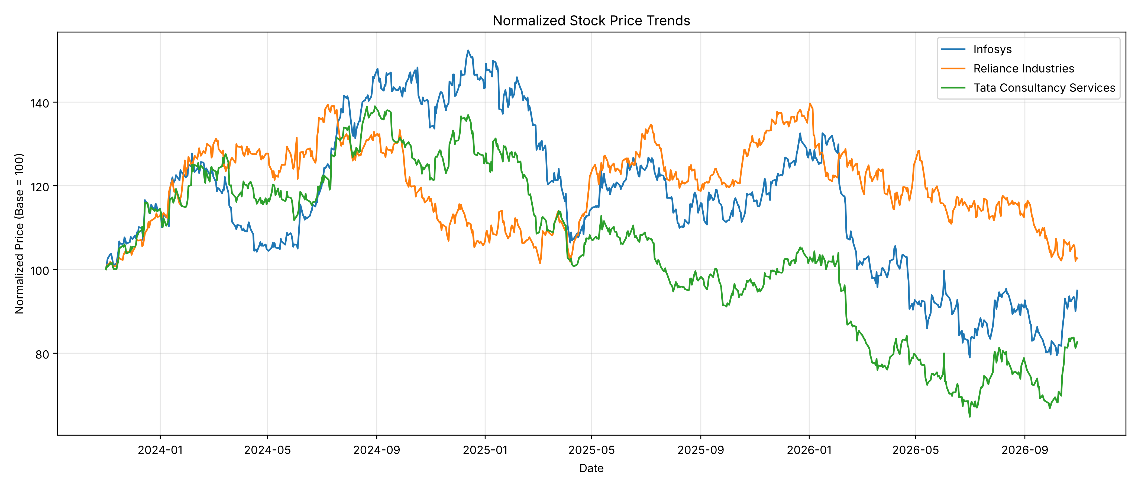
Figure 1. Normalized Stock Price Trends (Base = 100)
What the chart shows. All three lines rise together during the first months of the period, then diverge. Infosys and TCS climb to peaks in late 2024 and decline thereafter, with a pronounced fall in early 2026. Reliance moves more independently, dipping in late 2024 to early 2025, recovering through 2025 and reaching its peak at the start of 2026 before declining.
Numerical evidence. Peaks: Infosys 152.3 (13 December 2024), Reliance 139.6 (2 January 2026), TCS 139.0 (30 August 2024). Lowest values: Infosys 79.0 and TCS 64.8 (both on 1 July 2026); Reliance never fell below its starting value of 100. Final values on 30 October 2026: Infosys 94.96, Reliance 102.63, TCS 82.66.
Interpretation. Over the full period Reliance ended slightly above its starting level, Infosys finished about 5% below, and TCS finished about 17% below. TCS was the weakest performer by the end, even though it was close to the top of the group in 2024. These figures depend on the chosen starting date: a different base date would change the relative ordering, so Figure 1 describes this specific window and does not rank the companies' long-term quality.

7.2 Figure 2: Distribution of Daily Stock Returns
Why this visualization. A histogram shows how often each range of daily returns occurs, and the overlaid kernel density estimate (KDE) smooths the shape. Placing the three companies in separate panels with 30 bins each allows the spread, symmetry and tail behaviour to be compared directly with the standard deviations in Table 5.
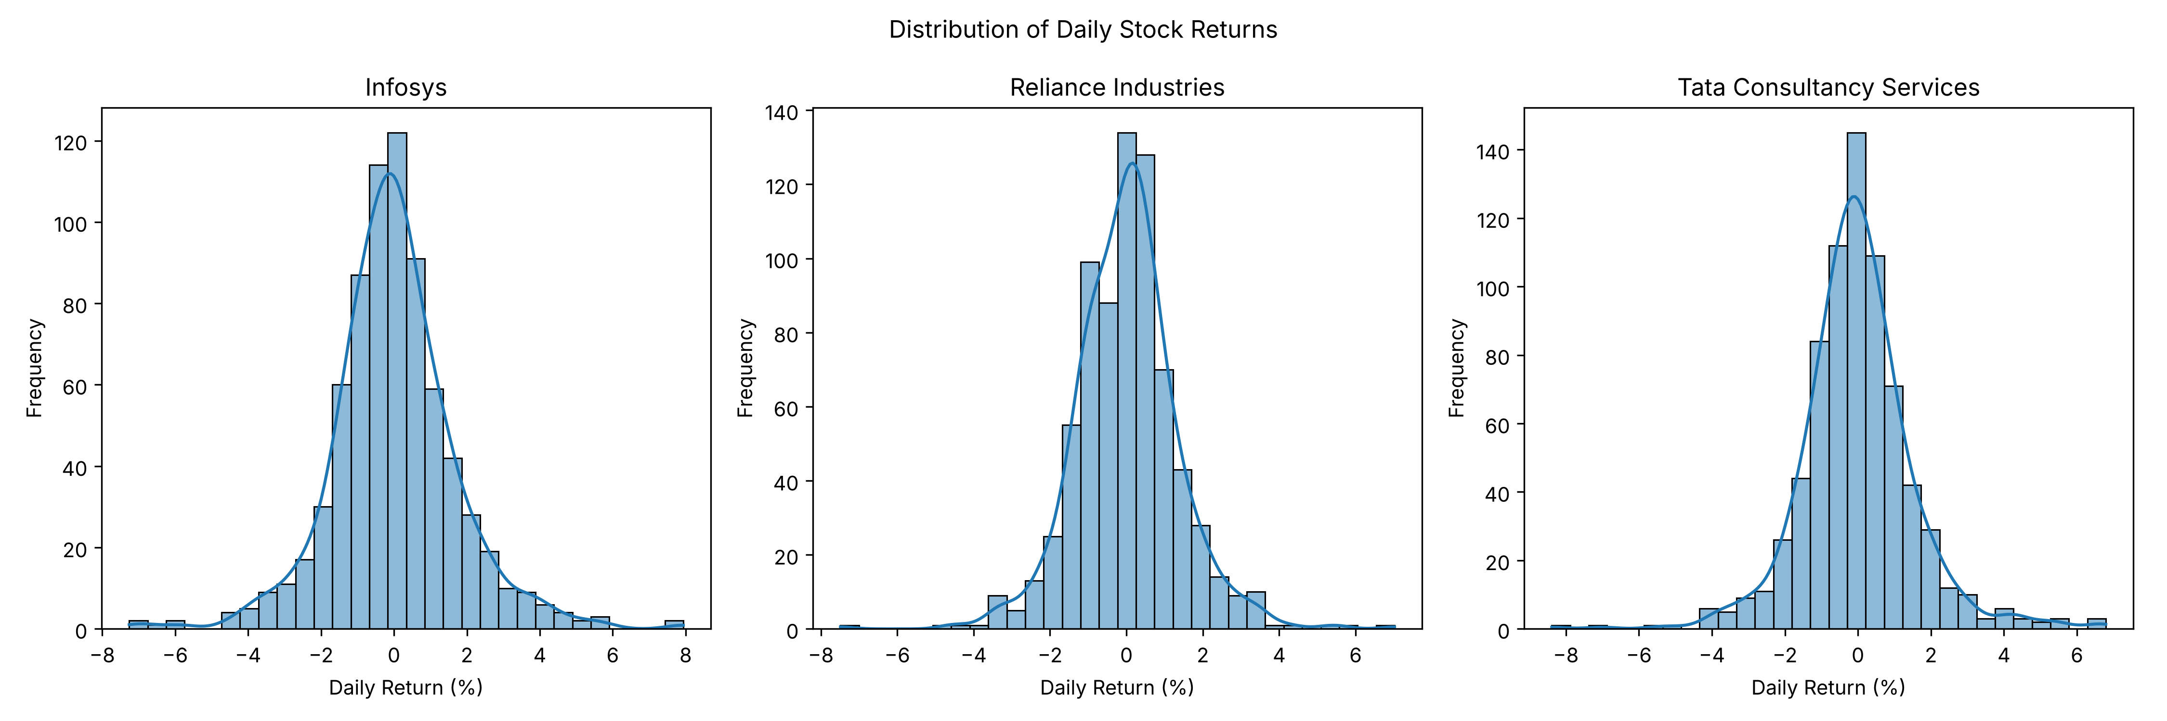
Figure 2. Distribution of Daily Stock Returns
What the chart shows. Each distribution is a single peak centred close to 0%, falling away fairly symmetrically on both sides. The tallest bars hold roughly 120 to 145 observations. Thin tails extend to about -7 to -8% on the left and about +7 to +8% on the right, with only a handful of observations in each tail bin.
Numerical evidence. Standard deviations are 1.70% (Infosys), 1.34% (Reliance) and 1.53% (TCS). Observed ranges are -7.26% to +7.93%, -7.49% to +7.02% and -8.39% to +6.79%. Between -2% and +2%, the share of days is 81.3%, 88.4% and 86.3%. Skewness is 0.19, 0.12 and 0.22, and excess kurtosis is 2.83, 3.09 and 3.92.
Interpretation. Infosys has the widest central spread, consistent with its higher standard deviation, whereas Reliance is the most concentrated around zero. The positive excess kurtosis indicates that all three have more extreme days than a normal distribution of the same variance would produce; a risk estimate that assumes normally distributed returns would therefore understate the frequency of large moves. The near-symmetry shows no strong tendency toward gains or losses on a typical day.

7.3 Figure 3: Daily Return Distribution and Outliers
Why this visualization. A box plot summarizes each distribution by its median, interquartile range (IQR) and whiskers, and marks observations beyond 1.5 times the IQR as individual points. It complements the histograms by making the extreme days explicit and by allowing a quick side-by-side comparison of the three companies on one axis.
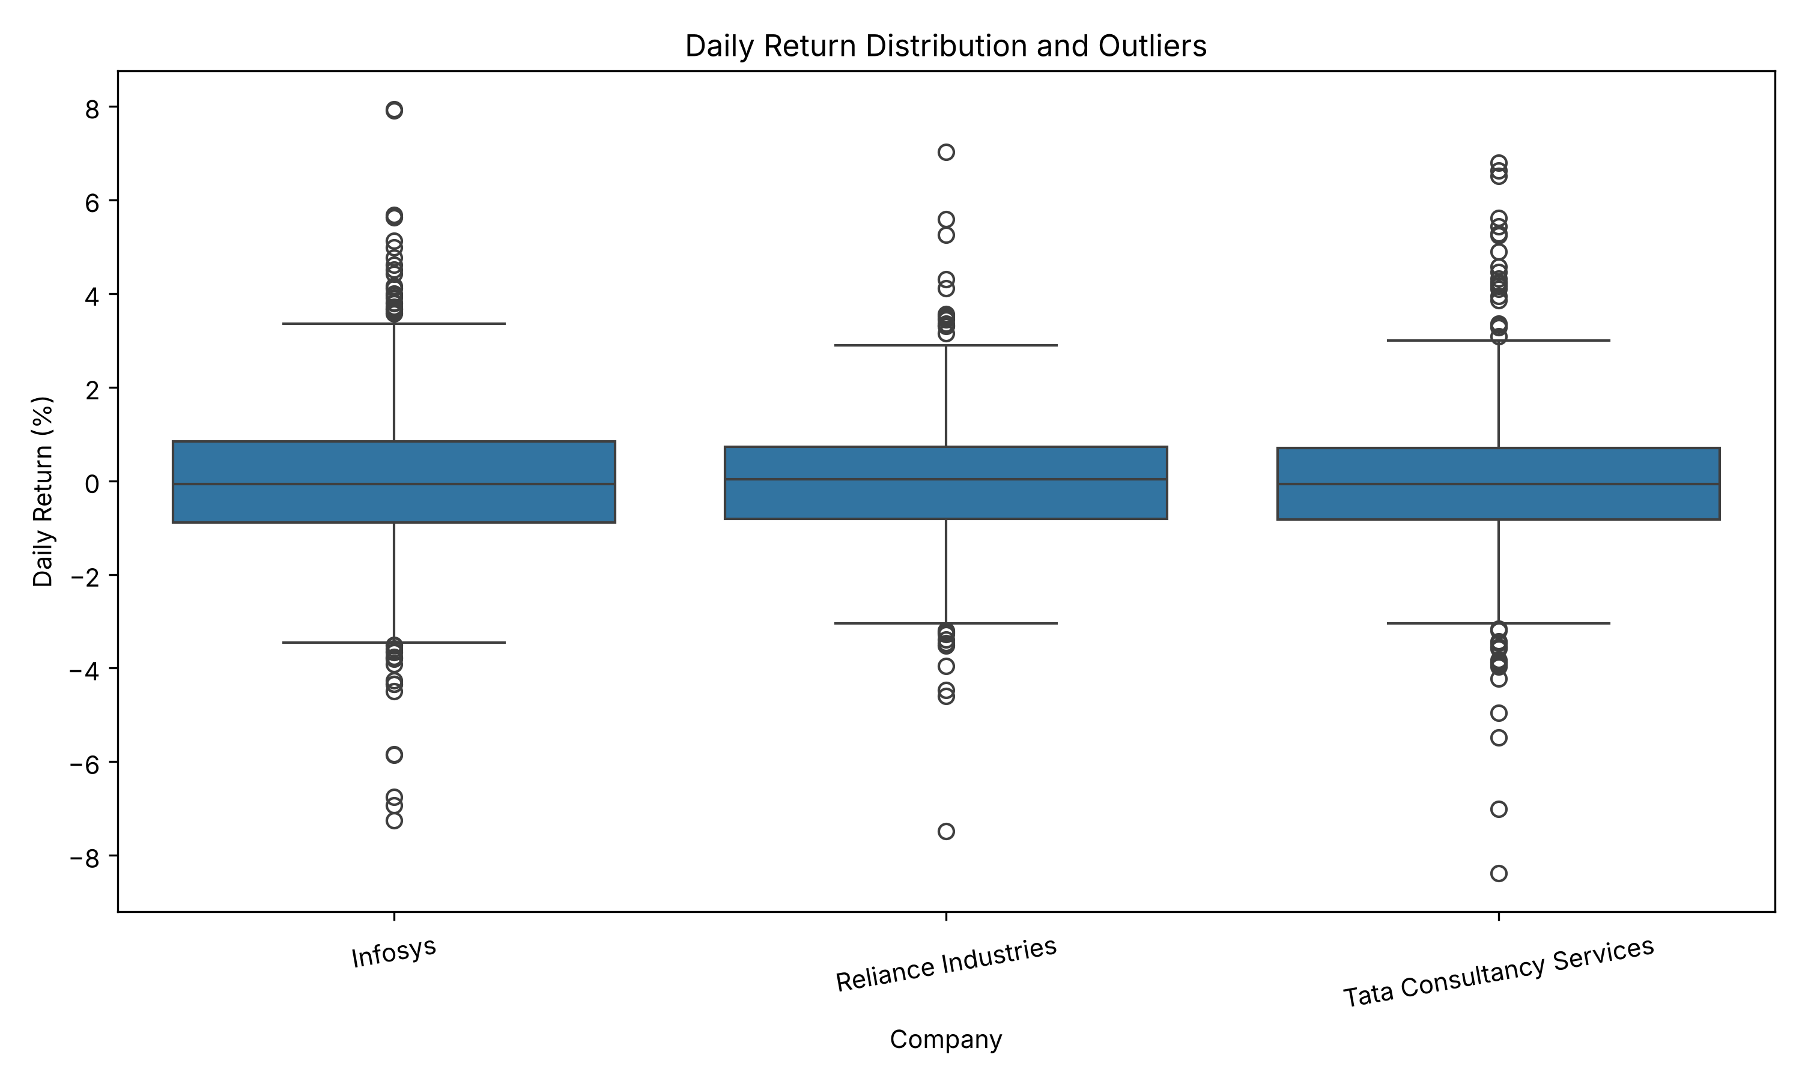
Figure 3. Daily Return Distribution and Outliers (Box Plot)
What the chart shows. The boxes are of similar size and centred just around zero. Infosys has a visibly taller box and longer whiskers. Each company has a cluster of outlier points above and below the whiskers, and the most extreme points are single observations well away from the rest: about -7.5% for Reliance and about -8.4% for TCS.
Numerical evidence. Medians are -0.07% (Infosys), 0.03% (Reliance) and -0.07% (TCS). Interquartile ranges run from -0.89% to 0.84% for Infosys (width 1.73), -0.81% to 0.72% for Reliance (1.53) and -0.83% to 0.70% for TCS (1.53). The number of flagged outliers is 45, 28 and 38, equal to 6.1%, 3.8% and 5.1% of returns.
Interpretation. The typical (middle 50%) behaviour of the three stocks is similar, but Infosys has the widest middle range and the most outliers, and Reliance has the fewest. Outliers appear in both tails, so extreme moves are not confined to falls or to gains. Because the 1.5 x IQR rule is applied to heavy-tailed data, a considerable number of points are flagged; they should be read as unusually large moves worth investigating, not as errors to be removed.

7.4 Figure 4: Correlation Between Daily Stock Returns
Why this visualization. A correlation heatmap condenses the pairwise relationships between the three return series into a single readable grid, using colour intensity and printed coefficients. It is a compact way to test whether companies move together, and it is calculated on returns, not prices, because price levels trend and would give misleading correlations.
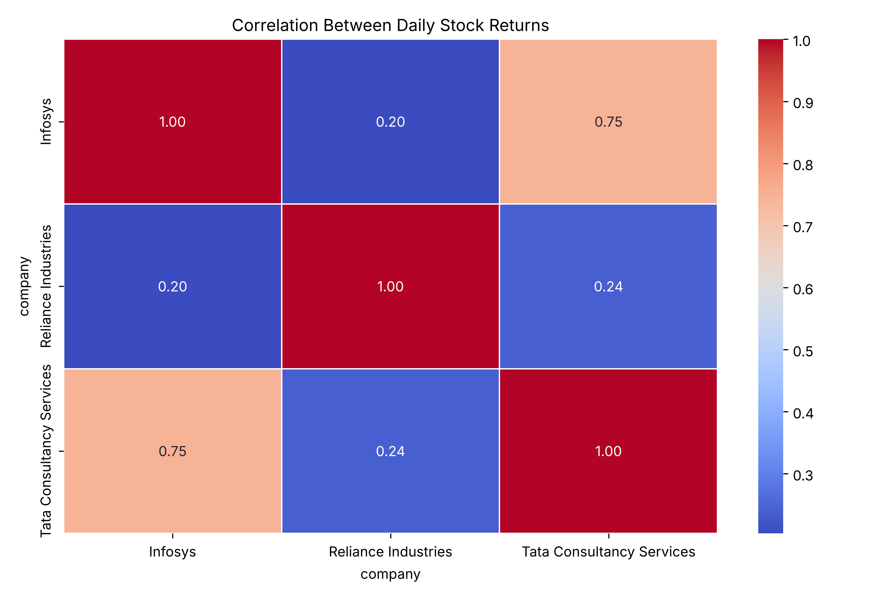
Figure 4. Correlation Between Daily Stock Returns
What the chart shows. The diagonal is 1.00 by definition. One off-diagonal cell stands out in a warm colour (Infosys and TCS), while the two pairs involving Reliance are in the cool blue range.
Numerical evidence. Infosys and TCS: 0.75. Infosys and Reliance: 0.20. Reliance and TCS: 0.24. The coefficients are Pearson correlations of same-day returns on the 739 dates on which all three have a return.
Interpretation. Infosys and TCS tend strongly to move in the same direction on the same day, whereas Reliance's daily returns are only weakly related to either. Infosys and TCS are both information-technology services companies, while Reliance is a diversified group, which is a plausible reason for the difference; this industry description is background knowledge and was not derived or tested in this dataset. Correlation measures co-movement only and does not establish that one stock's movement causes another's, since a common factor such as sector news or overall market direction could drive both.

7.5 Figure 5: Rolling 20-Day Volatility
Why this visualization. A single standard deviation for the whole period hides the fact that risk can rise and fall. The 20-day rolling standard deviation of daily returns shows how volatility changed over time and whether the three companies went through high-risk periods together.
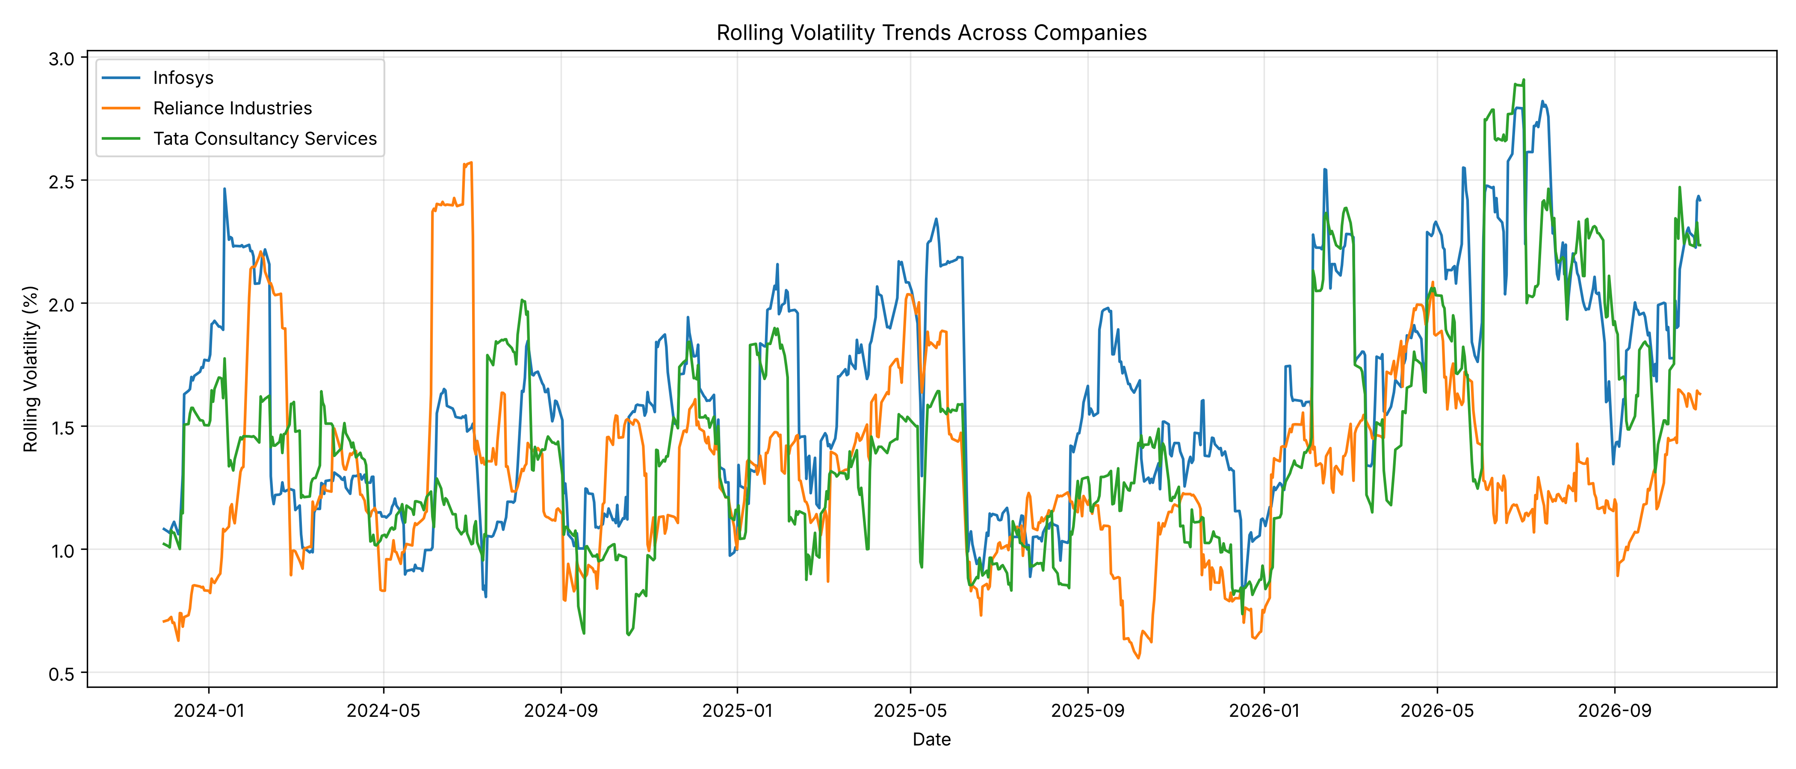
Figure 5. Rolling 20-Day Volatility Across Companies
What the chart shows. The lines fluctuate between about 0.6% and 3.0% rather than staying flat. Many sections move in abrupt steps, rising sharply and then dropping back, instead of drifting smoothly. In the second half of 2026 Infosys and TCS reach their highest levels of the period (above 2.5%), while Reliance remains lower, at roughly 1.1% to 1.6%. Reliance's own highest spell was in mid-2024.
Numerical evidence. Average volatility: Infosys 1.62%, TCS 1.45%, Reliance 1.30%. Minimum to maximum: Infosys 0.80% to 2.82% (maximum on 13 July 2026), Reliance 0.56% to 2.57% (1 July 2024), TCS 0.65% to 2.91% (30 June 2026). The highest value is 3.5, 4.6 and 4.5 times the lowest for Infosys, Reliance and TCS respectively.
Interpretation. Volatility clearly varies over time, with calm and turbulent stretches. The step-like pattern is a feature of the 20-day window: a single very large daily return raises the measure and keeps it high until it leaves the window 20 days later, at which point volatility drops abruptly. The Reliance plateau of about 2.4% to 2.57% in mid-2024 is consistent with its +5.59% and -7.49% returns on 3 and 4 June 2024. The elevated 2026 volatility of Infosys and TCS matches the higher 2026 return standard deviations in Table 9 and the decline in their prices over the same period (Figure 1), but this report does not test a causal link between them.

7.6 Figure 6: Daily Return Scatter Plots
Why this visualization. The heatmap gives one number per pair; a scatter plot shows whether that number reflects a consistent relationship or is driven by a few extreme points. Each point is one trading day, and the fitted regression line (with its shaded confidence band) shows the average direction and strength of the relationship. The two pairs with the highest and a low correlation were selected: Infosys against TCS, and Infosys against Reliance.
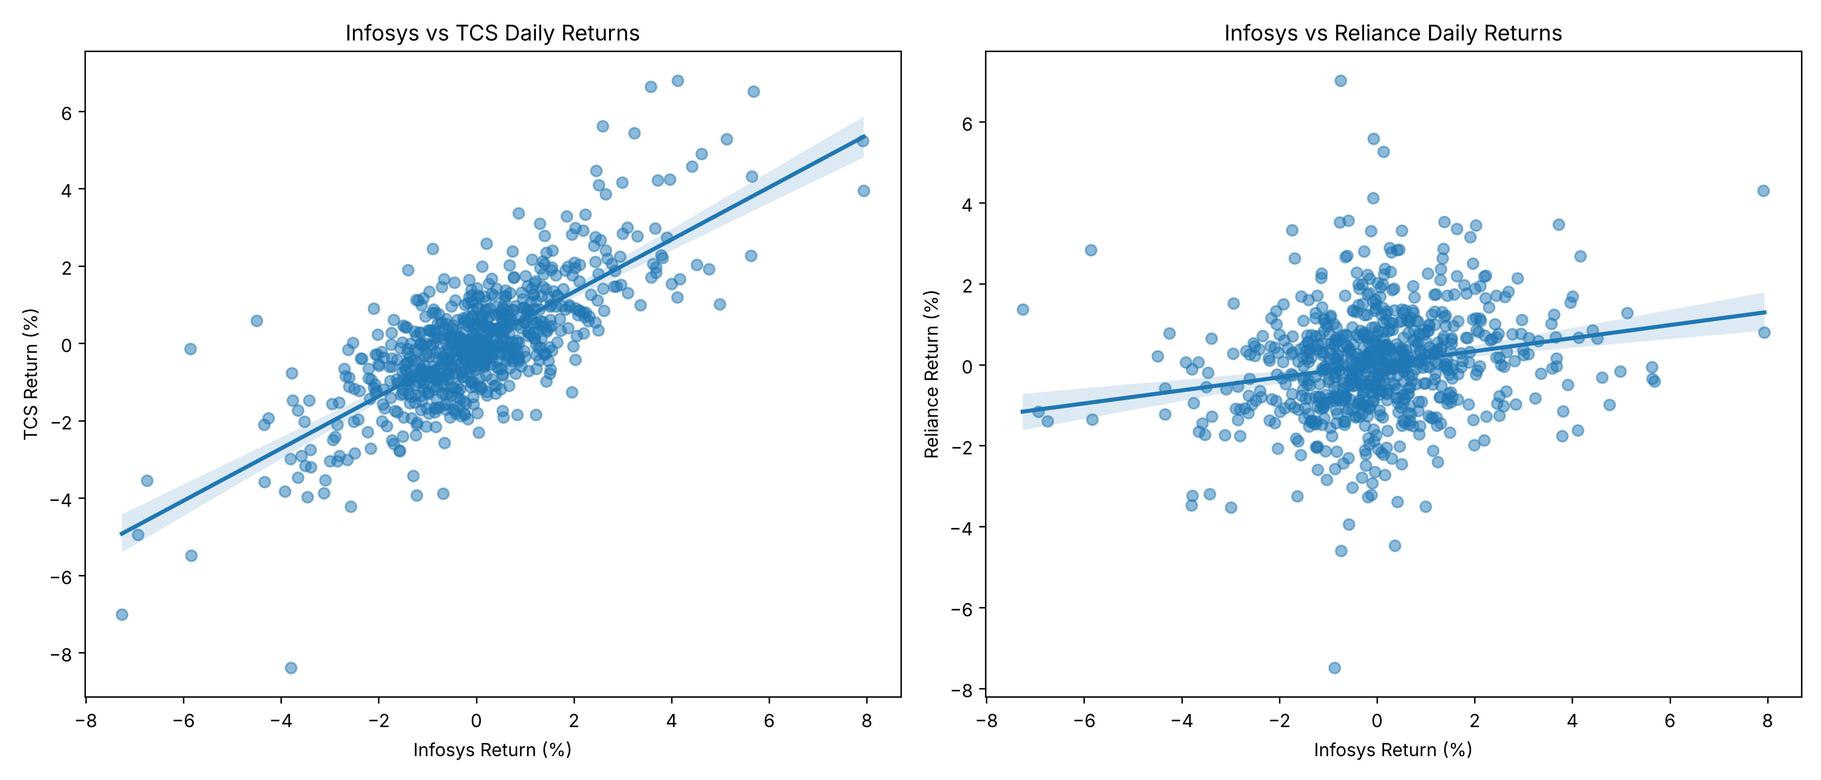
Figure 6. Daily Return Scatter Plots with Regression Lines
What the chart shows. In the left panel the points form a tilted elongated cloud around an upward-sloping line, tightest close to the origin and more scattered for large moves. In the right panel the points form a broad, almost round cloud, with the fitted line sloping upward only gently and many points far above or below it.
Numerical evidence. The correlations are 0.75 and 0.20 (Figure 4). From the correlations and standard deviations in Table 5, the implied slopes are about 0.68 percentage points of TCS return per 1-point Infosys return, and about 0.16 for Reliance (derived values; the regression itself was drawn by Seaborn and its coefficients were not printed in the notebook). The most extreme joint fall is at the lower left of the left panel, near -7.3% for Infosys and -7.0% for TCS, matching 4 February 2026.
Interpretation. The Infosys and TCS relationship is both strong and reasonably consistent across the range of returns, including on the largest down days. The Infosys-Reliance relationship is weak: knowing Infosys's return on a given day explains little about Reliance's, and several large Reliance moves occurred on days when Infosys barely moved. Only two of the three pairs are shown; the Reliance-TCS pair (correlation 0.24) appears in the heatmap only.

7.7 Figure 7: Monthly Average Daily Returns
Why this visualization. Aggregating to months removes day-to-day noise and shows whether returns were persistently positive or negative over longer stretches, and whether the companies moved together month by month. A line chart with markers shows the 36 monthly values for each company in time order.
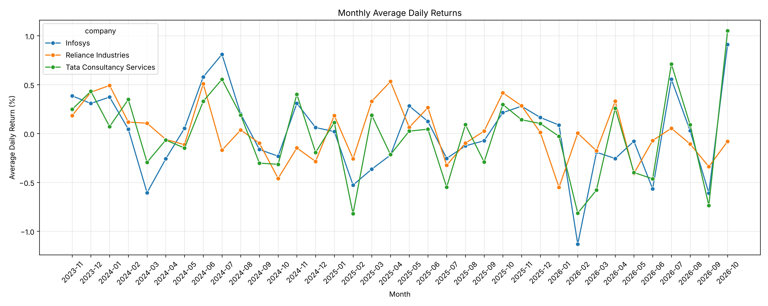
Figure 7. Monthly Average Daily Returns
Each value is the average of the daily returns within one month. It is not a compounded monthly investment return, and it should not be read as the percentage gain or loss from holding the stock for that month.
What the chart shows. Monthly averages swing between about -1.1% and +1.1% per day and change sign frequently. Infosys and TCS lines often move in the same direction in the same months, while Reliance follows its own path in several periods. The largest positive and negative values appear at the right-hand end of the chart, in 2026.
Table 11. Best and worst months by average daily return
Company | Best month | Average daily return | Worst month | Average daily return
Infosys | October 2026 | +0.91% | February 2026 | -1.13%
Reliance Industries | April 2025 | +0.53% | January 2026 | -0.55%
TCS | October 2026 | +1.05% | February 2025 | -0.82%

Numerical evidence. Infosys and TCS share the same best month, October 2026 (+0.91% and +1.05%), and the worst months differ (February 2026 for Infosys, February 2025 for TCS). Reliance's best and worst months, April 2025 (+0.53%) and January 2026 (-0.55%), are smaller in size. The standard deviation of the 36 monthly averages is 0.42 (Infosys), 0.28 (Reliance) and 0.42 (TCS), calculated from the plotted values.
Interpretation. The month-to-month pattern supports the earlier finding that Infosys and TCS behave similarly and that Reliance is less variable and partly independent. An average daily return of +1.05% in October 2026 means the average trading day in that month for TCS was a gain of about one percent; it does not mean TCS gained 1.05% over the month. Because only 36 months per company are available, the appearance of recurring seasonal patterns (for example several February lows) is not strong enough to claim seasonality.

8. Initial Hypotheses and Evaluation
Four hypotheses were set out before the interpretation of the results. Each is compared with the observed evidence below. Because no formal statistical tests were run, the assessments describe consistency with the sample and are not statistical confirmations.
Table 12. Evaluation of initial hypotheses
# | Hypothesis | Evidence | Assessment
H1 | Daily return variability differs among the three companies. | Return standard deviation 1.70% (Infosys), 1.53% (TCS), 1.34% (Reliance); IQR widths 1.73, 1.53, 1.53; outlier flags 45, 38, 28 (Figures 2 and 3). | Supported descriptively. Differences are visible, but their statistical significance was not tested.
H2 | Companies in the same broad industry show stronger co-movement in daily returns. | Infosys-TCS correlation 0.75 against 0.20 (Infosys-Reliance) and 0.24 (Reliance-TCS) (Figures 4 and 6). | Supported for these three companies. The industry grouping is external context; only one same-industry pair exists.
H3 | Volatility changes over time rather than staying constant. | Rolling volatility ranges from 0.56% to 2.91%; maximum is 3.5 to 4.6 times the minimum; 2026 return standard deviations above earlier years for Infosys and TCS (Figure 5, Table 9). | Supported. Volatility is clearly time-varying in this sample.
H4 | Higher average trading volume does not necessarily imply higher return volatility. | Reliance has the highest average volume (12.97m) and lowest volatility (1.34% std.; 1.30% rolling). TCS has the lowest volume (3.00m) and middle volatility. Infosys has middle volume (8.81m) and highest volatility. | Consistent with the hypothesis in this three-company comparison. With only three points and different share counts, this is weak evidence.

9. Key Findings and Practical Implications

9.1 Key Findings
- Data quality is high. The dataset has 2,220 rows, 0 duplicates and 740 observations per company. The only missing values (3 daily returns, 3 price changes and 60 rolling-volatility values) arise from feature engineering and are expected.
- Average daily returns are near zero, but risk differs. Mean daily returns are 0.007%, 0.013% and -0.014%, while return standard deviations are 1.70% (Infosys), 1.34% (Reliance) and 1.53% (TCS).
- Returns have heavy tails. Excess kurtosis of 2.83 to 3.92 and 111 flagged return outliers show that large moves are common compared with a normal distribution.
- Infosys and TCS move closely together. Their daily-return correlation is 0.75, compared with 0.20 and 0.24 for pairs involving Reliance.
- Volatility is time-varying. Rolling volatility ranged from 0.56% to 2.91%, with the highest values for Infosys and TCS in mid-2026 and for Reliance in mid-2024.
- Performance diverged over the period. From a base of 100, the final values were 94.96 (Infosys), 102.63 (Reliance) and 82.66 (TCS), though peaks and troughs occurred at different times for each.
- Monthly averages are volatile and sign-changing. Best and worst months range from +1.05% (TCS, October 2026) to -1.13% (Infosys, February 2026) in average daily return, and these are not compounded monthly returns.

9.2 Practical Implications
- Diversification. Infosys and TCS overlap heavily in daily behaviour (correlation 0.75), so holding both adds less diversification than the number of holdings suggests. Reliance's weaker correlation with either (0.20 to 0.24) indicates greater diversification potential in this sample, although correlations are not stable guarantees.
- Risk measurement. Because volatility varies over time and returns are heavy-tailed, a single fixed standard deviation or a normal-distribution assumption would understate risk in turbulent periods. A rolling measure, as in Figure 5, gives a more current view.
- Outlier handling. Extreme returns are a regular feature, so removing them automatically could discard genuine market information. Each should be linked to a specific event before any exclusion.
- Comparison basis. Normalized prices and percentage returns, not raw prices, should be used when comparing companies with different price levels.
These observations describe historical patterns in the sample and are not investment advice or forecasts.

9.3 Suggested Further Analysis
The following extensions would build on the findings but were not carried out in this report:
- Formal tests of whether return variances differ between companies (for example, Levene's test), to move H1 beyond description.
- Rolling correlations, to check whether the Infosys-TCS relationship is stable over time or strengthens in turbulent periods.
- A day-by-day review of the flagged outlier dates against company announcements and market news.
- Within-company analysis of volume against volatility or absolute returns, to examine H4 more rigorously than the three-company comparison used here.
- Compounded monthly returns and drawdown measures, which describe investor outcomes more directly than monthly average daily returns.
- Comparison against a broad market index, to separate market-wide movements from company-specific ones.

10. Limitations of the Analysis
- Small sample of companies. Only three companies, two of which are in the same sector, are analysed. Conclusions about co-movement and diversification cannot be generalized to other stocks or sectors.
- Limited time window. About three years of data are covered. Patterns, rankings and the relative performance in Figure 1 depend on the chosen start and end dates.
- Descriptive analysis only. No statistical tests, models or forecasts were used. Statements of support for the hypotheses are based on visible differences in this sample.
- Correlation is not causation. The correlations and scatter plots describe co-movement and cannot show that one company's movement causes another's. Unobserved factors such as sector or market-wide news were not examined.
- Same-day correlation only. Lagged relationships, for example one stock leading another, were not examined, and correlations were calculated over the whole period, not within sub-periods.
- Monthly figures are averages of daily returns. They are not compounded monthly returns and cannot be used to estimate the gain or loss from holding a stock for a month. October 2026 includes trading days only up to 30 October 2026.
- Outlier definition. The 1.5 x IQR rule is a screening convention, and on heavy-tailed data it flags a relatively large number of days. Flagged days are not necessarily errors.
- Zero-volume dates. Two dates (18 March 2025 and 15 January 2026) show zero volume for all three companies; their cause was not verified, and they were kept in the data.
- Rolling-window artefacts. The 20-day window produces step-like jumps when a single large return enters or leaves, so abrupt changes in Figure 5 partly reflect the calculation method.
- Mode is of limited value. As noted in Section 5.2, the mode is not informative for continuous financial variables in this dataset.
- Data source. Yahoo Finance data were used as downloaded and were not cross-checked against an exchange or another provider.
- Volume comparison. Share volumes are not adjusted for differences in share count, price level or free float, so the volume-volatility comparison in H4 is only indicative.

11. Conclusion
This exploratory analysis examined 2,220 daily observations for Infosys, Reliance Industries and Tata Consultancy Services from November 2023 to October 2026. The dataset is complete apart from three expected types of missing value created by feature engineering, and contains no duplicate rows.
Daily returns are centred near zero for all three companies but differ in spread (standard deviation 1.70% for Infosys, 1.53% for TCS and 1.34% for Reliance) and have heavier tails than a normal distribution. Infosys and TCS show a strong same-day relationship (correlation 0.75), while Reliance is only weakly related to both (0.20 and 0.24). Volatility varies materially over time, with the highest 20-day readings for Infosys and TCS in mid-2026. Prices diverged: from a base of 100, Reliance ended at 102.63, Infosys at 94.96 and TCS at 82.66.
The seven visualizations support these observations and show how the choice of chart affects what can be seen: the line charts reveal timing, the histograms and box plots reveal shape and outliers, the heatmap and scatter plots reveal co-movement, and the monthly chart reveals month-level variation. The findings are descriptive, rest on a small sample and a short window, and do not establish causes. They provide a basis for the further analysis outlined in Section 9.3, in particular formal testing of the variability differences, rolling correlation analysis and event-level investigation of the extreme days.

12. References and Data Source
- Market data: Yahoo Finance historical daily price, volume, dividend and stock-split data for INFY.NS, RELIANCE.NS and TCS.NS, accessed through the yfinance Python library (Week 2 data acquisition).
- Dataset used: combined_cleaned_data.csv, the Week 2 cleaned and feature-engineered dataset (2,220 rows x 18 columns).
- Software: Python with the pandas, NumPy, Matplotlib and Seaborn libraries, run in a Google Colab notebook (week2_3_yuvaintern.ipynb).
- Task specification: Week 3 Task: Exploratory Data Analysis & Visualization, as provided for the internship.

Appendix A: Code Annotations for Analysis
The snippets below are taken from the project notebook (week2_3_yuvaintern.ipynb), shortened only where a cell was very long. Each is followed by a short explanation of what it does.

A.1 Feature Engineering (Week 2)
# Daily percentage returns (adjusted close, per company)
df["daily_return"] = (
df.groupby("ticker")["adj_close"].pct_change(fill_method=None) * 100
)
# Absolute price change
df["price_change"] = df.groupby("ticker")["adj_close"].diff()
# Normalized price (first valid adjusted close = 100)
df["normalized_price"] = (
df.groupby("ticker")["adj_close"].transform(lambda x: x / x.iloc[0] * 100)
)
# 20-day rolling volatility (std of daily returns)
df["rolling_volatility"] = (
df.groupby("ticker")["daily_return"].transform(lambda x: x.rolling(20).std())
)
# Cumulative return since the first observation
df["cumulative_return"] = (
df.groupby("ticker")["adj_close"].transform(lambda x: (x / x.iloc[0] - 1) * 100)
)
These five statements create the engineered variables used throughout the report. Grouping by ticker ensures that each company's first row has no previous value, producing the expected missing values. pct_change gives the daily percentage return; diff gives the absolute change; the lambda in transform rescales each company to a base of 100; rolling(20).std() produces the 20-day volatility; and the final transform gives the cumulative return since the first observation.

A.2 Loading and Inspecting the Dataset
import pandas as pd
import numpy as np
import matplotlib.pyplot as plt
import seaborn as sns

# Load Week 2 cleaned dataset
df = pd.read_csv(
"/content/Financial_Market_Analysis/cleaned_data/combined_cleaned_data.csv"
)
print("Shape:", df.shape) # (2220, 18)
print("Dataset Shape:", df.shape)
df.info() # column names and data types
print(df.isnull().sum()) # missing values per column
print("Duplicate Rows:", df.duplicated().sum())
print(df['company'].value_counts()) # records per company
df['date'] = pd.to_datetime(df['date'])
print("Start:", df['date'].min())
print("End:", df['date'].max())
The first block loads the cleaned dataset and confirms its shape of 2,220 rows and 18 columns. The second block reports data types, missing values per column (3, 3 and 60 in the three engineered columns), duplicate rows (0), records per company (740 each) and the date range.

A.3 Summary Statistics: Mean, Median, Mode and Standard Deviation
numeric_cols = ['adj_close', 'volume', 'daily_return',
'price_change', 'rolling_volatility', 'cumulative_return']

summary_stats = df.groupby('company')[numeric_cols].agg(
['mean', 'median',
lambda x: x.mode().iloc[0] if not x.mode().empty else np.nan,
'std']
)
summary_stats.columns = [
f'{col}_{stat if isinstance(stat, str) else "mode"}'
for col, stat in summary_stats.columns
]
This block applies four aggregation functions to six variables for each company. A lambda returns the first mode of each variable (or NaN if none), and the resulting column names are flattened into a single level (for example daily_return_std). Its output is the source of Table 5.

A.4 Return, Volatility and Volume Comparison
company_analysis = df.groupby('company').agg(
Average_Return=('daily_return', 'mean'),
Minimum_Return=('daily_return', 'min'),
Maximum_Return=('daily_return', 'max'),
Return_Std_Dev=('daily_return', 'std'),
Average_Volatility=('rolling_volatility', 'mean'),
Maximum_Volatility=('rolling_volatility', 'max'),
Minimum_Volatility=('rolling_volatility', 'min'),
Average_Volume=('volume', 'mean')
).round(3)
Named aggregation computes the average, minimum, maximum and standard deviation of daily return, the average, minimum and maximum of rolling volatility, and the average volume for each company. It is the source of Table 6 and the volatility figures in Section 7.5.

A.5 Monthly Average Daily Returns
# NOTE: the cell that created monthly_returns is not present in the saved
# notebook. This reconstruction reproduces the reported best/worst months.
df['year_month'] = df['date'].dt.to_period('M')
monthly_returns = (
df.groupby(['company', 'year_month'])['daily_return'].mean().reset_index()
)
monthly_extremes = monthly_returns.loc[
monthly_returns.groupby('company')['daily_return'].idxmax()
].rename(columns={'year_month': 'Best_Month',
'daily_return': 'Best_Month_Return'})

worst_months = monthly_returns.loc[
monthly_returns.groupby('company')['daily_return'].idxmin()
].rename(columns={'year_month': 'Worst_Month',
'daily_return': 'Worst_Month_Return'})

monthly_extremes = monthly_extremes[['company', 'Best_Month', 'Best_Month_Return']].merge(
worst_months[['company', 'Worst_Month', 'Worst_Month_Return']], on='company')
The first block averages daily returns within each calendar month for each company (not compounded returns). The second uses idxmax and idxmin to locate each company's best and worst month and merges them into one table, which is the source of Table 11. The notebook cell that originally created monthly_returns was not found in the saved file; the first block is a reconstruction whose output reproduces the best and worst months reported in this document.

Appendix B: Code Annotations for Visualizations
Each snippet below produced one of the seven figures. All figures were saved at 300 dpi to the week_3_visualizations folder. The seaborn and Matplotlib libraries were imported as shown in Appendix A.2.

B.1 Figure 1: Normalized Stock Price Trends
plt.figure(figsize=(14, 6))
for company in df['company'].unique():
company_data = df[df['company'] == company]
plt.plot(company_data['date'], company_data['normalized_price'], label=company)

plt.title('Normalized Stock Price Trends')
plt.xlabel('Date')
plt.ylabel('Normalized Price (Base = 100)')
plt.legend()
plt.grid(True, alpha=0.3)
plt.tight_layout()
plt.savefig('week_3_visualizations/normalized_price_trends.png', dpi=300)
Loops over the three companies and draws one line each of normalized_price against date. Because every series starts at 100, differences in the lines show relative performance; the semi-transparent grid helps the reader estimate values.

B.2 Figure 2: Distribution of Daily Stock Returns
plt.figure(figsize=(15, 5))
for i, company in enumerate(df['company'].unique(), 1):
plt.subplot(1, 3, i)
sns.histplot(df[df['company'] == company]['daily_return'].dropna(),
bins=30, kde=True)
plt.title(company)
plt.xlabel('Daily Return (%)')
plt.ylabel('Frequency')
plt.suptitle('Distribution of Daily Stock Returns')
plt.tight_layout()
plt.savefig('week_3_visualizations/daily_return_distribution.png', dpi=300)
Creates a one-row, three-panel layout. For each company sns.histplot draws a 30-bin histogram of daily returns with a kernel density curve (kde=True). dropna() removes the single missing first-day return.

B.3 Figure 3: Daily Return Box Plot
plt.figure(figsize=(10, 6))
sns.boxplot(data=df, x='company', y='daily_return')
plt.title('Daily Return Distribution and Outliers')
plt.xlabel('Company')
plt.ylabel('Daily Return (%)')
plt.xticks(rotation=10)
plt.tight_layout()
plt.savefig('week_3_visualizations/daily_return_boxplot.png', dpi=300)
sns.boxplot draws one box per company from the pooled data frame. The box shows the interquartile range with the median line, whiskers extend to 1.5 x IQR, and points beyond are the outliers discussed in Section 7.3.

B.4 Figure 4: Correlation Heatmap
# Pivot so each company's daily returns form one column
returns_pivot = df.pivot(index='date', columns='company', values='daily_return')
correlation_matrix = returns_pivot.corr() # Pearson correlation

plt.figure(figsize=(9, 6))
sns.heatmap(correlation_matrix, annot=True, cmap='coolwarm',
fmt='.2f', linewidths=0.5)
plt.title('Correlation Between Daily Stock Returns')
plt.tight_layout()
plt.savefig('week_3_visualizations/return_correlation.png', dpi=300)
pivot reshapes the long table into one column of returns per company so that dates align. DataFrame.corr() computes pairwise Pearson correlations (ignoring dates where a value is missing), and sns.heatmap prints each coefficient to two decimals with a diverging colour map.

B.5 Figure 5: Rolling Volatility
plt.figure(figsize=(14, 6))
for company in df['company'].unique():
company_data = df[df['company'] == company]
plt.plot(company_data['date'], company_data['rolling_volatility'],
label=company)
plt.title('Rolling Volatility Trends Across Companies')
plt.xlabel('Date')
plt.ylabel('Rolling Volatility (%)')
plt.legend()
plt.grid(True, alpha=0.3)
plt.tight_layout()
plt.savefig('week_3_visualizations/rolling_volatility.png', dpi=300)
Plots the 20-day rolling standard deviation for each company. The first 20 values of each series are missing and are therefore not drawn.

B.6 Figure 6: Scatter Plots with Regression Lines
# Keep only dates on which all three companies have a return
returns_pivot = df.pivot(index='date', columns='company',
values='daily_return').dropna()

fig, axes = plt.subplots(1, 2, figsize=(14, 6))
sns.regplot(x=returns_pivot['Infosys'],
y=returns_pivot['Tata Consultancy Services'],
ax=axes[0], scatter_kws={'alpha': 0.5})
axes[0].set_title('Infosys vs TCS Daily Returns')
axes[0].set_xlabel('Infosys Return (%)')
axes[0].set_ylabel('TCS Return (%)')

sns.regplot(x=returns_pivot['Infosys'],
y=returns_pivot['Reliance Industries'],
ax=axes[1], scatter_kws={'alpha': 0.5})
axes[1].set_title('Infosys vs Reliance Daily Returns')
axes[1].set_xlabel('Infosys Return (%)')
axes[1].set_ylabel('Reliance Return (%)')
plt.tight_layout()
plt.savefig('week_3_visualizations/return_scatterplots.png', dpi=300)
dropna() keeps only dates on which all three companies have a return (739 dates). sns.regplot draws each day as a semi-transparent point (alpha = 0.5) and adds a fitted linear regression line with a confidence band. Infosys is on the horizontal axis in both panels.

B.7 Figure 7: Monthly Average Daily Returns
# Convert monthly periods into strings for plotting
monthly_returns['year_month'] = monthly_returns['year_month'].astype(str)

plt.figure(figsize=(15, 6))
sns.lineplot(data=monthly_returns, x='year_month', y='daily_return',
hue='company', marker='o')
plt.title('Monthly Average Daily Returns')
plt.xlabel('Month')
plt.ylabel('Average Daily Return (%)')
plt.xticks(rotation=45)
plt.grid(True, alpha=0.3)
plt.tight_layout()
plt.savefig('week_3_visualizations/monthly_average_returns.png', dpi=300)
Converts the month periods to strings so Seaborn can place them on the axis, then draws one marked line per company (hue='company'). Labels are rotated 45 degrees for readability.

