FINANCIAL MARKET ANALYSIS
Week 2: Data Wrangling and Processing
Python | pandas | yfinance | Matplotlib
Reliance Industries (RELIANCE.NS) • Tata Consultancy Services (TCS.NS) • Infosys (INFY.NS)

1. Introduction
This report describes how daily stock-market data for three NSE-listed companies (Reliance Industries, Tata Consultancy Services and Infosys) was imported, cleaned, structured and prepared for analysis using Python. The data was obtained from Yahoo Finance through the yfinance library and processed with pandas. The objective is to produce a consistent, well-documented dataset for later analysis.
The workflow follows a conservative approach: the original download is saved unchanged, every cleaning rule is applied through a recorded check, and no values were filled, no outliers were removed and no records were dropped, because the checks found nothing that had to be excluded (see Section 12). Where the final dataset still contains empty (NaN) values, these come from feature engineering and are explained in Section 9.2.

1.1 Workflow overview (pseudo-code)

FOR each ticker in [RELIANCE.NS, TCS.NS, INFY.NS]:
download daily OHLC, Adj Close, Volume, Dividends, Stock Splits
standardize column names, add ticker and company, save raw CSV
COMBINE all companies into one DataFrame, sort by ticker and date
CONVERT columns to numeric; CHECK missing values; DROP rows missing essential fields
REMOVE exact duplicates; EXCLUDE conflicting ticker-date records
VALIDATE prices, OHLC relationships and volume; EXCLUDE invalid rows
EXTRACT corporate-action events (dividends, stock splits)
COMPUTE daily_return; FLAG IQR outliers in daily_return and volume (per company)
CREATE features: price_change, normalized_price, rolling_volatility, cumulative_return
SAVE cleaned datasets, quality reports and charts

2. Data Importation
Historical daily data was downloaded from Yahoo Finance for the period 2023-11-01 to 2026-11-01. In yfinance the end date is exclusive, and 31 October and 1 November 2026 fall on a weekend, so the last record returned for every company is 2026-10-30. The three tickers were downloaded in a loop using the following settings:
- interval="1d" requests daily observations.
- auto_adjust=False keeps the original Close price and returns Adj Close as a separate column.
- actions=True adds the Dividends and Stock Splits columns.

Code 1: Importing and saving the raw data (abridged from the notebook)

companies = {"RELIANCE.NS": "Reliance Industries",
"TCS.NS": "Tata Consultancy Services",
"INFY.NS": "Infosys"}
start_date, end_date = "2023-11-01", "2026-11-01"

for ticker, company in companies.items():
# Download daily data with separate Adj Close, dividends and splits
data = yf.download(ticker, start=start_date, end=end_date, interval="1d",
auto_adjust=False, actions=True, progress=False)

# Flatten Yahoo's MultiIndex columns and use lower-case names
if isinstance(data.columns, pd.MultiIndex):
data.columns = data.columns.get_level_values(0)
data.columns = [str(c).lower().replace(" ", "_") for c in data.columns]

data.index = pd.to_datetime(data.index) # make sure the index is a date
data.index.name = "date"
data["ticker"], data["company"] = ticker, company # identify each company

# Save the downloaded data unchanged as the raw record
data.to_csv(f"Financial_Market_Analysis/raw_data/{ticker.replace('.', '_')}_raw.csv")
raw_data[ticker] = data.copy()

Each company returned 740 daily records. The downloaded data has 8 fields from Yahoo Finance (open, high, low, close, adj_close, volume, dividends, stock_splits) plus the ticker and company columns added in the code, which gives the 10 columns shown in Table 1.

3. Initial Data Assessment
Before any cleaning, each raw dataset was assessed for the number of rows and columns, date range, missing values, duplicate dates, data types and descriptive statistics. This identifies data-quality problems before any change is made.
Table 1: Initial assessment of the raw data
Company | Ticker | Rows | Columns | Start Date | End Date | Missing Values | Duplicate Dates
Reliance Industries | RELIANCE.NS | 740 | 10 | 2023-11-01 | 2026-10-30 | 0 | 0
Tata Consultancy Services | TCS.NS | 740 | 10 | 2023-11-01 | 2026-10-30 | 0 | 0
Infosys | INFY.NS | 740 | 10 | 2023-11-01 | 2026-10-30 | 0 | 0
The raw data contained no missing values and no duplicate dates for any company.
Table 2: Data types of the raw columns (identical for all three companies)
Column | Data type | Description
date (index) | datetime64 | Trading date, converted with pd.to_datetime()
open, high, low, close | float64 | Opening, highest, lowest and closing prices
adj_close | float64 | Closing price adjusted by Yahoo Finance for corporate actions
volume | int64 | Number of shares traded
dividends, stock_splits | float64 | Dividend per share; split ratio (0 when no event)
ticker, company | object (text) | Identifiers added during import

Code 2: Initial assessment checks

print(data.dtypes) # data type of each column
print(data.isnull().sum()) # missing values per column
print(data.describe()) # count, mean, std, min, quartiles, max
data.index.duplicated().sum() # number of repeated dates

The descriptive statistics showed a minimum volume of 0 for all three companies. This is discussed in Section 6.

4. Missing Value Handling

4.1 Combining the datasets and converting data types
The three company DataFrames were joined into one long-format DataFrame (one row per company per date) and sorted by ticker and date. The price, volume and corporate-action columns were then converted to numeric type. With errors="coerce", any value that cannot be converted becomes NaN, so that it is picked up by the missing-value check that follows.
Code 3: Combining the datasets (merge) and converting types

df = pd.concat([d.reset_index() for d in raw_data.values()], ignore_index=True)
df["date"] = pd.to_datetime(df["date"])
df = df.sort_values(["ticker", "date"]).reset_index(drop=True)

numeric_columns = ["open", "high", "low", "close", "adj_close",
"volume", "dividends", "stock_splits"]
for col in numeric_columns:
df[col] = pd.to_numeric(df[col], errors="coerce") # unparseable -> NaN

4.2 Checking and handling missing values in the raw data
Missing values were counted for every column of the combined dataset. The handling rule defined in the code is:
- Essential fields (date, ticker, open, high, low, close, adj_close): a record missing any of these is saved to missing_records.csv and removed from the analysis dataset.
- Other fields (volume, dividends, stock_splits): not on the essential list, so they are not used to drop records and are never replaced with estimated values.
- Non-trading days (weekends and market holidays) were not added or filled; the data keeps only the days on which the market was open.

Code 4: Missing-value handling for essential fields

essential_columns = ["date", "ticker", "open", "high", "low", "close", "adj_close"]

# Save records that miss essential price information, then exclude them
missing_records = df[df[essential_columns].isnull().any(axis=1)].copy()
df = df.dropna(subset=essential_columns).copy()

Table 3: Result of the missing-value check on the combined raw data
Check | Result
Records checked (3 companies × 740) | 2,220
Missing values in any of the 11 columns | 0
Records missing essential fields (saved to missing_records.csv) | 0
Records excluded | 0
Records remaining | 2,220
No missing values were found in the raw data, so no record was excluded and nothing needed to be filled at this stage.

5. Duplicate Detection
Two types of duplicates were checked. Exact duplicates are rows in which every column is identical; they are saved to exact_duplicates.csv and removed with drop_duplicates(). Conflicting duplicates are rows that share the same ticker and date but differ in some value. Since it is not possible to know which version is correct, all rows in such a group are saved to conflicting_duplicates.csv and excluded, instead of choosing one arbitrarily.
Code 5: Duplicate detection

exact_duplicates = df[df.duplicated(keep=False)].copy()
df = df.drop_duplicates().copy() # remove exact duplicates

duplicate_mask = df.duplicated(subset=["ticker", "date"], keep=False)
conflicting_duplicates = df[duplicate_mask].copy() # same ticker and date
df = df[~duplicate_mask].copy() # exclude the whole group

Exact duplicate rows found: 0. Conflicting duplicate rows found: 0. All 2,220 records remained.

6. Data Consistency Validation
Three groups of checks were applied to confirm that the price and volume data are logically valid: (1) open, high, low, close and adjusted close must all be greater than zero; (2) the high price must not be lower than the low, open or close, and the low price must not be higher than the open or close; (3) volume must not be negative. Invalid records would be saved to invalid_records.csv and excluded.
Code 6: Price, OHLC and volume validation

invalid_price = ((df["open"] <= 0) | (df["high"] <= 0) | (df["low"] <= 0) |
(df["close"] <= 0) | (df["adj_close"] <= 0))

invalid_ohlc = ((df["high"] < df["low"]) | (df["high"] < df["open"]) |
(df["high"] < df["close"]) | (df["low"] > df["open"]) |
(df["low"] > df["close"]))

invalid_volume = df["volume"] < 0

invalid_mask = invalid_price | invalid_ohlc | invalid_volume
invalid_records = df[invalid_mask].copy() # saved for investigation
df = df[~invalid_mask].copy() # excluded from analysis

Table 4: Results of the consistency validation
Validation | Count
Non-positive prices | 0
Inconsistent OHLC values | 0
Negative trading volume | 0
No invalid records were found; 2,220 records remained.
Observation on zero volume. The validation only flags negative volume. The descriptive statistics in Section 3 show a minimum volume of 0 for all three companies. These records were not treated as invalid and were retained, and the notebook does not examine how many such days exist or why. This could be investigated in later analysis.

7. Corporate Actions
Dividends and stock splits can change the price level of a share without reflecting any change in the company's market value, so they affect historical price comparisons and returns. A corporate-action event was defined as any record where dividends or stock_splits is non-zero. Returns in this project are calculated from the adjusted close (adj_close), which Yahoo Finance adjusts for these events, so no second manual adjustment was applied.
Code 7: Extracting corporate-action events (abridged)

action_columns = ["dividends", "stock_splits"]

# Keep rows where a dividend or a split is recorded
corporate_actions = df[(df[action_columns] != 0).any(axis=1)].copy()
corporate_actions = corporate_actions[["date", "ticker", "company"] + action_columns]

# Per company: number of events and total dividend per share
dividend_events = (company_actions["dividends"] != 0).sum()
total_dividends = company_actions["dividends"].sum()
split_events = (company_actions["stock_splits"] != 0).sum()

Table 5: Corporate-action summary by company
Company | Dividend Events | Total Dividends (per share) | Stock Split Events | Split Ratio Recorded
Reliance Industries | 3 | 16.5 | 1 | 2.0 (on 2024-10-28)
Tata Consultancy Services | 12 | 315.0 | 0 | –
Infosys | 5 | 119.0 | 0 | –
Dividend amounts are per-share values as reported by Yahoo Finance.
Reliance Industries: split event count versus split ratio
The table reports one stock-split event for Reliance Industries (count). The value 2.0 is not the number of events. It is the split ratio recorded in the stock_splits column on the event date, 2024-10-28. The other two companies have no split event. The 2024-10-28 record has a dividend of 0.0, so it is counted as a split event and not as a dividend event; Reliance's 3 dividend events are the records dated 2024-08-19, 2025-08-14 and 2026-06-05.

Table 6 lists all 21 event records saved in corporate_actions.csv (5 for Infosys, 4 for Reliance Industries and 12 for TCS). The Reliance split record is highlighted.
Table 6: Corporate-action event records
Date | Ticker | Company | Dividends | Stock Splits
2024-05-31 | INFY.NS | Infosys | 28.0 | 0.0
2024-10-29 | INFY.NS | Infosys | 21.0 | 0.0
2025-05-30 | INFY.NS | Infosys | 22.0 | 0.0
2025-10-27 | INFY.NS | Infosys | 23.0 | 0.0
2026-06-10 | INFY.NS | Infosys | 25.0 | 0.0
2024-08-19 | RELIANCE.NS | Reliance Industries | 5.0 | 0.0
2024-10-28 | RELIANCE.NS | Reliance Industries | 0.0 | 2.0
2025-08-14 | RELIANCE.NS | Reliance Industries | 5.5 | 0.0
2026-06-05 | RELIANCE.NS | Reliance Industries | 6.0 | 0.0
2024-01-19 | TCS.NS | Tata Consultancy Services | 27.0 | 0.0
2024-05-16 | TCS.NS | Tata Consultancy Services | 28.0 | 0.0
2024-07-19 | TCS.NS | Tata Consultancy Services | 10.0 | 0.0
2024-10-18 | TCS.NS | Tata Consultancy Services | 10.0 | 0.0
2025-01-17 | TCS.NS | Tata Consultancy Services | 76.0 | 0.0
2025-06-04 | TCS.NS | Tata Consultancy Services | 30.0 | 0.0
2025-07-16 | TCS.NS | Tata Consultancy Services | 11.0 | 0.0
2025-10-15 | TCS.NS | Tata Consultancy Services | 11.0 | 0.0
2026-01-16 | TCS.NS | Tata Consultancy Services | 57.0 | 0.0
2026-05-25 | TCS.NS | Tata Consultancy Services | 31.0 | 0.0
2026-07-15 | TCS.NS | Tata Consultancy Services | 12.0 | 0.0
2026-10-14 | TCS.NS | Tata Consultancy Services | 12.0 | 0.0
Dividends: amount per share. Stock Splits: split ratio recorded by Yahoo Finance (0.0 means no split).

8. Outlier Detection
Outliers in daily return and trading volume were identified with the Interquartile Range (IQR) method, applied separately to each company. For each variable the first quartile (Q1), third quartile (Q3) and IQR = Q3 − Q1 were calculated, and a value was flagged if it fell below Q1 − 1.5 × IQR or above Q3 + 1.5 × IQR. Daily return had to be calculated before this step, so it was computed first (Section 9 gives the formula).
Flagged observations were kept in the dataset and marked with the Boolean columns return_outlier and volume_outlier. They were not removed because large price moves and high-volume days are often genuine market events. The flagged records are saved in outlier_records.csv.
Code 8: IQR outlier detection (abridged)

for ticker in df["ticker"].unique():
company_data = df[df["ticker"] == ticker]
for column, flag_column in [("daily_return", "return_outlier"),
("volume", "volume_outlier")]:
values = company_data[column].dropna() # first return is NaN
q1, q3 = values.quantile(0.25), values.quantile(0.75)
iqr = q3 - q1
lower, upper = q1 - 1.5 * iqr, q3 + 1.5 * iqr

outlier_mask = (values < lower) | (values > upper)
df.loc[outlier_mask.index, flag_column] = outlier_mask # flag only

Table 7: IQR outlier thresholds for daily return (values in %)
Company | Q1 | Q3 | IQR | Lower Bound | Upper Bound | Outliers
Reliance Industries | -0.8109 | 0.7229 | 1.5339 | -3.1117 | 3.0237 | 28
Tata Consultancy Services | -0.8250 | 0.7048 | 1.5299 | -3.1198 | 2.9996 | 38
Infosys | -0.8891 | 0.8405 | 1.7296 | -3.4835 | 3.4348 | 45

Table 8: IQR outlier thresholds for trading volume (number of shares)
Company | Q1 | Q3 | IQR | Lower Bound | Upper Bound | Outliers
Reliance Industries | 8,621,395.50 | 15,713,797.00 | 7,092,401.50 | -2,017,206.75 | 26,352,399.25 | 31
Tata Consultancy Services | 1,808,836.25 | 3,446,918.00 | 1,638,081.75 | -648,286.38 | 5,904,040.62 | 43
Infosys | 5,139,626.00 | 10,186,068.00 | 5,046,442.00 | -2,430,037.00 | 17,755,731.00 | 49
Bounds were recalculated from Q1, Q3 and IQR and match the notebook output. TCS bounds are shown to two decimals as in the notebook display.
The lower volume bounds are negative, and volume cannot be negative, so only unusually high-volume days are flagged. Daily-return outliers can be above the upper bound or below the lower bound; the notebook does not separate the two.
Why the totals differ. The six outlier counts add up to 234 flags (111 for daily return and 123 for volume), but Section 12 reports 184 outlier records. The 184 is the number of unique records flagged for at least one variable, so about 50 records (234 − 184) were flagged for both daily return and volume and are counted once in the 184.

9. Data Structuring and Transformation

9.1 Structure of the dataset and new features
The combined DataFrame has one row per company per trading day and identifies each row by date, ticker and company. The text columns ticker and company were kept as labels; no encoding of categorical variables was performed in this notebook. Five features were derived from the adjusted close price, in addition to the two outlier flag columns described in Section 8 (11 original columns + 7 added = 18 columns in the final dataset).
Table 9: Features created during data structuring
Feature | Definition | Unit
daily_return | Percentage change in adj_close from the previous trading day | %
price_change | Difference in adj_close from the previous trading day | Price
normalized_price | adj_close rebased so the first observation = 100 | Index
cumulative_return | Total percentage change in adj_close since the first observation | %
rolling_volatility | Standard deviation of daily_return over the last 20 trading days (not annualized) | % points

Code 9: Feature engineering (from the notebook)

# Daily percentage return, calculated separately for each company
df["daily_return"] = df.groupby("ticker")["adj_close"].pct_change(fill_method=None) * 100

# Daily price change (difference between consecutive adjusted closes)
df["price_change"] = df.groupby("ticker")["adj_close"].diff()

# Cumulative return since the first observation of each company
df["cumulative_return"] = (df.groupby("ticker")["adj_close"]
.transform(lambda x: (x / x.iloc[0] - 1) * 100))

# 20-day rolling volatility = rolling standard deviation of daily returns
df["rolling_volatility"] = (df.groupby("ticker")["daily_return"]
.transform(lambda x: x.rolling(20).std()))

groupby("ticker") ensures that each calculation uses only one company's prices, so the first day of one company is never compared with the last day of another. The daily-return formula appears twice in the notebook, first before outlier detection and again with the other features. Both use identical code and give identical values. Figure 1 shows the 20-day rolling volatility; each line starts only after the first 20 observations because the window needs 20 valid returns (explained in Section 9.2).
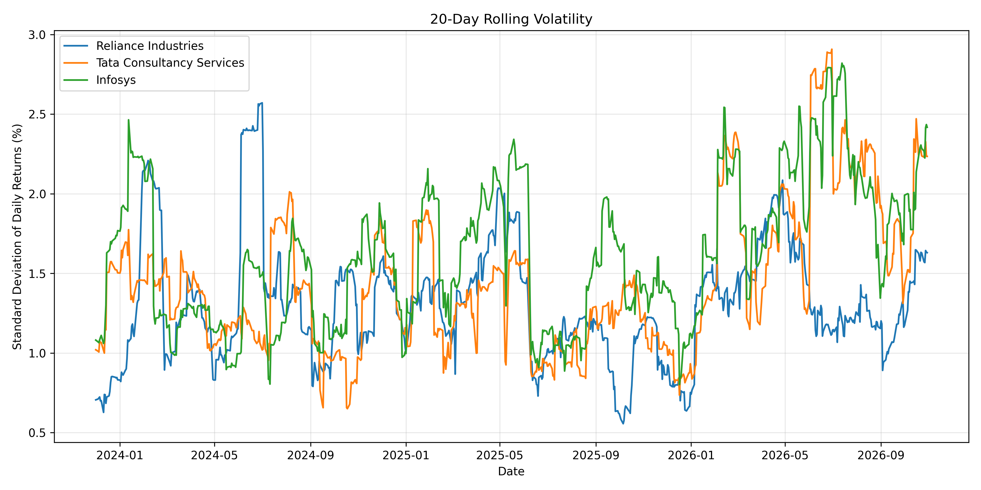
Figure 1: 20-day rolling volatility (standard deviation of daily returns, %) for the three companies.

9.2 Missing values introduced by feature engineering
The raw data had no missing values (Section 4.2). The empty values in the final dataset were created by the calculations above, after the cleaning steps had finished. They were deliberately left as NaN: they were not filled, because a return or volatility value cannot be estimated for a period that does not yet exist, and they were not dropped, so that all 740 records per company are kept. The reasons are:
- daily_return and price_change: both compare a day with the previous day. The first record of each company has no previous day, so it gets NaN. This is 1 value per company for each feature.
- rolling_volatility: rolling(20) needs 20 valid daily returns. The first return is itself NaN, so the first 20 records of each company have an incomplete window, and the first valid value appears on the 21st record. This is 20 values per company.
- normalized_price and cumulative_return: start from the first adjusted close (100 and 0%), so they have no missing values.
Table 10: Missing values in the final cleaned dataset, by feature
Column | Missing per Company | Missing, All 3 Companies | Cause
daily_return | 1 | 3 | No previous day for the first record
price_change | 1 | 3 | No previous day for the first record
rolling_volatility | 20 | 60 | Fewer than 20 valid returns in the first 20 records
Total | 22 | 66
Combined figures (3, 3 and 60) are 3 companies × the per-company figures (1, 1 and 20). Total per company = 1 + 1 + 20 = 22, which equals the Missing Values figure in Table 11.

10. Price Normalization
The three stocks trade at very different price levels, so their raw prices cannot be compared directly. Adjusted close prices were therefore rebased to an index value of 100 at the first observation of each company (2023-11-01 for all three). This is a rebasing method and not a statistical scaling such as min-max or z-score. A value of 120 means that the price is 20% above its starting level. The same ratio, minus 1, gives cumulative_return.
Code 10: Price normalization (base = 100)

# Divide each price by the company's first adjusted close and multiply by 100
df["normalized_price"] = (df.groupby("ticker")["adj_close"]
.transform(lambda x: x / x.iloc[0] * 100))

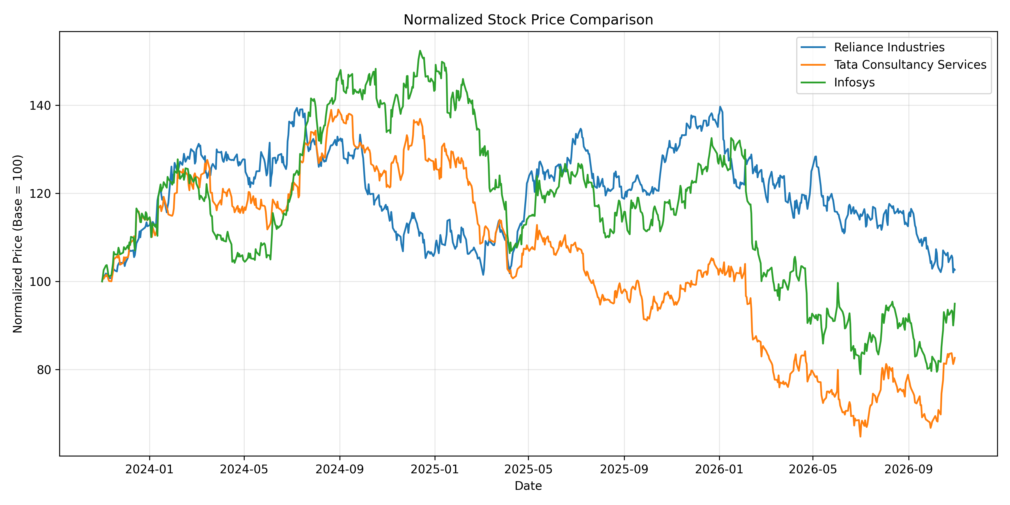
Figure 2: Normalized adjusted close prices (base = 100 on 2023-11-01) for the three companies.
The chart shows that the three stocks moved together at the start of the period and then diverged. At the end of the period Reliance Industries is close to its starting level, while TCS and Infosys are below it (approximate values read from the chart).

11. Final Data Quality Report
Table 11: Quality summary of the final cleaned dataset
Company | Final Records | Missing Values | Duplicate Dates | Return Outliers | Volume Outliers | Start Date | End Date
Reliance Industries | 740 | 22 | 0 | 28 | 31 | 2023-11-01 | 2026-10-30
Tata Consultancy Services | 740 | 22 | 0 | 38 | 43 | 2023-11-01 | 2026-10-30
Infosys | 740 | 22 | 0 | 45 | 49 | 2023-11-01 | 2026-10-30
Missing Values = NaN cells in the final dataset (all columns). All 22 per company come from feature engineering: 1 (daily_return) + 1 (price_change) + 20 (rolling_volatility). The raw data had 0 missing values.

12. Processing Summary
Table 12: Record counts through the processing steps
Metric | Value
Initial records (3 × 740) | 2,220
Records with missing essential values | 0
Exact duplicate records | 0
Conflicting duplicate records | 0
Invalid records | 0
Final records (3 × 740) | 2,220
Outlier records (unique records flagged, kept in dataset) | 184
Companies processed | 3
“Records with missing essential values” refers to the raw price fields checked in Section 4.2 and is separate from the NaN values created by feature engineering (Section 9.2). Outlier records are flagged, not removed, so they are included in the 2,220 final records.

13. Output Files
All outputs were written to the Financial_Market_Analysis project folder, which gives a reproducible record of the preparation process.
Table 13: Files produced by the notebook
Folder | Files
raw_data | RELIANCE_NS_raw.csv, TCS_NS_raw.csv, INFY_NS_raw.csv (unchanged downloads)
cleaned_data | combined_cleaned_data.csv and one cleaned CSV per company (RELIANCE_NS, TCS_NS, INFY_NS)
reports | initial_assessment, missing_values, missing_records, exact_duplicates, conflicting_duplicates, consistency_report, invalid_records, corporate_actions, corporate_actions_summary, outlier_report, outlier_records, final_quality_report, processing_summary (all .csv)
visualizations | normalized_prices.png, rolling_volatility.png

14. Conclusion
The Week 2 workflow prepared three years of daily data for Reliance Industries, TCS and Infosys (740 records each, 2,220 in total). The raw data had no missing values, duplicates or invalid price or volume records, so no records were excluded. Corporate actions were identified (21 event records, including one Reliance split with a recorded ratio of 2.0), and outliers in daily return and volume were flagged with the IQR method and retained. New features (daily return, price change, cumulative return, normalized price and 20-day rolling volatility) were created, and the 22 missing values per company in the final dataset come from these calculations at the start of each series. The raw data was saved separately from the cleaned data, giving a documented dataset for the exploratory analysis in later weeks.

15. References
- Yahoo Finance: https://finance.yahoo.com/
- yfinance: https://pypi.org/project/yfinance/
- pandas documentation: https://pandas.pydata.org/docs/
- Matplotlib documentation: https://matplotlib.org/

