Online Assessment System

Project Progress report submitted
to
MANIPAL ACADEMY OF HIGHER EDUCATION
For Partial Fulfilment of the Requirement for the
Award of the Degree
of
Master of Computer Applications
in
Data Science and Engineering
by

Bhoomika
240970030
Under the guidance of

Dr Savitha G  Assistant professorAssistant Professor  School of Computer Engineering  M.I.T., Manipal - 576 104 | Puneeth Acharya  Technical Trainee, MSDC  MSDC Building, Dr T.M.A Pai Polytechnic Campus, Eshwar Nagar, Manipal, Karnataka – 576104

DEPARTMENT OF DATA SCIENCE AND COMPUTER APPLICATIONS

April 2026
Table of Contents

1 Introduction 1
1.1 Overview of the existing project 1
1.2 Feature Proposal 2
1.2.1 User Registration and Authentication: 2
1.2.2 Role-Based Access(Student & Admin): 2
1.2.3 Online Assessment Creation: 2
1.2.4 Random Question Selection: 2
1.2.5. Secured Examination: 3
1.2.6. Automated Evaluation and Result Generation: 3
1.2.7 Performance Analysis: 3
1.2.8 Certificate Generation: 3

2 Literature Survey/ Related Works 4
2.1 Online Assessmnet System: 4
2.2 Random Question Generation: 4
2.3 Additional Features and Functionalities: 5
3 Problem Definition 5
4 Objectives 6
5 Methodology 7
5.1 Process model 7
5.2 Modules 8
5.3 Process flow visualization 9
6 Work done So Far 14
7 Future Work 24
References 25

1 Introduction

Overview of the existing project

The proposed system is a web-based Online Assessment Platform designed to facilitate efficient and secure examination processes. The system is divided into two primary modules: the Student Module and the Admin Module. It aims to provide a structured, user-friendly, and malpractice-resistant environment for conducting assessments.

Student Module:
The student module is designed for users who wish to participate in assessments. A new user must first register on the platform by providing essential details such as name, phone number, course, email, password, and profile photo. Upon successful registration, the user can log in using their email and password, which are validated against the database.
After logging in, the student is directed to a dashboard that contains various options such as Home, Achievements, Assessments, and Performance.
- The Home/Dashboard provides an overview of available activities.
- The Achievements section displays certificates earned by the student in a gallery format. If no certificates are available, the section remains empty.
- The Assessment section shows active assessments assigned to the student. If no assessments are available, it remains blank.
When a student selects an assessment, they are redirected to the examination interface, which includes.
- A list of questions with multiple-choice options
- Full-screen mode enforcement
- Proctoring mechanisms such as tab-switch detection and face visibility monitoring
The system ensures academic integrity by automatically submitting the assessment if malpractice is detected, such as switching tabs or absence of face detection for a certain duration. Additionally, the test is automatically submitted when the allotted time expires.
After submission, the system displays detailed results, including:
- Total score
- Number of correct and unanswered questions
- Correct answers for review
Students are also provided with options to:
- View their certificate (if eligible)
- Return to the dashboard

Each assessment can be attempted only once. The student’s overall performance is visually represented using graphs in the Performance section.

Admin Module:
The admin module is designed for teachers or assessment organizers who manage the system. Admins have the authority to create, manage, delete and monitor assessments.
While creating an assessment, the admin:
- Selects the subject
- Uploads three sets of question papers: Easy, Medium, and Hard
- Specifies the number of questions and their distribution across difficulty levels
- Each assessment also incorporates a random question selection mechanism. Based on the defined distribution of easy, medium, and hard questions, the system dynamically selects questions from the respective question banks based on the number of questions needed to be taken from each set as specified by the admin. This ensures that each student receives a unique set of questions while maintaining the overall difficulty balance of the assessment.

The system automatically assigns assessments to students based on their subject. Admins also have the ability to:
- Delete assessments
- Monitor student performance
- Track progress across different assessments and subjects
Overall, the proposed system provides a secure, automated, and efficient platform for conducting online assessments. By integrating features such as real-time monitoring, automated evaluation, and performance tracking, the system ensures reliability, fairness, and ease of use for both students and administrators.

Feature Proposal

    - User Registration and Authentication

The system provides a secure registration and login mechanism for students. Users must register using basic details such as name, email, phone number, course, and password. Authentication ensures that only valid users can access the system, maintaining data security and integrity.

1.2.2 Role-Based Access (Student and Admin)
The application is divided into two main roles: Student and Admin. Students can attend assessments and view results, while admins can create, manage, and monitor assessments. This separation ensures proper control and system organization.

1.2.3 Online Assessment Creation
Admins can create assessments by selecting a subject and uploading question sets categorized into Easy, Medium, and Hard levels. They can also define the number of questions and exam duration, enabling flexible and structured test creation.

1.2.4 Random Question Selection
The system dynamically selects a unique question paper for each student by randomly selecting questions from different difficulty levels. This ensures fairness and reduces the chances of cheating during examinations.

1.2.5 Secure Examination Environment (Proctoring)
The system includes basic proctoring features such as full-screen enforcement, tab-switch detection, and face visibility monitoring. If any suspicious activity is detected, the system automatically submits the test to prevent malpractice.

1.2.6 Automated Evaluation and Result Generation
Once the assessment is completed, the system automatically evaluates the answers and generates results instantly. It displays total score, correct answers, and unanswered questions, saving time and reducing manual effort.

1.2.7 Performance Analysis
The system provides graphical representation of student performance, helping users analyze their progress across different assessments and subjects.

1.2.8 Certificate Generation
Students who successfully complete assessments can view and download certificates, which are displayed in the achievements section.

1.2.9 Assessment Management (Admin Control)
Admins can monitor student performance, track progress, and delete or update assessments as needed. This provides full control over the examination system.

Overall, the proposed features significantly enhance the functionality and effectiveness of the online assessment system by ensuring secure, efficient, and user-friendly examination processes. The integration of role-based access, random question selection, automated evaluation, and basic proctoring mechanisms helps maintain fairness and reduce malpractice. Additionally, features such as performance analysis and certificate generation improve user experience and provide valuable feedback to students. These functionalities collectively make the system reliable, scalable, and suitable for modern digital assessment needs.

2 Literature Survey/ Related Works

In the field of modern education, online assessment systems have become essential for conducting efficient and scalable examinations. With the rapid growth of digital learning platforms, there is an increasing demand for secure, reliable, and user-friendly assessment solutions. Web-based technologies have enabled the development of systems that support remote examinations, automated evaluation, and performance tracking. By integrating such technologies into web applications, developers can streamline the examination process, reduce manual effort, and enhance the overall user experience.

2.1 Online Assessment Functionalities:

Online assessment systems provide a structured environment where students can participate in examinations through a web interface. These systems allow users to attempt multiple-choice questions, submit answers, and receive results instantly. The platform ensures smooth interaction between the user and the system, enabling efficient handling of large numbers of participants. Additionally, features such as timed tests and automatic submission help maintain discipline during examinations. This significantly improves the efficiency and reliability of conducting exams in a digital environment while enhancing user convenience and accessibility [1].

2.2 Random Question Selection and Question Management
Modern online examination systems incorporate random question selection techniques to ensure fairness and reduce the chances of malpractice. Questions are stored in a database and categorized based on difficulty levels such as easy, medium, and hard. The system dynamically selects questions from each category based on predefined criteria, ensuring that every student receives a unique question paper. This approach maintains a consistent difficulty level across all assessments while preventing question repetition and cheating. Such intelligent question management systems play a crucial role in improving the credibility of online examinations [2].

2.3 Secure Examination and Proctoring Mechanisms
To maintain the integrity of online examinations, various security and proctoring mechanisms are implemented in modern systems. These include features such as full-screen enforcement, tab-switch detection, and basic face monitoring using webcam technologies. Such mechanisms help in detecting suspicious activities during the examination process. If any malpractice is identified, the system may automatically submit the test or restrict further actions. These security measures ensure that students adhere to examination rules, thereby enhancing trust and reliability in the system [3][4].

2.4 Additional Features and Functionalities
Online assessment platforms also provide additional functionalities such as automated result generation, performance analysis, and certificate management. Automated evaluation systems calculate scores instantly by comparing student responses with correct answers stored in the database.
Performance analysis tools use graphical representations to help students understand their strengths and weaknesses. Furthermore, certificate generation features allow students to download proof of their achievements, enhancing motivation and engagement. These features collectively improve the usability and effectiveness of the system, making it suitable for modern educational needs.

Summary
In summary, online assessment systems integrate various functionalities such as automated evaluation, random question selection, and secure proctoring to provide an efficient examination environment. By leveraging modern web technologies, developers can build scalable and reliable platforms that address the challenges of traditional examination methods. These systems play a vital role in supporting digital education by ensuring fairness, accuracy, and ease of use for both students and administrators.

3 Problem Definition
In recent years, online assessment systems have become increasingly important in educational institutions and organizations for conducting examinations efficiently. However, many existing assessment methods still face several challenges related to security, fairness, and scalability.
Traditional examination systems are often conducted manually, which leads to increased administrative workload, delays in result processing, and potential human errors. Additionally, maintaining fairness during online assessments is a major concern due to the possibility of malpractice such as cheating, impersonation, and unauthorized assistance.
Another significant issue is the lack of effective monitoring mechanisms in many online assessment platforms. Without proper proctoring features, it becomes difficult to ensure that students adhere to examination rules, especially in remote environments. Furthermore, most existing systems do not provide dynamic question paper selection, which increases the risk of question sharing among students.
In addition to these challenges, many platforms lack comprehensive features such as performance analysis, instant result evaluation, and certificate generation. This limits the ability of students to track their progress and understand their performance effectively.
To address these challenges, there is a need for a secure, efficient, and user-friendly online assessment system that incorporates features such as random question selection, automated evaluation, basic proctoring, and real-time result analysis. The proposed system aims to reduce manual effort, ensure fairness, and improve the overall assessment experience for both students and administrators.
The primary users of this system include students, educators, and administrators who require a reliable platform for conducting and managing assessments. The success of the system will be evaluated based on its ability to provide secure assessments, accurate evaluation, efficient performance tracking, and ease of use.

4 Objectives

• To design and develop a secure and user-friendly online assessment system that allows students to register, log in, and participate in assessments efficiently.
• To implement a role-based system with separate functionalities for students and administrators, ensuring proper access control and system management.
• To enable administrators to create and manage assessments by uploading questions categorized into easy, medium, and hard difficulty levels.
• To develop a random question selection mechanism that provides each student with a unique set of questions, thereby reducing the possibility of malpractice.
• To implement basic proctoring features such as full-screen enforcement, tab-switch detection, and monitoring mechanisms to ensure examination integrity.
• To design an automated evaluation system that calculates results instantly, displaying scores, correct answers, and performance details after submission.
• To provide performance tracking and visualization features, enabling students to analyze their progress through graphical representation.
• To implement a certificate generation system for students who successfully complete assessments, enhancing motivation and recognition.
• To allow administrators to monitor student performance and manage assessments efficiently for better control and analysis.

These objectives aim to develop a comprehensive and secure online assessment platform that enhances the efficiency, fairness, and reliability of examinations. By incorporating features such as random question selection, automated evaluation, and performance analysis, the system provides a robust solution for modern digital assessment needs while ensuring a seamless experience for both students and administrators.

5 Methodology

A systematic approach will be employed to achieve the outlined objectives involving design, development, testing, and integration phases. The following methods will be used:

5.1Process model

Requirement Gathering: In this stage, the requirements and specifications for the online assessment system are collected from stakeholders such as students, administrators, and developers. This includes understanding features like user registration, assessment creation, random question generation, proctoring mechanisms, and result evaluation. This stage is critical in defining the project scope, objectives, and system constraints.

Design: In this stage, the system architecture and software design are developed based on the gathered requirements. The design includes frontend and backend structure, database schema, user interface layouts, and security mechanisms. It also defines modules such as student dashboard, admin panel, assessment interface, and performance analysis system.

Development: In this stage, the system is implemented using appropriate technologies such as Flask (Python) for backend development, HTML, CSS, and JavaScript for frontend development, and MySQL for database management. Core functionalities such as user authentication, assessment creation, random question selection, proctoring features (tab-switch detection, face monitoring), and automated evaluation are developed. Best coding practices are followed to ensure scalability, security, and maintainability.

Testing: In this stage, the developed system undergoes thorough testing to identify and fix errors. Testing includes functional testing (to verify system features), performance testing (to ensure system efficiency), and security testing (to protect user data and prevent malpractice). Both manual and basic automated testing methods are used to ensure reliability.

Integration: In this stage, all modules such as student interface, admin panel, database, and proctoring mechanisms are integrated into a single system. End-to-end testing is performed to ensure smooth interaction between components. User Acceptance Testing (UAT) is conducted to validate whether the system meets user expectations.

Deployment: In this stage, the application is deployed on a suitable platform such as a local server or cloud environment. The deployment includes configuring the server, database, and application settings to make the system accessible to users.

Maintenance: In this stage, the system is continuously monitored and updated to ensure proper functioning. This includes fixing bugs, improving features, and updating the system based on user feedback and new requirements.
The Online Assessment System follows an iterative and incremental process model, where each phase is continuously improved based on feedback. This approach ensures flexibility, better performance, and the ability to adapt to changing requirements efficiently.

5.2 Module

➤ User Module (Student Module):
• Dashboard: Displays an overview of available assessments, achievements, and performance.
• Profile Management: Allows students to view and update personal details such as name, email,
And profile photo.
• Assessment Interface: Enables students to attempt exams with multiple-choice questions and submit responses.
• Result View: Displays assessment results including score, correct answers, and unanswered questions.
• Certificate View: Allows students to view and download certificates earned after successful completion of assessments.

- Assessment Module:
- Question Display: Presents question with multiple-choice in a structure format.
- Timer Display: manages the duration of the assessment and automatically submits when time expiries
- Random Question Selection: Dynamically selects questions from easy, medium and hard categories.
- Answer Submission: Records students responses and stores them in the database
- Admin Module:
- Admin Dashboard: Provides an overview of assessment, student participation, and system activity.
- Create Assessment: Enables admin to create assessment by selecting subject, uploading question sets, and defining difficulty distribution.
- Student performance Monitoring: Display performance data of students across different assessments.

- Authentication Module:
- Registration: Allows new users to create an account by providing required details.
- Login: Authenticates users using email and password.
- Forgot Password: Enables user to reset their password securely.
- Session Management: Maintains user login sessions and access control.

- Proctoring Module:
- Tab Switch Detection: Detects if the user switches tabs during the exam.
- Full-Screen Detection: detect if the user switches tabs during the exam.
- Face Monitoring: Checks for user presence using webcam(if implementation).
- Auto Submission: automatically submit the test if malpractice is detected.

- Performance Module:
- Score Calculation: Calculation marks based on correct answers.
- Graphical Analysis: Display performance using chart and graph.
- Progress Tracking: Tracks student performance across multiple assessment.
- Database module:
- User data Management: Stores Student and admin details securely.
- Question Bank: Maintains categorized questions (Easy, Medium, Hard).
- Assessment Records: Stores assessment details and results.
- Response Storage: Records student answers for evaluation.

- Other Modules:
- Home Page: Provides entry point and general information about the system .
- Navigation panel: helps user move between different section like dashboard, assessment and performance.
- Achievements Section: Display earned certificates in a structured format.

These modules collectively contribute to the functionality and efficiency of the Online Assessment System, enabling secure examination processes, automated evaluation, and effective performance tracking for both students and administrators.

5.3 Process Visualization Flow:

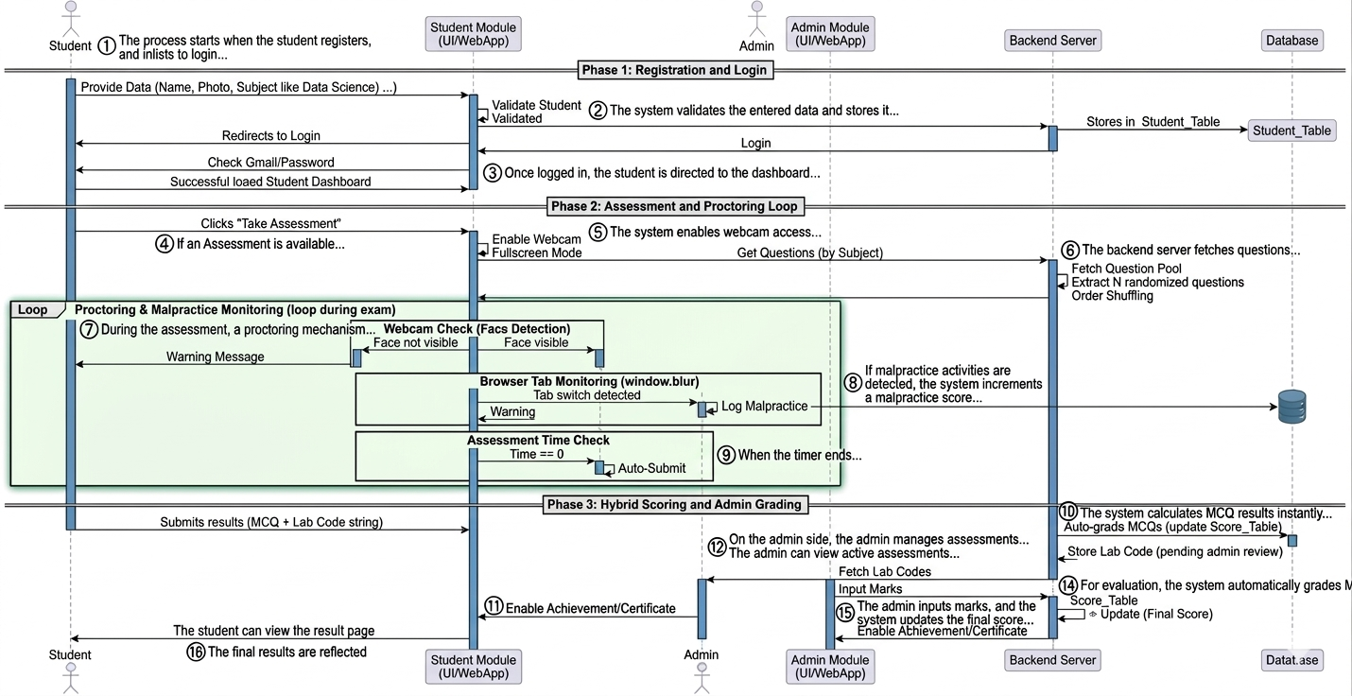

Figure 1 Sequence Diagram

Below is a detailed explanation of the process:

- The process starts when the student registers and logs into the system by providing details such as name, photo, subject, and credentials.
- The system validates the entered data and stores it in the database. After successful validation, the student is redirected to the login page.
- Once logged in, the student is directed to the dashboard, where they can view performance, achievements, and profile details.
- If an Assessment is available for the selected subject, the student clicks on “Take Assessment”.
- The system enables webcam access and Fullscreen mode to ensure proper monitoring during the exam.
- The backend server fetches questions from the database, randomly selects questions, and displays them to the student.
- During the assessment, a proctoring mechanism continuously monitors the student:
- If the face is not visible => a warning is generated if it continues for 10 seconds exam will be terminated.
- If the student switches tabs => malpractice is recorded.
- A timer tracks the exam duration
- If malpractice activities are detected, the system increments a malpractice score and shows warnings.
- When the timer ends or the student submits manually, the system auto-submits the assessment.
- The system calculates MCQ results instantly and stores lab/code answers for further evaluation.

- The student can view the result page, including:
- MCQ score
- Correct and wrong answers
- Unanswered questions
- Certificate (if passed)
- On the admin side, the admin manages assessments by:
- Create questions and sets
- Defining number of questions
- Setting timers and shuffling

- The admin can view active assessments and history, including deleted ones.
- For evaluation, the system automatically grades MCQs, while the admin reviews lab/code submissions.
- The admin inputs marks, and the system updates the final score in the database.
- The final results are reflected in the student dashboard, including performance graphs and achievements.


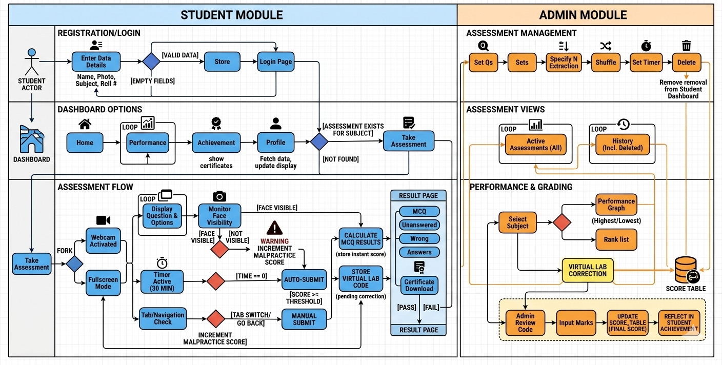
Figure 2 Activity diagram

Below is a detailed explanation of the process:

Student Module Flow:

Start: The process begins when a student registers or logs into the system.

Enter Details: The student enters name, photo, and subject password while registering.

Validate Data: The system checks whether the entered data is valid.

Store Data: If valid, the data is stored and the student is redirected to the Longin page.

Dashboard Access: After login, the student enters the dashboard.

View Options: The student can navigate through Home, Performance, achievement and profile sections.

Checks Assessment: The system checks if an assessment is available for the selected subject.

Take Assessment: if available, the student processes to take the assessment activation.

Assessment Flow (Student Side):

Start Assessment: the assessment begins with full screen mode and webcam activation.

Display Questions: Questions and options are shown one by one.

Face Monitoring: the system continuously monitors face visibility.

Malpractice Detection: If the face is not visible or tab switching occurs, malpractice score increases with waring.

Timer Start: A timer (ex: 30 minutes) start for the test.

Answer Questions: The student answers questions within the given time.

Auto Submit: If time reaches zero, the test is automatically submitted.

Manual Submit: The student can also submit manually before time ends.

Result Calculation: The system calculates MCQ result instantly

Store Lab Code: If applicable, virtual lab code is stored for evaluation.

View Result: The student can see answered, unanswered, and wrong questions.

Certificate: If passed, the student can download the certificate.

End: The student completes the assessment process.

Admin Module Flow:

Start: Admin logs into the system.

Set Questions: Admin create and uploads questions.

Create Sets: Questions are organized into sets.

Specify extraction: Admin defines how many questions to extract.

Shuffle Questions: Questions are randomized for fairness.

Set Timer: time duration for assessment is configured.

Delete Option: admin can remove assessment if needed.

Assessment Management:

View Active Assessment: Admin can see all active assessments.

View History: Admin can also view past or deleted assessments.

Performance and Grading:

Select Subject: Admin, select a subject to analyses performance.

Performance Graph; System shows highest and lowest scores.

Rank List: Student rankings are generated.

Virtual Lab Correction: lab submissions are reviewed.

Admin Review Code: admin checks submitted code.

Input Marks: marks are entered manually required.

Update score table: final scores are updated in the system.

Reflect Achievement: Result are reflected in student dashboard.

End: Admin completes the evaluation process

6 Work done So Far

  - User Registration
The implementation of the user registration feature has been successfully completed. New users can register by providing details such as name, email, phone number, course, password, and profile photo.

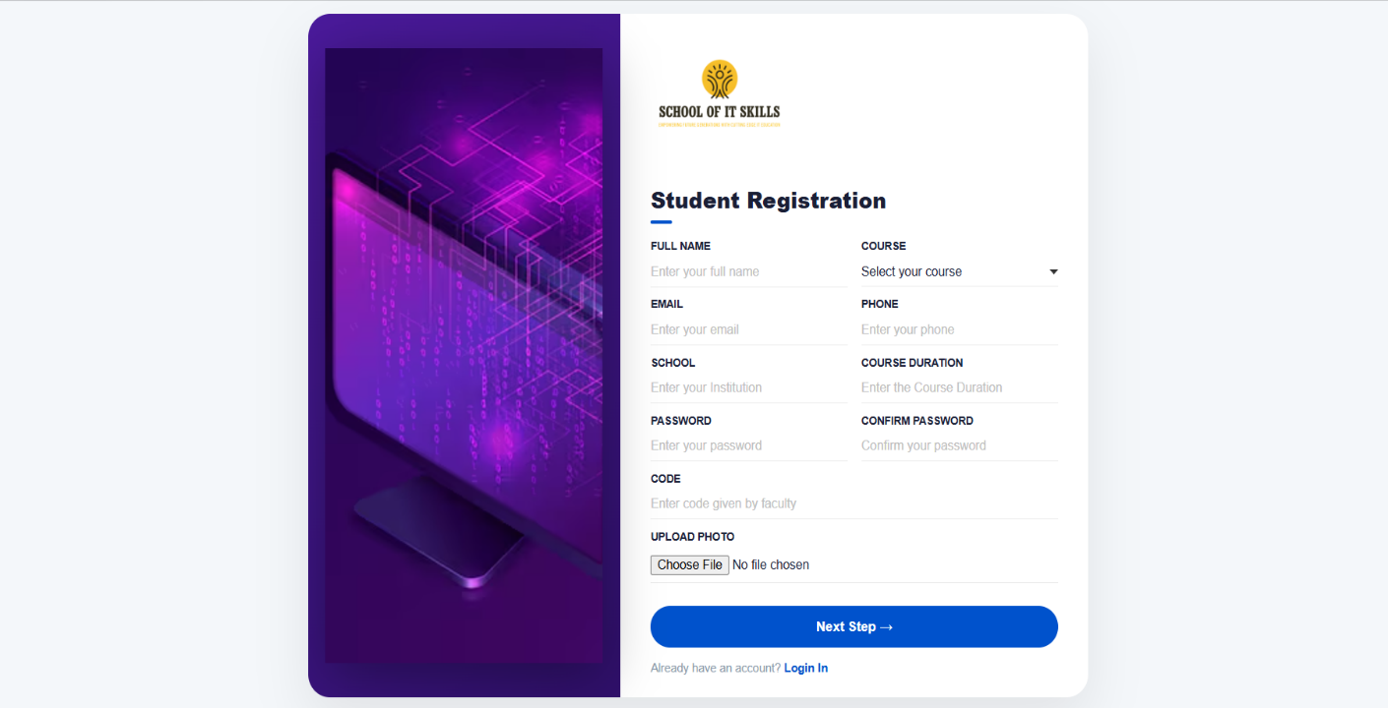

  - User Login:
The login functionality allows registered users to access the system securely using their email and password.

- Users enter credentials
- System verifies with database
- Successful login redirects to dashboard

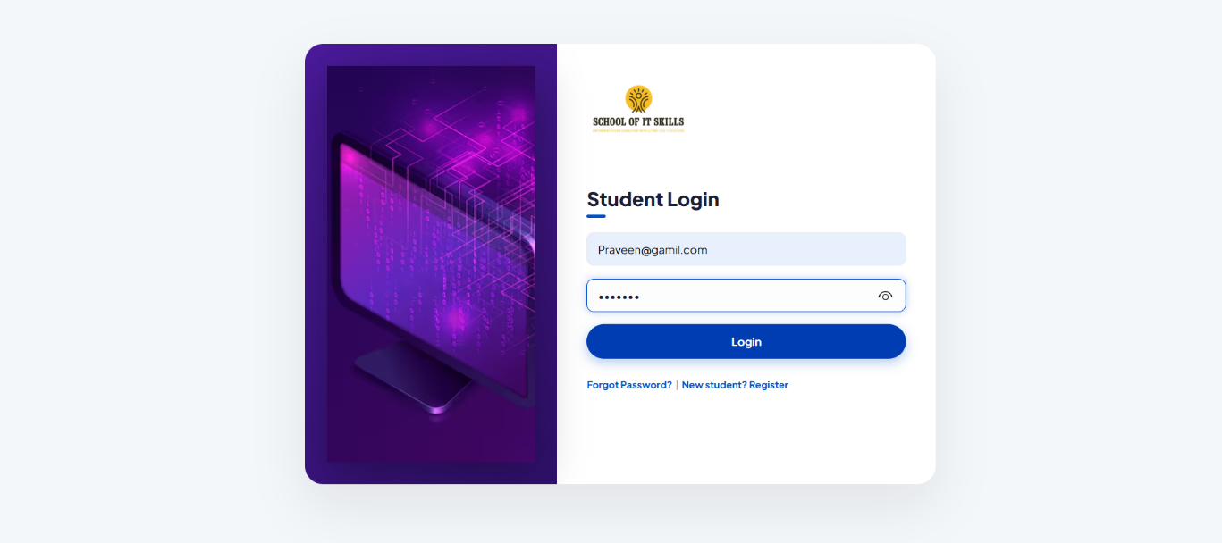

  - Student Dashboard:

The dashboard provides access to assessments, achievements, and performance.
- Displays available assessments
- Shows navigation options
- Provides quick access to features

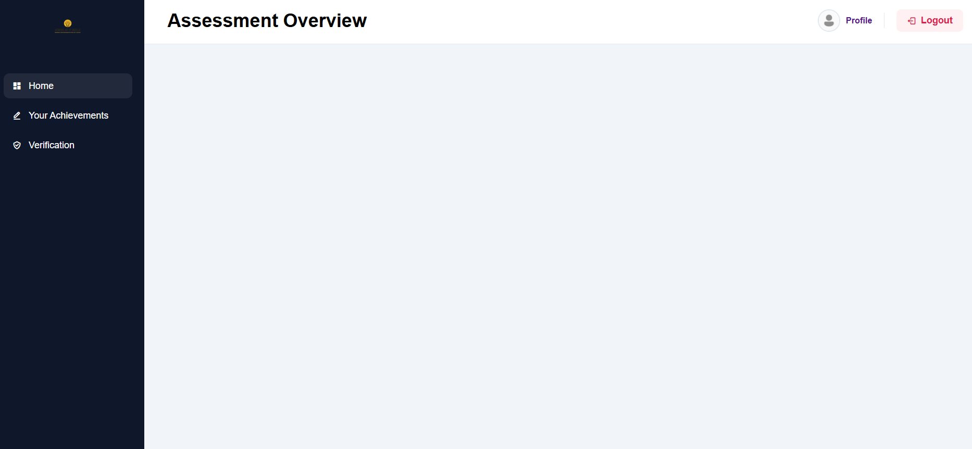
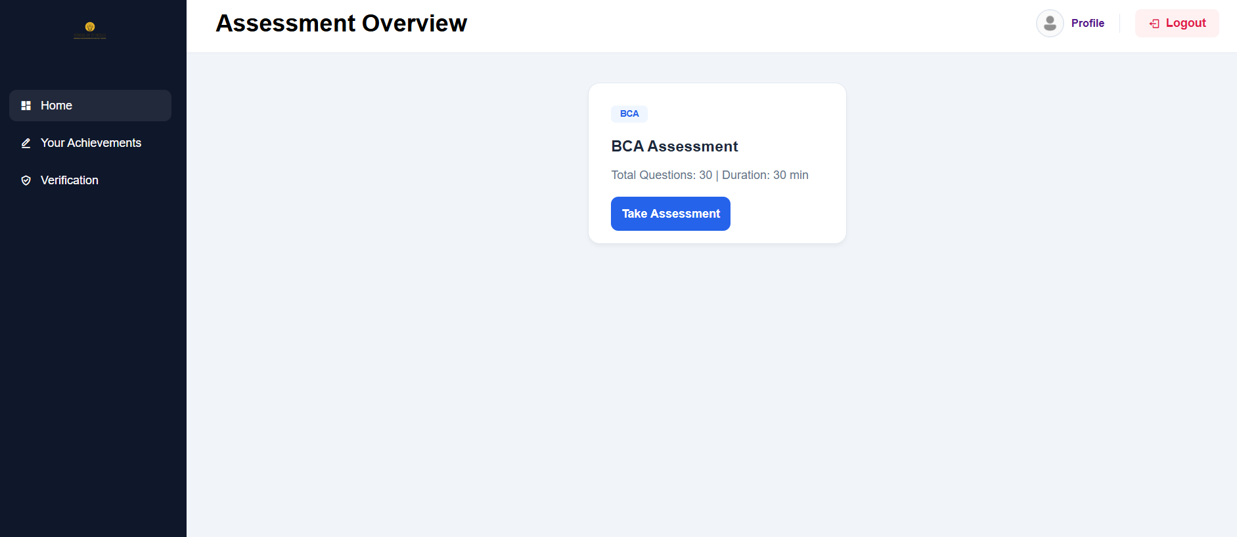
  - Profile:

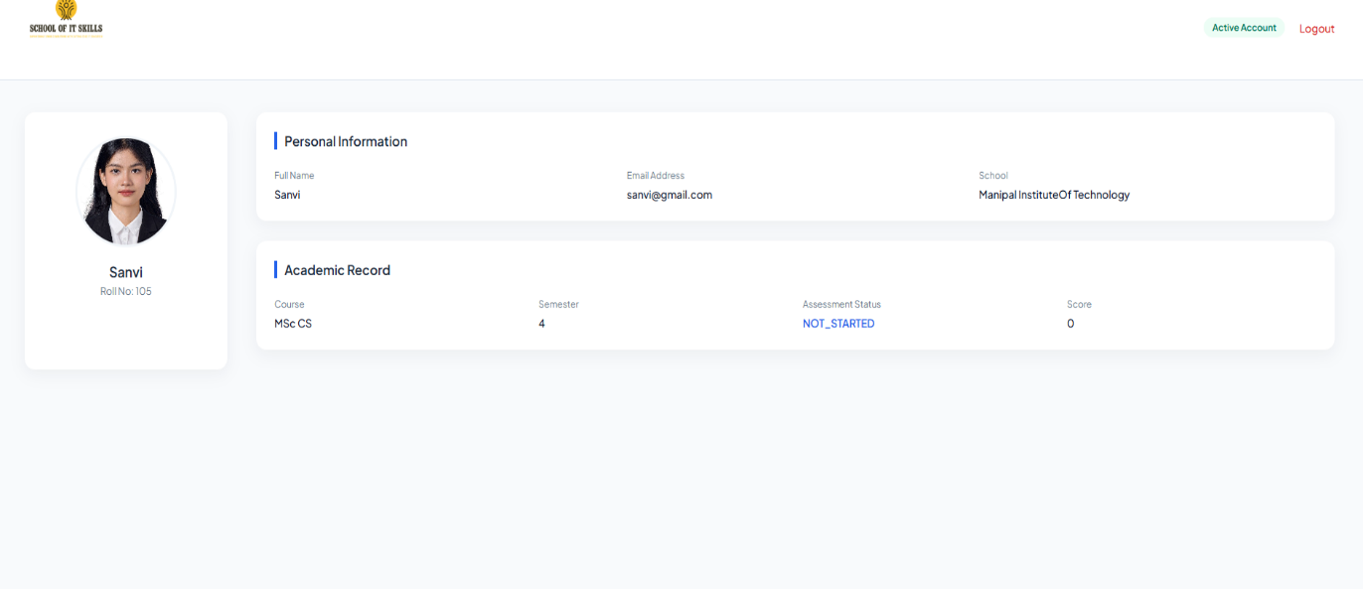

  - Assessment Interface:
The assessment module allows students to attempt exams with multiple-choice questions.
- Questions displayed with options
- Timer is active
- One-time attempt restriction
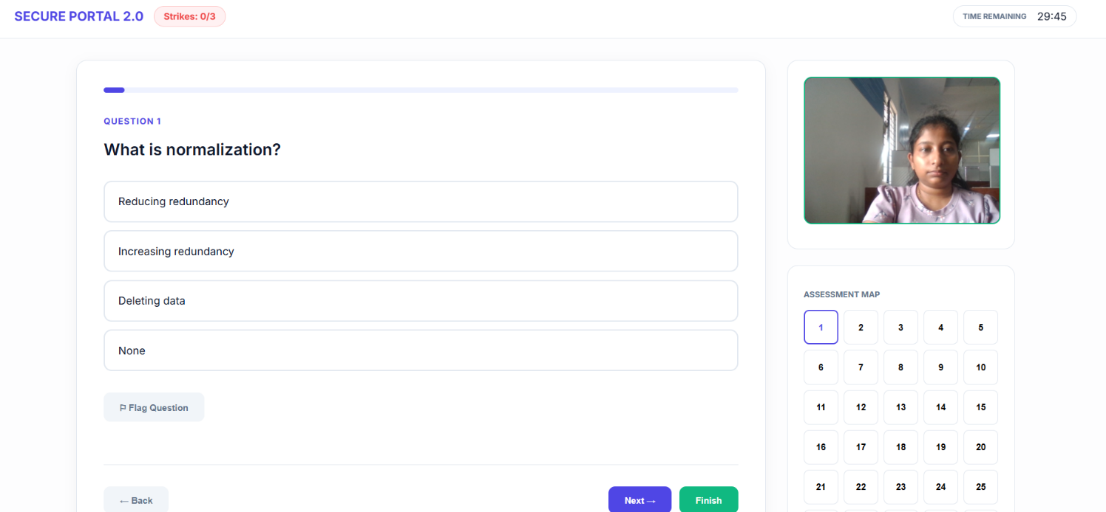
  - Proctoring Features:
Basic proctoring mechanisms are implemented to prevent malpractice.

- Tab switch detection
- Full-screen enforcement
- Auto submission on violation

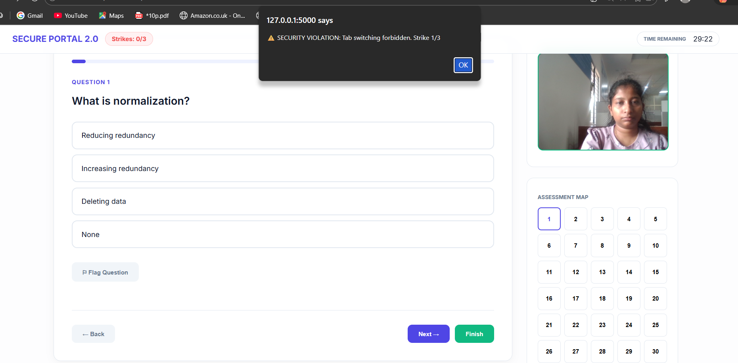

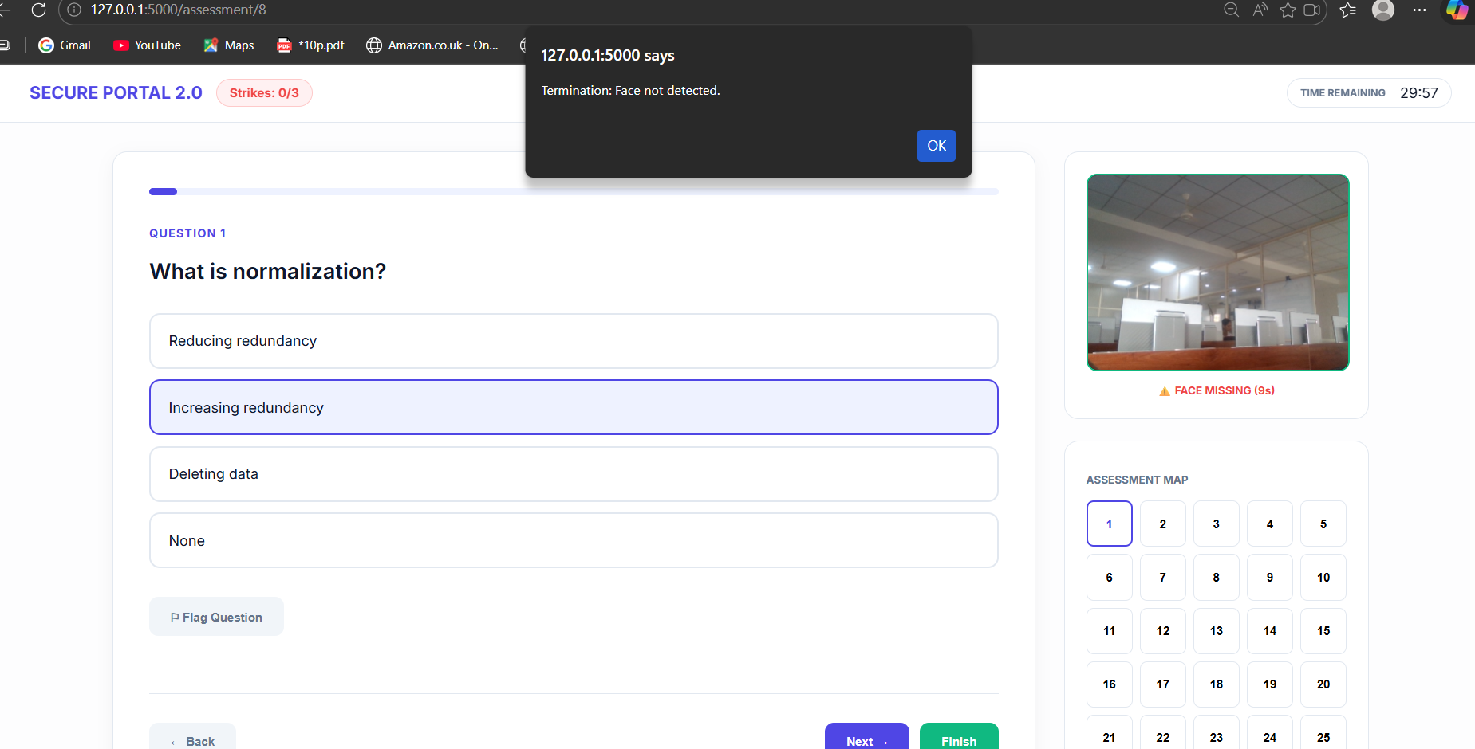

  - Result:
Shows the score with the question and correct answers.

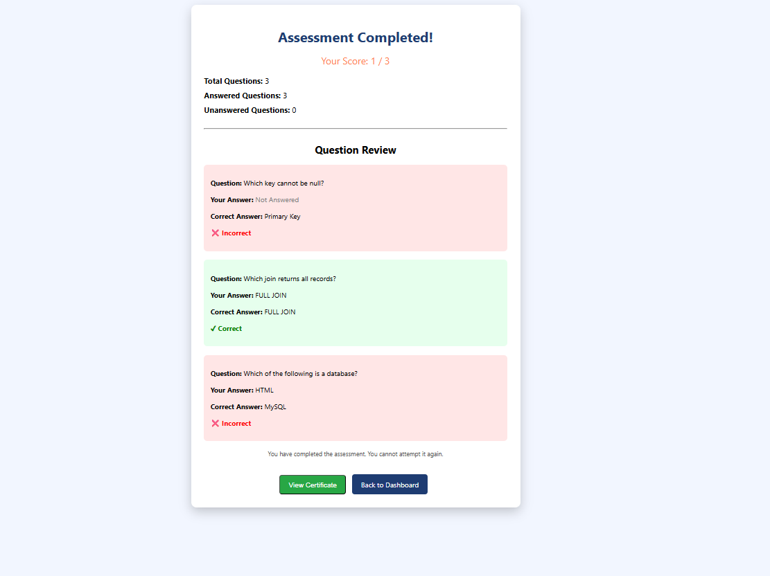

  - Certificate Generation:
The Certificate will be generated if the student score above the threshold
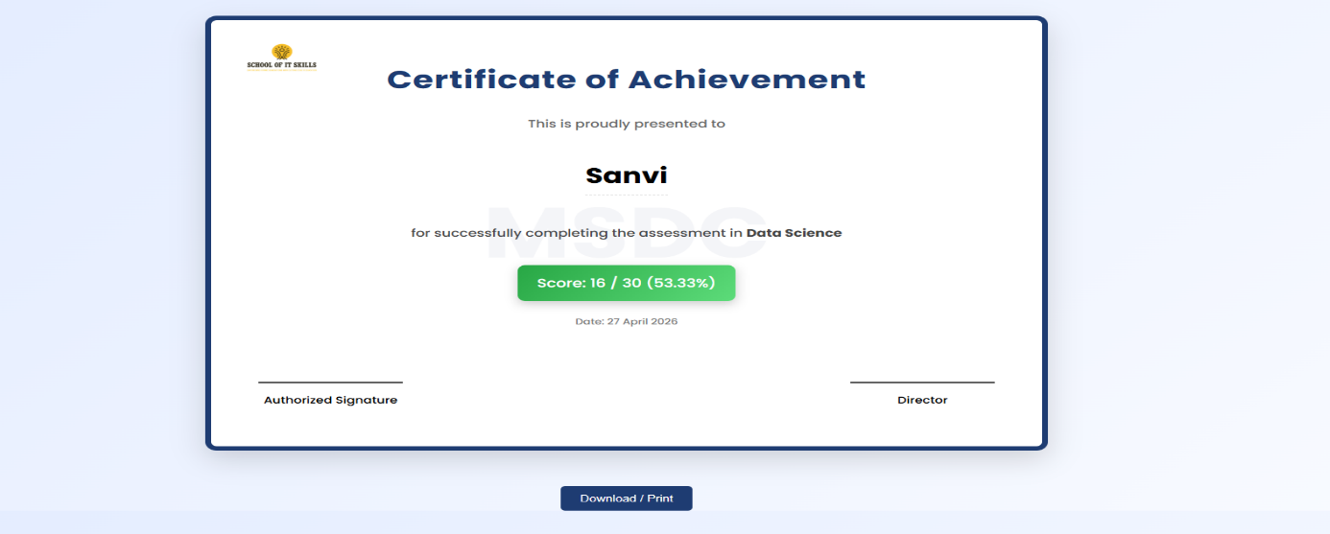

  - Achievement Section:
Shows All The certificates earned by the pertifularestudent.

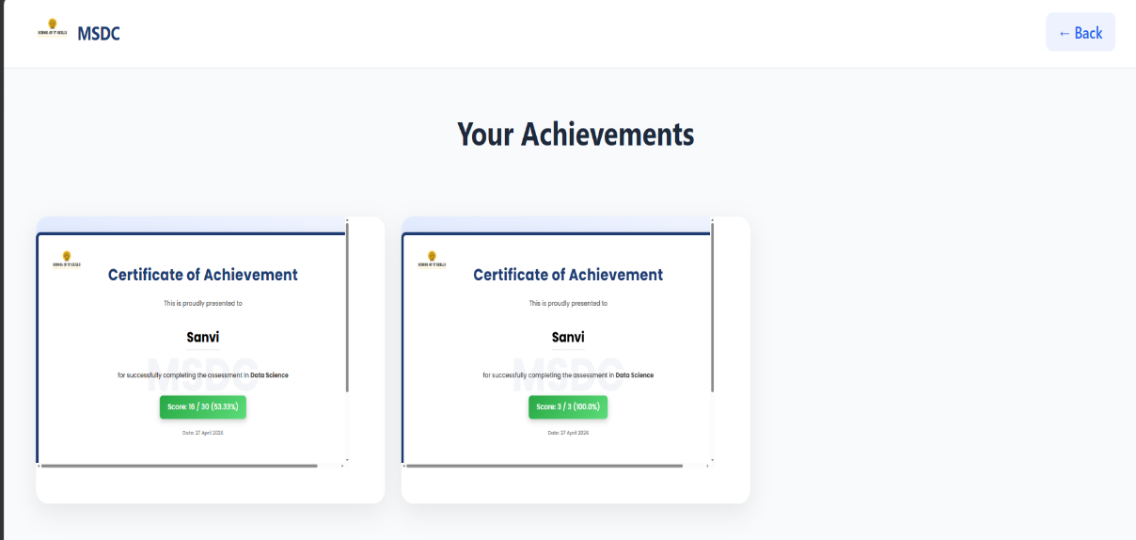

  - Performance:
Used to track the performance of student at the student module.

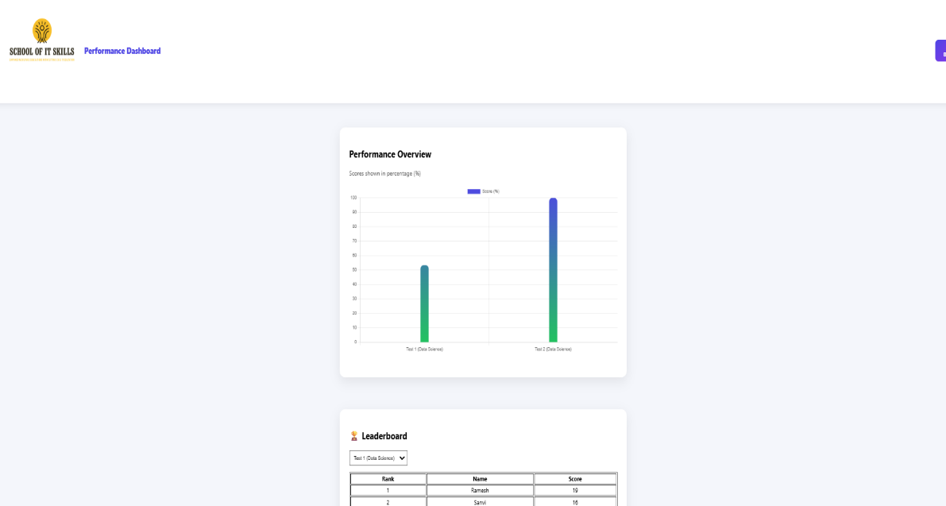

6.11 Admin Login:
Admins can securely log in using their credentials to access the system.

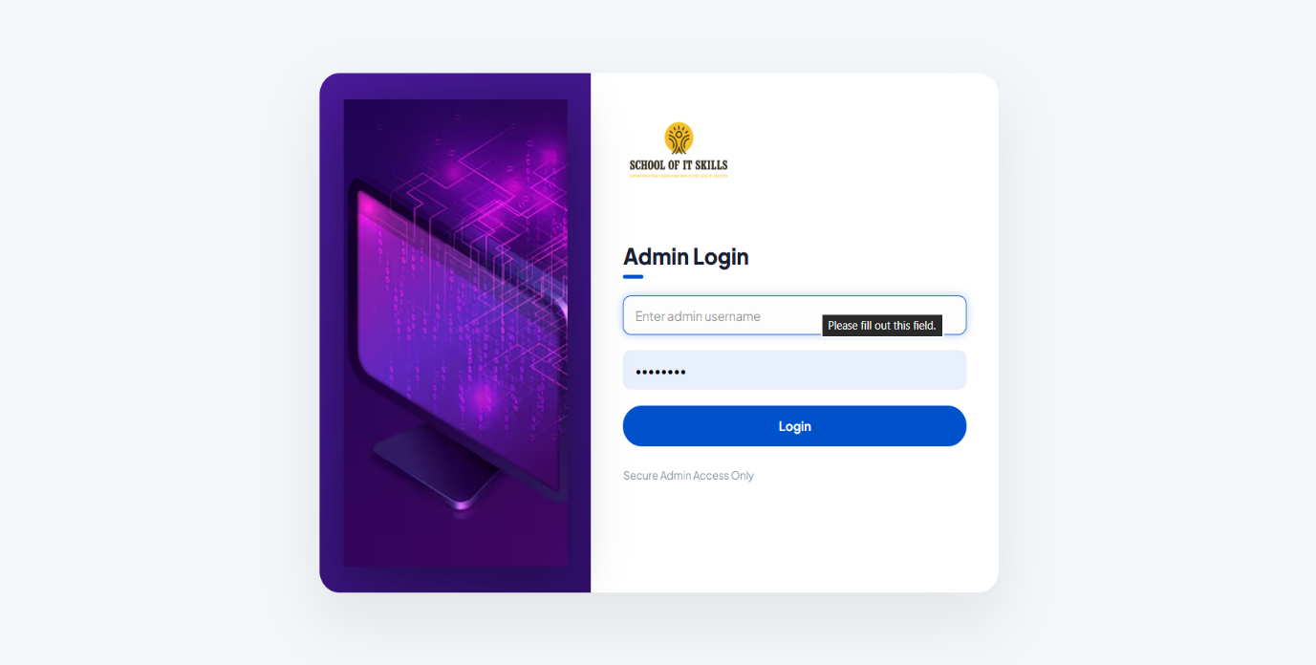
  - Dashboard:
The admin dashboard provides an overview of available assessments and system functionalities.
- Admin Create The assessment
- Set the number of questions, timing, difficulty level, and question paper set.
- Delete The Assessment
- View The Active Assessment
- View All Assessment
- View Student Performance

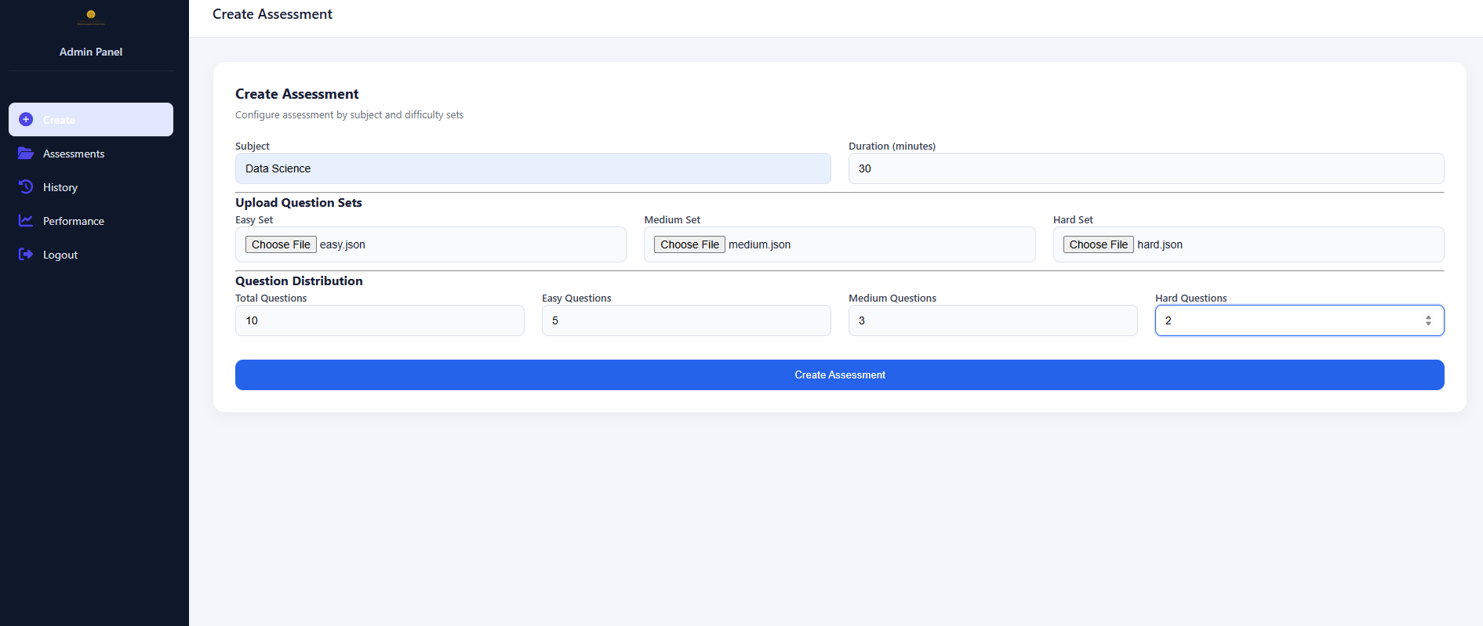

  - View Assessment:
Shows all the available active assessments.

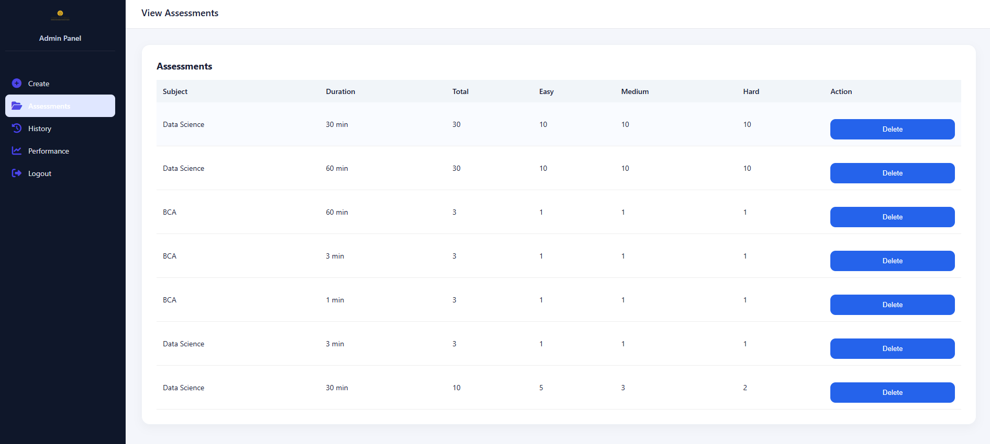

  - History
Shows all the assessment details including deleted.

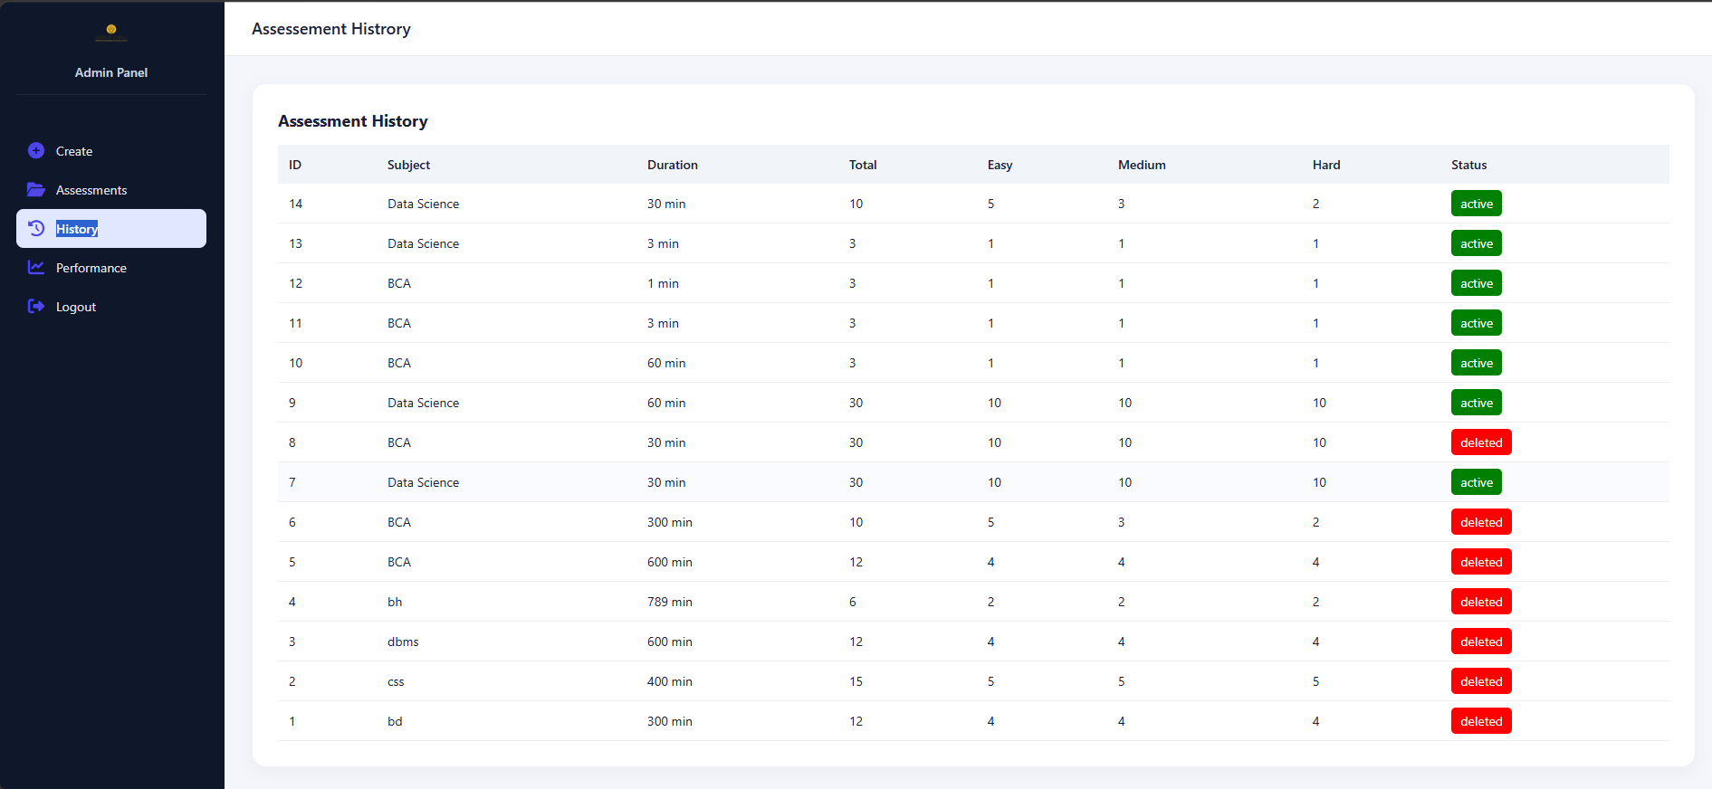

7 Future Work

- UI Enhancements and Optimization:
- Improve the user interface for better usability and more interactive experience
- Optimize system performance to ensure smooth operation across different devices and network condition

- Advanced Proctoring Mechanisms:
- Implement continuous face detection using AI for improved monitoring
- Add eye-tracking and audio monitoring to further reduce malpractice.
- Introduce waring alert before automatic submission

- Performance Analysis and Visualization:
- Develop advance graphic report such as bar charts and progress trends.
- Provided detailed subject-wise and assessment -wise performance insights.
- Introduce waring alert before automatic submission.

- Certificate Generation System:
- Implement automatic certificate generation for students upon successful completion of assessments.
- Allow users to download certificate in PDF format.

- Question Bank Enhancement:
- Expand the question bank into a large variety of questions
- Add support for different question types such as descriptive and coding- based questions

- Security Improvement:
- Implement encryption techniques for secure data storage.
- Add multi-factor authentication (MFA) for enhancement login security.

- Admin Analytics Dashboard:
- Provide detailed analytics for admin to track student performance trends.
- Enable fileting and report generation for better decision-making.

- Integrated Testing and bug fixing:
- perform comprehensive testing to ensure seamless integration of all modules
- Fix existing bugs and improve system reliability.

- User Feedback and Continuous Improvement:
- Collect feedback from users to identify issues and improve features
- Continuously update the system based on user require

References:
[1] “Online Examination System,” GeeksforGeeks, https://www.geeksforgeeks.org/online-examination-system/ (accessed Mar. 27, 2026).
[2] “ Flask Documentation,” Flask Official Documentation, https://flask.palletsprojects.com/ (accessed Mar. 27, 2026).
[3] “MYSQL Tutorial,” MySQL Official Website, https://dev.mysql.com/doc/ (accessed Mar. 27, 2026).
[4] “Chart.js Documentation,” Chart.js, https://www.chartjs.org/docs/latest/ (accessed Mar. 27, 2026).
[5] “Online Proctoring System Overview”, ResearchGate, https://www.researchgate.net/publication/312676827_Automated_Online_Exam_Proctoring (accessed Mar. 27, 2026).
[6] “Random Question Generation in E-Learning,” IJERT, https://www.ijert.org/online-examination-system (accessed Mar. 27, 2026).

