DMML Assignment

MLflow Experiment Tracking with DagsHub Centralized Collaboration

Group Members Name with Student ID:
- Bhooshaan A - 2025cs05032
- Shanmathy S - 2025cs05019
- Sathiya L - 2025cs05023
- Swaminathan M - 2025cs05009

Recording Link: https://drive.google.com/file/d/1o9aU2Y9pKBKLu3LeSSSR1boyFNB9eKAm/view?usp=sharing

Repository Link:
https://github.com/Bhooshaan-2025cs05032/DMML-Assignment

Architecture Diagram:

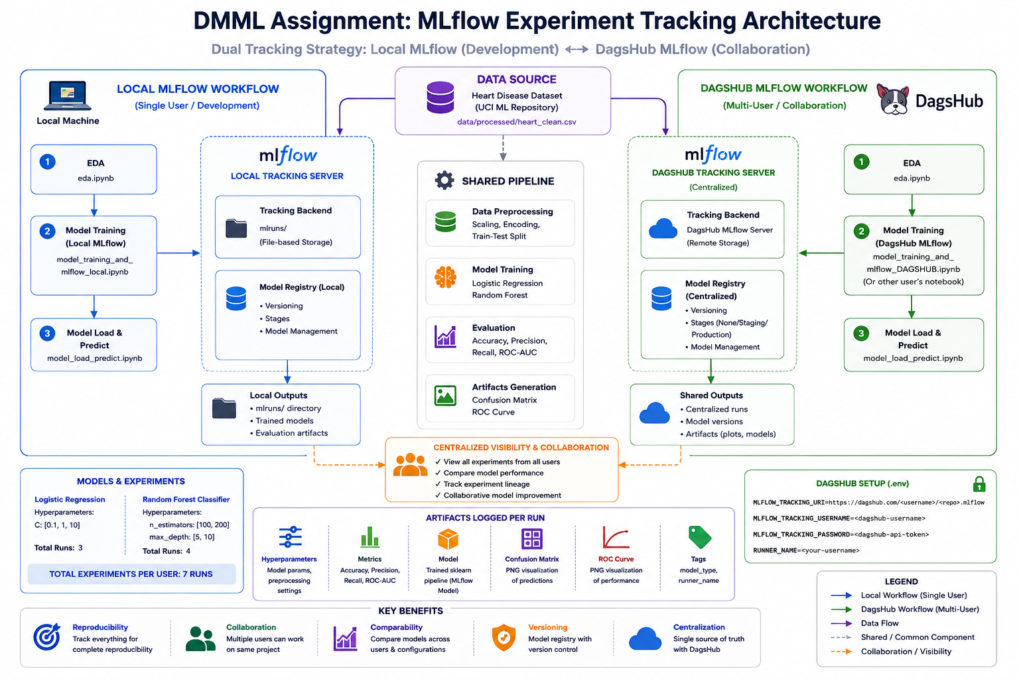
Figure 1: MLflow + DagsHub Experiment Tracking Architecture

1. Project Overview
This assignment demonstrates the implementation of MLflow-based experiment tracking and DagsHub centralized MLflow integration for collaborative machine learning workflows. The project focuses on training and evaluating heart disease prediction models while tracking hyperparameters, metrics, artifacts, and model versions in both local and remote MLflow environments.

2. Objectives
- Implement experiment tracking using MLflow.
- Enable centralized collaboration using DagsHub MLflow.
- Track model parameters, metrics, and artifacts.
- Maintain reproducibility of experiments.
- Register and version trained machine learning models.
- Compare multiple machine learning configurations and performance.

3. Dataset Information
The project uses the Heart Disease dataset obtained from the UCI Machine Learning Repository. The dataset contains patient health attributes such as age, cholesterol, blood pressure, and other medical indicators used to predict the presence or absence of heart disease.
Attribute | Details
Dataset Source | UCI Machine Learning Repository
Problem Type | Binary Classification
Target Variable | Heart Disease Presence
Preprocessing | Scaling, Encoding, Train-Test Split

4. Folder Structure
DMML-Assignment/
│
├── README.md
├── DOCUMENTATION.md
├── notebooks/
│ ├── eda.ipynb
│ ├── model_training_and_mlflow_local.ipynb
│ ├── model_training_and_mlflow_DAGSHUB.ipynb
│ └── model_load_predict.ipynb
├── data/
├── artifacts/
├── models/
├── mlruns/
└── dmmlenv/

5. Workflow Explanation

5.1 Exploratory Data Analysis (EDA)
The EDA notebook performs dataset inspection, feature analysis, missing value handling, and visualization of correlations and feature distributions.
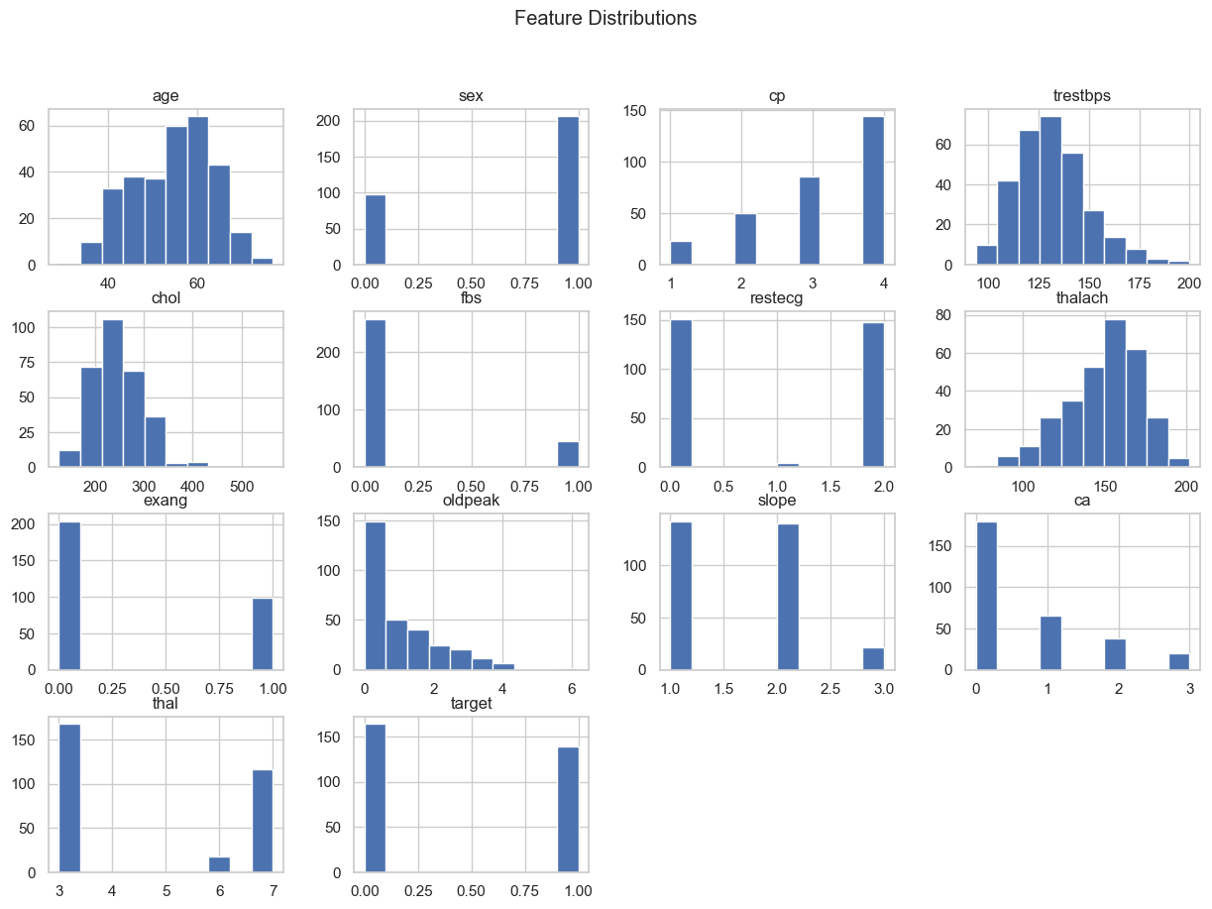
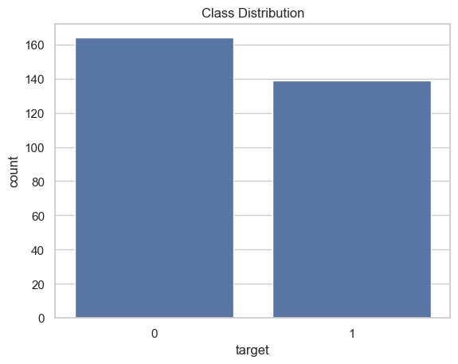
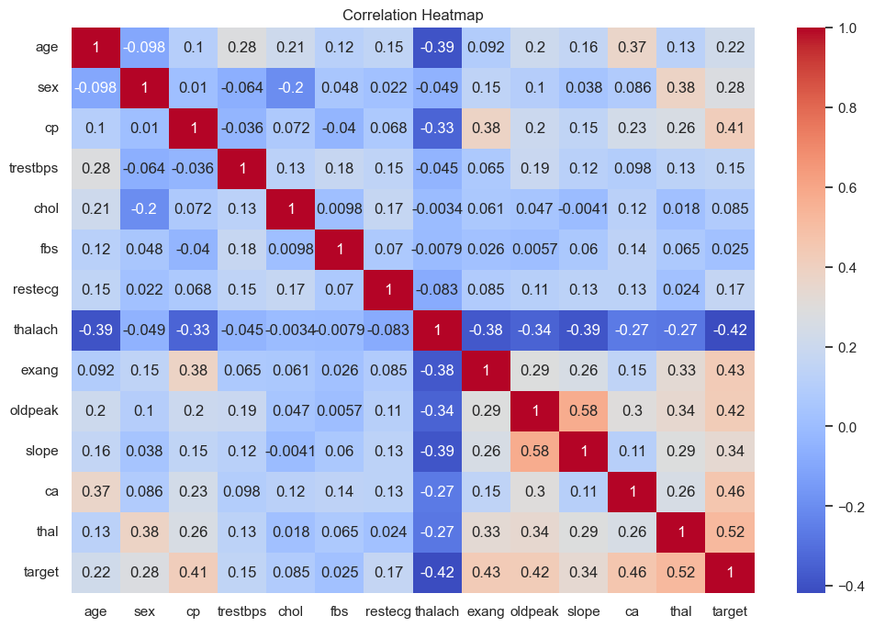

5.2 Local MLflow Tracking
Local MLflow tracking is used during development and debugging. All experiment runs are stored in the local mlruns directory.
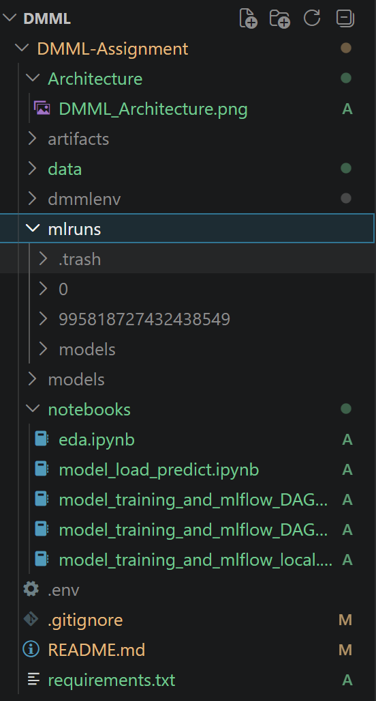
mlruns Folder in Local Directory
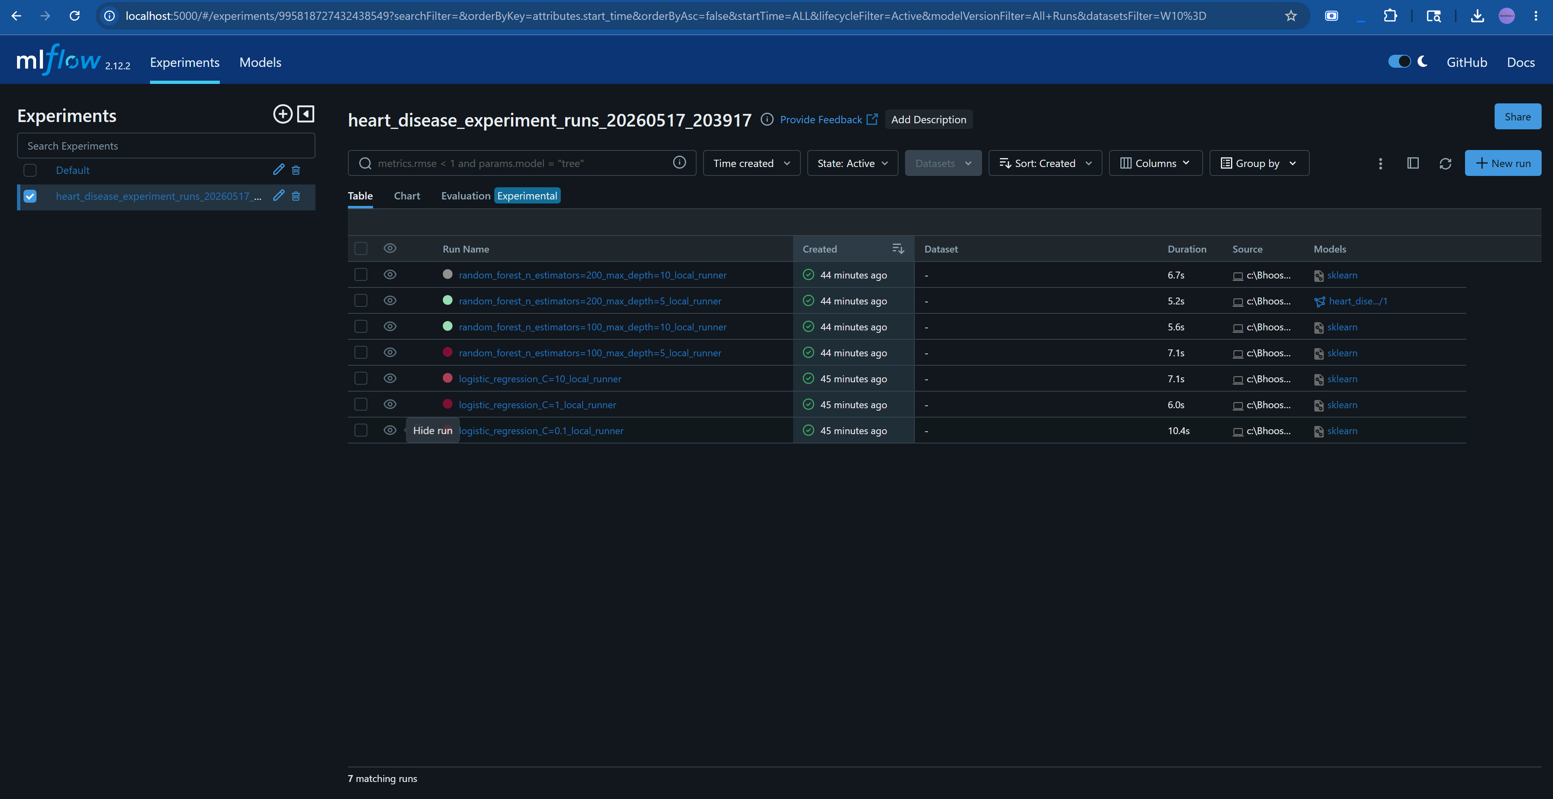
mlflow running on localhost:5000

5.3 DagsHub MLflow Tracking
DagsHub acts as a centralized MLflow tracking server enabling multi-user collaboration. All users can log experiments to a shared backend and compare results.
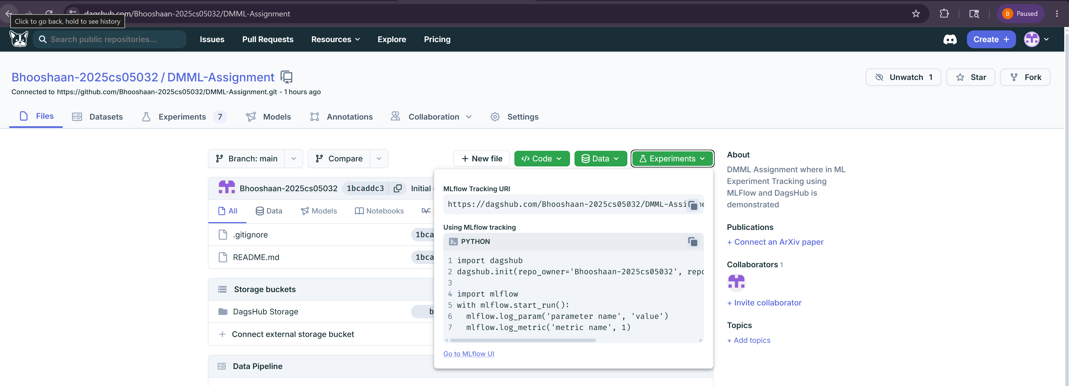
DagsHub Repository Linked to Github Repository with Centralized MLFlow URL

5.4 Model Loading and Prediction
The final trained model can be loaded either from the MLflow Model Registry or from a locally stored pickle file for inference.
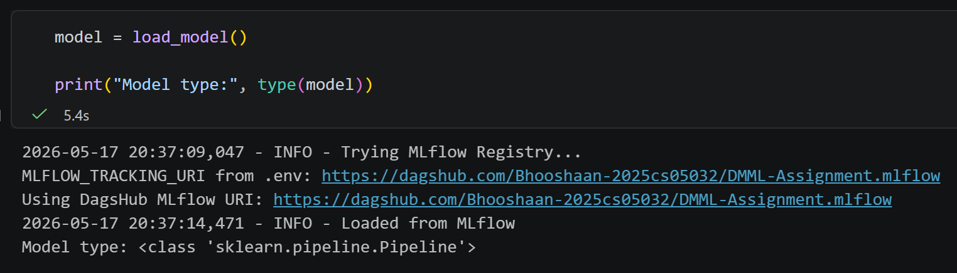
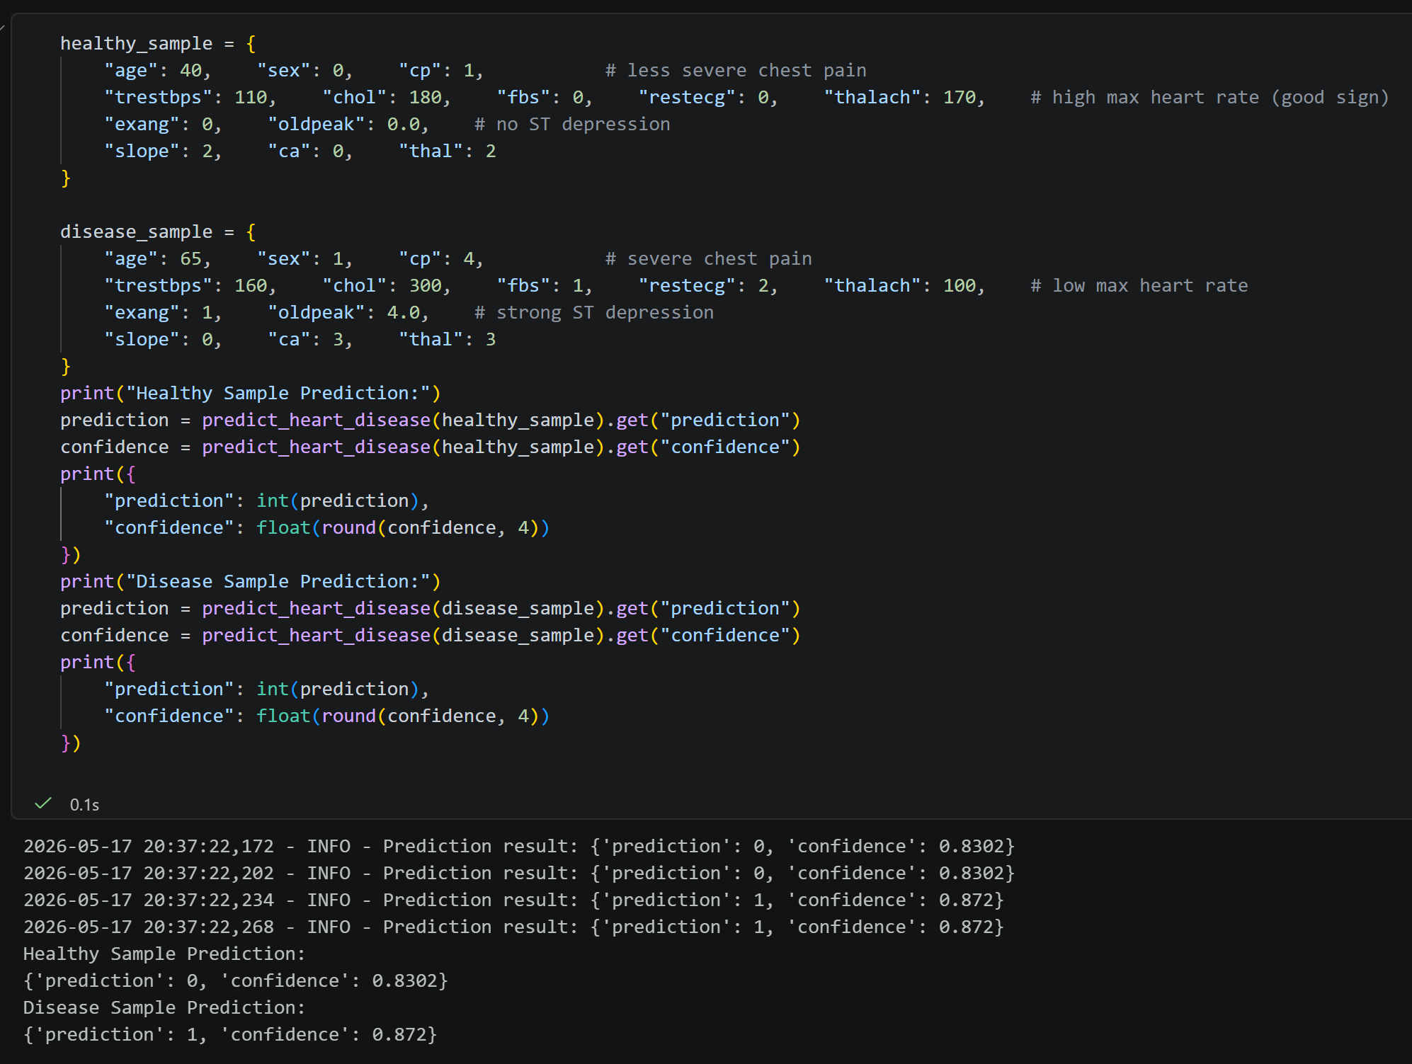

6. Models Evaluated
Model | Hyperparameters | Total Runs
Logistic Regression | C = [0.1, 1, 10] | 3
Random Forest | n_estimators=[100,200], max_depth=[5,10] | 4

7. Experiment Tracking Components
- Hyperparameters: Model configuration values.
- Metrics: Accuracy, Precision, Recall, ROC-AUC.
- Artifacts: Confusion Matrix, ROC Curve, Trained Models.
- Tags: Runner Name and Model Type.
- Model Registry: Version control and deployment readiness.

8. DagsHub Integration
DagsHub provides a centralized MLflow tracking backend that enables collaboration between multiple users. Using DagsHub integration, experiments, metrics, artifacts, and model versions are accessible through a common dashboard.
DagsHub URL: https://dagshub.com/Bhooshaan-2025cs05032/DMML-Assignment.mlflow
MLFLOW_TRACKING_URI=https://dagshub.com/<username>/<repo>.mlflow
MLFLOW_TRACKING_USERNAME=<username>
MLFLOW_TRACKING_PASSWORD=<api-token>
RUNNER_NAME=<your-name>

9. Technology Stack
Library | Version | Purpose
pandas | 2.2.3 | Data Analysis
numpy | 1.26.4 | Numerical Computing
scikit-learn | 1.5.2 | Machine Learning
mlflow | 2.12.2 | Experiment Tracking
matplotlib | 3.10.3 | Visualization
python-dotenv | 1.0.1 | Environment Variables

10. Key Features Demonstrated
- Hyperparameter Optimization
- Experiment Reproducibility
- Model Registry and Versioning
- Artifact Management
- Collaborative Experiment Tracking
- Evaluation Metric Logging
- Centralized Visibility using DagsHub

11. Learning Outcomes
- Understanding MLflow experiment tracking.
- Working with centralized MLflow backends.
- Logging metrics, artifacts, and parameters.
- Collaborative machine learning workflows.
- Managing model versions using MLflow Registry.

12. Conclusion
This project successfully demonstrates a complete experiment tracking workflow using MLflow and DagsHub. The implementation highlights best practices for reproducible machine learning experimentation, centralized collaboration, model versioning, and artifact management.

