**DBMS PROJECT SEM3**

* TABLES REQUIRED:

1. Customers: cols-> customer id(primary key), name, address, contact details, email
2. Meters: cols-> meter id(primary key),customer id(foreign key),update last reading date, meter type
3. Readings: cols->reading id(primary key), meter id(foreign key), reading date, reading value
4. Billing: cols-> billing id(primary key), customer id(foreign key), meter id(foreign key), total amount, due date, payment status
5. Payment Transactions: cols-> transaction id(primary key), bill id(foreign key), transaction date, amount paid, payment method

* Trigger: *(usage->to automatically calculate and update relevant data upon certain events)* to calculate the total amount in bills in billing table when a new bill is generated based on meter readings.
* Cursor: *(usage-> to retrieve and manipulate data in database)* to be used in procedure and trigger to process data by row to row
* Procedure: *(usage-> to perform specific task)* to record meter readings
* Transaction: (usage->to ensure data consistency and integrity and implementing error handling)
* DIAGRAM REPRESENTATION:

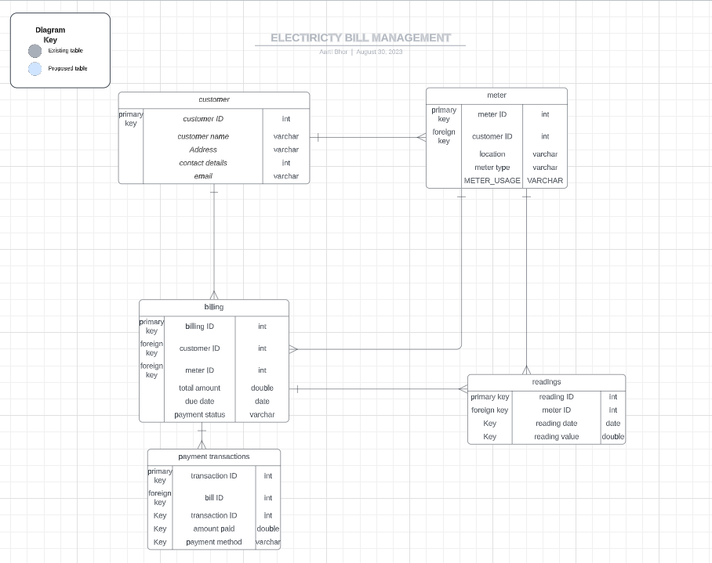

PL/SQL CODE:

|  |
| --- |
| -- Customer:  CREATE TABLE customer(customer_id number(10) primary key, customer_name varchar(50), address varchar2(70),contact_no number(10) unique, email_id varchar2(20) );  INSERT INTO customer values(1000000000,’Gopal Maharishi’, ‘Kripa Nagar Vile Parle’,9110010010,’gopal@gmail.com’ );  INSERT INTO customer values(1000000001,’Tushar More’, ‘Ram Nagar Andheri’,9110018810,’tushar@gmail.com’ );  INSERT INTO customer values(1000000002,’Vijay Singh’, ‘Junaid Nagar Jogeshwari’,9110910910,’vijay@gmail.com’ );  INSERT INTO customer values(1000000003,’Mansi Singh’, ‘Kailash Nagar Jogeshwari’,9910910910,’mansi@gmail.com’ );  INSERT INTO customer values(1000000004,’Beenu Patel’, ‘Paradise Bul Bandra’,9918910910,’beenu@gmail.com’ );  INSERT INTO customer values(1000000005,’Suresh Manik’, ‘Manik Bul Vile Parle’,9910918910,’suresh@gmail.com’ );  INSERT INTO customer values(1000000006,’Ali Shaikh’, ‘Golden Bul Bandra’,8854610910,’ali@gmail.com’ );  INSERT INTO customer values(1000000007,’Shivani Gavale’, ‘Punik Nagar Jogeshwari’,9934910910,’shivani@gmail.com’ );  INSERT INTO customer values(1000000008,’Mohan Dave’, ‘Hanuman Nagar Santacruz’,9110910777,’mohan@gmail.com’ );  INSERT INTO customer values(1000000009,’Kishan Panth’, ‘Kishor Nagar Khar Road’,9122210910,’kishan@gmail.com’ );  INSERT INTO customer values(1000000010,’Manik Chand’, ‘Vishwa Nagar Andheri’,9112010910,’manik@gmail.com’ );  SELECT * FROM customer; |

OUTPUT:

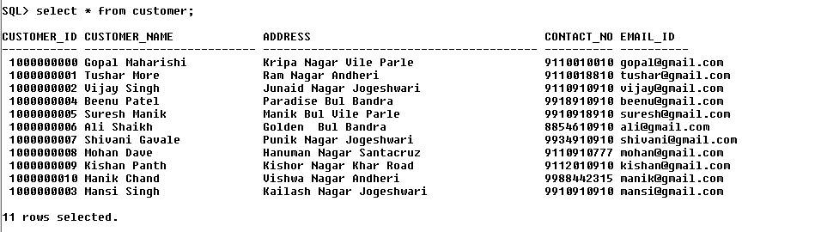

|  |
| --- |
| --Meter:  CREATE TABLE meter(meter_id number primary key, customer_id number(10) ,update_last_reading_date date, meter_type varchar(50),foreign key (customer_id) references customer(customer_id));  INSERT INTO meter values(1001, 1000000000, to_date(’17-Aug-23’,’DD-MON-YY’),’smart meter’);  INSERT INTO meter values(1002, 1000000001, to_date(’20-Aug-23’,’DD-MON-YY’),’single-phase meter’);  INSERT INTO meter values(1003, 1000000002, to_date(’10-Aug-23’,’DD-MON-YY’),’three-phase meter’);  INSERT INTO meter values(1004, 1000000003, to_date(’29-Aug-23’,’DD-MON-YY’),’single-phase meter’);  INSERT INTO meter values(1005, 1000000004, to_date(’29-Aug-23’,’DD-MON-YY’),’three-phase meter’);  INSERT INTO meter values(1006, 1000000005, to_date(’27-Aug-23’,’DD-MON-YY’),’smart-phase meter’);  INSERT INTO meter values(1007, 1000000006, to_date(’28-Aug-23’,’DD-MON-YY’),’single-phase meter’);  INSERT INTO meter values(1008, 1000000007, to_date(’27-Aug-23’,’DD-MON-YY’),’single-phase meter’);  INSERT INTO meter values(1009, 1000000008, to_date(’29-Aug-23’,’DD-MON-YY’),’three-phase meter’);  INSERT INTO meter values(1010, 1000000009, to_date(’30 -Aug-23’,’DD-MON-YY’),’smart-phase meter’);  INSERT INTO meter values(1011, 1000000010, to_date(’29-Aug-23’,’DD-MON-YY’),’single-phase meter’);  SELECT * FROM meter; |

OUTPUT:

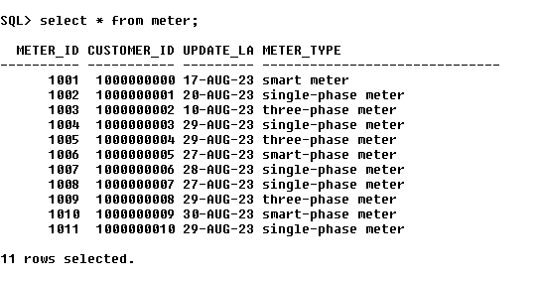

|  |
| --- |
| --Readings:  CREATE TABLE readings (reading_id number primary key, meter_id number, reading_date date, reading_value_Kwh decimal(10, 2),foreign key (meter_id) references meter(meter_id));  INSERT INTO readings values( 998, 1001,to_date(’17-Aug-23’,’DD-MON-YY’),390);  INSERT INTO readings values( 978, 1002,to_date(’20-Aug-23’,’DD-MON-YY’),650);  INSERT INTO readings values( 968, 1003,to_date(’10-Aug-23’,’DD-MON-YY’),250);  INSERT INTO readings values( 958, 1004,to_date(’29-Aug-23’,’DD-MON-YY’),782);  INSERT INTO readings values( 948, 1005,to_date(’29-Aug-23’,’DD-MON-YY’),910);  INSERT INTO readings values( 938, 1006,to_date(’27-Aug-23’,’DD-MON-YY’),287);  INSERT INTO readings values( 928, 1007,to_date(’28-Aug-23’,’DD-MON-YY’),394);  INSERT INTO readings values( 918, 1008,to_date(’27-Aug-23’,’DD-MON-YY’),913);  INSERT INTO readings values( 920, 1009,to_date(’29-Aug-23’,’DD-MON-YY’),729);  INSERT INTO readings values( 921, 1010,to_date(’30 -Aug-23’,’DD-MON-YY’),1109);  INSERT INTO readings values( 922, 1011,to_date(’29-Aug-23’,’DD-MON-YY’),478);  SELECT * FROM readings; |

OUTPUT:

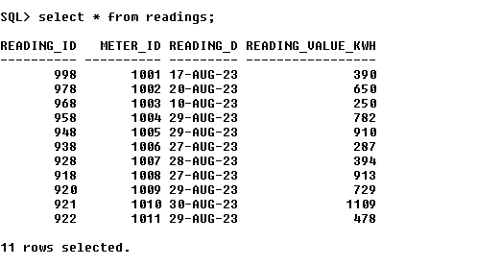

|  |
| --- |
| --Billling:  CREATE TABLE billing(bill_id number primary key,  customer_id number(10),  meter_id number,  total_amount decimal(10,2),  due_date date,  payment_status varchar (20) ,  foreign key (meter_id)references meter(meter_id));  INSERT INTO billing values(412, 1000000000, 1001,54,to_date(‘9-Sep-23’,’DD-MON-YY’),’Pending’);  INSERT INTO billing values(413, 1000000001, 1002 ,1262,to_date(‘9-Sep-23’,’DD-MON-YY’),’Paid’);  INSERT INTO billing values(414, 1000000002, 1003,1072,to_date(‘9-Sep-23’,’DD-MON-YY’),’Paid’);  INSERT INTO billing values(411, 1000000003, 1004,1200,to_date(‘9-Sep-23’,’DD-MON-YY’),’Pending’);  INSERT INTO billing values(415, 1000000004, 1005,1530,to_date(‘9-Sep-23’,’DD-MON-YY’),’Pending’);  INSERT INTO billing values(416, 1000000005, 1006, 1897,to_date(‘9-Sep-23’,’DD-MON-YY’),’Pending’);  INSERT INTO billing values(417, 1000000006, 1007,1076,to_date(‘9-Sep-23’,’DD-MON-YY’),’Paid’);  INSERT INTO billing values(418, 1000000007, 1008,1457,to_date(‘9-Sep-23’,’DD-MON-YY’),’Pending’);  INSERT INTO billing values(419, 1000000008, 1009,1564,to_date(‘9-Sep-23’,’DD-MON-YY’),’Paid’);  INSERT INTO billing values(420, 1000000009, 1010 ,1347,to_date(‘9-Sep-23’,’DD-MON-YY’),’Pending’);  INSERT INTO billing values(421, 1000000010, 1011,1678,to_date(‘9-Sep-23’,’DD-MON-YY’),’Pending’);  SELECT * FROM billing; |

OUTPUT:

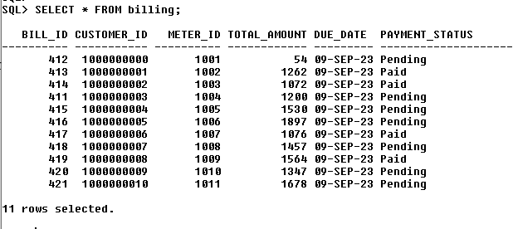

|  |
| --- |
| --Payment transactions:  CREATE TABLE payment_trans(transaction_id varchar2(50) ,  bill_id number ,  transaction_date date,  amount_paid decimal(10,2),  payment_method varchar(20),  foreign key (bill_id) references billing(bill_id));  INSERT INTO payment_trans values(‘ATM-CASH/NEAR NATIONAL HAND/MUMBAI/010219’, 412,to_date(‘01-Jul-23’,’DD-MON-YY’),3000,’credit card’ );  INSERT INTO payment_trans values(‘null’, 413,null,null,’null’ );  INSERT INTO payment_trans values(‘ATM-CASH/NEAR NATIONAL HAND/MUMBAI/010200’, 414, to_date(‘03-Jul-23’,’DD-MON-YY’),1078,’credit card’ );  INSERT INTO payment_trans values(‘null’, 411,null,null,’null’ );  INSERT INTO payment_trans values(‘null’, 415,null,null,’null’ );  INSERT INTO payment_trans values(‘NEFT/BANK OF INDIA/MUMBAI/011780’, 416, to_date(‘03-Jul-23’,’DD-MON-YY’),1500,’cheque’ );  INSERT INTO payment_trans values(‘NEFT/BANK OF MAHA/MUMBAI/011920’, 417, to_date(‘02-Jul-23’,’DD-MON-YY’),1570,’cheque’ );  INSERT INTO payment_trans values(‘null’, 418,null,null,’null’ );  INSERT INTO payment_trans values(‘NEFT/BANK OF BOR/MUMBAI/019980’, 419, to_date(‘03-Jul-23’,’DD-MON-YY’),1250,’cheque’ );  INSERT INTO payment_trans values(‘null’, 420,null,null,’null’ );  INSERT INTO payment_trans values(‘NEFT/BANK OF MAHA/MUMBAI/019980’, 421, to_date(‘05-Jul-23’,’DD-MON-YY’),1670,’cheque’ );  SELECT * FROM payment_trans; |

OUTPUT:

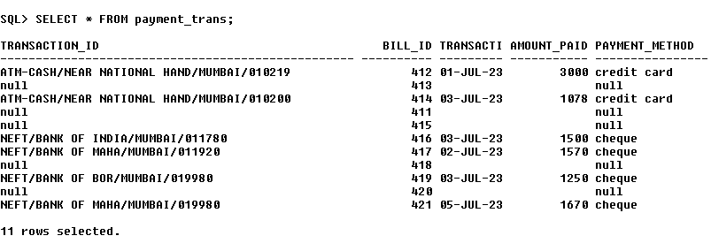

|  |
| --- |
| --FUNCTION🡪on entering meter_id and reading_value the total_amount of billing table will be updated. |
| --FUNCTION: TO CALCULATE BILL AMOUNT  CREATE OR REPLACE FUNCTION calculate_bill_amount(p_bill_id IN NUMBER, p_reading_value IN DECIMAL)  RETURN DECIMAL  AS  v_total_amount DECIMAL;  BEGIN  v_total_amount :=p_reading_value * 1.60;  RETURN v_total_amount;  END;  / |
| --CALLING OF FUNCTION:  DECLARE  v_bill_id NUMBER := &v_bill_id;  v_reading_value DECIMAL := &v_reading_value;  v_bill_amount DECIMAL(10,2);  BEGIN  --calling of function  v_bill_amount := calculate_bill_amount(v_bill_id, v_reading_value);  --updating the total_amount in the billing table for the specified bill_id  UPDATE billing  SET total_amount =v_bill_amount  WHERE bill_id=v_bill_id;  COMMIT;    END;  / |

OUTPUT:

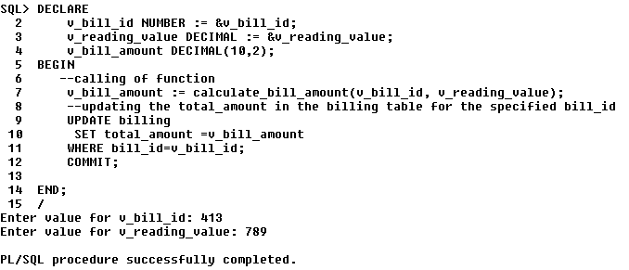

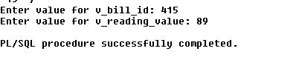

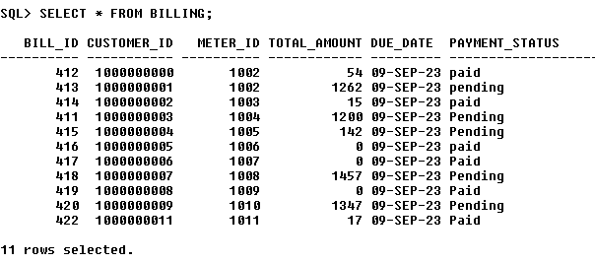

|  |
| --- |
| --TRIGGER🡪 SUCH THAT WHENEVER UPDATING TRANSACTION_ID OF PAYMENT_TRANS TABLE THE PAYMENT_STATUS= PAID AND THE TOTAL AMOUNT=0 OF BILLING TABLE |
| --TRIGGER:  CREATE OR REPLACE TRIGGER update_payment_status  AFTER INSERT OR UPDATE ON payment_trans  FOR EACH ROW  DECLARE  v_total_amount billing.total_amount%TYPE;  BEGIN  SELECT total_amount INTO v_total_amount  FROM billing  WHERE bill_id = :new.bill_id;  IF :new.amount_paid >= v_total_amount THEN  UPDATE billing  SET payment_status = 'Paid'  WHERE bill_id = :new.bill_id;  END IF;  END;  / |

OUTPUT:

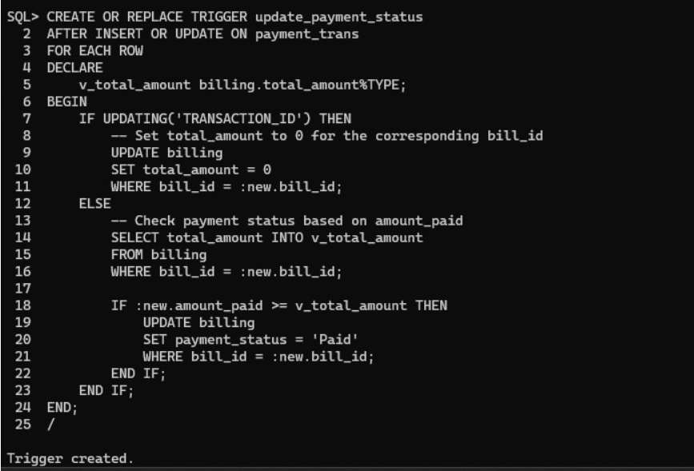



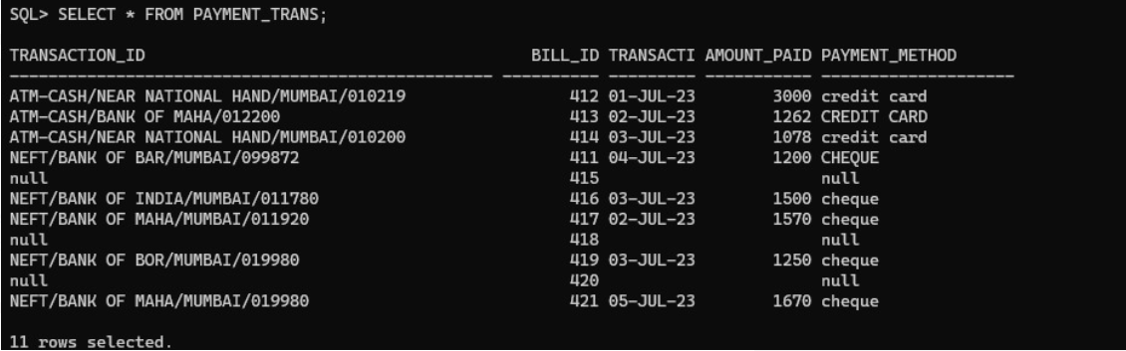

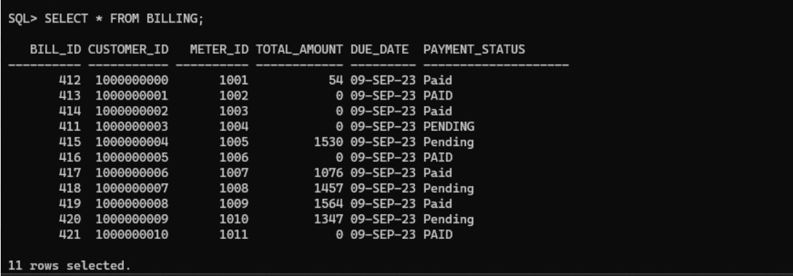

|  |
| --- |
| --PROCEDURE🡪 display bill based on customer_name |
| --PROCEDURE  -- Create a procedure to display bill based on customer name  CREATE OR REPLACE PROCEDURE display_bill_by_customer_name(p_customer_name IN VARCHAR2)  IS  v_customer_id NUMBER;  v_meter_id NUMBER;  v_total_amount NUMBER ;  v_due_date DATE;  v_payment_status VARCHAR2(20);  BEGIN  -- Get the customer ID  SELECT customer_id INTO v_customer_id  FROM customer  WHERE customer_name = p_customer_name;  -- Get billing information  SELECT meter_id, total_amount, due_date, payment_status  INTO v_meter_id, v_total_amount, v_due_date, v_payment_status  FROM billing  WHERE customer_id = v_customer_id;  -- Display the bill information  DBMS_OUTPUT.PUT_LINE('Customer: ' || p_customer_name);  DBMS_OUTPUT.PUT_LINE('Meter ID: ' || v_meter_id);  DBMS_OUTPUT.PUT_LINE('Total Amount: ' || v_total_amount);  DBMS_OUTPUT.PUT_LINE('Due Date: ' || TO_CHAR(v_due_date, 'DD-MON-YY'));  DBMS_OUTPUT.PUT_LINE('Payment Status: ' || v_payment_status);  END;  / |
| --CALLING OF FUNCTION  DECLARE  -- Call the procedure to display bill for a specific customer  BEGIN  display_bill_by_customer_name(’Tushar More’);  END;  / |

OUTPUT:

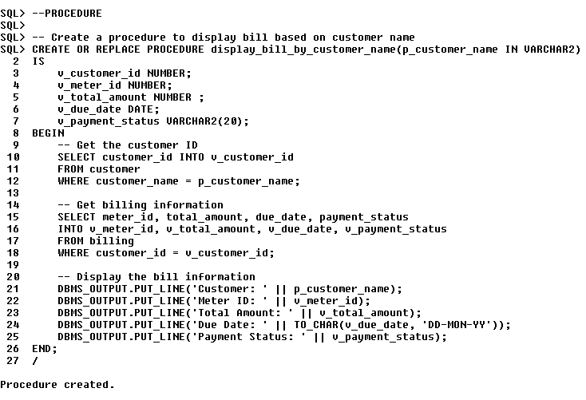

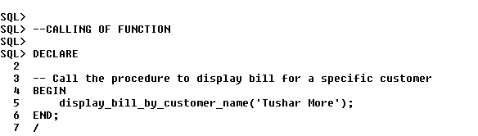

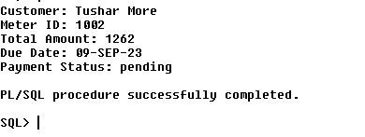

|  |
| --- |
| FUNCTION🡪 TO FIND CUSTOMER WITH PENDING BILLS |
| --FUNCTION  DECLARE  v_cursor SYS_REFCURSOR;  v_customer_name customer.customer_name%TYPE;  BEGIN  v_cursor := get_customers_with_pending_payments();    LOOP  FETCH v_cursor INTO v_customer_name;  EXIT WHEN v_cursor%NOTFOUND;  DBMS_OUTPUT.PUT_LINE('Customer Name with Pending Payment: ' || v_customer_name);  END LOOP;    CLOSE v_cursor;  END;  / |
| --CALLING OF FUNCTION  DECLARE  v_cursor SYS_REFCURSOR;  v_customer_name customer.customer_name%TYPE;  BEGIN  v_cursor := get_customers_with_pending_payments();    LOOP  FETCH v_cursor INTO v_customer_name;  EXIT WHEN v_cursor%NOTFOUND;  DBMS_OUTPUT.PUT_LINE('Customer Name with Pending Payment: ' || v_customer_name);  END LOOP;    CLOSE v_cursor;  END;  / |

OUTPUT:

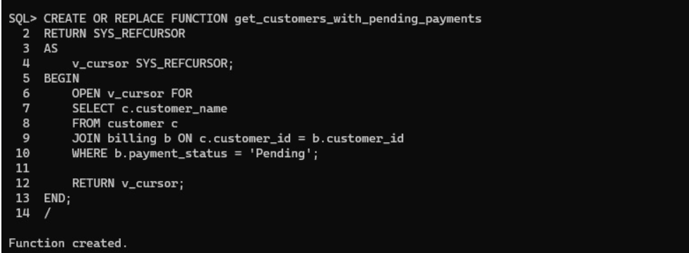

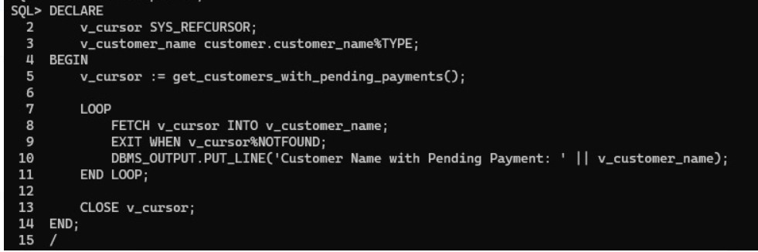

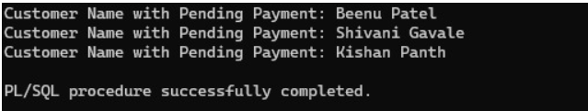

|  |
| --- |
| --PROCEDURE🡪 TO DELETE CUSTOMER ALONG WITH ITS DATA |
| --PROCEDURE  CREATE OR REPLACE PROCEDURE delete_customer(  p_customer_id NUMBER  ) AS  BEGIN  DELETE FROM payment_trans WHERE bill_id IN (SELECT bill_id FROM billing WHERE customer_id = p_customer_id);  DELETE FROM billing WHERE customer_id = p_customer_id;  DELETE FROM readings WHERE meter_id IN (SELECT meter_id FROM meter WHERE customer_id = p_customer_id);  DELETE FROM meter WHERE customer_id = p_customer_id;  DELETE FROM customer WHERE customer_id = p_customer_id;  COMMIT;  END;  / |
| --CALLLING OF PROCEDURE  BEGIN  delete_customer(p_customer_id => 1000000003);  END;  / |

OUTPUT:

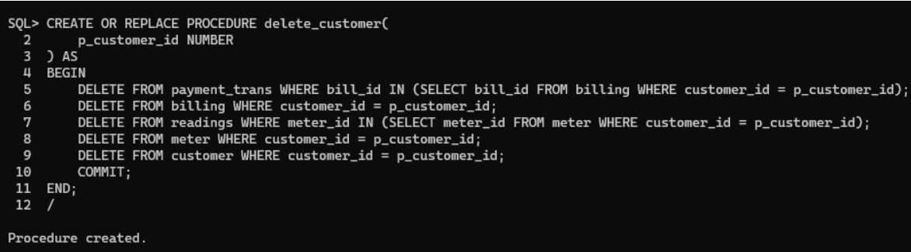

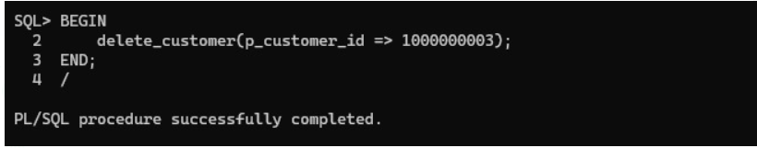

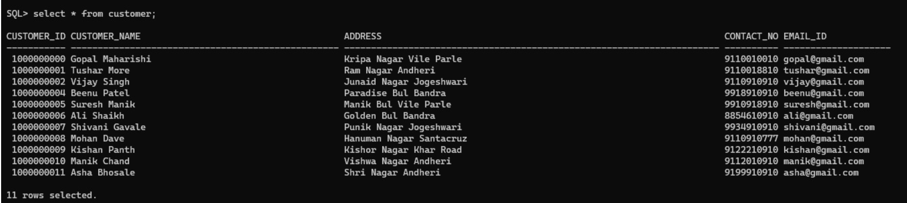

|  |
| --- |
| TRANSACTION🡪 TO INSERT DATA IN CUSTOMER TABLE |
| --TRANSACTION  INSERT INTO customer values(1000000011,'Asha Bhosale', 'Shri Nagar Andheri',9199910910,'asha@gmail.com' ); |

OUTPUT:



|  |
| --- |
| TRANSACTION🡪 TO UPDATE DATA IN CUSTOMER TABLE |
| --TRANSACTION update customer set customer_name='Meena Patel', address='Kripe Nagar Vile Parle', contact_no=8877787779, email_id='meena@gmail.com' where customer_id=1000000005; |

OUTPUT:

