**E-COMMERCE WEBSITE**

PROJECT NAME – **TATA CLIQ**

By- Gaurav Pal

Edureka intern

Batch – 61

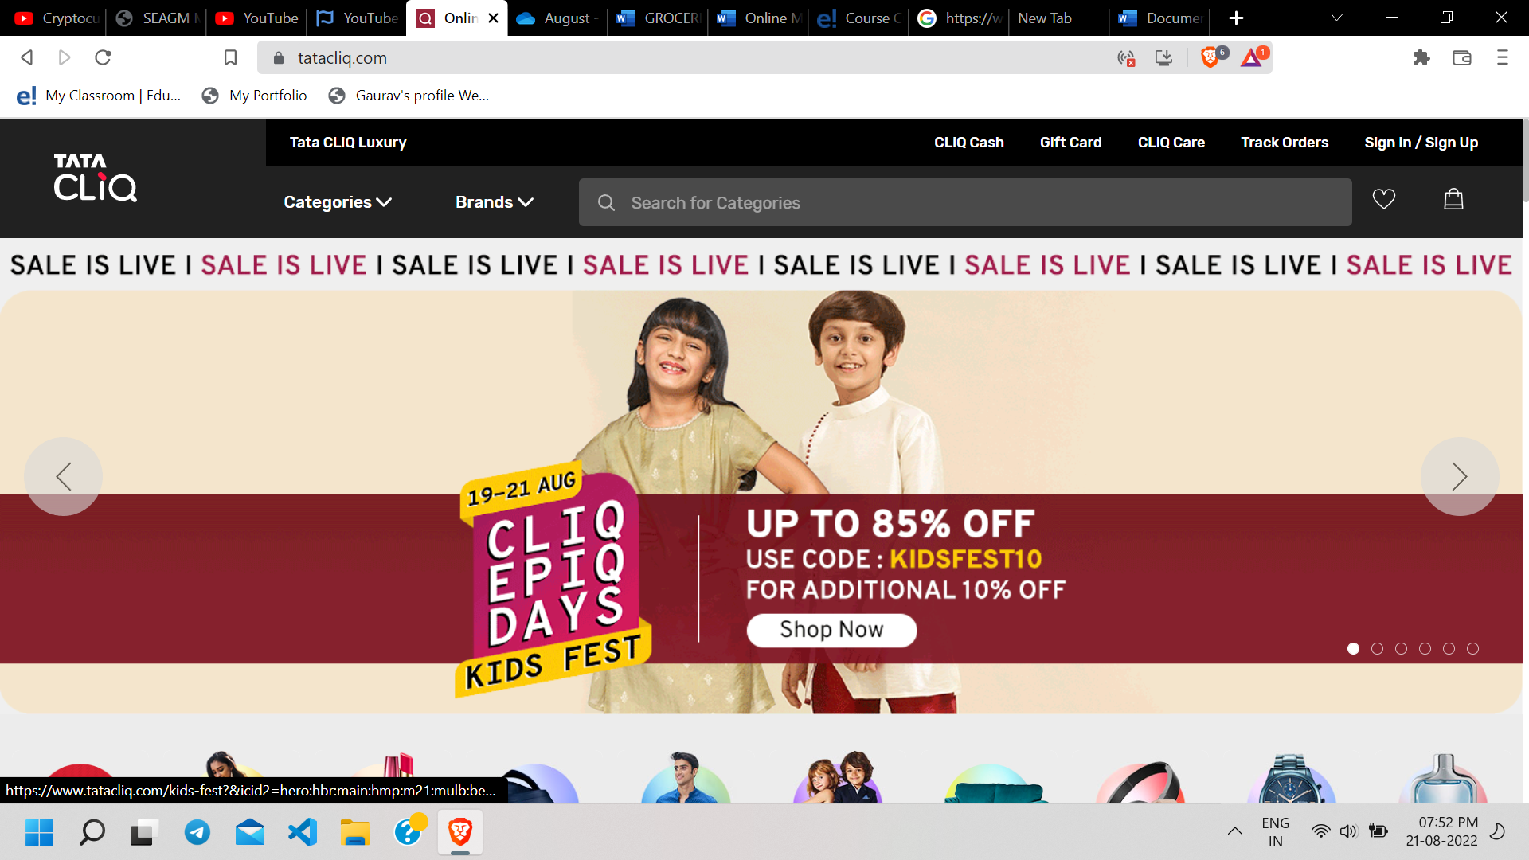

**Overview**

Tata CliQ is an Indian e-commerce company based in Mumbai, India. It is owned by Tata Digital Limited, of Tata Group. Tata CLiQ operates in categories such as Electronics, Fashion, Footwear and Accessories.

**Objective**

* Login/Signup Page
* Home Page
* Listing Page
* Product page
* Buying option
* Payment Gateway

**Page Structure**

Login / Signup Page:

Just like a usual login page, asks user to enter login id and password.

For new users a signup page asking their personal details.

Home page:

This contains header (navigation bar), banners (showing offers and featured products), cards (takes you to listing page) and footer (containing contact details of the company and other details).

Listing page:

Opens list of products with a filter option available to the page.

Product page:

Shows description of selected product in detail

Buying options:

User has Wishlist option and

Add to cart option available

Payment method:

Cod / EMI / online payment

**Technologies used**

Front-end technology:

* HTML
* CSS
* Bootstrap

Programming language:

* Javascript

Web development framework:

* REACT

Code Compilers:

* VS code
* Git bash

On reference to site

[https://tatacliq.com/](https://grofers.com/)