Node Calibration Windows Application

- Introduction
This document outlines the architectural design and functional requirements for the Node Calibration Windows Desktop Application, developed using C# and the .NET Framework in Microsoft Visual Studio. The application serves as a central interface for [describe primary purpose: e.g., hardware testing, network diagnostics, data monitoring].

- User Interface (UI) Layout Overview
Region | Location | Purpose
Navigation Bar | Top-Right | Provides access to global application commands (File, Save, Help, Login).
Navigation Panel | Left Side (Vertical) | Contains command buttons for switching between major functional modules.
Main Content Area | Centre (Remaining Space) | Dynamically displays the active module view or the company logo on startup.

2.1. Form Snapshot
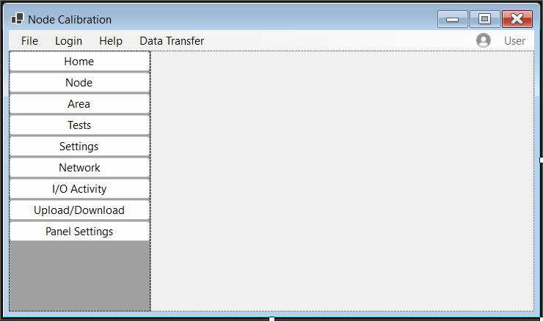
- Detailed Component Specifications
3.1. Top Navigation Bar (Menu Bar)
This component is positioned at the top of the application window. It provides standard Windows application controls.
Menu Item | Sub-Items | Functional Description
File | New | Opens a dialog to upload a specification file.
 | Open | Opens a file browser dialog to select and load an existing PDF specification.
 | Save | Saves the current state or configuration data.
 | Print | Sends the current active report or view to the printer.
Login | (Direct Action) | Displays a modal dialog or panel overlay prompting for user credentials. Authenticates the session.
Help | User Manual | Opens the compiled help file (.chm) or redirects to a web-based documentation URL.
 | About | Displays a dialog box showing version number, copyright, and system information.
Data Transfer | Upload | Initiates a transfer protocol (upload of logs or configs).
 | Download | Download of logs or configs.

  - Left Navigation Panel
This panel contains a vertical stack of selectable command buttons. Only one view can be active at a time.
Button ID | Action on Click
Home | Resets the main content area to display the Company Logo and welcome message.
Node | Loads Node Creation and other functionalities.
Area | Initiates the area functionalities for the respective nodes.
Tests | Loads the Test Execution Module (list of available hardware/software tests).
Settings | Loads the Configuration Panel (network params, thresholds, user preferences).
Network | Loads the Network Status View (IP config, adapter status, ping results).
I/O Activity | Loads the Input/Output Monitor (real-time graph or log of system I/O).
Upload/Download | Loads the File Transfer Manager interface.

  - Main Content Area
- Default State (Home): Displays a Picture Box containing the company logo (centred). This is the view presented upon application launch.
- Active State: When a button in the Left Navigation Panel is clicked, the content of this area is replaced entirely with the corresponding User Control or Form for that module.
- Detailed Explanation of Panel Navigation Tabs
The left panel of the main application window contains a vertical stack of command buttons. Each button corresponds to a distinct functional module of the application. Clicking a button dynamically loads the associated view into the central content area, replacing the previously displayed content.
4.1. Login Window Form
The Login Form is a modal dialog that authenticates the user before granting access to protected features. It validates credentials against a locally stored JSON file.
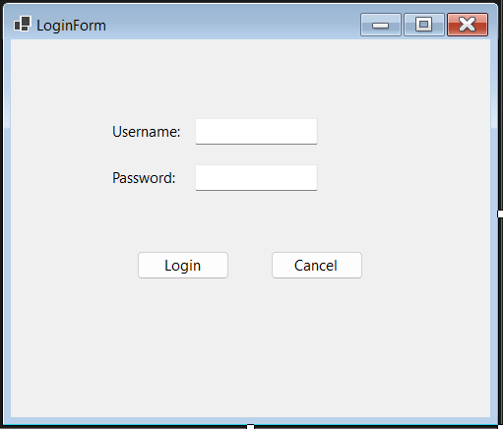

4.1.1 Component Template
Component | Type | Purpose
lblUsername | Label | Labels the username field.
txtUsername | TextBox | Input field for username.
lblPassword | Label | Labels the password field.
txtPassword | TextBox | Input field for password (masked).
btnLogin | Button | Submits credentials for validation.
btnCancel | Button | Cancels login and closes the form.

Form-Level Properties:
- FormBorderStyle = FixedDialog – Prevents user resizing.
- StartPosition = CenterParent – Centers the dialog over the main application window.
4.1.2 Credential Storage
Credentials are stored in a JSON file at the following location:
C:\ProgramData\Company Name\ApplicationName\auth.json
The file contains a single administrator account.
4.1.3 Post-Login Behaviour
Upon successful validation:
- The main menu strip displays a user icon and the text "Administrator".
- The Login menu item text changes to Logout.

  - Nodes User Control Form
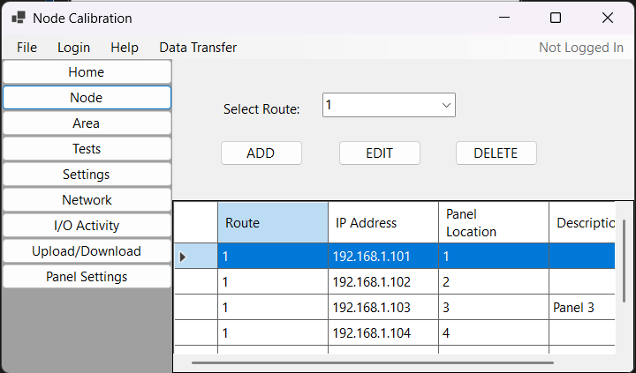
The Node Management module allows users to view, add, edit, and delete network node configurations. Data is persisted in a Microsoft SQL Server LocalDB database.
4.2.1 Component Template
Component | Type | Purpose
lblRoute | Label | Labels the route selection dropdown.
cmbRoute | Combo Box | Allows selection of a route (1, 2, 3, or 4).
btnAdd | Button | Opens the Add Node dialog.
btnEdit | Button | Opens the Edit Node dialog for the selected row.
btnDelete | Button | Deletes the selected node after confirmation.
dgvNodes | DataGridView | Displays all existing nodes in a tabular format.

4.2.2 Add / Edit Node Window Form
This dialog is used for both creating a new node and modifying an existing one.
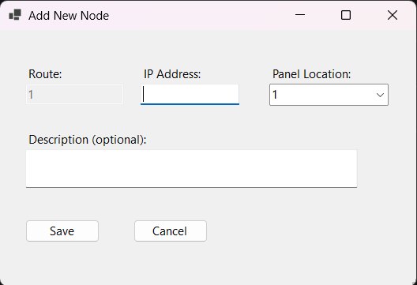
Component | Type | Purpose
lblRoute | Label | Labels the route display field.
txtRoute | Text Box | Displays the selected route (read-only).
lblIP | Label | Labels the IP address input field.
txtIPAddress | Text Box | Accepts an IPv4 address.
lblPanel | Label | Labels the panel location dropdown.
cmbPanelLocation | Combo Box | Accepts a numeric panel location (1–100).
lblDescription | Label | Labels the description field.
txtDescription | Text Box | Accepts optional descriptive text.
btnSave | Button | Saves the node data.
btnCancel | Button | Cancels the operation.

4.2.3 Database Storage
Node records are stored in a SQL Server LocalDB table named Nodes with the following schema:
Column | Data Type | Constraints
Id | int | PRIMARY KEY, IDENTITY(1,1)
Route | int | NOT NULL
IPAddress | nvarchar(15) | NOT NULL, UNIQUE
PanelLocation | int | NOT NULL
Description | nvarchar(MAX) | NULL

4.2.5 Functional Workflow
- View Nodes: On loading, the DataGridView is populated with all records from the Nodes table, ordered by PanelLocation.
- Add Node: User selects a route, clicks ADD, completes the dialog, and upon successful validation the record is inserted and the grid refreshes.
- Edit Node: User selects a row, clicks EDIT, modifies fields in the dialog, and upon validation the record is updated.
- Delete Node: User selects a row, clicks DELETE, confirms the action, and the record is removed.

  - Area User Control Form
The Area Management module allows the user to assign descriptive labels to each of the 100 panel locations across the four routes. These descriptions help document the physical placement of hardware panels.
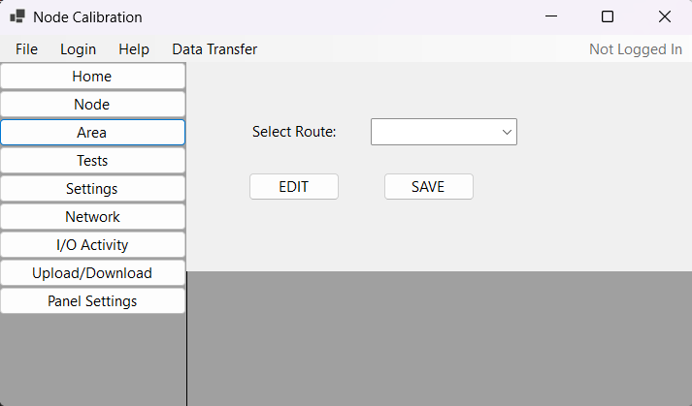
4.3.1 Component Template
Component | Type | Purpose
lblRoute | Label | Labels the route selection dropdown.
cmbRoute | Combo Box | Allows selection of a route (1, 2, 3, or 4).
btnEdit | Button | Opens the Edit Description dialog for the selected row.
btnSave | Button | Saves all pending description changes to the database.
dgvAreas | DataGridView | Displays panel location data for the selected route.

4.3.2 Grid Column Definition
The DataGridView displays the following columns for the selected route:
Column Name | Data Source | Description
Panel Location | PanelLocation | The numeric panel identifier (1–100). This column is read-only.
Description | Description | The user-defined label describing the physical location.

4.3.3 Edit Description Dialog Template
When the user selects a row and clicks EDIT, a modal dialog opens with the following components:
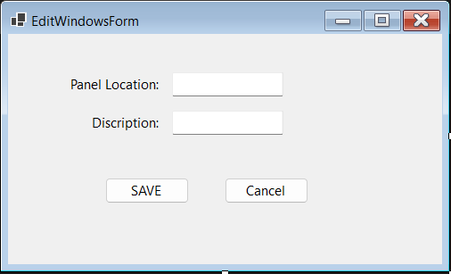
Component | Type | Purpose
lblPanelLocation | Label | Labels the panel location display field.
txtPanelLocation | Text Box | Displays the selected panel location number (read-only).
lblDescription | Label | Labels the description input field.
txtDescription | Text Box | Accepts the descriptive text for the panel location.
btnSave | Button | Saves the description and closes the dialog.
btnCancel | Button | Cancels editing and closes the dialog.

Form-Level Properties:
- FormBorderStyle = FixedDialog
- StartPosition = CenterParent
- Text = "Edit Panel Description"
4.3.4 Functional Workflow
- Route Selection: The user selects a route (1–4) from the dropdown. The grid is populated with 100 rows representing panel locations 1 through 100. If descriptions have been previously saved, they are displayed; otherwise, default values (e.g., A1, A2, ...) may be shown.
- Edit Description:
  - The user selects a row in the grid.
  - Clicking EDIT opens the Edit Description dialog. The Panel Location field is pre-filled and non-editable. The current description (if any) is loaded into the text box.
  - The user modifies the description and clicks Save. The dialog closes, and the grid is updated to reflect the new description.
- Save to Database:
  - Clicking the SAVE button on the main AreaControl commits all pending description changes to the database. This may be a batch save of all modified rows or a single save operation depending on implementation.

4.3.5 Database Storage
Panel descriptions are stored in a SQL Server table named Panel Descriptions with the following schema:
Column | Data Type | Constraints
Id | int | PRIMARY KEY, IDENTITY (1,1)
Route | int | NOT NULL
PanelLocation | int | NOT NULL
Description | nvarchar(255) | NULL
4.3.6 Relationship to Node Management
The PanelLocation values used in the Node Management module correspond to the same panel locations managed here. The Node module assigns IP addresses to panels, while the Area module provides the human-readable physical description for those same panel slots.

  - Settings User Control Form
The Settings module allows the user to configure technician contact information and maintenance notification preferences. These settings are saved locally and persist between application sessions.

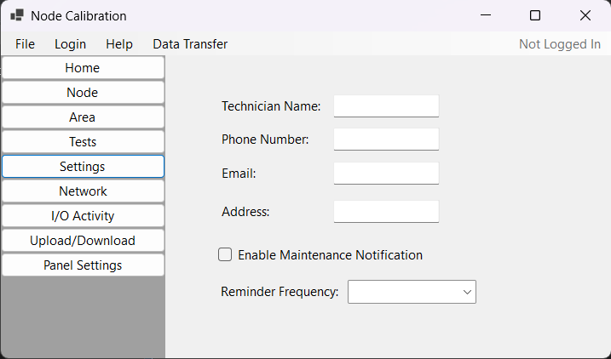

4.4.1 Component Template
Component | Type | Purpose
lblTechnicianName | Label | Labels the technician’s name input field.
txtTechnicianName | TextBox | Stores the name of the responsible technician.
lblPhoneNumber | Label | Labels the phone number input field.
txtPhoneNumber | TextBox | Stores the technician's contact phone number.
lblEmail | Label | Labels the email address input field.
txtEmail | TextBox | Stores the technician's email address.
lblAddress | Label | Labels the physical address input field.
txtAddress | TextBox | Stores the technician's or site address.
CheckNotification | CheckBox | Toggles the maintenance reminder feature.
lblFrequency | Label | Labels the frequency dropdown.
cmbFrequency | ComboBox | Selects the reminder interval in months.

4.4.1 Functional Workflow
- Load Settings: When the SettingsControl is instantiated, it reads the settings.json file (if it exists) and populates the text boxes, checkbox, and dropdown with the saved values. Default values are used if no file exists.
- Edit Settings: The user can modify any of the fields.
- Enable/Disable Frequency: The frequency dropdown is enabled only when the "Enable Maintenance Notification" checkbox is checked. When unchecked, the dropdown is disabled.
- Save Settings: Changes are typically saved automatically when the user navigates away from the Settings module or when an explicit Save button is provided (implementation may vary). The updated values are written back to the JSON file.

4.5 Network User Control Form
The Network Configuration module allows the user to view and modify Ethernet and optional Wi-Fi network settings. Ethernet settings are always visible, while Wi-Fi settings are conditionally displayed when enabled via a checkbox.

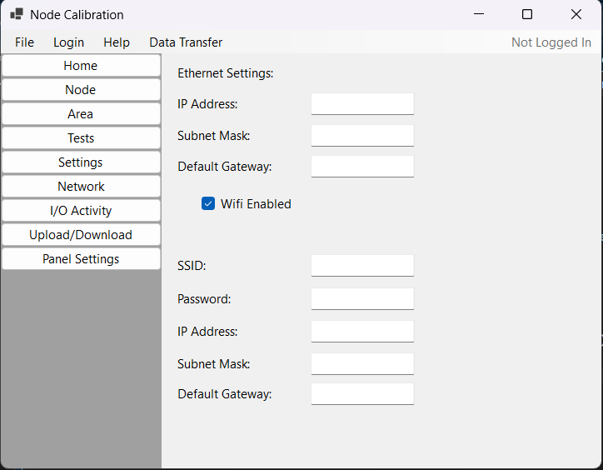
4.5.1 Component Template
Component | Type | Purpose
lblEthernet | Label | Subheading for wired network settings.
lblEthernetIP | Label | Labels the Ethernet IP field.
txtEthernetIP | Text Box | Displays/accepts Ethernet IPv4 address.
lblEthernetSubnet | Label | Labels the Ethernet subnet mask field.
txtEthernetSubnet | Text Box | Displays/accepts Ethernet subnet mask.
lblEthernetGateway | Label | Labels the Ethernet gateway field.
txtEthernetGateway | Text Box | Displays/accepts Ethernet default gateway.
chkWifiEnabled | Check Box | Toggles visibility of Wi-Fi settings panel.

4.5.3 Functional Workflow
- Load Settings: When the NetworkControl loads, it retrieves saved network configuration from the application settings file. Ethernet fields are populated. If Wi-Fi was previously enabled, the checkbox is checked and the Wi-Fi panel is made visible with its fields populated.
- Toggle Wi-Fi Panel: When the user checks or unchecks, the Wi-Fi Enabled checkbox, the pnlWifiSettings panel's Visible property is updated accordingly. When unchecked, any entered Wi-Fi data is retained but hidden.

