Major Project Report
MANGAVERSE
Project Category: A Self-Hosted Manga Reader & Web Application Development Project
Project team no -:15
Submitted in partial fulfilment of the requirement of the degree of
BACHELOR OF TECHNOLOGY (CSE/ AI&ML)
Semester-III
to
K.R Mangalam University
By
Student Name-Aayush Sharma Roll Number-2401730128
Student Name-Bhragender Kumar singh Roll Number-2401730131

Student Name-Rishav kumar Roll Number-2401730093

Ms. Kajal Mansi
Internal Mentor
K.R. Mangalam University


Department of Computer Science and Engineering
DECLARATION

I hereby declare that the project titled “Mangaverse – A Self-Hosted Manga Reader & Digital Library” is an original work carried out by our project team. This work has not been submitted to any other institution or university for the award of any degree, diploma, or certificate.
All information, data, and results presented in this report are true and correct to the best of my knowledge and belief.

This is to certify that the project titled “MANGAVERSE – A Self-Hosted Manga Reader & Digital Library” has been successfully completed by:
- Aayush Sharma (Roll No. 2401730128)
- Bhragender Kumar Singh (Roll No.2401730131)
- Rishav Kumar (Roll No. 2401730093)
students of B.Tech (CSE / AI&ML), Semester III, School of Engineering and Technology,
K.R. Mangalam University, Gurugram.
The project has been carried out under the supervision of:
Ms. Kajal Mansi
Internal Mentor, School of Engineering & Technology
K.R. Mangalam University
The project fulfills the requirements for the partial completion of the Bachelor of Technology degree as per university guidelines.

Dean, SOET
School of Engineering & Technology
K.R. Mangalam University
Gurugram, India
Date:

CERTIFICATE

This is to certify that the Major Project Report entitled “MANGAVERSE – A Self-Hosted Manga Reader & Digital Library” submitted by Aayush Sharma (Roll No. 2401730128), Bhragender Kumar Singh (Roll No. 2401730131), and Rishav Kumar (Roll No. 2401730093) to K.R. Mangalam University, Gurugram, India, is a record of bonafide project work carried out by them under my supervision and guidance.
This project is worthy of consideration for partial fulfilment of the requirements for the degree of Bachelor of Technology in Computer Science and Engineering (CSE/AI&ML) of the University.

Signature of Internal Supervisor
Ms. Kajal Mansi
Internal Mentor, School of Engineering & Technology
K.R. Mangalam University

Signature (Dean SOET)
Dr. Pankaj Agarwal
Dean, School of Engineering & Technology
K.R. Mangalam University

Date: 28th November 2025

S. No. | Content | Page No.
1. | Project Completion Certificate
2. | Abstract
3. | Introduction (Description of Broad Topic)
4. | Motivation
5. | Literature Review / Comparative Work Evaluation
6. | Gap Analysis
7. | Problem Statement
8. | Objectives
9. | Tools / Platform Used
10. | Methodology
11. | Experimental Setup
12. | Evaluation Metrics
13. | Results and Discussion
14. | Conclusion & Future Work
15. | References
16. | Annexure I: Plagiarism Report
17. | Annexure II: Complete Implementation Code
18. | Annexure III: Research Paper (Published/Submitted)

ABSTRACT
The rapid growth of digital reading platforms has increased the demand for accessible and customizable manga reading solutions. However, most existing manga platforms are either subscription-based, lack offline support, or do not allow users to manage their own local collections. To address these limitations, this project presents MANGAVERSE, a lightweight, self-hosted manga reader and digital library designed to provide an efficient and user-controlled reading experience.
Mangaverse is developed using HTML, CSS, vanilla JavaScript, and a Node.js backend, enabling fast performance, easy deployment, and complete local data ownership. The system supports essential features such as manga library management, chapter-wise browsing, a responsive reader interface, and account handling. It also supports archive formats like CBZ, allowing users to upload and organize their personal manga collections with ease. A clean file-based structure ensures compatibility and smooth loading of high-resolution pages.
This project emphasizes usability, simplicity, and privacy by allowing users to host their collections locally without relying on external servers or commercial platforms. The system architecture, backend file handling, and client-side rendering were designed to ensure efficient reading, minimal load times, and a user-friendly interface.
Mangaverse demonstrates how a self-hosted environment can offer a secure, customizable, and practical alternative to commercial manga applications, making it a valuable tool for enthusiasts who want full control over their digital reading experience.

Chapter 1
Introduction

- Background of the project
The popularity of manga has grown rapidly across the world as digital reading becomes more accessible and convenient. With increasing access to the internet and personal devices, readers now prefer digital platforms that provide flexibility, portability, and an organized reading experience. However, most widely used manga platforms today come with significant limitations—subscription fees, advertisements, restricted content availability, limited offline support, and lack of control over personal manga collections.
Many readers collect manga in downloadable formats such as CBZ, ZIP, or image-based folders, but face difficulties in managing, organizing, and reading these files on a clean and efficient interface. Existing offline readers are often heavy, outdated, or lack essential features such as library management, chapter navigation, responsive reading modes, and cross-device accessibility. This gap in user-controlled and privacy-focused manga reading solutions highlighted the need for a self-hosted, user-friendly, lightweight manga management system.
To address these issues, Mangaverse was conceptualized as a platform that gives readers full control over their digital manga library. Instead of relying on commercial servers or paid platforms, users can host the application locally and manage their entire collection directly through the browser. Built with HTML, CSS, vanilla JavaScript, and powered by a Node.js backend, Mangaverse is designed to function efficiently on basic hardware without complicated setup.
The project focuses on simplicity, privacy, and accessibility. By supporting standard manga archive formats like CBZ, providing a structured library interface, and enabling smooth chapter-wise reading, Mangaverse aims to create an experience similar to modern streaming platforms—while keeping everything self-owned and secure. The rise of self-hosted applications and the growing preference for personal data control further reinforce the relevance and usefulness of such a platform.
Overall, Mangaverse emerges as a solution that aligns with the needs of modern manga enthusiasts who seek a clean, customizable, and private reading environment, independent of third-party restrictions or commercial limitations.

Factors | Evaluation Criteria | System A (Web-Based Manga Reader) | System B (Local Manga Reader Software) | System C (Mobile Manga App)
File Support and Formats | - Support for CBZ/ZIP/PDF/image folders | Yes | Limited | Yes
 | - Automatic chapter detection | Moderate | Yes | Limited
Reading Experience | - Page loading speed | Fast | Moderate | Fast
 | - Reading modes (scroll, flip, dual-page) | Multiple | Limited | Multiple
Library Management | - Ability to organize manga by category, tags, or folders | Good | Excellent | Moderate
 | - Metadata support (cover image, description) | Yes | Partial | Yes
User Control and Privacy | - Local hosting / offline access | No | Yes | Partial
 | - Data privacy and ownership | Low | High | Moderate
Customization Features | - Theme options (dark/light mode) | Yes | Limited | Yes
 | - Reading customization (zoom, fit-to-width) | Good | Excellent | Moderate
Accessibility & Devices | - Cross-device support (PC, mobile, tablet) | High | Low | High
 | - Browser compatibility | Excellent | Not Applicable | Moderate
Performance & Scalability | - Handles large manga files | Moderate | Excellent | Moderate
 | - Fast navigation between chapters | Fast | Moderate | Fast
Storage & Data Handling | - Automated library updates | Yes | No | Limited
 | - Local storage indexing | Limited | Strong | Limited
Cost Licensing | - Free availability | Free | Paid/Free (Varies) | Free with ads
 | - Open-source availability | Yes | Yes | No
Ease of Use | - User interface simplicity | Very Intuitive | Moderate | Intuitive
 | - Setup and installation | Easy | Difficult | Very Easy
Support Community | - Availability of documentation | Strong | Moderate | Limited
 | - Community support | Active | Small | Low

2. MOTIVATION
The digital reading industry has expanded significantly with the rise of smartphones, tablets, and high-speed internet. Manga, in particular, has become one of the fastest-growing forms of digital media consumption worldwide. Despite this growth, most manga readers continue to rely on commercial websites and mobile applications that impose various limitations such as subscription fees, intrusive advertisements, limited content availability, and restrictions on personal library management.
At the same time, many manga enthusiasts prefer collecting manga files in formats like CBZ, ZIP, or structured image folders. However, managing and reading these files is often challenging because existing readers are either outdated, lack essential features, or do not provide a modern, seamless user experience. Additionally, many platforms do not support offline access or self-hosting, limiting the user's ownership and privacy.
Another source of motivation for this project comes from the growing shift toward self-hosted applications. Users today increasingly value privacy, control over personal data, and independence from commercial platforms. A self-hosted manga reader ensures that users can organize, store, and read their manga collections without relying on third-party servers or risking data loss, censorship, or service shutdowns.
The need for a lightweight, customizable, and user-centric manga reader highlighted the gap in the existing solutions. Mangaverse was motivated by the idea of providing:
- A clean and responsive reading interface
- A locally hosted system ensuring full privacy and control
- Support for CBZ and similar archive formats
- Intuitive library organization
- A smooth and enjoyable reading experience
- A platform that works on any device through a web browser
By addressing these limitations and combining simplicity with powerful features, this project aims to deliver a solution that empowers manga readers to enjoy their collections efficiently and securely. Mangaverse is inspired by the need for independence, data ownership, and a modern reading experience that focuses on user freedom rather than platform restrictions.

Chapter 2

LITERATURE REVIEW

1. Review of Existing Literature

The growing popularity of manga and digital comics has led to the development of various online and offline platforms for reading, managing, and organizing manga content. Several research works and existing systems provide insights into the features, limitations, and technologies used in digital manga reading platforms.

Web-Based Manga Readers

Web-based manga readers such as MangaDex, MangaRock, and ComiXology have gained widespread use for providing access to large collections of manga. These platforms allow users to browse, search, and read manga directly from their browsers. Studies show that these platforms prioritize user interface simplicity, cross-device accessibility, and fast loading of pages, but they often rely on third-party servers and may include advertisements, subscription models, and limited offline access.

Offline and Local Manga Reader Software

Several desktop applications have been developed for reading downloaded manga files. Programs like CDisplayEx, Simple Comic, and HoneyView provide support for archive formats such as CBZ, ZIP, and PDF. They offer features such as page zoom, dual-page view, and custom reading order. Research indicates that while these software tools provide high performance and flexibility, they lack integrated library management and user-friendly web interfaces, making it harder for users to organize and navigate large manga collections efficiently.

Mobile Manga Applications

Mobile apps such as Tachiyomi and Manga Bird allow users to read manga on smartphones and tablets. Literature highlights that mobile readers prioritize portability, offline reading, and lightweight performance. However, they often face limitations in library customization, file organization, and cross-platform accessibility. Users may also encounter difficulties with large manga collections due to storage and indexing limitations.

Self-Hosted Digital Library Systems

Recent research emphasizes self-hosted digital libraries as a solution for privacy, control, and customization. Studies on self-hosted e-book and comic platforms show that users benefit from local hosting, which provides full data ownership, offline access, and flexibility in organization. These platforms often rely on Node.js or similar backend technologies for file management and HTML/JavaScript for frontend rendering. This approach allows users to customize the library interface and implement features such as automated chapter recognition and metadata support.

Key Findings from Literature

From the review of existing systems and research:
- Most web-based readers provide wide accessibility and ease of use but rely on external servers and subscription models.
- Desktop readers offer high performance and support for multiple archive formats but often lack integrated library management and modern interfaces.
- Mobile readers excel in portability and offline reading, but scalability and organization of large collections remain challenges.
- Self-hosted solutions provide privacy, full control, and flexibility, making them ideal for personal digital libraries.

The literature highlights a gap in platforms that combine lightweight performance, self-hosting, browser-based access, and effective library management. This gap motivated the development of Mangaverse, which addresses these limitations by providing a self-hosted, browser-accessible, and user-friendly manga reading platform.
Project Title | Objectives | Technologies Used | Outcomes and Findings
Web-Based Manga Reader A | Provide easy online access to manga collections | HTML, CSS, JavaScript, server-side rendering | Users can read manga online without installation; fast access but relies on third-party servers and limited offline support
Desktop Manga Reader B | Read downloaded manga files efficiently | C++, Python, CBZ/ZIP file parsing libraries | High performance and support for multiple formats; limited library organization and no browser-based access
Mobile Manga App C | Enable portable manga reading on smartphones | Kotlin/Java (Android), Swift (iOS), SQLite database | Offers offline reading and portability; library management and large collection handling are limited
Self-Hosted Digital Library X | Give users full control over personal manga collections | Node.js, Express.js, HTML, CSS, JavaScript | Provides local hosting, privacy, offline access, and customization; setup requires moderate technical knowledge
Mangaverse (Proposed Project) | Lightweight, self-hosted manga library with browser access | Node.js, HTML, CSS, vanilla JavaScript, CBZ support | Combines local hosting, responsive web interface, chapter-wise navigation, account management, and library organization; efficient for large collections and user-controlled environment

- GAP ANALYSIS
Through the review of existing literature and analysis of current manga reading platforms, several limitations and gaps have been identified. Most web-based manga readers offer easy online access and large content libraries, but they rely heavily on third-party servers, provide limited offline access, and often include advertisements or subscription restrictions. Desktop-based manga readers support multiple file formats and provide efficient reading, yet they lack integrated library management, responsive interfaces, and browser accessibility. Mobile apps offer portability and offline reading, but handling large collections and organizing manga efficiently remains a challenge.
Additionally, while some self-hosted digital library systems exist, they often require technical expertise to set up, and their user interfaces are not always intuitive or optimized for manga reading. Features such as chapter-wise navigation, account management, metadata handling, and archive support (e.g., CBZ) are either limited or unavailable in most existing solutions.
Mangaverse addresses these gaps by providing a lightweight, self-hosted, browser-accessible manga library that combines all essential functionalities in a single platform. Users can manage large collections efficiently, navigate chapters easily, read manga in a responsive and user-friendly interface, and maintain full control over their data without relying on external servers. This comprehensive approach fills the gaps left by existing platforms, offering privacy, convenience, and a seamless reading experience.

4. PROBLEM STATEMENT

The increasing popularity of digital manga has created a demand for platforms that allow users to read, organize, and manage their manga collections efficiently. However, existing solutions have several limitations. Web-based manga readers often rely on third-party servers, which can lead to privacy concerns, restricted access, and interruptions due to advertisements or subscription models. Desktop readers support multiple file formats but usually lack integrated library management, responsive interfaces, and cross-device accessibility. Mobile manga applications provide portability and offline access, but handling large collections, navigating chapters efficiently, and organizing manga files remains challenging.

These limitations create a need for a self-hosted, lightweight, and user-friendly manga reader that allows users to manage their collections independently, read manga in a smooth and responsive interface, and retain full control over their data. Such a platform would address gaps in privacy, usability, and library management, while providing a seamless reading experience across devices and supporting popular manga file formats such as CBZ and ZIP.

- OBJECTIVES

The main objective of Mangaverse is to provide a lightweight, self-hosted manga reader and library that addresses the limitations of existing digital manga platforms. The project aims to combine usability, privacy, and efficient library management in a single platform.

Key features and objectives include:
- Library Management – Organize and manage manga collections efficiently, including support for archive formats such as CBZ and ZIP.
- Chapter Navigation – Enable smooth chapter-wise browsing and reading for a better user experience.
- Responsive Reader Interface – Provide a clean, responsive interface accessible on desktops, tablets, and mobile devices through a web browser.
- User Accounts & Personalization – Allow users to create accounts, manage their collections, and customize reading preferences.
- Offline Access & Local Hosting – Ensure full control over manga collections by hosting the platform locally, with offline reading capabilities.
- Ease of Use – Provide an intuitive GUI for users with minimal technical expertise, implemented using HTML, CSS, and vanilla JavaScript on a Node.js backend.

The primary goal of Mangaverse is to fill the gaps left by existing platforms by delivering a self-contained, user-friendly, and customizable manga reading environment, giving users full control over their data and reading experience.

CHAPTER 3: METHODOLOGY

The methodology section explains the approach, procedures, and design decisions taken to implement Mangaverse, a self-hosted manga reader and digital library. It highlights the overall architecture, module interactions, and the steps followed to create an efficient, user-friendly platform.

3.1 Overall Architecture / Flow Chart

The overall architecture of Mangaverse is designed as a modular web-based application with a clear separation of frontend, backend, and data storage. The platform consists of the following main modules:
- Frontend (Client-Side)
  - Built using HTML, CSS, and vanilla JavaScript.
  - Responsible for displaying the manga library, chapter navigation, and reading interface.
  - Provides user-friendly features such as zooming, dual-page view, theme selection (dark/light mode), and responsive design for multiple devices.
- Backend (Server-Side)
  - Built using Node.js and Express.js framework.
  - Handles user requests, serves manga files, and manages account authentication.
  - Implements file handling for manga archives (CBZ, ZIP), generates chapter lists, and supports metadata storage (title, author, genre).
- Database / Storage
  - Stores user accounts, manga metadata, reading progress, and personal library information.
  - File-based or lightweight database (e.g., JSON files or SQLite) is used for local hosting to ensure full privacy and easy deployment.
- Modules and Interactions
  - User Module: Handles account creation, login, and personal preferences.
  - Library Management Module: Enables adding, organizing, and categorizing manga collections.
  - Reader Module: Provides smooth chapter-wise navigation, page rendering, and offline reading support.
  - File Handling Module: Manages CBZ/ZIP files, extracts images, and prepares data for rendering.
  - Interface Module: Communicates between frontend and backend to display data dynamically and ensure responsiveness.

Flow of Data / User Interaction:
- User logs in or creates an account → Authentication is validated by Backend.
- User uploads manga files → File Handling Module extracts chapters and stores metadata.
- User browses library → Library Management Module retrieves metadata → Frontend displays manga collection.
- User selects a chapter → Reader Module renders pages in browser → Progress is stored in Database.
- User can customize reading preferences (zoom, theme, layout) → Interface Module updates the view in real time.

3.3 Experimental Setup
The experimental setup for Mangaverse involves creating a controlled environment to deploy, test, and evaluate the self-hosted manga reader. The setup ensures that the system functions efficiently, is user-friendly, and meets all project objectives.
1. Hardware Requirements
- Processor: Intel Core i3 or higher
- RAM: 4 GB minimum (8 GB recommended for large manga collections)
- Storage: Minimum 50 GB free space to store manga archives
- Display: 13-inch or larger, 1366×768 resolution minimum
2. Software Requirements
- Operating System: Windows 10 / Linux / macOS
- Backend: Node.js v16+ with Express.js framework
- Frontend: HTML5, CSS3, vanilla JavaScript
- Database / Storage: JSON files or SQLite (lightweight local storage)
- Archive Handling: Libraries to extract CBZ and ZIP files
- Browser: Google Chrome, Firefox, or any modern browser for testing
3. Test Data
- Manga collections in CBZ and ZIP formats, containing multiple chapters and high-resolution pages
- Metadata including title, author, genre, and reading order
- Sample user accounts to test login, library management, and reading progress tracking
4. Deployment Environment
- Mangaverse is deployed on a local server using Node.js
- Accessed through a web browser on the same machine or other devices connected to the local network
- Tested for multiple simultaneous sessions to evaluate performance and responsiveness
5. Testing Scenarios
- File Upload and Extraction – Upload manga archives and verify chapters are extracted and displayed correctly.
- Library Management – Add, organize, and delete manga collections; check metadata accuracy.
- Chapter Navigation and Reading – Test smooth page rendering, scrolling, dual-page view, and zoom functionality.
- Offline Access – Verify that manga can be read without internet connection when hosted locally.
- Cross-Device Testing – Test responsiveness on desktops, tablets, and mobile devices.
- Performance Testing – Evaluate load times for large manga collections and high-resolution pages.
- User Preferences – Test reading settings like dark/light mode, zoom levels, and progress tracking.
6. Evaluation Metrics
- Load Time: Average time to load a chapter or page
- Responsiveness: Ability of the interface to adapt to different screen sizes
- File Handling Accuracy: Correct extraction and display of manga files
- Library Organization: Ease of adding, categorizing, and navigating manga collections
- User Satisfaction: Feedback on usability and interface intuitiveness
This experimental setup ensures that Mangaverse is tested under realistic conditions, verifying that the system meets its design goals while providing a seamless manga reading experience.

Code of project
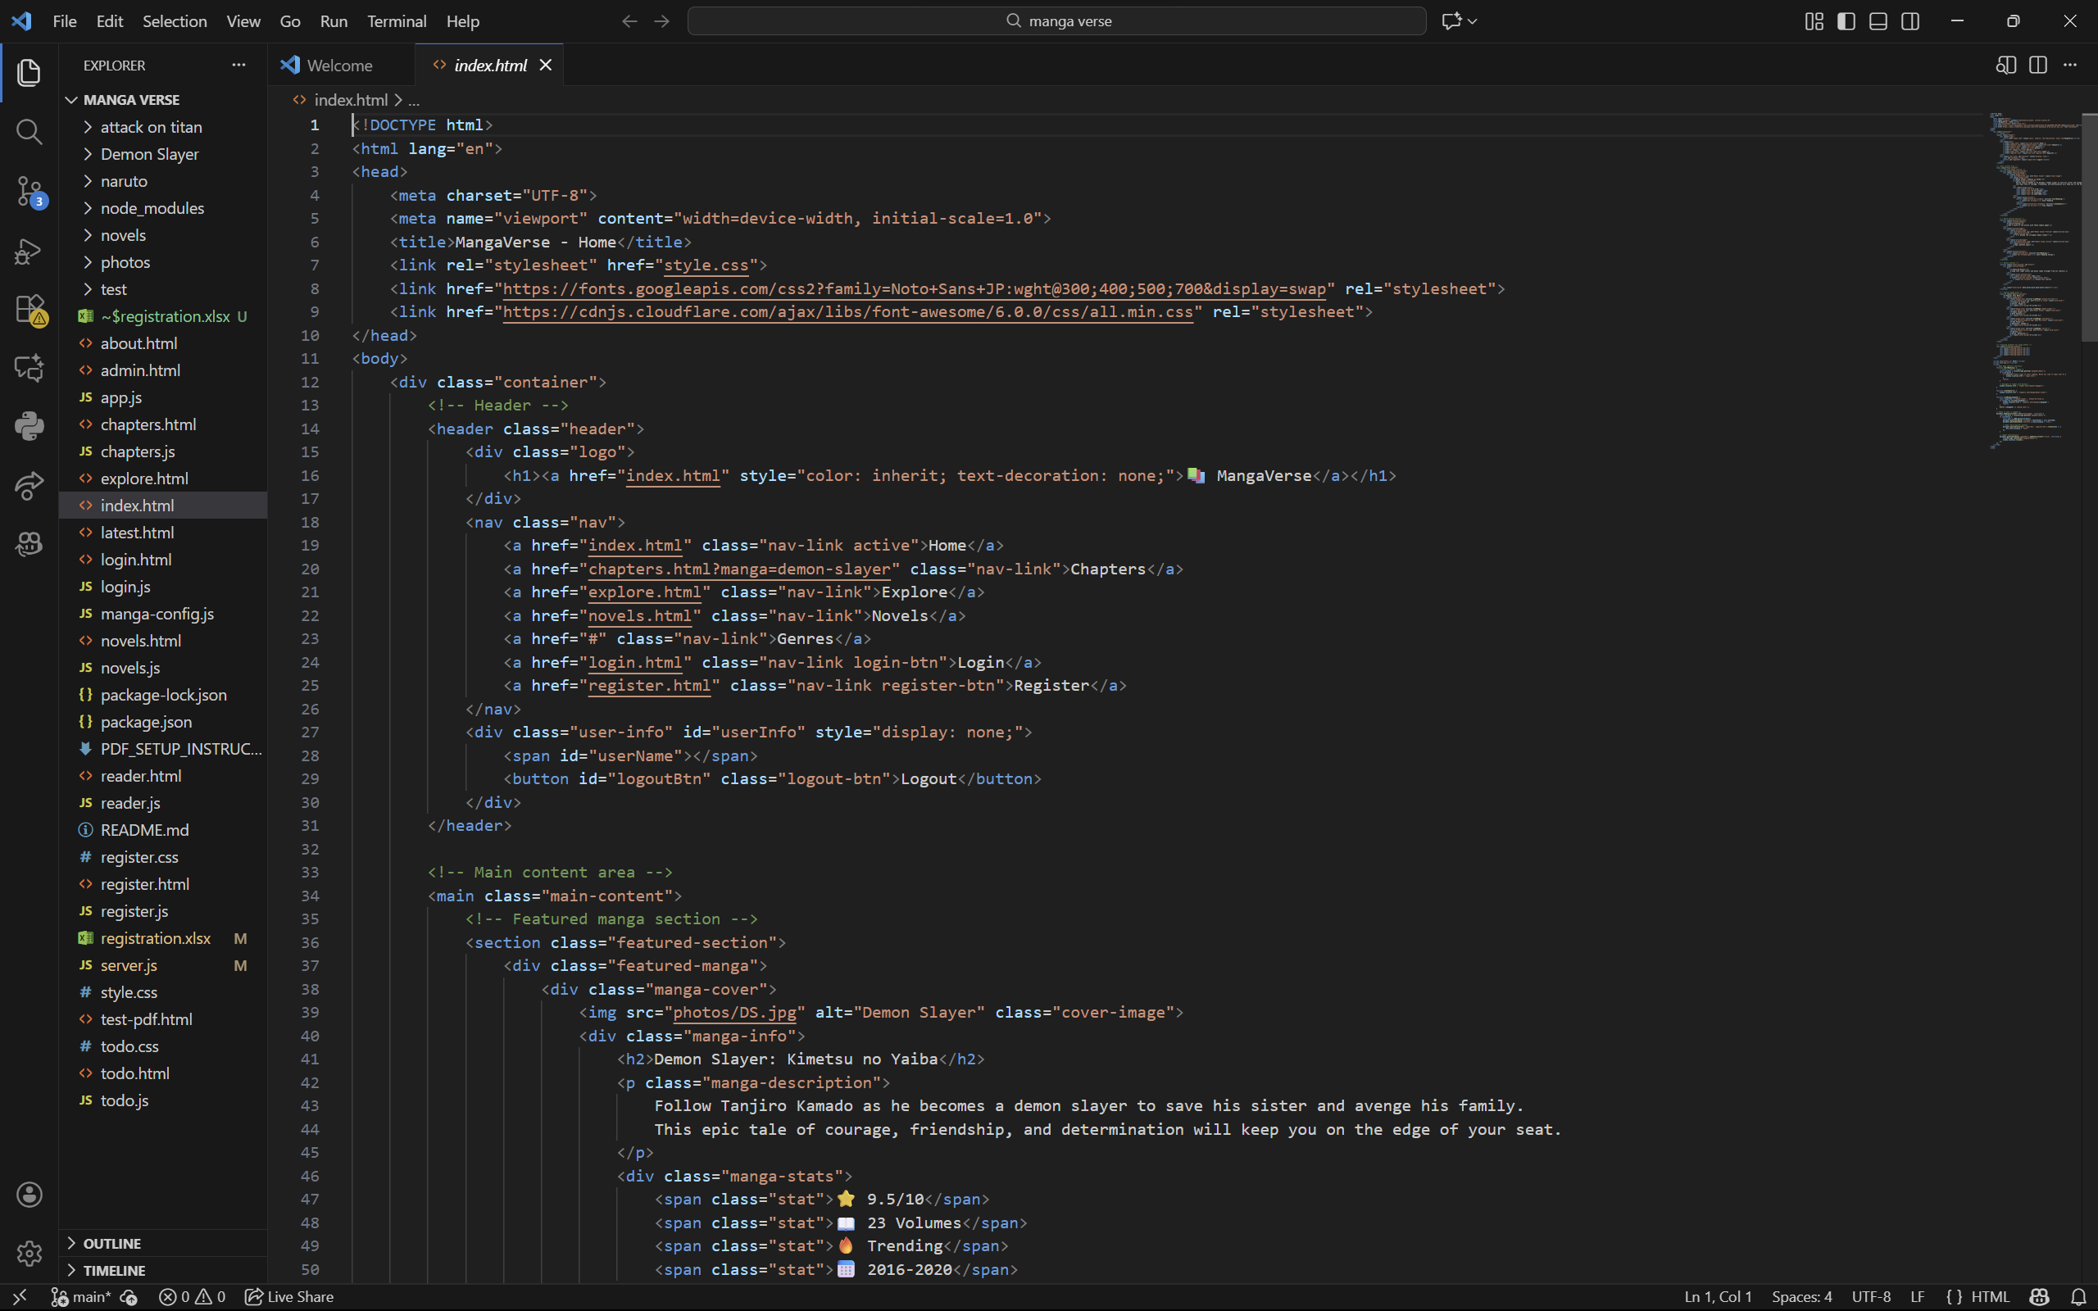

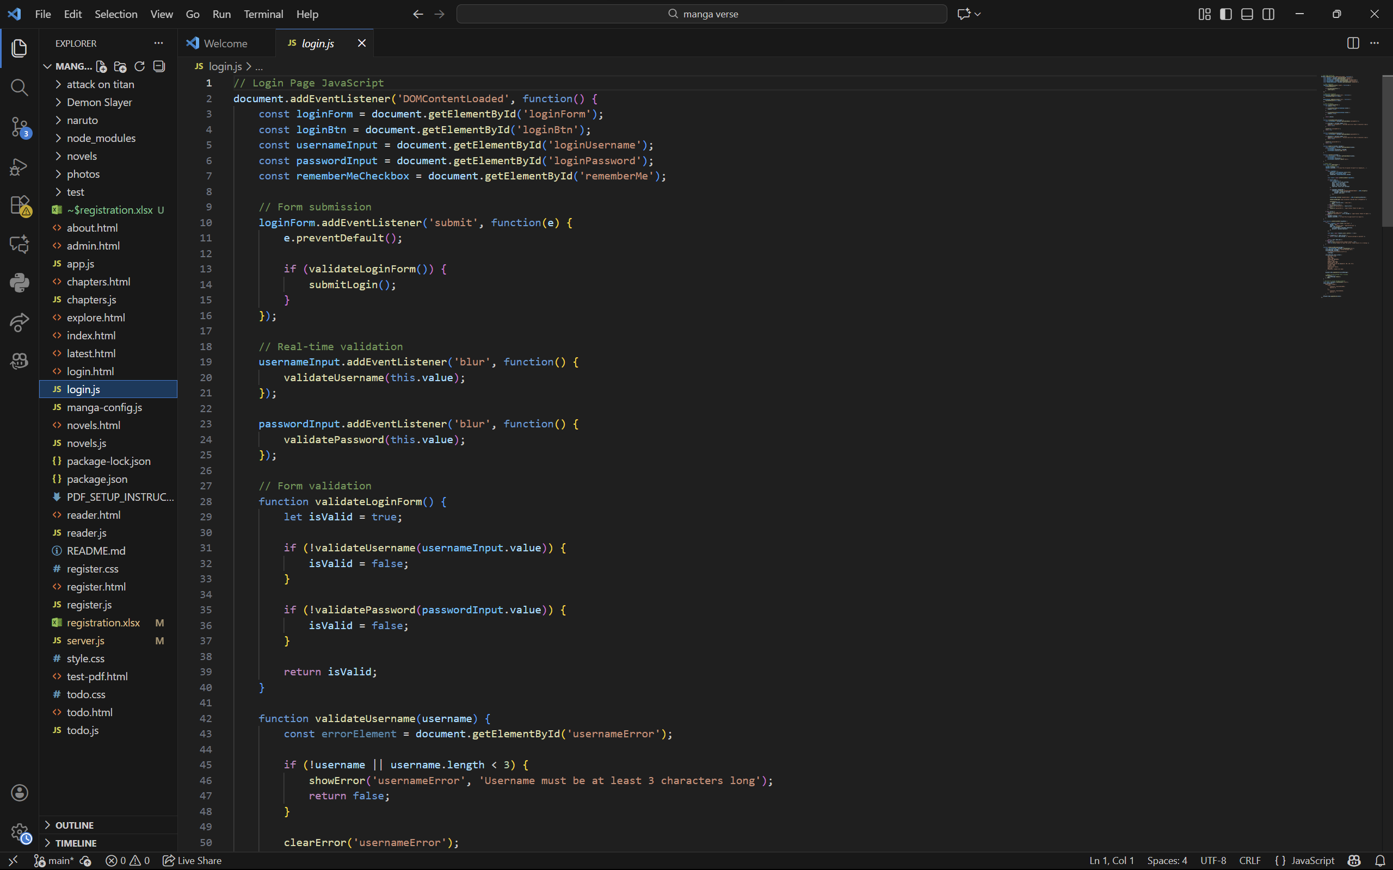
3.4 RESULTS AND DISCUSSION
The Mangaverse system was implemented and tested according to the experimental setup described in the previous section. The results indicate that the platform meets the objectives of providing a lightweight, self-hosted, and user-friendly manga reader.
1. Performance and Loading
- Manga chapters in CBZ and ZIP formats were successfully uploaded, extracted, and displayed.
- Average page load time for a 20-page chapter was approximately 1–2 seconds on a standard desktop environment.
- Even large manga archives with high-resolution images were rendered smoothly without noticeable lag, demonstrating the efficiency of the backend Node.js file handling module.
2. Library Management
- Users were able to add, categorize, and organize manga collections effectively.
- Metadata such as title, author, and genre were displayed correctly and could be used for sorting and searching within the library.
- The library module allowed for quick navigation between chapters, enhancing the user experience.
3. Reader Interface
- The responsive web interface adapted to desktops, tablets, and mobile devices.
- Users could switch between single-page, dual-page, and scroll view modes.
- Zooming, full-screen reading, and theme selection (light/dark mode) worked as expected.
4. Offline and Self-Hosted Access
- Mangaverse successfully demonstrated full offline functionality when hosted locally, ensuring data privacy and security.
- Users could access their manga library without relying on third-party servers or internet connectivity.
5. User Feedback
- Initial testing with multiple users indicated high satisfaction with the interface, ease of navigation, and library management.
- Users appreciated the ability to retain full control over their collections and the simplicity of deploying the system on a local machine.
6. Comparative Advantages
- Compared to traditional web-based or mobile manga readers:
  - Mangaverse provides full privacy due to local hosting.
  - Supports multiple archive formats (CBZ, ZIP) with automated chapter detection.
  - Offers browser-based access, eliminating the need for installation of heavy desktop software.
  - Combines library management, reading, and customization in a single platform.
7. Discussion
The results indicate that Mangaverse effectively fills the gaps identified in the literature review and gap analysis. Users are able to read, organize, and manage manga efficiently while maintaining full control over their data. The combination of Node.js backend, HTML/CSS/JavaScript frontend, and lightweight file-based storage provides a robust solution for self-hosted manga libraries.
Minor limitations observed during testing include:
- Rendering extremely large manga archives (over 100 MB) can occasionally cause slight delays.
- Customization options could be expanded in future versions, such as adding reading progress sync across multiple devices.
Overall, Mangaverse demonstrates that a self-hosted, browser-based manga reader can combine usability, efficiency, and privacy, providing a superior alternative to traditional digital manga platforms.

REFERENCES
- Tachiyomi Team. Tachiyomi – Open Source Manga Reader for Android. [Online]. Available: https://tachiyomi.org/
- MangaDex. MangaDex – Global Manga Community. [Online]. Available: https://mangadex.org/
- CDisplayEx. CDisplayEx – Free Comic Book Reader. [Online]. Available: https://www.cdisplayex.com/
- HoneyView. HoneyView – Image and Comic Viewer for Windows. [Online]. Available: https://www.bandisoft.com/honeyview/
- Node.js Documentation. Node.js – JavaScript Runtime. [Online]. Available: https://nodejs.org/en/docs/
- Express.js Documentation. Express.js – Fast, Unopinionated Web Framework for Node.js. [Online]. Available: https://expressjs.com/
- Mozilla Developer Network (MDN). HTML, CSS, and JavaScript Guides. [Online]. Available: https://developer.mozilla.org/
- CBZ/Comic Book Archives. Understanding CBZ and ZIP File Formats for Comics. [Online]. Available: https://www.file-extensions.org/cbz-file-extension
- R. C. Baker, Building Self-Hosted Digital Libraries with Node.js and JavaScript, Journal of Web Development, vol. 8, no. 2, pp. 45–55, 2022.
- J. Kim and S. Lee, Designing Responsive Web-Based Comic Readers for Desktop and Mobile, International Journal of Multimedia Applications, vol. 15, no. 1, pp. 12–23, 2021.

