1

If **startDate** and **enddate** provided, then -

URL

http://localhost:8081/api/transaction/?startDate=2021-12-03&endDate=2021-12-15

Method Type = GET

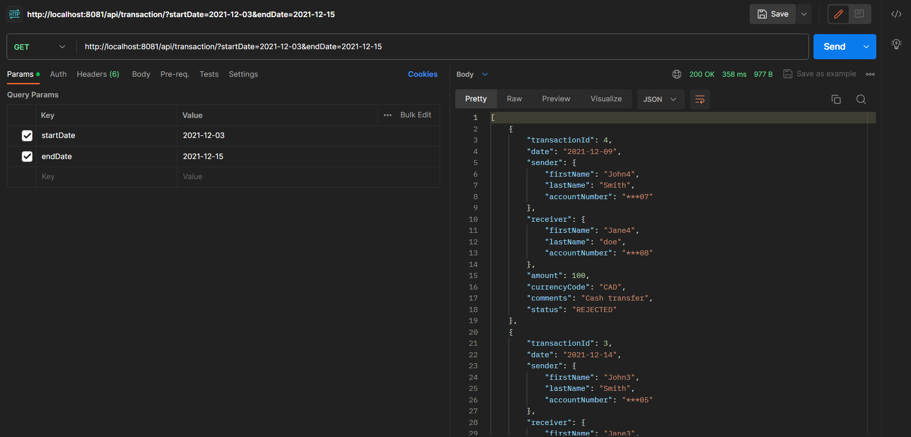

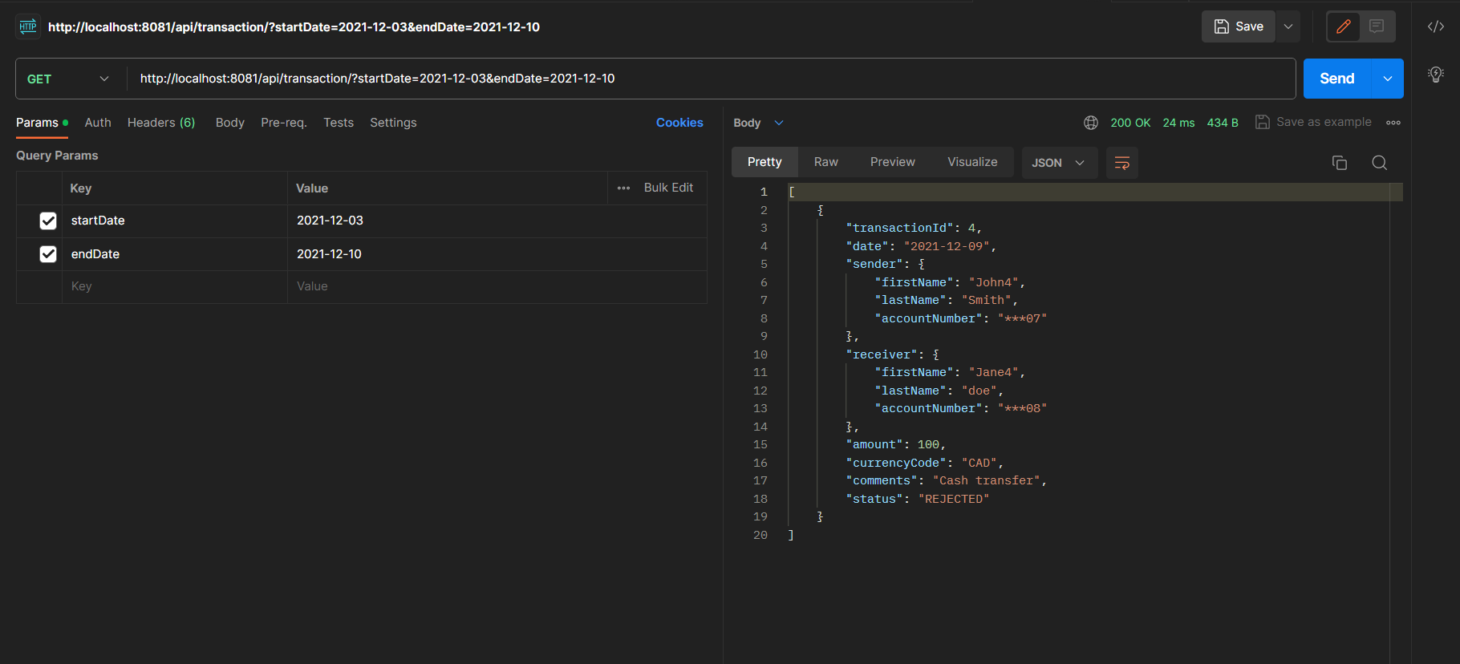

2

If **enddate** not provided user, it will take the current date is the end date

URL

http://localhost:8081/api/transaction/?startDate=2021-12-03

Method Type = GET

