**Software Requirements**

**Specification**

**for**

**Elections Management**

**Software (EMS)**

**Version 1.0**

**Prepared by**

Waynetta Naughton USI: 1039889

Carita Morris USI: 1040410

Kristeen Chase USI: 1039656

Angelique Browne USI: 1035438

Bhudram Singh USI: 1040381

Teyana Shivsankar USI: 1034534

Rokaylia Thomas USI: 1041560

**University Of Guyana**

Faculty Of Natural Sciences

Computer Science Department

**November 16, 2022**

# **Table of Contents**

**Table of Contents** **II**

**1. Introduction** **1**

1.1 Purpose 1

1.2 Intended Audience and Reading Suggestions 1

**2. Overall Description** **2**

2.1 Product Perspective 2

2.2 Product Functions 2

2.3 User Classes and Characteristics 2

2.4 Design and Implementation Constraints 2

2.5 Assumptions and Dependencies 3

**3. System Features** **3**

3.1 System Features and Stimulus Sequence 3

3.1.1 Priority Levels 3

3.2 Functional Requirements 6

3.3 Use Case specification and description 7

3.3.1 Use case specifications 7

3.3.2 Use Case Diagram 11

**4. Other Nonfunctional Requirements** **12**

4.1 Performance Requirements 12

4.1.1 Workload and Response Time 12

4.1.2 Platform and Scalability 12

4.2 Safety Requirements 12

4.3 Security Requirements 13

4.3.1 Confidentiality 13

4.3.2 Integrity 13

4.4 Software Quality Attributes 13

4.4.1 Maintainability 13

4.4.2 Usability 14

4.4.3 Speed 14

4.4.4 Portability 14

4.4.5 Robustness 14

4.5 Business Rules 14

# **Introduction**

## **1.1 Purpose**

The purpose of this document is to outline the development and implementation of a simple and secure Elections Management Software (EMS) that aims to simplify the validation and other background processes, as well as to secure the voting process and ensure confidence in election outcomes produced by the Guyana Elections Commission (GECOM). This document will go over the software's functions and users, as well as detail the constraints that may stymie the project during the design or implementation stages. Most essentially, the document will define the system's features as well as its requirements, regulations, and attributes. In other words, it specifies what the system is going to do.

## **1.2 Intended Audience and Reading Suggestions**

This document is intended for all individuals directly involved in the development of the Elections Management Software. These include software developers, project managers, testers, and marketing personnel, but it is understandable to the broader public, which includes possible users. It is not necessary to read this document in chronological order; in fact, readers are urged to skip to any section that interests them. Having said that, developers should read parts one, two, and three in their entirety. Each section of the document is summarized below.

* Part 1 (Introduction)

This section provides an overview of the Elections Management Software project, including its goals and general purpose.

* Part 2 (Overall Description)

This section goes into more detail about the individual functions, and its users, as well as highlights the design and implementation constraints of the EMS. Additionally, it includes the assumptions and dependencies which are especially directed at the developers of this program.

* Part 3 (System Features)

This section describes the EMS's features as well as the functional requirements associated with these features. It also includes response sequences that stimulate the operation of each feature, as well as the use case diagram for these features.

* Part 4 (Other Nonfunctional Requirements)

This section describes the non-functional requirements, which include the requirements for performance, safety, and security. You can also find a breakdown of the software quality attributes and business regulations that may impact the overall system quality.

# **Overall Description**

## **2.1 Product Perspective**

Our program is a new product developed to replace the use of handwritten records at the GECOM Election. It allows the recording and analyzing of the results produced from the election.

## **2.2 Product Functions**

* The system must allow users (legal voters) to vote for their preferred candidate.
* The system must identify voters before allowing them to vote.
* The system will keep a database of legal voters and their identifying information.
* The system must keep an activity log of all voters using it.
* The system must allow authorized personnel to view activity logs
* The system must allow authorized personnel to update the candidate list.

## **2.3 User Classes and Characteristics**

* **User 1:** Voter

The system is created to cater to this user’s needs and preferences. The voter uses the system once: entering all required identifying information, and selecting and confirming their preferred candidate.

* **User 2:** IT Administrator

This user is employed by GECOM and will be interacting with the system for the entirety of the voting period. Their purpose is to add and/or remove candidates, monitor the system for network disruptions and make sure all system synchronization attempts are successful.

* **User 3:** IT Specialists/ Engineers

This person is provided by the developers, and will be interacting with the system for the entirety of the voting period. Their purpose is to fix any system malfunctions and guide the IT administrators.

## **2.4 Design and Implementation Constraints**

* One of the developers becomes ill during the development process.
* The required development software becomes outdated and therefore unusable.
* The laws of Guyana may change, barring the developers from accessing the voters’ personal information.

## **2.5 Assumptions and Dependencies**

* All developers have working devices to contribute. These devices must also have an appropriate amount of available memory.
* All developers have access to the necessary hardware and software requirements.
* All developers have a thorough knowledge of the system being created.
* All commercial software being used in development remain available for the duration of the development.
* All developers have a consistent internet connection.
* The laws of Guyana do not change in a manner that would impact the development.
* The developers and application in general would have access to a database containing the personal and identifying information of voters.
* The voter information provided is valid.

# **System Features**

System feature is a broad description of functionality.

## 3.1 System Features and Stimulus Sequence

### 3.1.1 Priority Levels

High - critical feature that allows the system to perform its fundamental operation

Medium - supporting feature that will enhance the system’s operation

Low - feature than improves overall quality but is not necessary

**Create profile**

**Description and Priority:**

This feature shall allow users to create a profile which grants them access to the website’s homepage.

**Priority:** Medium

**Stimulus and Responses:**

1. The user clicks the “create button”
2. The system prompts the user to create a new profile
3. Upon successful completion of this action the user is welcome with a home page

**Login**

**Description and Priority:**

This feature shall allow users with an account to login to the homepage.

**Priority:** Medium

**Stimulus and Responses:**

1. If user already has an account;
2. The user clicks the “login’ button
3. The systems allows the user to login into their profile if they have successfully passed the two-step verification
4. Users are now greeted with a home page that asks them to register as either a voter, admin or political party

**Register for admin’s ID**

**Description and Priority:**

This feature shall allow authorized admins to enter information which will be used to validate them to enter the admin page.

**Priority:** High

**Stimulus and Responses:**

1. If user selects “register as admin”;
2. The systems asks for clear identity pictures and the appropriate proof/documents
3. An automated AI systems will scan the documents for verification and compare the information with the official admin list provided by the government to avoid any fraud or impersonation
4. If the admin meets the criteria the systems allows the into the admin home page that has a list of parties, the option to total display votes, the option to edit features on all dashboards and is alerted if there is any obstruction of web traffic or technical problems users might face
5. Admin should be able to modify, add and delete voters, parties information
6. Admin should be able to grant authorities appropriate privileges
7. Admin should be able to modify circumscriptions

**Register for Voter’s ID**

**Description and Priority:**

This feature shall allow prospective voters to enter information that will be used to validate them as eligible voters.

**Priority:** High

**Stimulus and Responses:**

1. If user selects “register as voter”;
2. The system asks for clear identity pictures and the appropriate proof/documents
3. If the verification is successful the user is prompted to cast votes else the user is denied access because of an error e.g they have already voted or they are not on the voters' list or their verification document was invalid

**Validate Voters**

**Description and Priority:**

This feature shall allow admins to validate the registration of prospective voters so that only voters with approved registrations will be allowed to cast a vote.

**Priority:** High

**Stimulus and Responses:**

1. User clicks the “verify me” button;
2. An automated AI system will scan the documents for verification and compare the information with the official voters list provided by the government to avoid any fraud/ invalid votes
3. If the voter meets the criteria the system allows them into the voting homepage that has a list of parties and the option to total display votes

**Cast Votes**

**Description and Priority:**

This feature shall allow eligible voters to select the political party of their choice.

**Priority:** High

**Stimulus and Responses:**

1. After voters have successfully verified their identity and met the voting criteria
2. User clicks the “cast vote button”;
3. The system prompts a voting list of parties to choose from
4. After the user has chosen a party, the system asks for a final confirmation
5. If the user is sure about the vote they can click the “submit” button to confirm or the “cancel” button to change vote
6. If sure clicks “submit” button the system returns a successful message confirming that the vote has been cast
7. If there were any technical errors e.g obstruction of internet and the vote was not cast the system returns an error message that prompts the user to repeat the casting process

**Register for “Election authority ID”**

**Description and Priority:**

This feature shall allow users to enter information which will be used to validate them to have authorized access to the system.

**Priority:** Medium

**Stimulus and Responses:**

1. If user clicks “register for election authority ID”;
2. The system prompts the user to provide verification/identification documents
3. The system then sends a notification to the admin for approval/denial of access
4. If the user is approved they will have the privilege to view results, generate reports, and publish results else the user is denied access.

**Publish results**

**Description and Priority:**

This feature shall allow election authorities to generate and publish the results of the elections once the voting period is over.

**Priority:** High

**Stimulus and Responses:**

1. Election authority clicks “publish results” button;
2. The systems prompts the election authority to use generated results and publish elections results e.g; the winner and each parties number of votes and the location of voters(region), along with the filtered amount of voters from each region

**Display results**

**Description and Priority**

This feature shall allow users to view the statistics of the election once the voting period is over.

**Priority:** Medium

**Stimulus and Responses:**

1. User clicks “view election results”;
2. The system displays the votes of the election and the appropriate parties vote counts
3. If user clicks “exit results” the system returns user to the homepage

## 3.2 Functional Requirements

1. The system should allow the user to create a new account if they don't already have one
2. The system should authenticate user login using the two-step encryption login mechanism
3. The system should allow the user to choose the account type appropriate to them
4. The system should allow the admin to view statistical report of election and monitor election
5. The system should allow the admin to make changes that would fix any unexpected events
6. The system should alert the admin of any suspicious activities
7. The system should allow admin to grant privileges to election authorities
8. The system should allow the election authorities to generate results
9. The system should allow the election authorities to publish results
10. The system should allow the user to upload ID documents
11. The system should compare the ID information with the information given by GECOM and the government to ensure there is no fraud
12. The system should deny access to anyone who doesn't meet the voting criteria e.g under 18, has voted already, is not on the voters' list, or insufficient ID proof
13. The system should allow the user to access the home page and dashboard upon successful verification of ID
14. The system should save user information
15. The system should save user choice
16. The system should allow the user to cast votes and display election results upon entering the dashboard
17. The system should allow the user to choose their preferred party
18. The system should add a point to each party that receives a vote and total the results automatically
19. The system should send the user a confirmation message if the vote has been cast successfully
20. The system should send the user an error message if the was any technical difficulties during the casting of votes e.g obstruction of the internet, or web traffic
21. The system should allow the user to return to the home page after the vote has been cast
22. The system should allow the user to view election results

## 3.3 Use Case specification and description

### 3.3.1 Use case specifications

| Use Case  UC1 | Create Profile/login |
| --- | --- |
| Summary | Create a user profile if the user has not yet been registered |
| Actor | Voter and election authority |
| Precondition | Sytem should be ready to verify account |
| Description | Basic path  Created the account successfully and pending user identification documents  Alternative path  User already have an account and is asked to login instead |

| Use Case  UC2 | Register |
| --- | --- |
| Summary | Registration for online election |
| Actor | Voter, admin, election authority |
| Precondition | System should be able to grant access upon successful registration |
| Description | Basic path  Identification confirmed and user is greeted with the software’s dashboard to cast votes or view results  Alternative path  Access denied because of invalid identification or user has already registered |

| Use Case  UC3 | Registration for admins ID |
| --- | --- |
| Summary | Confirming admin ID to be granted privileges |
| Actor | Admin |
| Precondition | System should have a list of admins who can access the system |
| Description | Basic path  Admin is verified and gets privileges  Alternative path  User denied and prompt to change registration type |

| Use Case  UC4 | Registration for Voter’s ID |
| --- | --- |
| Summary | Register for voters ID and confirmation of voters eligibility |
| Actor | Voter |
| Precondition | System should be connected to the voters' list database system and ready to make verifications |
| Description | Basic path  Voter is verified and greeted with the voter’s home page  Alternative path  User is denied access because of invalid ID or has already registered |

| Use Case  UC5 | Registration for election authority ID |
| --- | --- |
| Summary | Registration of election authority and prompts admin to verify user |
| Actor | Election authority |
| Precondition | System must have a list of personnel who will be given privileges to make changes and publish results. |
| Description | Basic path  User is granted access and is allowed to perform tasks  Alternative path  User is denied access because of invalid identification |

| Use Case  UC6 | Cast votes |
| --- | --- |
| Summary | System records successful votes and point is given to voters specified party |
| Actor | Voter |
| Precondition | System must collect voters choice, save choice and add points to chosen party |
| Description | Basic path  User has successfully cast votes and is given a confirmation message  Alternative path  Votes has not been sent because of technical issues e.g obstruction of internet |

| Use Case  UC7 | Publish votes |
| --- | --- |
| Summary | After results have been generated the election authority has the privilege of publishing results |
| Actor | Election authority |
| Precondition | System should have already granted privileges to election authority to user the publish results function |
| Description | Basic path  Results has been successfully published  Alternative path  Results has not been published because of technical issues which the admin should resolve |

| Use Case  UC8 | Display results |
| --- | --- |
| Summary | Voters are allowed to view election results after the elections authority has published the results |
| Actor | Voter |
| Precondition | Voters must have successfully registered and cast votes |
| Description | Basic path  Results is displayed  Alternative path  Results are not displayed because of internet obstruction or web traffic |

### 3.3.2 Use Case Diagram

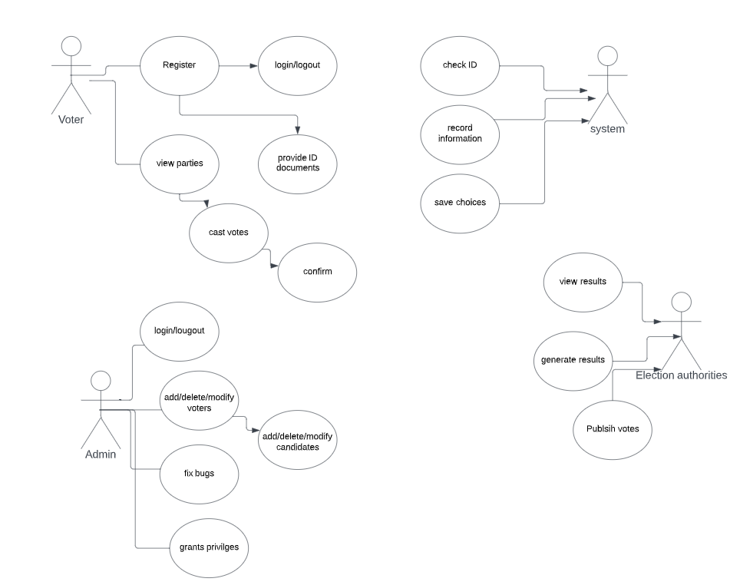

Figure 1. Diagram showing use case

# Other Nonfunctional Requirements

Non-functional requirements of the voting system that are not explicit functions of the system, however, do play an integral role in optimizing the system’s overall performance.

## 4.1 Performance Requirements

### 4.1.1 Workload and Response Time

The system should be able to manage a large quantity of users at once for the provision of a speedy voting process where users will not need to worry about things like a system crash or a drastic deceleration in the response time of the system. This would be achieved by equipping the machines used to capture data with enough disk space, memory and processing power to handle the amount of data that will be inputted into the databases.

### 4.1.2 Platform and Scalability

As the users will be entering different sets of information on the web, it is best to have a dynamic web application. The web application will be linked to a database which will be normalized so as to prevent data redundancy. The mentioned strategies will be continuously analyzed over time and adjustments will be made based on the requirements of the system. Constructing an application which will be easily understood by voters will coherently be easier to manage.

## 4.2 Safety Requirements

With regards to possible harm that can be caused when a voter is using the software via their electronic devices, the majority of possibilities will be faults that are beyond our control. On the other hand, the equipment that will be used to house and make our product accessible—hardware requirements (computers, routers, backup systems, etc.)—will be kept under optimal safety practices. This would include: keeping the equipment in a cool environment; proper cable storage; optimizing electricity usage (using the right voltage, shutting off the power when items are not in use); keeping fire safety equipment at hand. In addition, periodic checks will be conducted on the equipment to check for faults and to maintain them.

## 4.3 Security Requirements

### 4.3.1 Confidentiality

As the eligible citizens of Guyana will be required to input their personal data into the system, it is prerogative that the system provides all users with extreme confidentiality in how their data will be collected, handled, processed and stored.

This would include:

1. Ensuring that users go through a two-step authentication process whenever they log in to their voting portal. These would include entering both their username and passwords where they would be notified and asked to verify their identity by a third party (such as their mobile device through SMS).

2. Ensuring that the users’ passwords are hashed

3. Encrypting their data in such a way that it is decrypted only when authorized personnel access the database.

### 4.3.2 Integrity

In conjunction with the voting system’s confidentiality, there would also be measures put in place such as privacy policies to assure the users that the system is safe to use and that everything said about the system is true.

Such privacy policies would include:

1. All personal data about you will be used only to verify your identity.
2. Most of your personal data will be kept if and only if your account is open
3. Your password will only be saved to our database if you make the decision to save it to our system.

## 4.4 Software Quality Attributes

### 4.4.1 Maintainability

The Elections Voting System will be built in such a way that there will be an ease to continuously enhance the system over time. Proper documentation will be put in place in case other developers will have to develop the system and will need to understand both the frontend and backend of how it is built and how it works to ensure that effective enhancements will be done.

### 4.4.2 Usability

Since this application will be used by the adult population (18+), it will cater to those that are not familiar with modern technology usage. The user interface will make interaction as simple as possible.

### 4.4.3 Speed

The application will be utilized by the masses, so speed is a crucial requirement. The system will be built by optimizing computing resources however the developers see fit.

### 4.4.4 Portability

The operating systems of users’ devices may vary depending on personal preference, financial standing, etc. The developers will therefore also construct in a language that is universally compatible with operating systems across the board.

### 4.4.5 Robustness

In the case that there are issues with regard to hardware, software, or user-induced faults, the developers will seek to cater for anticipated errors.

* User related- eg. Wrong input from the voter. The system will display instructions on how to eradicate the problem and lead the user back to safety.
* Hardware- there will be backup systems in place to replace damaged instruments.
* Software- to detect errors so that the probability of them occurring upon implementation, extensive testing (run-time as well as compile-time checking) and validation will be done on the software.

## 4.5 Business Rules

GECOM, like most voting authorities, has a series of rules in place to make sure the election process runs smoothly. These rules will be integrated into the election management software.

1. Only Guyanese citizens who are 18 years old or above can vote in elections.
2. Users must be verified before voting so as to prevent them from voting multiple times or voting ineligibly.
3. Only authorised users can register potential voters, and access, view and monitor voting and election statistics.
4. Only authorised users can access reports generated by the software after the voting period has ended.

If users do not meet the criteria or have not been granted access to the system or functions within the system, the system will restrict them and display error messages.