**INFLATION! INFLATION! INFLATION! We can’t avoid**

Almost everyone reading this article would be aware of the term inflation. Reiterating it again, Inflation is the rise in prices of goods and services over a period of time. Inflation is generally expressed as percentage. As inflation rises i.e as prices start rising, each rupee we hold buys fewer and fewer goods. The following example is a very old one but I couldn’t think of something better than this for conveying what is inflation. Some 5-6 years back if you had 50 Rupees we could have bought 1 litre of petrol. But now with the same 50 rupees we could only buy half a litre petrol. There are multiple factors that causes prices of goods to rise such as demand-supply mismatch, money supply in the economy, and so on. Maintaining a steady rate of inflation irrespective of these factors is one of the main jobs of Reserve Bank of India (RBI) or the Federal Reserve (USA) or any other Central bank in the world. Inflation is not bad, but high inflation is the one that causes troubles. Moderate inflation causes consumers to spend today rather than saving for tomorrow which in turn feeds economic growth.

As mentioned before there are several factors playing out with inflation. I have taken 3 factors: Interest rates, Money supply and Exchange rates. There are some general conceptions like lowering interest rates increase inflation, more money supply means higher inflation, etc. The objective of this article is to find out whether the data supports these assumptions. The data was collected from multiple sources and I have listed some of the sources at the end. The plots were drawn using **Plotly** (Python library). It’s a long article. I didn’t know how to summarize this content further. Please bear with me.

**Inflation in India**

Let’s first look at how inflation has fared in India from 1960 till now. In recent times after the pandemic and especially after the Russia-Ukraine war, inflation is seeing a steep rise and it is being seriously discussed. But hasn’t inflation seen such high’s before? Lets find out

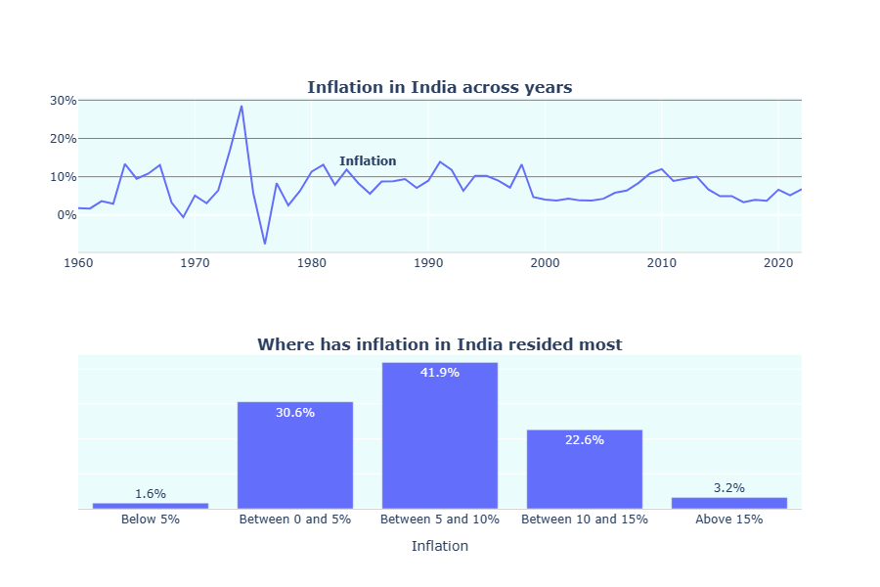

No, in India from 1960 to today above 40% of the times inflation has exceeded 10%. From 2000's inflation has remained well in control except two occasions where it has marginally crossed 10%. Only in 90's inflation has been erratic. There could have been various factors contributing to them which I won't explore in this blog. Comparatively the current rise in inflation is not bad as it seems.

**CPI**

Before getting into the factors affecting inflation let us know how inflation is measured. The Consumer Price Index (CPI) analyses the price levels of certain goods in the economy and estimates the inflation levels in the country. The goods included represents items indispensable for consumers in the economy. The items are grouped into segments such as Milk & Products, Transportation, etc and each segment is given a weightage upon which CPI is calculated. Essentially CPI tracks the change in price of this basket of goods year on year. Currently in the past 2 years inflation has remained a bit high. Let’s see which product segment has contributed more to this rising inflation in India. There is a separate CPI basket each for rural and urban India and product categories for those baskets differ from each other. I have analysed both the baskets individually.

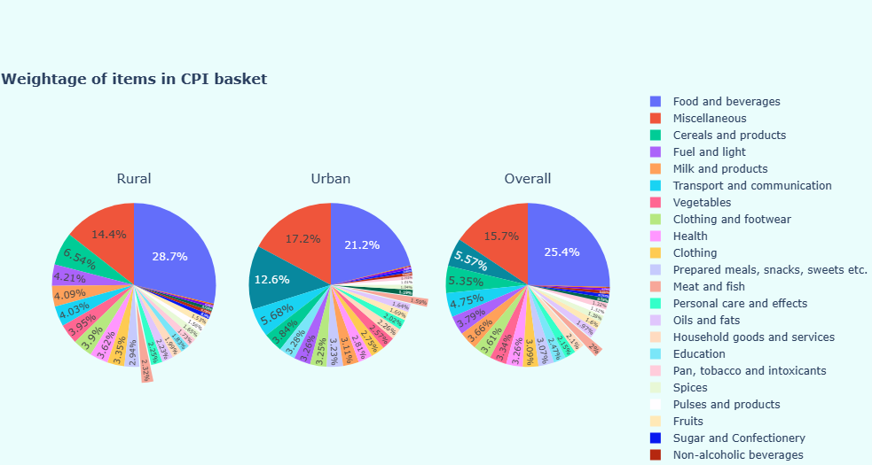

From the above chart it is evident that the weightage of goods differs across rural and urban India. For example, in rural side Foods and Beverages constitute 28% while in urban areas the same category constitutes 21%. In urban India, housing as a category constitutes 12.6% of weightage whereas in rural India housing is not even included in the basket.

In the below plot I have selected some important categories and compared the rise of prices from April 2021 to December 2022. For example, whenever there is a rise in inflation our general assumption is rise in fuel prices is the reason. But from 2021-2022, vegetables and spices have been two groups attributing more to the inflation followed by fuel. The reason for high prices of vegetables could either be high demand or supply side issues. Starting from the pandemic, fertilizer prices have also been very high which could be another reason.

From the below charts one interesting insight is, RBI in its latest press release has announced that inflation has come down to 5.72% in the month of December which is lowest in the past 1 year and it is also within the 2-6% tolerance limit fixed by RBI. But **the** **major reason for the fall in inflation is vegetable prices which have drastically come down from Oct-Dec 22. If we exclude vegetables then actually inflation should have increased year on year.**

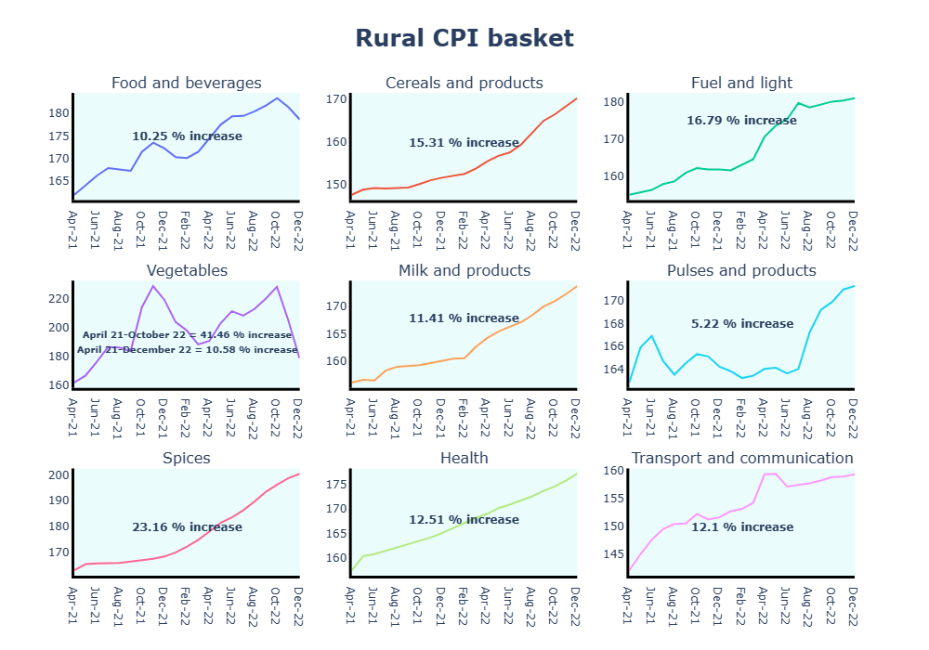

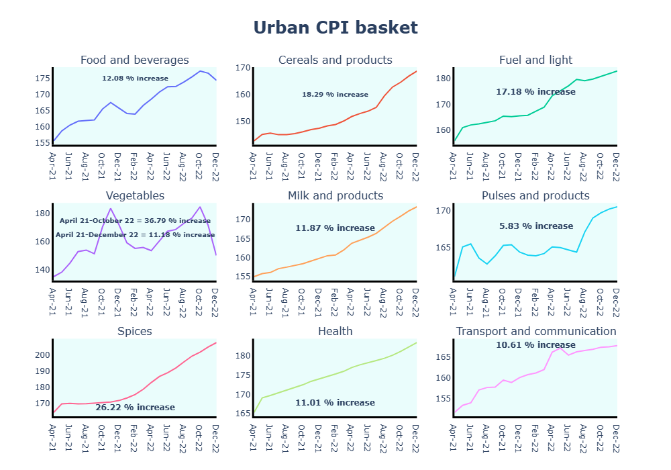

Next let us start exploring the relationship between inflation and other factors.

**Interest rate and Inflation**

When we hear the word 'inflation', the next word that immediately pops up in the minds of people with some exposure to economics and finance is interest rate. Interest rate and inflation are very much associated. This is because the first and foremost tool used by Federal Reserve or RBI or any other central bank around the world to keep inflation in control is interest rate. Central banks raise interest rates when the inflation is high i.e people are spending more and lower interest rate when the economy is down or they want people to spend more. The general ideology is when interest rates are low, it would encourage people to take more loans, people will spend more in luxury purchases, factories can undergo expansion, this in turn leads to more employment, increased wages and puts more money in the hands of people and they start purchasing more. This leads to more demand for products increasing the prices of products leading to inflation. When inflation starts exceeding certain limits the central reserve steps in and raises interest rate to lower the money circulation bringing inflation down. But it is not as simple as it seems. There are innumerable factors arising out of nowhere to cause havoc to the above- mentioned scenario and the best examples would be the Covid pandemic followed by the Russia-Ukraine war. These are the most recent instances and if we recall the past there have been more such incidents which had caused headaches to the monetary policy committees of various countries. But the role of interest rate doesn't stop with inflation. For example, lowering interest rates has a positive impact on stock markets and vice-versa.

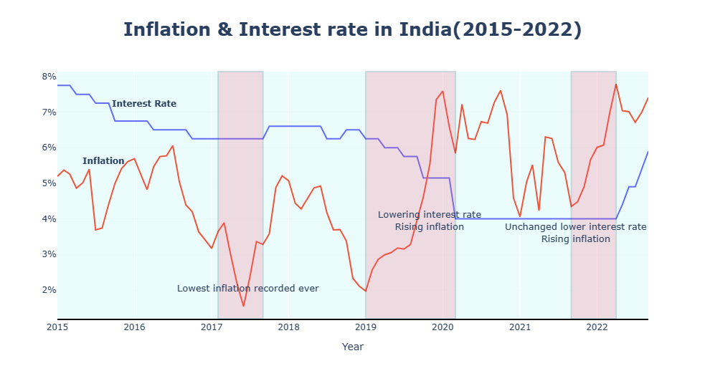

The above chart represents the trajectory of inflation rates and interest rates in India from 2015-2022. As per the theoretical rule, as interest rates rise inflation should fall down. But in reality this is not possible. Policymakers respond to changes in economic outlook with a lag, and their policy changes, in turn, take time to affect inflation trends. In the above chart from January 2019 to January 2020 a sustained decrease in interest rates resulted in inflation peaking to very high levels. It is to be noted that inflation was on a high even before the pandemic began. After the onset of pandemic to reduce the impact of the economic damage, RBI kept interest rates unchanged and inflation was also low upto a certain point and after which this strategy backfired and inflation saw an alarming rise. But supply chain issues due to Russia-Ukraine war also acted as a catalyst. Now RBI is in the process of increasing rates swiftly and as a result inflation has started to cool down.

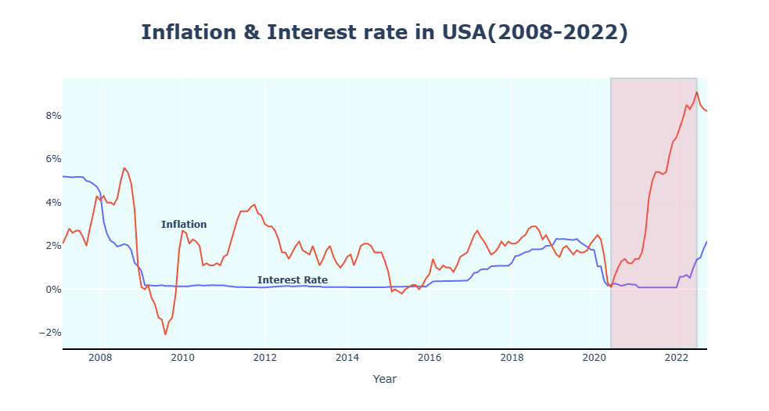

Historically Fed has maintained a lower interest rate (compared to India) and its inflation has also not seen much fluctuation. But starting with the pandemic, unchanged interest rates pushed inflation to never seen before levels in USA (In USA only in 1980 inflation reached above 13%) and only in the beginning of January Fed started increasing interest rates.

**How interest rate and inflation increase/decreased**

**in major economies?**

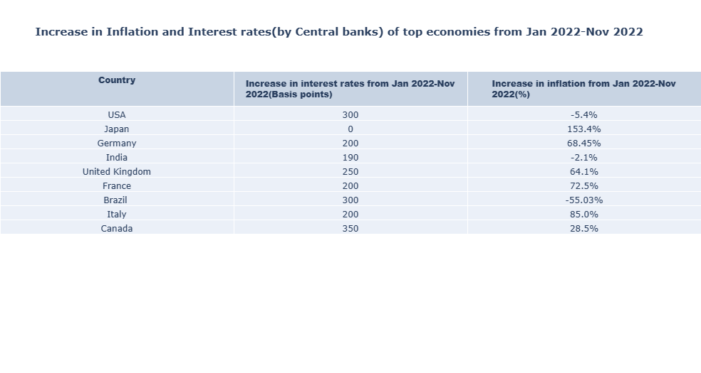

Most major economies in the world kept their interest rates unchanged during the pandemic and started raising rates from beginning of 2022. Interest rates have been increased by the central banks in quick successions with USA, UK and Canada posting double digit increase in interest rates in the period in consideration. Out of the major economies India, USA and Brazil have seen a fall in inflation from January to November. **Brazil is the only country with the steepest decrease in inflation from Jan to Nov 2022 and the reason might be that Brazil was the only country which started increasing its lending rates starting with 2021 while all other economies kept their interest rates unchanged during 2021.** In India and USA inflation has come down a bit after very long period of increase. Japan has kept its interest rates undisturbed and it has seen the maximum increase in inflation rates within this time period.

**Money supply and Inflation**

In an economy when money supply outpaces the ability to produce goods, it often results in inflation. When money supply grows consumers are willing to spend more but if production of goods and services remains same then consumers are willing to pay more for the same goods. In the below plot I have considered the growth in M3 money supply which includes the currency in the hands of the public, deposit money of the public and the deposits in the banking system with CPI.

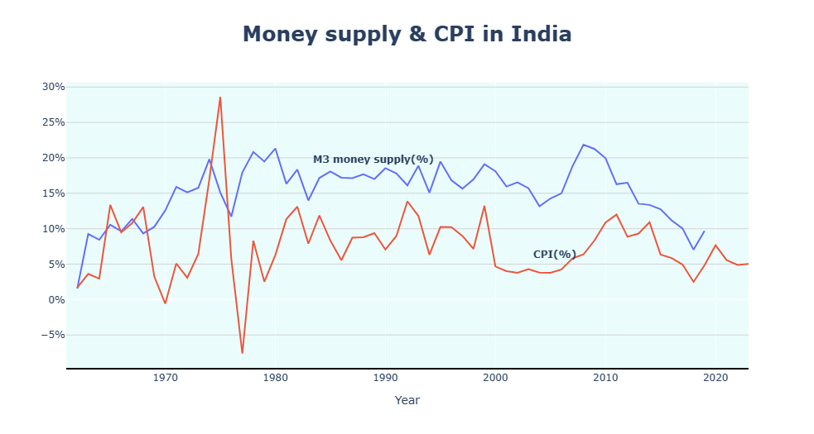

From the above plot it is evident that inflation closely follows money supply in the economy. Every time there is an increase in money supply there is a corresponding increase in inflation. We can't conclude that inflation is determined by money supply. But more money supply/circulation in the economy is also one of the factors contributing to inflation.

**Exchange rates and Inflation**

Exchange rate is the value of a currency in terms of currency of some other nation. At the time of writing this article US Dollar exchange rate was at 81.52 Rupees which means to buy 1 US Dollar we need 81.52 Rupees. If the value of rupees increases from here then we call it rupee depreciation because for every dollar we are paying more rupees. Inflation is closely associated with interest rates which in turn influences exchange rates. Higher interest rates attract more foreign investments whereas lower interest rates tends to do the opposite. Let’s say in USA interest rate is at 2% whereas in India interest rate is at 4%. Automatically investors in USA would be interested in investing in India because of the difference in interest rates. When interest rates are increasing in USA itself the investors don’t have significant benefits to invest in India. In fact, it is a risk to invest in emerging economies during periods of volatility. Hence when the interest rates in India is higher compared to our counterparts more foreign funds will flow into our nation generating higher demand for our currency which means appreciation of our currency. There is also another scenario where exchange rate affects inflation and this time the impact will be on trade of goods. When our currency value depreciates, we need to pay more for every dollar of good imported. For example, India meets 85% of crude oil needs via imports. If crude oil prices increase then petrol/diesel prices will also increase which means transportation of goods domestically also increases which will increase the retail prices of goods leading to inflation. This is called imported inflation. In general, when we import more than we export, there is a less demand for our currency across the global economy. An additional fact, when a currency depreciates it makes imports expensive and exports cheaper and some countries engage in currency manipulation to enjoy this benefit.

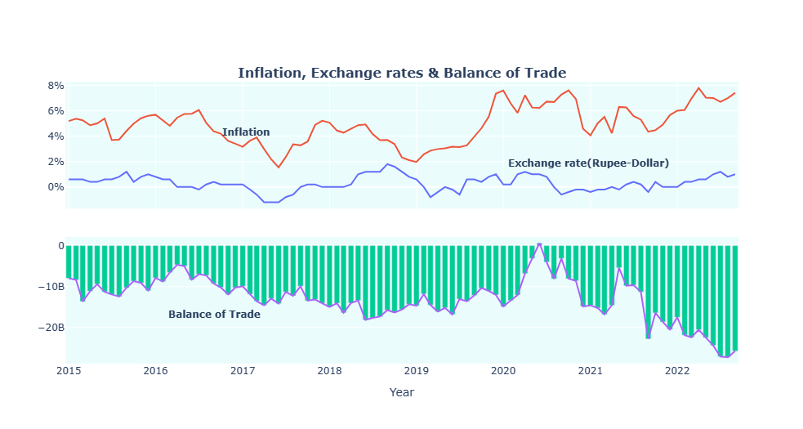

In the above plot, red and blue lines depict inflation and exchange rate in terms of percentage growth respectively. Whenever there is an appreciation in our currency value (i.e rupee-dollar exchange rate decreases) then inflation is lower during that period and periods of high inflation corresponds to a modest depreciation in currency value. This is not conclusive but it is pretty much evident when we look at the graph. The green bars represent the Balance of Trade in India (i.e Value of Exports - Value of imports). From the graph it is clear that there is no strong relationship between exchange rate and trade account balance as well as inflation and trade account balance. This is because in the past 13 years India has recorded a trade surplus only once in the last quarter of 2019-2020 and on every other occasion, we have only encountered trade deficit.

Crude oil prices have most influenced the Balance of Trade. Whenever crude oil prices have fallen down trade deficit has significantly come down and when crude oil prices touched record lows India recorded a trade surplus immediately. From 2020 onwards a depreciating rupee has made our trade deficits worse.

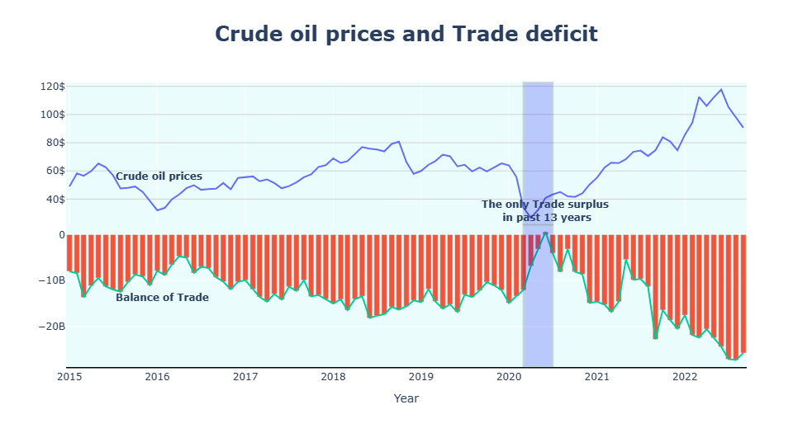

Thanks to those who are still reading. Inflation is one of the vital and fundamental topics in the field of macroeconomics. Most articles about inflation briefly explain the theoretical concepts surrounding it but I wanted to explore if data supports the theory. As a result, I have summarized some of my insights into this article. I haven’t arrived at any conclusion or inference. Some of the facts in this article might be wrong. Please feel free to correct if I am wrong (Don’t be too harsh). Also please provide your feedback if I could improve upon anything.

**THANKS FOR READING. I REALLY MEAN IT**