# **Question 1: School Uniform Combinations**

Calculate possible uniform combinations based on color choices

Each student at East High School wears a uniform consisting of 1 shirt, 1 pair of pants, and 1 tie. The table shows the colors available for each item of clothing. How many different complete uniforms are possible?

## Uniform Choices

|  |  |  |
| --- | --- | --- |
| Shirt Color | Pants Color | Tie Color |
| White | Black | Red |
| Blue | Navy | Blue |
| Gray | Khaki | Green |
| Yellow |  | Yellow |

**Instruction:** Calculate all possible combinations considering available colors

## **Options:**

* ○ 6
* ○ 9
* ✓ 12
* ○ 15
* ○ 18

**Difficulty:**

moderate

**Explanation:**

There are 3 shirt options (White, Blue, Gray), 2 pants options (Black, Navy), and 2 tie options (Red, Blue). Total combinations are 3 × 2 × 2 = 12. Yellow shirt has no matching pants, so it cannot form a complete uniform.

**Subject:**

Quantitative Math > Problem Solving > Counting Principles

**Marks:**

1

# **Question 2: Packed Spheres Dimensions**

Calculate dimensions of a rectangular package containing spheres

The top view of a rectangular package of 8 tightly packed balls is shown. If each ball has a radius of 3 centimeters, which of the following are closest to the dimensions, in centimeters, of the rectangular package?

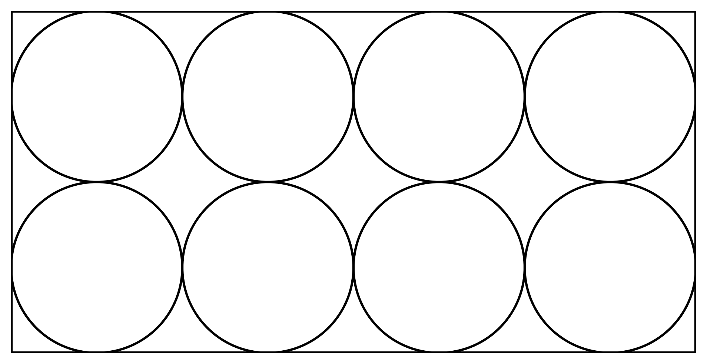

**Instruction:** Calculate based on sphere diameter and packing arrangement

## **Options:**

* ○ 6 × 12 × 6
* ○ 6 × 24 × 6
* ✓ 6 × 24 × 12
* ○ 12 × 24 × 12
* ○ 12 × 24 × 24

**Difficulty:**

hard

**Explanation:**

Each ball has diameter 6 cm (2 × radius). The package width would be 4 × 6 cm = 24 cm, height 2 × 6 cm = 12 cm, and depth equal to diameter = 6 cm.

**Subject:**

Quantitative Math > Geometry and Measurement > Volume

**Marks:**

1