Class Diagram : #1 Bhulakshmi Makkena

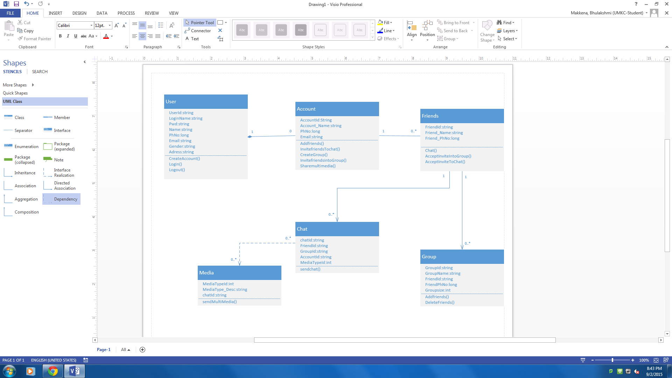

#2

