Assignment-8

Login page

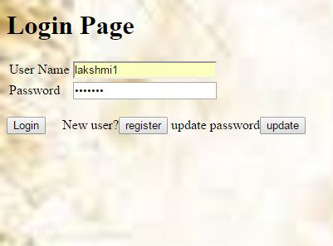

Login in MongoDB

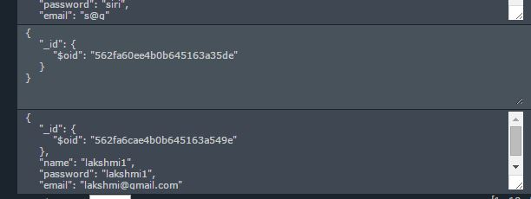

Register Page

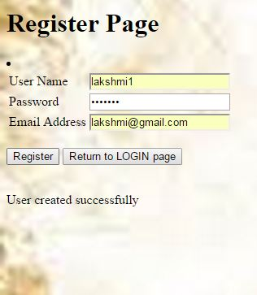

Register Page MongoDB



Updation Page

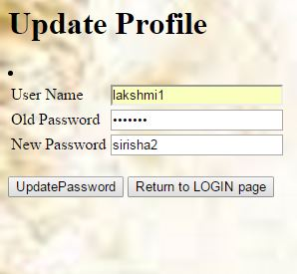

Update MongoDB

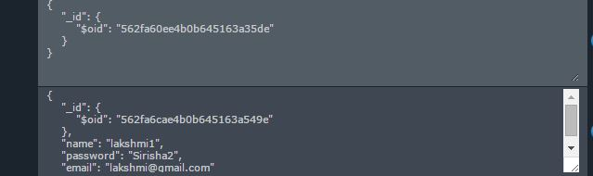

WebSphere Retrieval of MongoDb

