**Assignment-5**

**Team:4**

**Harshi priya Yarragonda**

**Bhulakshmi Makkena**

**Naga Mounica Dandlamudi**

**GitHub URL**

**Graph algorithm**

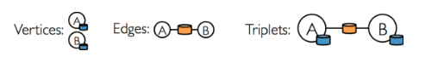

**Page Rank**



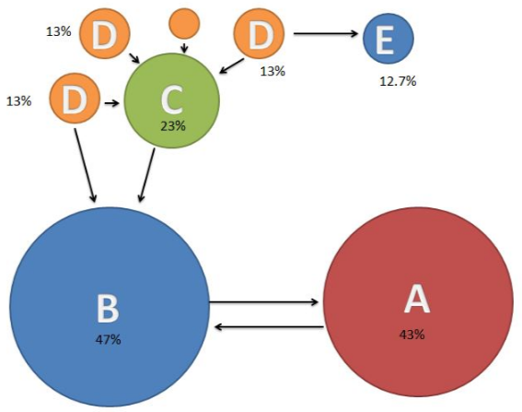

**Input Dataset**

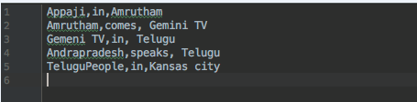

**Code Snippet**

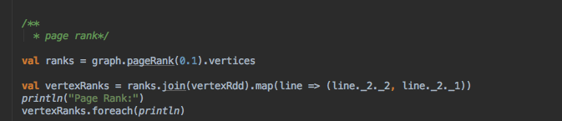

**Output values**

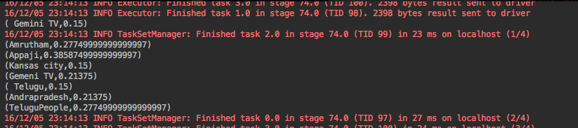

**Connected Components**



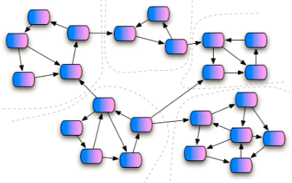

**Input Dataset**



**Code snippet**

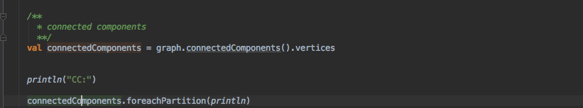

**Output values**

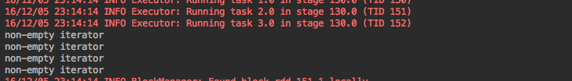

**Triangle Counting**

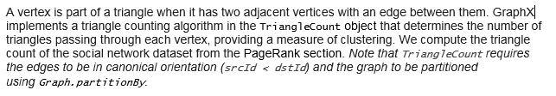

**Input Dataset**



**Output values**

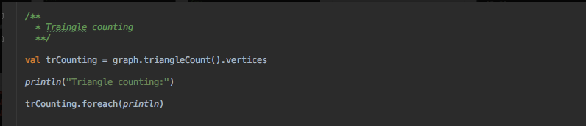

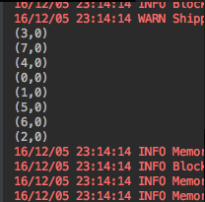

**Partition strategies**



**Input Dataset**



**Code snippet**



