Using Python

Installing python
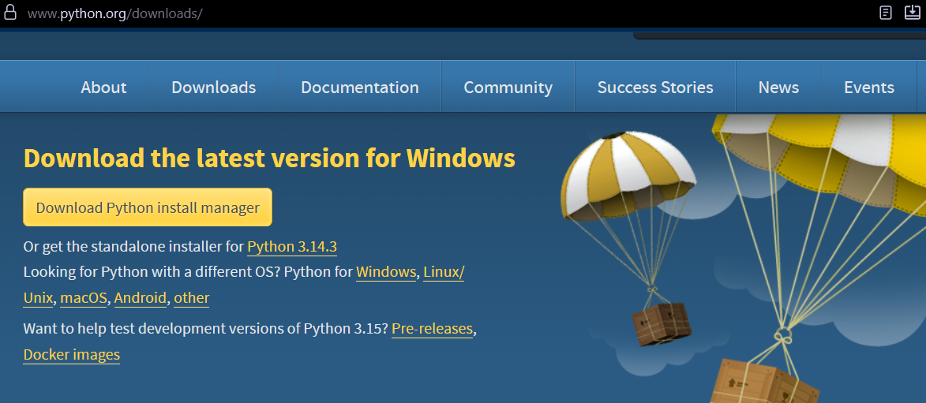
Download from the website and run through the entire install process run through using an administrator account with admin permissions.

Check the python version
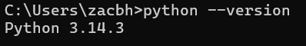

Check python works in cmd

Hello world
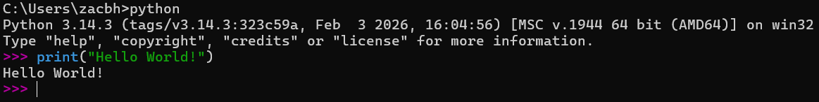
Using python will open the editor, then test you’re in the editor by using a simple call like print() to confirm it’s working.

The Zen of Python
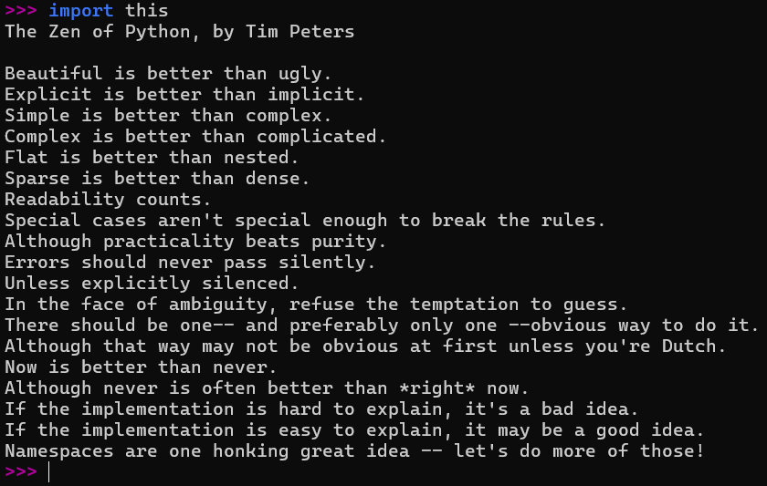

Exit
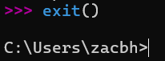
Using exit() will exit the editor

Fundamentals

Variables
A variable is a mutable named storage location.

Constants
A constant is an immutable named storage location. Enforcing constants is not “pythonic”, as such, Python does not allow for constants.

Data types

Character
A character or a ‘char’ is a single unicode or ascii symbol, depending on the system.

String
A string is a ‘string of text’, as such any character can be included in a string.

Integer
An integer is a numerical whole number, i.e., 0, 1, 2 or 10, but not 1.2 as that is not a whole number. Integers can be negative or positive values.

Float
A float is a numeric value that includes fractional parts and decimal points, i.e., 1.2, 10.9 or even 1.0, but not 1. All floating point numbers must have a ‘floating’ or ‘decimal’ point, so 1 becomes 1.0.

Boolean
A boolean value is either True or False. Booleans are logical values that can have logical operations performed on them. Boolean values are base 2, meaning there will only ever be two options for Boolean values. Usually most people represent this as True or False, but it could also be 1 or 0, in accordance with binary.

Operations

Strings
Useful String Methods | Print & User Input
name = "Python"​  greeting = 'Hello'​  ​  # Concatenation​  full = greeting + ", " + name # Hello, Python​  ​  # Length​  print(len(name)) # 6​  ​  # Upper / Lower​  print(name.upper()) # PYTHON​  print(name.lower()) # python​  ​  # f-strings (modern way!)​  age = 30​  print(f"My age is {age}") # My age is 30 | s = " Hello, Python World! "​  ​  print(s.strip()) # Remove whitespace​  print(s.replace("Python", "Beautiful"))​  print(s.split(",")) # [' Hello', ' Python...']​  print(s.startswith(" Hello")) # True​  print(s.endswith("! ")) # True​  print(s.find("Python")) # 9 (index)​  print(s.count("l")) # 3​  print("42".isnumeric()) # True​  print("hello".capitalize()) # Hello​  print("hi".center(10, "*")) # ****hi****

Arithmetic
Standard Operators | Real examples
a = 10​  b = 3​  print(a + b) # 13 — Addition​  print(a - b) # 7 — Subtraction​  print(a * b) # 30 — Multiplication​  print(a / b) # 3.333 — True Division​  print(a // b) # 3 — Floor Division​  print(a % b) # 1 — Modulus (remainder)​  print(a ** b) # 1000 — Exponentiation​ | # Real example: km to miles​  km = 100​  miles = km * 0.621371​  print(f"{km} km = {miles:.2f} miles")​

Operator​ | Symbol​ | Example​
Addition​ | +​ | 5 + 3 = 8​
Subtraction​ | -​ | 5 - 3 = 2​
Multiply​ | *​ | 5 * 3 = 15​
Divide​ | /​ | 5 / 2 = 2.5​
Floor Div​ | //​ | 5 // 2 = 2​
Modulus​ | %​ | 5 % 2 = 1​
Power | ** | 2 ** 8 = 256

Assignment

Assignment Operators
Assignment operators are short cut operators to manipulate a variable's values.
x = 10 # Basic assignment
x += 5 # x = x + 5 → 15​
x -= 3 # x = x - 3 → 12​
x *= 2 # x = x * 2 → 24​
x /= 4 # x = x / 4 → 6.0​
x //= 2 # x = x // 2 → 3.0​
x **= 3 # x = x ** 3 → 27.0​
x %= 5 # x = x % 5 → 2.0​
# String multiplication!​
line = "-" * 20​
print(line) # --------------------​
word = "Ha"​
print(word * 3) # HaHaHa

Logic

Comparison | Logical
a, b = 10, 5  # Comparison (returns True or False)​  print(a == b) # False — equal​  print(a != b) # True — not equal​  print(a > b) # True — greater than​  print(a < b) # False — less than​  print(a >= 10) # True — greater or equal​  print(a <= 9) # False — less or equal | a, b = 10, 5  # Logical operators​  print(a > 5 and b < 10) # True (both true)  print(a > 15 or b < 10) # True (one is true)​  print(not a > 5) # False (flipped)

Logic Tables
A | B | And | Or | Not (A) | XOR | Not (A) And B
0 | 0 | 0 | 0 | 1 | 0 | 0
0 | 1 | 0 | 1 | 1 | 1 | 1
1 | 0 | 0 | 1 | 0 | 1 | 0
1 | 1 | 1 | 1 | 0 | 0 | 0

