Activity: Navigating and Creating Files Using Command Line

Aim
Learners will use basic command line commands to view folders, move between directories, create a new folder, and create a text file.

Duration
20–30 minutes (online or classroom).

Step-by-Step Learner Task
- Part 1 – View the Working Directory:
Open Command Prompt, type 'dir', and observe the list of files and folders.
Question: What does the 'dir' command show?
Ans: It shows a list of files and folders that are immediately one level below the current folder.
- Part 2 – Create a New Folder:
Type 'mkdir BootcampPractice' and then 'dir' to confirm creation.
Question: Which command creates a new directory?
Ans: mkdir
- Part 3 – Move Into the Folder:
Type 'cd BootcampPractice' and then 'dir' to confirm you are inside.
Question: What does the 'cd' command do?
Ans: cd moves the cmd to the specified file directory.
- Part 4 – Create a Text File:
Type 'notepad notes.txt', write 'My first command line file.', save, close, then type 'dir' to confirm.
Question: Which command creates and opens a new file?
Ans: notepad

Challenge Task
Create the structure BootcampPractice → Tasks → task1.txt using command line commands only.
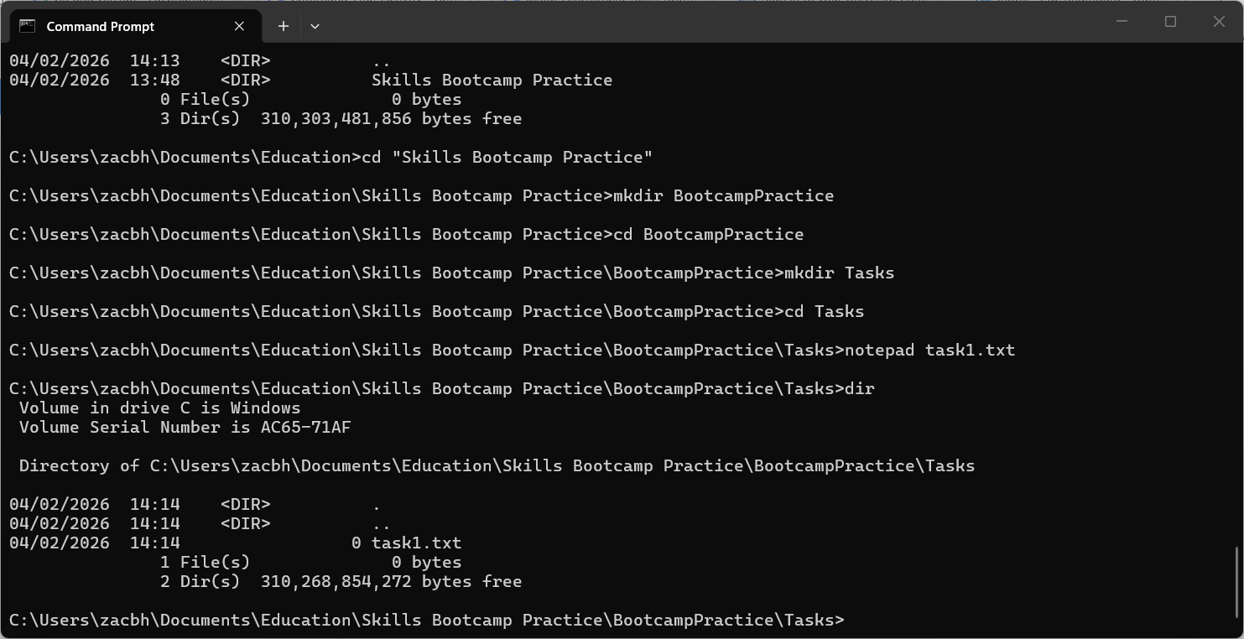

Assessment Evidence
Provide a screenshot of Command Prompt showing commands used and confirm the notes.txt file exists inside BootcampPractice.
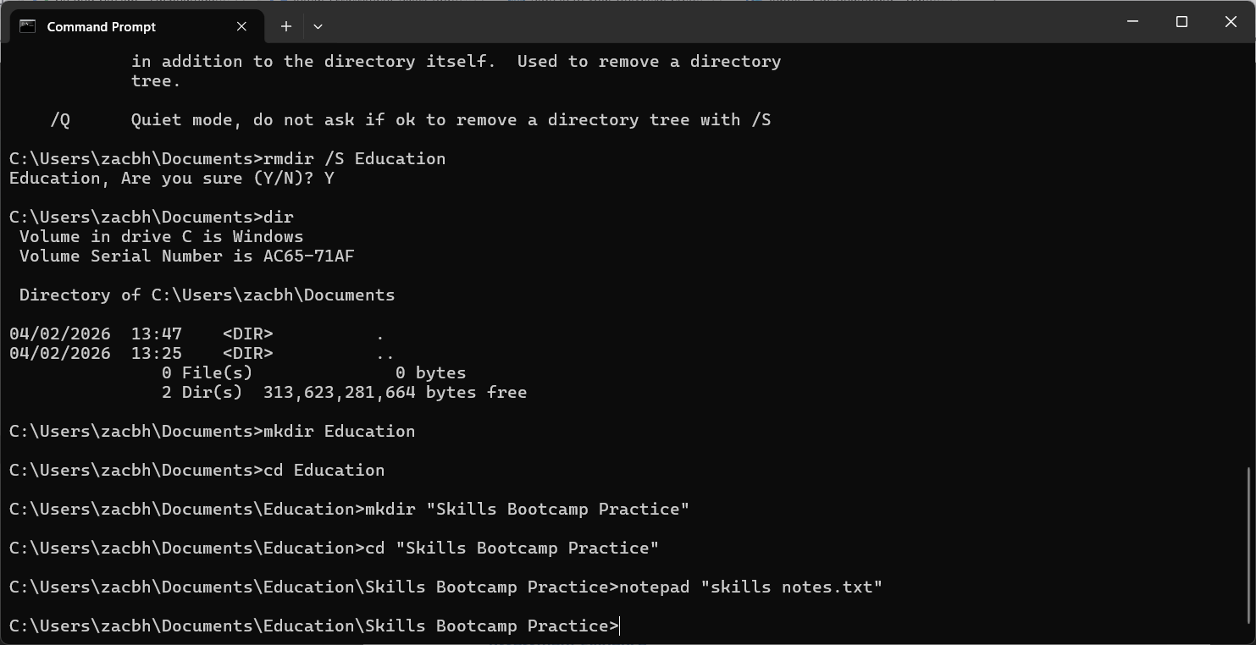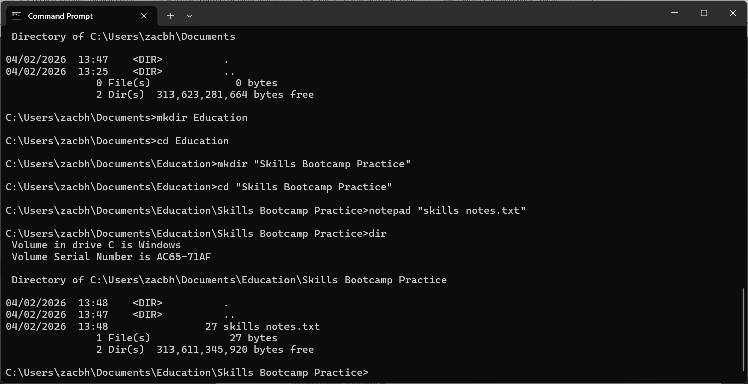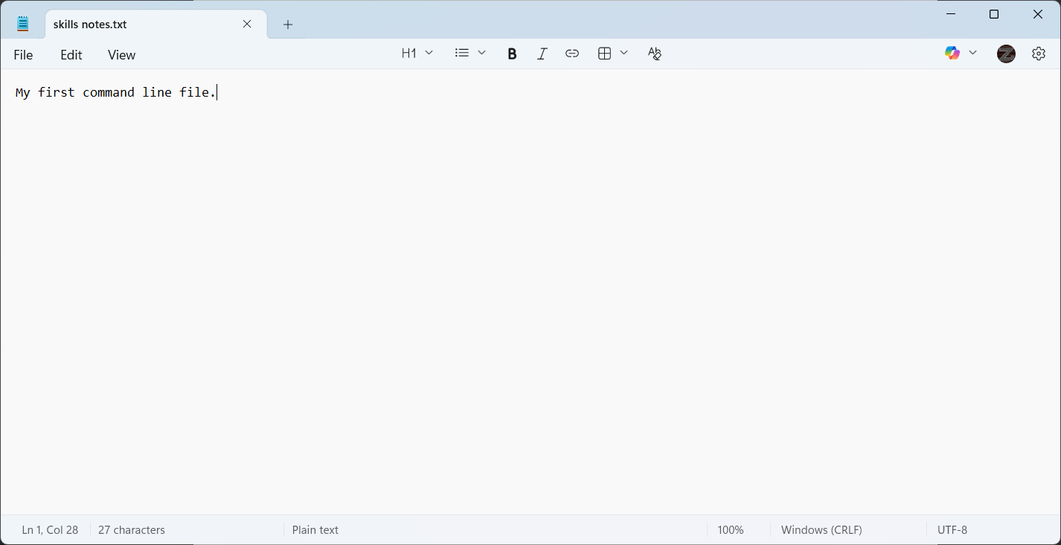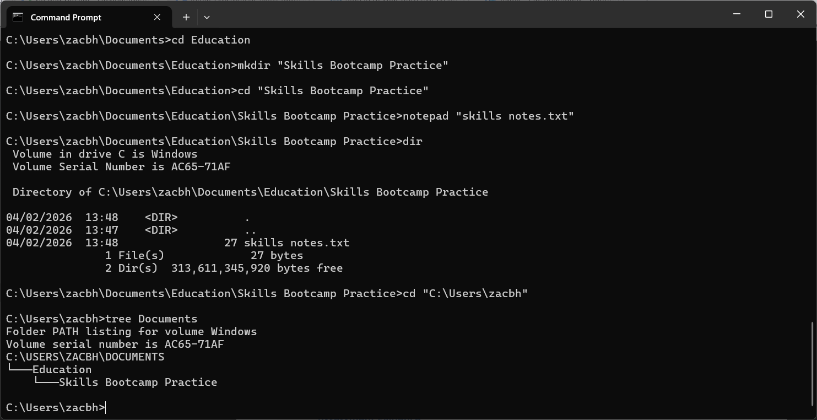

Success Criteria
- List files using 'dir'.
- Create folders using 'mkdir'.
- Navigate using 'cd'.
- Create files using 'notepad'.

Task 1 - Evidence

Task 2 - Evidence
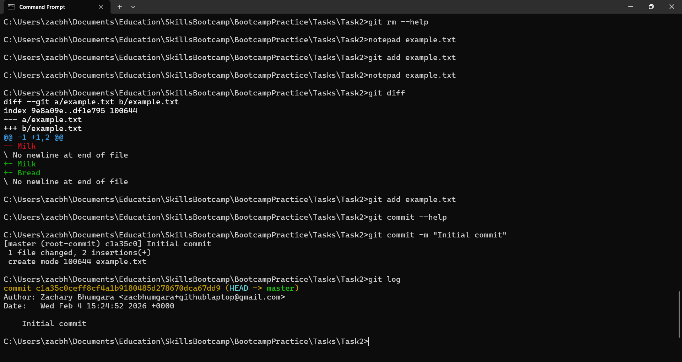

Task 3 - Evidence
