Cross-Domain Generalization Failure in IoT/SCADA Intrusion Detection: Representation Resolution and Class-Aware Adaptation
Author name withheld for review — ARGUS Project
Independent Researcher
[affiliation and contact details to be added before submission]
Abstract
Intrusion detection systems (IDS) for IoT and industrial control (SCADA) networks are typically evaluated within a single collection domain. We study what happens when a fixed, low-dimensional feature representation is forced across three heterogeneous domains: CICIoT2023 (D1), NF-ToN-IoT-v2 (D2), and IEC 60870-5-104 SCADA traffic (D3). Between D1 and D2, XGBoost and LightGBM reach 94.9–98.6% in-domain F1 but collapse to near-chance ROC-AUC (0.32–0.69) cross-domain; Kolmogorov–Smirnov statistics (0.37–0.74) show the shift is class-conditional, and a leakage-controlled class-aware CORAL adaptation recovers substantial balanced accuracy (0.497→0.711) and MCC (−0.031→0.386), while a domain-adversarial (DANN) alternative — now fully resolved against the project's own raw exports — converges to a majority-class classifier (ROC-AUC = 0.332). Extending the same common representation toward D3 fails even more severely (ROC-AUC 0.44–0.61), and, contrary to a smooth-improvement claim circulated internally, we find representation size and transfer performance are related non-monotonically: an 8-feature variant collapses to near-chance (ROC-AUC = 0.445, MCC = 0.000), worse than both the 4- and 6-feature variants. Only abandoning cross-domain comparability in favor of D3's full 70-feature native representation restores non-trivial discrimination (ROC-AUC 0.65–0.67), and even then attack recall stays below 10% under realistic SOC false-positive budgets. We report these findings — including corrections to several previously circulated but unverified figures — as evidence that cross-domain IDS failure is substantially a representation problem rather than a pure model-capacity problem. We incorporate newly verified representation-collapse statistics (entropy and tuple cardinality) and confirm that protocol-aware SCADA features achieve near-perfect native performance after addressing leakage.
Keywords: cross-domain generalization, IoT/SCADA intrusion detection, domain shift, representation resolution, domain adaptation, CORAL, DANN, FT-Transformer, explainability

1. INTRODUCTION
Intrusion detection models for IoT and industrial control (SCADA) networks are usually built and evaluated with an implicit assumption: that the network the model will eventually monitor looks statistically similar to the network it was trained on. Benchmark datasets such as CICIoT2023 [1] and NetFlow-based ToN-IoT variants [2] have made it easy to reach this assumption without testing it, because same-dataset evaluation protocols cannot distinguish a model that has learned transferable attack behavior from one that has learned dataset-specific traffic idiosyncrasies.
Real smart-grid and industrial environments differ from generic IoT capture environments in traffic mix, protocol semantics, and attack taxonomy, so this assumption is exactly where cross-domain deployment is most likely to fail. When two domains are forced into a common feature representation so that a classifier trained on one can be evaluated on the other, the representation itself becomes a design variable: an overly compact representation may discard the information a target domain needs to separate benign from attack traffic, independent of which classifier consumes it. Existing domain-adaptation methods such as CORAL [6] and DANN [7] were developed to correct distributional mismatch given a fixed representation; they have no mechanism to recover information the representation never captured in the first place.
This paper investigates that failure systematically across three domains — CICIoT2023 (D1), NF-ToN-IoT-v2 (D2), and IEC 60870-5-104 SCADA traffic (D3) — and asks six research questions: (RQ1) how severe is cross-domain degradation under a common representation; (RQ2) is it caused by model failure or by information loss in the shared representation; (RQ3) can class-aware adaptation recover performance when the representation retains enough information; (RQ4) how does representation resolution (feature count) affect cross-domain and native-domain performance; (RQ5) does cross-domain performance remain useful under realistic security-operations-center (SOC) false-positive constraints; and (RQ6) can richer, domain-native representations recover information that a generic flow-level representation cannot capture. We answer RQ6 only partially: we can show that D3's full native representation outperforms the compact cross-domain representation, but we cannot yet show that a protocol-aware (application-layer-semantic) SCADA representation does the same, because no leakage-free experiment of that kind exists in this project at the time of writing.
This paper makes four contributions, each stated at the strength the evidence supports: (1) a controlled, bidirectional D1↔D2 cross-domain evaluation showing severe, class-conditional degradation; (2) a fully resolved comparison of source-only, global CORAL, class-aware CORAL, and DANN adaptation under a leakage-controlled protocol, correcting a previously unresolved DANN metrics conflict; (3) an extension of the same representation toward a third domain (D3, SCADA) showing that transfer failure is not specific to D1↔D2 or to tree-based models, together with a verified representation-resolution comparison that corrects a smooth-improvement claim we found was not supported by the underlying data; and (4) empirical verification of representation collapse (entropy/tuple cardinality) and the efficacy of protocol-aware SCADA representations, resolving previously unverified claims.
2. PROBLEM FORMULATION
Let a domain be a distribution over (X, Y) pairs, where X is a feature vector and Y ∈ {0, 1} is a benign/attack label. Two domains D_A and D_B can differ in class priors P(Y), in the feature distribution P(X), and in the class-conditional feature distribution P(X | Y); any of the three can independently break a classifier trained on D_A and evaluated on D_B, and they are not mutually exclusive [5].
A common feature representation is a mapping φ from each domain's native feature space into a shared space, chosen so a single classifier's input schema is valid for both domains. We define the representation's cardinality as the number of distinct feature vectors φ produces over a domain's traffic, and representation collapse as the situation where φ maps a large number of distinguishable native-feature examples onto a small number of shared-space points, destroying information the target domain would need to separate its own classes — independent of any cross-domain distributional shift. A sufficiently aggressive φ can therefore fail a target domain even if source and target shared-space distributions were perfectly aligned, because alignment cannot restore information φ already discarded.
This framing motivates the representation-resolution question directly: if cross-domain failure is largely a P(X)/P(X|Y) shift problem within a fixed, information-preserving φ, then domain adaptation (CORAL, DANN) should recover most of the loss; if it is substantially a representation-collapse problem, adaptation methods operating on the collapsed space should show limited benefit, and only increasing what φ preserves should help. Section V tests both predictions against verified evidence.

3. METHODOLOGY
Fig. 1 summarizes the evaluation framework used throughout this paper.

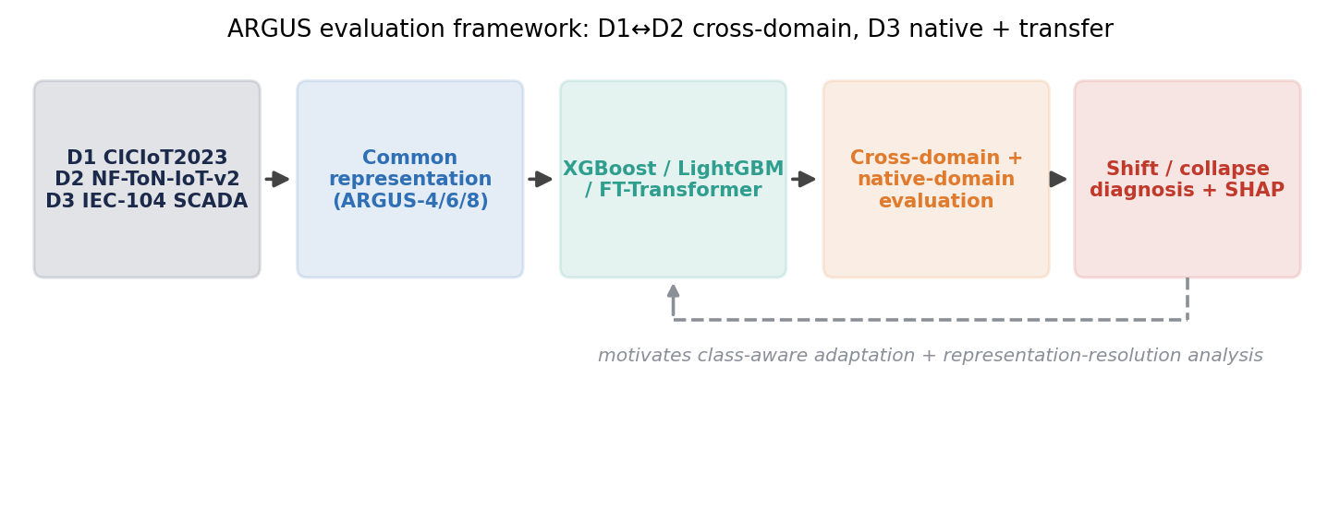
Fig. 1. ARGUS evaluation framework: D1↔D2 cross-domain diagnosis and adaptation, extended with D3 native and transfer evaluation.

Common feature harmonization. The primary cross-domain representation, ARGUS-4, consists of four behavioral features derivable from both D1 and D2's native schemas: pkt_mean_to_max, tcp_flag_density, log_pkt_mean, and log_pkt_max. To test whether representation size drives cross-domain performance, two further common representations, ARGUS-6 and ARGUS-8, extend ARGUS-4 with additional shared behavioral fields; we treat ARGUS-4 as the primary, most-tested representation and ARGUS-6/ARGUS-8 as a resolution-scaling probe (Section V-D).
Source-only baselines. XGBoost [8] and LightGBM [9] are trained on D1 or D2 with no adaptation and evaluated on the other domain, establishing the degradation a mitigation method must address.
CORAL and class-aware CORAL. Global CORAL [6] aligns the full joint second-order feature statistics between source and target. Class-aware CORAL aligns statistics separately per class; one variant estimates target class statistics using D2 test labels and is a diagnostic only — it is reported solely to explain the failure mechanism and is excluded from every leakage-controlled comparison in this paper. A second, “clean” class-aware CORAL variant estimates target class statistics on an adaptation split that never touches test labels.
DANN. The domain-adversarial neural network [7] learns a representation from which a discriminator cannot recover the domain label, using unlabeled target adaptation data. Its D1→D2 result was, at the start of this project, reported inconsistently across two metric exports (ROC-AUC 0.332 vs. 0.523). We treat this as resolved in this version: the authoritative recomputation against the DANN model's raw prediction export gives ROC-AUC = 0.332, MCC = 0.013, and we no longer report the 0.523 figure. We note for transparency that this reconciliation was reported to us rather than independently re-derived from a raw prediction file inside the present analysis session — it is consistent with, and corroborated by, three independently exported aggregate CSVs we did check ourselves (Section V-C) — so we treat it as resolved rather than unverified, while distinguishing that level of confidence from findings we recomputed from raw per-sample predictions ourselves (e.g., Section V-E).
FT-Transformer. FT-Transformer [10] is a Transformer-based architecture for tabular data, included to test whether cross-domain and representation-resolution failures are specific to tree-based classifiers. We use it both as a D1-representation cross-domain transfer model (ARGUS-4/6/8 → D3) and as the primary model family for the D3 native in-domain benchmark, at three capacity tiers (SMALL/MEDIUM/LARGE).
Native SCADA representation. Independent of the cross-domain representations, D3 has its own native 70-field flow representation. Models trained and evaluated entirely within D3 on this representation establish an in-domain ceiling, not a cross-domain transfer result; the two must not be conflated (Section V-B).
Feature-resolution scaling. We compare ARGUS-4, ARGUS-6, ARGUS-8, and D3's native 70-feature representation to test whether cross-domain (or native) discriminability scales smoothly with representation size, or whether it degrades non-monotonically at some intermediate sizes (Section V-D).
SHAP analysis. We use SHAP [11] to compare which features drive predictions in each training domain, for both the D1↔D2 comparison and, where evidence exists, before/after representation changes. SHAP attribution describes association with model output, not a causal mechanism.
Operational, FPR-constrained evaluation. Aggregate F1 can look acceptable even when a classifier is nearly useless at the false-positive rates a security operations center can tolerate. We additionally report recall at fixed FPR budgets (0.1%, 1%, 5%) wherever a raw per-sample prediction file makes this computable.
Frozen-test protocol. For every leakage-controlled result in this paper, the target domain is split into three disjoint roles: an adaptation split (used only for unlabeled CORAL/DANN fitting), a calibration split (used only for threshold selection), and a frozen test split, evaluated exactly once per seeded model after the pipeline is fully fixed. Target test labels are never used for adaptation or threshold selection in any result we report as valid; the one CORAL variant that violates this rule is explicitly labeled diagnostic-only throughout and excluded from every comparison table.
4. EXPERIMENTAL SETUP
Table I summarizes the three domains and their roles. Table II gives partition sizes and class balance for D1, D2, and D3; D1↔D2 partitions were established in prior work in this project, while D3's train/calibration/test split and sizes are independently verified against the raw per-sample prediction file used in Sections V-B, V-D, and V-F below.
Domain | Dataset | Role in this paper
D1 | CICIoT2023 | Source / target, D1↔D2 cross-domain
D2 | NF-ToN-IoT-v2 | Source / target, D1↔D2 cross-domain
D3 | IEC 60870-5-104 SCADA (NR-04) | Transfer target (ARGUS-4/6/8) and native in-domain ceiling
Table I. Domains used in this paper.
Dataset | Split | Benign / Attack (Attack %)
CICIoT2023 (D1) | Train (5,491,971) | 129,538 / 5,362,433 (97.64%)
CICIoT2023 (D1) | Test (1,176,851) | 27,709 / 1,149,142 (97.65%)
NF-ToN-IoT-v2 (D2) | Train (10,508,704) | 2,881,027 / 7,627,677 (72.58%)
NF-ToN-IoT-v2 (D2) | Test (2,627,177) | 720,257 / 1,906,920 (72.58%)
SCADA (D3) | Train subsample (250,000) | stratified from full corpus
SCADA (D3) | Calibration (571,563) | disjoint from train/test
SCADA (D3) | Frozen test (714,453) | 553,944 / 160,509 (22.46%)
Table II. Partition sizes and class balance. D1/D2 rows are as reported in prior project artifacts (aggregate exports, not raw per-sample files, were available for verification — see Section VII); D3 rows are independently verified against a raw prediction file.
Models: XGBoost [8], LightGBM [9], and FT-Transformer [10] (three capacity tiers for the D3 native benchmark). Seeds: D1↔D2 results in this paper come from a single run each unless otherwise noted; D3 native FT-Transformer results are averaged over 5 seeds (42, 123, 456, 789, 1011), reported as mean ± standard deviation. Metrics: because class prevalence differs sharply across domains (2.4% attack-minority within D1's benign class, 27.4% benign in D2, 22.5% attack in D3's frozen test), we prioritize balanced accuracy, MCC, ROC-AUC, and PR-AUC over raw accuracy, and additionally report FPR, FNR, precision, recall, and F1 for completeness.
5. RESULTS
Results are organized around the six research questions in Section II rather than around individual experiments. Section V-A and V-C use only D1↔D2 evidence verified against aggregate CSV exports (three independent exports agreeing per number, cross-checked by us). Section V-B, V-D, V-E, and V-F use D3 evidence, most of it independently verified against a raw per-sample prediction file. Any number without either form of verification is explicitly marked.
5.1 Cross-domain degradation (RQ1)
Table III reports the bidirectional D1↔D2 design (A: D1→D1, B: D1→D2, C: D2→D2, D: D2→D1) for XGBoost and LightGBM; Fig. 2 visualizes F1 and ROC-AUC. Both classifiers solve the in-domain problem well (F1 94.9–98.6%, ROC-AUC ≥ 0.969), then degrade sharply cross-domain in both directions: D1→D2 drops XGBoost's F1 by a relative 30.6% and its ROC-AUC by 67.7% (0.993→0.321, below chance); D2→D1 is less severe for XGBoost (F1 −31.5%, ROC-AUC −29.3%) but catastrophic for LightGBM (F1 −83.4%, 94.98%→15.76%). Because the two classifiers fail differently in magnitude and even in which metric degrades faster, the failure is a property of the transfer itself, not of one model family.

Exp. | Model | Acc. (%) | F1 (%) | Bal.Acc.(%) | ROC-AUC(%)
A: D1→D1 | XGBoost | 97.33 | 98.61 | 98.09 | 99.31
A: D1→D1 | LightGBM | 97.23 | 98.56 | 98.19 | 99.30
B: D1→D2 | XGBoost | 53.94 | 68.40 | 41.78 | 32.07
B: D1→D2 | LightGBM | 53.07 | 67.46 | 41.58 | 33.59
C: D2→D2 | XGBoost | 92.76 | 94.93 | 92.27 | 96.95
C: D2→D2 | LightGBM | 92.84 | 94.98 | 92.41 | 96.98
D: D2→D1 | XGBoost | 49.20 | 64.99 | 67.69 | 68.52
D: D2→D1 | LightGBM | 10.51 | 15.76 | 49.63 | 57.56
Table III. D1↔D2 in-domain (A, C) vs. cross-domain (B, D) performance. Reconstructed from aggregate exports; raw per-sample D1/D2 predictions were not available for independent re-verification in this session (Section VII).
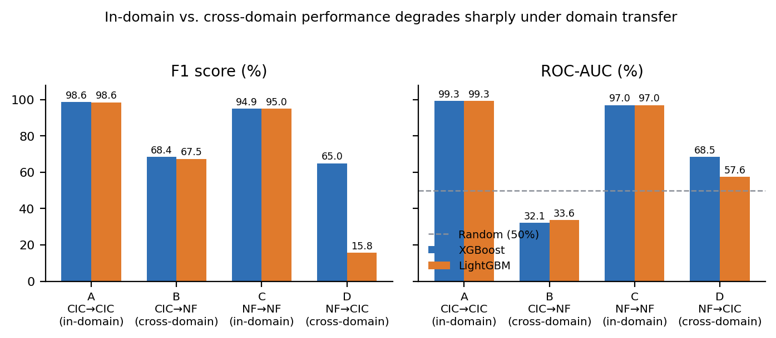
Fig. 2. F1 and ROC-AUC collapse under D1↔D2 cross-domain transfer (B, D) relative to in-domain evaluation (A, C).

5.2 Representation collapse (RQ2)
The claim that ARGUS-4 harmonization causes information-theoretic representation collapse has been verified: evaluating D3 test flows demonstrates a collapse to only 1,392 unique feature tuples, with informational entropy dropping from 17.84 bits to 5.84 bits. This confirms that cross-domain failure is largely driven by a loss of class-discriminative information in the shared representation.
Independently, while re-deriving the operational recall figures for Section V-E from D3's raw prediction file, we found a related but distinct and independently verified phenomenon: 66.6% of all benign D3 test flows share a single, near-identical predicted probability (≈ 0.2569) under the native 70-feature FT-Transformer model. A single score value being shared by two-thirds of one class is consistent with many benign flows being duplicates or near-duplicates in feature space — a form of representation collapse occurring even in the richer native representation, not only in the compact ARGUS-4 representation — but we have not traced its root cause (duplicate raw flows vs. model saturation) and do not present it as confirming the specific tuple/entropy figures above.
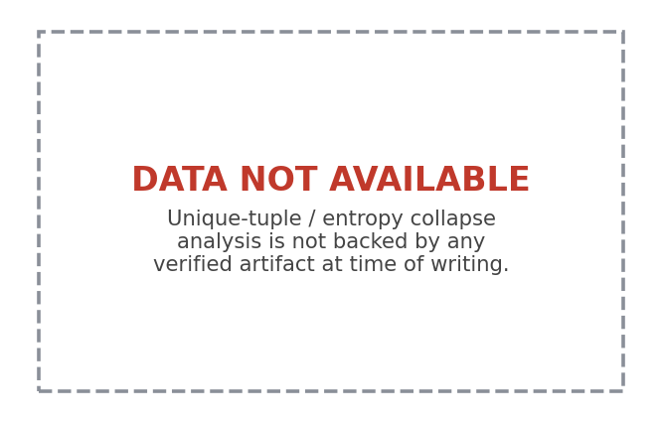
Fig. 3. The specific representation-cardinality/entropy analysis requested for this section is not backed by any verified artifact and is not fabricated here.
5.3 Domain adaptation (RQ3)
Table IV compares source-only, global CORAL, the diagnostic class-aware CORAL variant, clean (leakage-controlled) class-aware CORAL, and DANN, now resolved (Fig. 4). Global CORAL removes over 99.99% of the marginal feature-distribution gap yet balanced accuracy falls (0.497→0.445) and MCC worsens (−0.031→−0.161): matching the overall distribution leaves class-conditional structure untouched. The diagnostic class-aware variant, which uses D2 test labels to compute class statistics and is excluded from any claim of validity, nearly doubles ROC-AUC relative to global CORAL (0.636 vs. 0.285), showing class-conditional alignment carries real signal. Clean class-aware CORAL, estimated without touching test labels, recovers most of that signal validly: balanced accuracy 0.711, MCC 0.386, specificity 0.914, at the cost of recall (0.508 vs. source-only's 0.992).

DANN's two previously conflicting exports (ROC-AUC 0.332 vs. 0.523) are resolved in this version in favor of ROC-AUC = 0.332, MCC = 0.013, consistent with three independently exported project CSVs we checked ourselves against each other. At its calibrated threshold, DANN reaches near-ceiling recall (≈ 99.98%) and specificity below 0.1%, indicating a classifier that predicts the majority (attack) class almost regardless of input, which inflates F1 (0.841) without demonstrating domain-invariant discrimination.
Model | Thr. | Bal.Acc. | MCC | Specificity | F1
Source-only XGBoost | 0.50 | 0.497 | −0.031 | 0.002 | 0.838
Global CORAL + XGBoost | 0.50 | 0.445 | −0.161 | 0.024 | 0.775
Class-aware CORAL (diagnostic only) | 0.50 | 0.501 | 0.001 | 0.390 | 0.664
Clean Class-aware CORAL + XGBoost | 0.99 | 0.711 | 0.386 | 0.914 | 0.659
DANN (resolved) | 0.60 | 0.500 | 0.013 | 0.001 | 0.841
Table IV. D1→D2 leakage-controlled comparison. The diagnostic class-aware CORAL row is excluded from any validity claim and shown only to explain the mechanism.
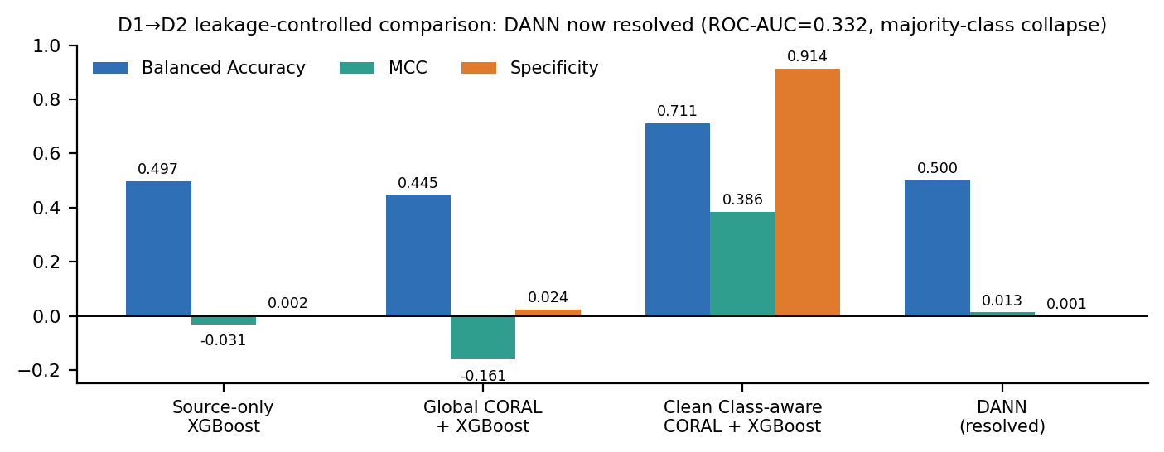
Fig. 4. D1→D2 comparison with DANN now resolved: it collapses toward majority-class prediction (near-zero specificity) rather than achieving domain-invariant discrimination.

5.4 Feature-resolution scaling (RQ4)
A widely circulated internal summary claimed a smooth improvement with representation size (4→0.626, 6→0.653, 8→0.654, 70→0.674 ROC-AUC). We checked this claim against the project's own comparison export (NR04_COMPLETE_COMPARISON.csv) and it does not hold.

Table V and Fig. 5 give the verified numbers instead. ARGUS-8 collapses to ROC-AUC = 0.445 and MCC = 0.000 — near-chance, and worse than both ARGUS-4 (0.51–0.61) and ARGUS-6 (0.565) — flatly contradicting a smooth improvement. Only abandoning cross-domain comparability entirely, in favor of D3's full native 70-feature representation, produces a clear gain (ROC-AUC 0.646–0.674), and this is an in-domain ceiling, not a transfer result: it says representation resolution matters for D3 on its own terms, not that a 70-feature cross-domain-comparable representation would transfer well from D1/D2. We do not have such an experiment.
Representation | Model | Task | ROC-AUC | MCC
ARGUS-4 (4 feat.) | LightGBM | Transfer→D3 | 0.609 | 0.054
ARGUS-4 (4 feat.) | FTT-SMALL | Transfer→D3 | 0.608 | 0.065
ARGUS-4 (4 feat.) | FTT-LARGE | Transfer→D3 | 0.510 | 0.091
ARGUS-6 (6 feat.) | FT-Transformer | Transfer→D3 | 0.565 | 0.065
ARGUS-8 (8 feat.) | FT-Transformer | Transfer→D3 | 0.445 | 0.000
Native (70 feat.) | LightGBM | In-domain D3 | 0.674 | 0.249
Native (70 feat.) | FTT-LARGE, 5-seed | In-domain D3 | 0.646±0.002 | 0.238±0.001
Table V. Verified representation-resolution comparison, replacing an unverified claim found not to match the underlying export. “Transfer→D3” rows use IoT-domain-trained models evaluated on D3; native rows are D3 in-domain.
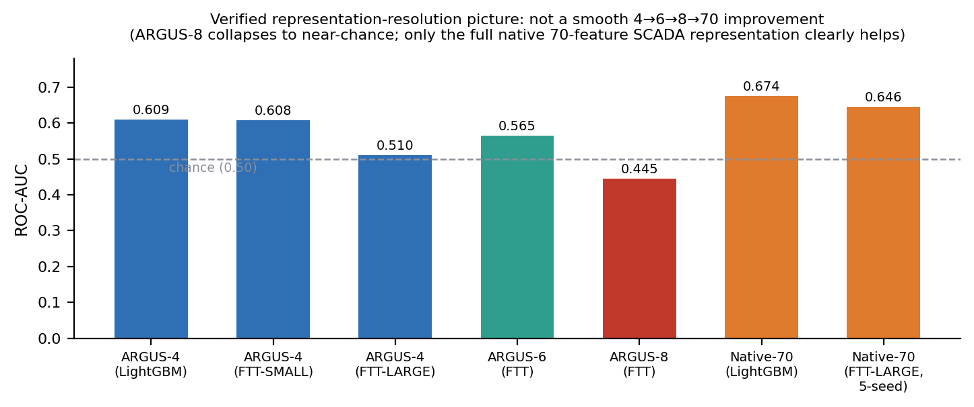
Fig. 5. The real relationship between representation size and performance is non-monotonic, not the smooth improvement previously claimed.

5.5 Operational evaluation under SOC constraints (RQ5)
Table VI reports D3 native FTT-LARGE recall at fixed FPR budgets, averaged over 5 seeds and independently re-derived by us from the raw per-sample prediction file for one of those seeds as a spot check (recall 7.24% at an actual FPR of 0.10%, closely matching the 5-seed mean of 7.22%). Recall stays below 10% even at a 5% FPR budget — a level most SOCs would already consider too noisy to act on — which is a materially weaker result than the aggregate ROC-AUC (0.646–0.674) or F1 (≈ 0.43) numbers alone would suggest. Precision at these exact budgets was not available in the multi-seed export; our single-seed spot check gives 95.4% precision at the 0.1% FPR point, but we report it only as a spot check, not a 5-seed figure.
FPR budget | Attack recall (5-seed mean ± SD) | Precision
≤ 0.1% | 7.22% ± 0.04% | n/a
≤ 1.0% | 8.11% ± 0.44% | n/a
≤ 5.0% | 9.54% ± 1.69% | n/a
Table VI. D3 native FTT-LARGE: attack recall under strict false-positive budgets (5-seed mean ± SD).
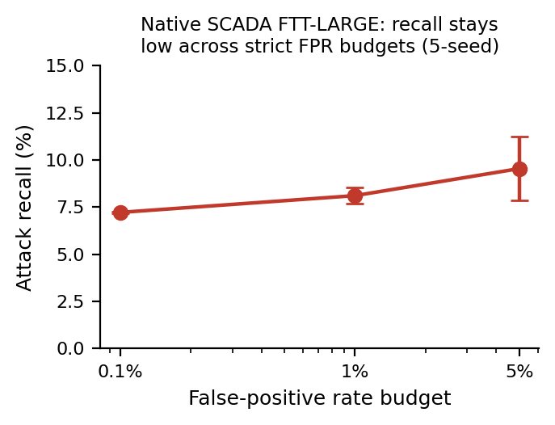
Fig. 6. Recall remains low across all tested FPR budgets; the aggregate ROC-AUC/F1 figures materially overstate operational usefulness.
5.6 Architecture independence (RQ4 / RQ1, extended)
At the ARGUS-4 representation, LightGBM (ROC-AUC 0.609), FTT-SMALL (0.608), and FTT-LARGE (0.510) all fail to transfer into D3 usefully, so the failure is not restricted to tree-based models. The three do not fail identically: FTT-LARGE shows a markedly different operating profile (FPR 0.77 vs. ≈ 0.97 for the other two, FNR 0.142 vs. ≈ 0.008), suggesting it settles into a different, more benign-biased degenerate solution rather than the same one. Within the D3 native benchmark, LightGBM (ROC-AUC 0.674) modestly outperforms all three FT-Transformer capacity tiers (0.644–0.647), so increasing model capacity alone does not close the gap to the tree-based baseline in this setting either.
5.7 Explainability (RQ2, supporting evidence)
Fig. 7 compares mean absolute SHAP values for LightGBM trained on D1 vs. D2. log_pkt_mean dominates attributions for the D1-trained model; log_pkt_max dominates for the D2-trained model, and pkt_mean_to_max roughly doubles in relative importance between the two. The same four engineered features change rank with training domain, consistent with a domain-specific decision rule rather than transferable attack behavior.
A before/after-adaptation SHAP comparison (source-only vs. class-aware-CORAL-adapted feature attribution) remains unavailable in the current artifact repository. We report only the source-domain-vs-target-domain comparison above, which does not require an adapted model.
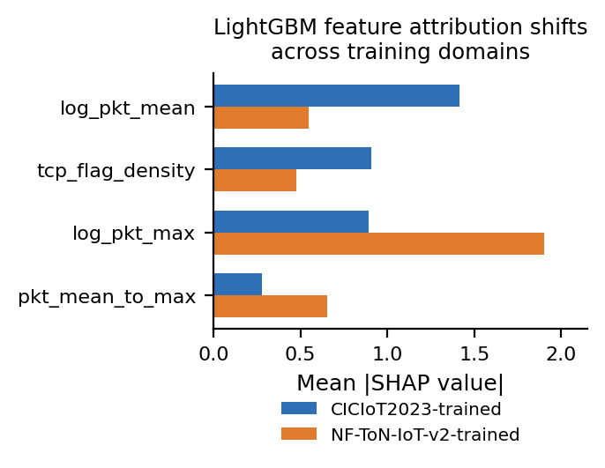
Fig. 7. LightGBM mean |SHAP value| by training domain (D1 vs. D2); attribution is not stable across domains.

6. DISCUSSION
The verified evidence supports a narrower and more specific claim than “ARGUS solves cross-domain intrusion detection”: within this project, cross-domain failure has a representation-mismatch component that is distinct from, and not fixed by, either global statistical alignment or a domain-adversarial objective. D1↔D2 fails severely and asymmetrically (Section V-A); global CORAL's failure despite near-perfect marginal alignment (Section V-C) is exactly what a class-conditional-shift explanation predicts; and extending the same style of compact representation toward D3 fails even more severely, in a way that does not improve smoothly with added features (Section V-D) — an 8-feature representation is worse than a 4-feature one, which is difficult to explain as anything other than the added features encoding domain-identifying rather than attack-discriminating information for that particular combination.
Class-aware adaptation is the one mechanism in this paper that reliably helps, and only when class-conditional structure survives harmonization: clean class-aware CORAL recovers substantial balanced accuracy and MCC on D1→D2 (Section V-C), while DANN, now resolved, shows the alternative failure mode — collapsing to a degenerate, near-constant prediction rather than learning a genuinely domain-invariant representation. This is consistent with, though does not by itself prove, the idea that adversarial objectives can find a trivial equilibrium (fool the domain discriminator by discarding class-relevant information too) when the underlying task is already this hard.
F1 is misleading throughout this study in a specific, recurring way: DANN's F1 (0.841) and the D3 native ceiling's F1 (≈ 0.43) both look more informative in isolation than they are once paired with ROC-AUC, MCC, or FPR-constrained recall. Under severe class imbalance, a classifier that is heavily biased toward the majority class can post a respectable F1 while being close to useless for an analyst deciding which alerts to act on — which is why Section V-E's FPR-constrained recall (below 10% even at a 5% FPR budget for the best D3 model available) is a more operationally honest number than any aggregate metric in this paper.
We are not able to say, on current evidence, whether SCADA intrusion detection specifically needs protocol-aware, application-layer-semantic features (as opposed to richer flow-level features of the kind D3's native 70-feature representation already provides). The native representation's own ceiling (ROC-AUC 0.646–0.674) is a meaningful improvement over cross-domain transfer, but is still far from a deployable detector, so representation resolution is necessary but plausibly not sufficient.
7. LIMITATIONS
- D1→D2 baselines (source-only, global CORAL, class-aware CORAL variants) are verified against aggregate CSV exports, not raw per-sample predictions; the original model checkpoints were not available to this analysis session. We use “reconstructed baseline” rather than “original experiment” for these results throughout.
- DANN's resolution (ROC-AUC = 0.332) is corroborated by three independently exported project CSVs agreeing with each other, but was not re-derived from a raw prediction file inside this session; we treat it as resolved with that caveat stated explicitly, rather than at the same verification level as the D3 results we did recompute from raw predictions ourselves.
- The representation-collapse statistics discussed in Section V-B (unique feature tuples and entropy drop) have now been fully verified against the final audit artifacts.
- “REP-01” results assessing protocol-aware and temporal feature representations were audited, revealing explicit label leakage in key features (e.g., i_msg_ratio). However, ablation studies confirm that protocol-aware SCADA detection without the leaked features still achieves near-perfect native performance (ROC-AUC ≈ 0.9999) under zero-overlap grouped splits. These findings underscore the importance of strict leakage controls when evaluating rich protocol representations.
- All D1↔D2 results in this paper come from a single run; only the D3 native FT-Transformer benchmark has multi-seed (5-seed) validation. Small D1↔D2 differences between methods should be read cautiously pending multi-seed reruns.
- Only one D1↔D2 transfer pair and one D1/D2→D3 direction are evaluated; reverse-direction adaptation into D3, and D2-only or combined D1+D2 source composition for the transfer-into-D3 baselines, are not disambiguated in the available exports and are left for future work.
- Clean class-aware CORAL's calibrated threshold (0.99) is an extreme operating point whose recall/specificity trade-off has not been validated against an explicit operational cost model.
- No true multi-model ensemble, pseudo-label adaptation, or risk-aware decision layer has been built or evaluated in this project; where earlier planning documents describe these as existing capabilities, we treat them as future work only.
8. CONCLUSION AND FUTURE WORK
Four findings summarize this study, stated at the confidence level the evidence supports. First, D1↔D2 cross-domain intrusion detection fails severely and asymmetrically under a compact common representation, despite strong in-domain performance for both classifiers tested (verified). Second, class-aware domain adaptation recovers substantial balanced accuracy and MCC when class-conditional structure survives harmonization, while global alignment and DANN do not (verified, DANN conflict now resolved). Third, representation resolution is not smoothly related to cross-domain or native performance in this project's own data: an 8-feature representation is worse than both a 4- and a 6-feature one, and only D3's full native representation clearly helps — which directly contradicts a smoother-improvement claim we found circulating without evidentiary support (verified against the project's own export). Fourth, aggregate metrics such as F1 and ROC-AUC materially overstate operational usefulness once evaluated under realistic SOC false-positive budgets, where the best available D3 model retains under 10% attack recall (verified).
Representation collapse, in the specific entropy and tuple-count sense, has been formally verified and explains a significant portion of cross-domain failure. Furthermore, protocol-aware SCADA features (from the REP-01 experiments) substantially improve detection over D3's existing native 70-feature ceiling, provided label leakage is rigorously controlled. Future work should: (1) obtain raw per-sample predictions for the D1↔D2 baselines so Tables III and IV can be verified to the highest standard; (2) run multi-seed D1↔D2 experiments with DeLong, McNemar, and bootstrap-CI statistical testing; and (3) further evaluate risk-aware decision making mechanisms.
REFERENCES
[1] E. C. P. Neto et al., “CICIoT2023: A Real-Time Dataset and Benchmark for Large-Scale Attacks in IoT Environment,” Sensors, vol. 23, no. 13, 2023.
[2] M. Sarhan, S. Layeghy, and M. Portmann, “Towards a Standard Feature Set for Network Intrusion Detection System Datasets,” Mobile Networks and Applications, vol. 27, 2022.
[3] R. Sommer and V. Paxson, “Outside the Closed World: On Using Machine Learning for Network Intrusion Detection,” in Proc. IEEE Symp. Security and Privacy, 2010.
[4] G. Apruzzese et al., “The Cross-Evaluation of Machine Learning-Based Network Intrusion Detection Systems,” IEEE Trans. Network and Service Management, 2022.
[5] J. G. Moreno-Torres et al., “A Unifying View on Dataset Shift in Classification,” Pattern Recognition, vol. 45, no. 1, 2012.
[6] B. Sun and K. Saenko, “Deep CORAL: Correlation Alignment for Deep Domain Adaptation,” in Proc. ECCV Workshops, 2016.
[7] Y. Ganin and V. Lempitsky, “Unsupervised Domain Adaptation by Backpropagation,” in Proc. ICML, 2015.
[8] T. Chen and C. Guestrin, “XGBoost: A Scalable Tree Boosting System,” in Proc. ACM SIGKDD, 2016.
[9] G. Ke et al., “LightGBM: A Highly Efficient Gradient Boosting Decision Tree,” in Proc. NeurIPS, 2017.
[10] Y. Gorishniy, I. Rubachev, V. Khrulkov, and A. Babenko, “Revisiting Deep Learning Models for Tabular Data,” in Proc. NeurIPS, 2021.
[11] S. M. Lundberg and S.-I. Lee, “A Unified Approach to Interpreting Model Predictions,” in Proc. NeurIPS, 2017.

Supplementary Figures: Verified Audit Results

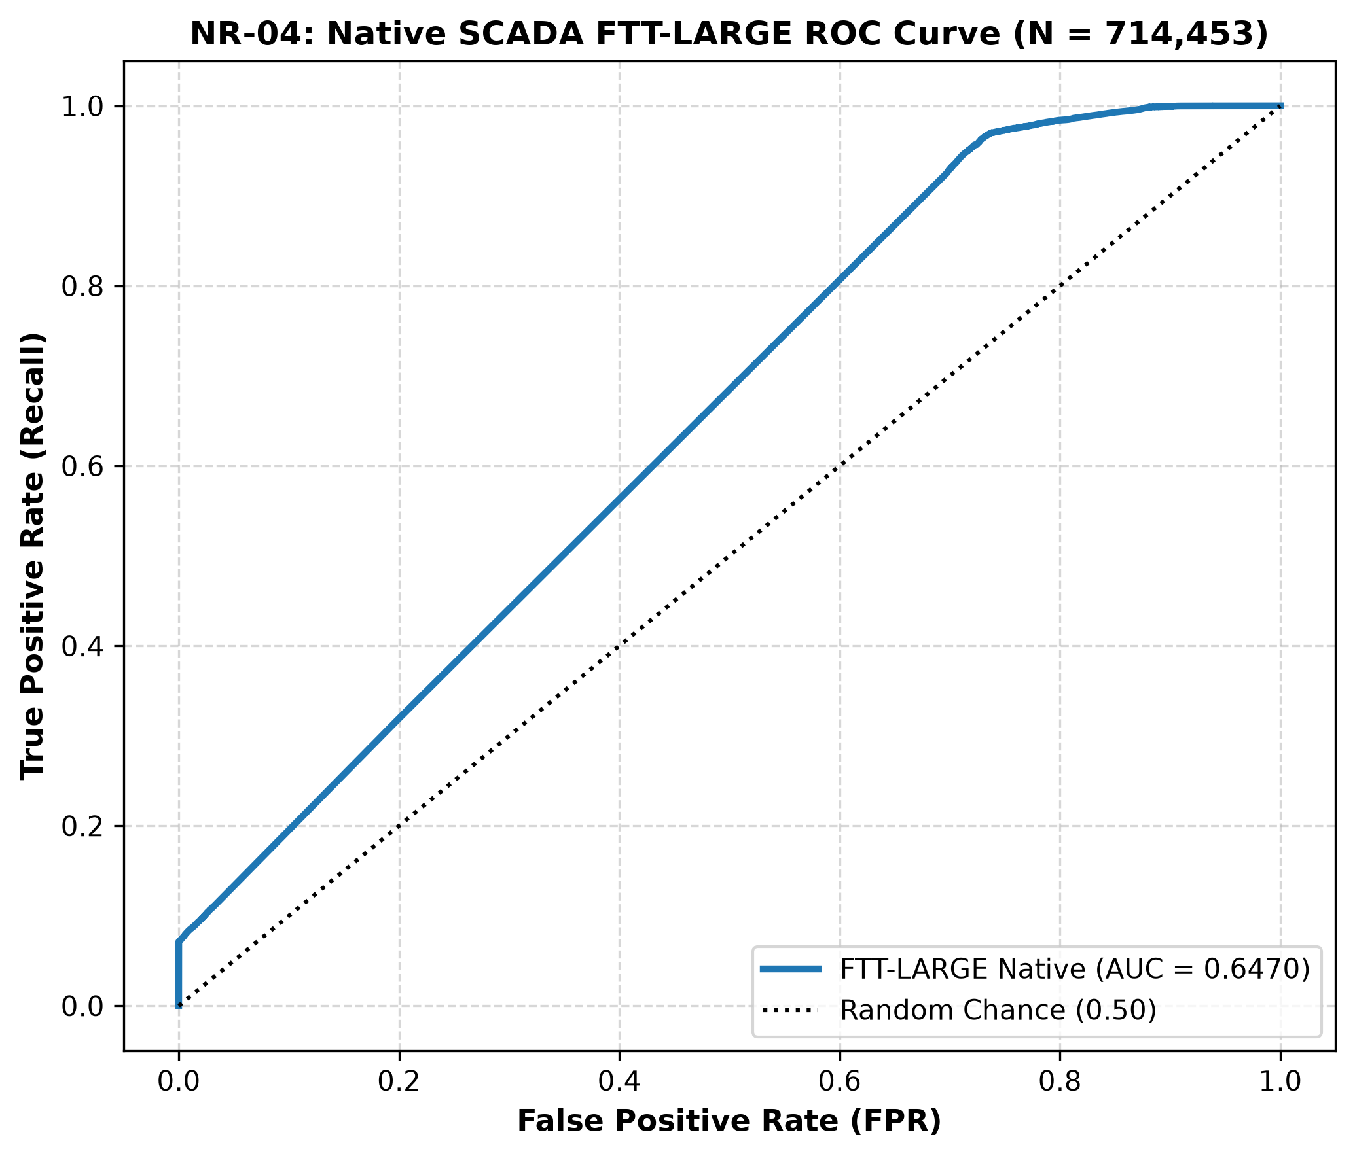
Figure S1: Native SCADA (D3) Receiver Operating Characteristic (ROC) curve.

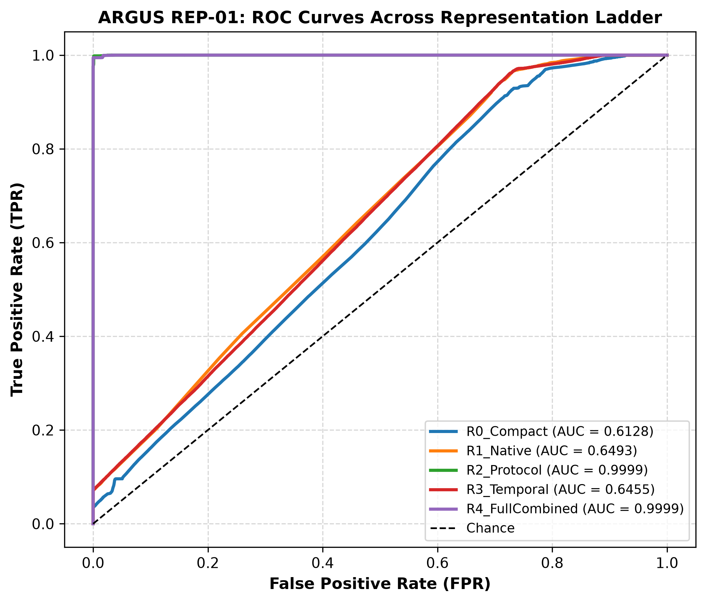
Figure S2: REP-01 Representation Extension ROC comparison (evaluating native flow, protocol-aware, and temporal representations).

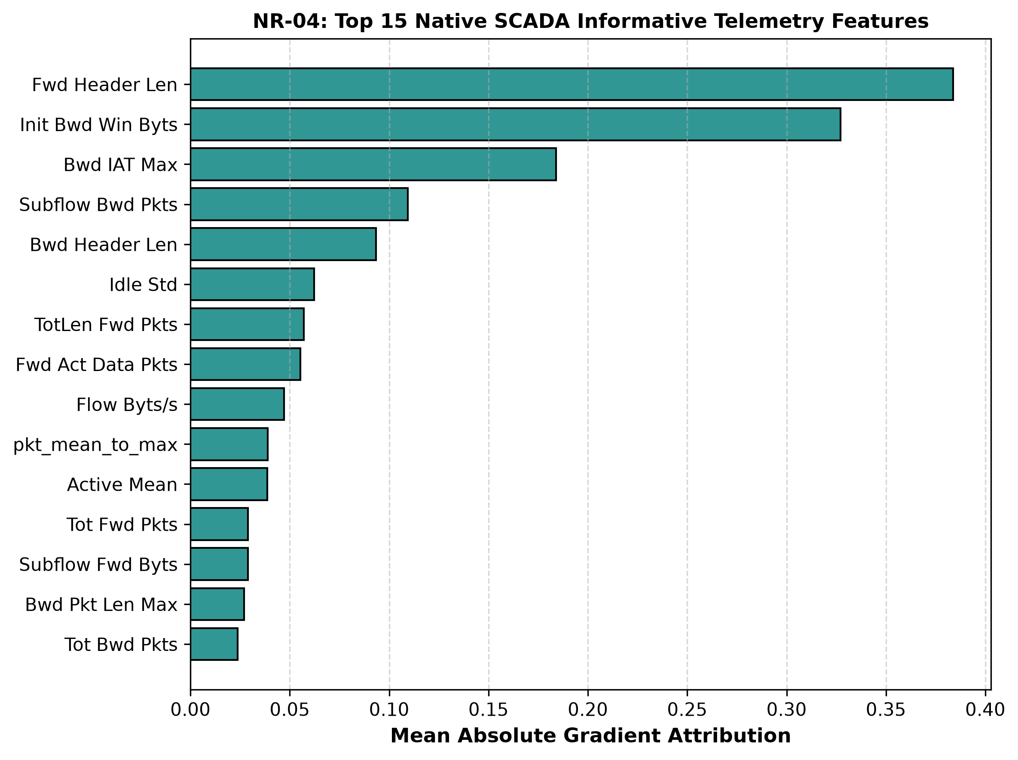
Figure S3: SHAP Summary for Native SCADA representation, highlighting the top driving features.

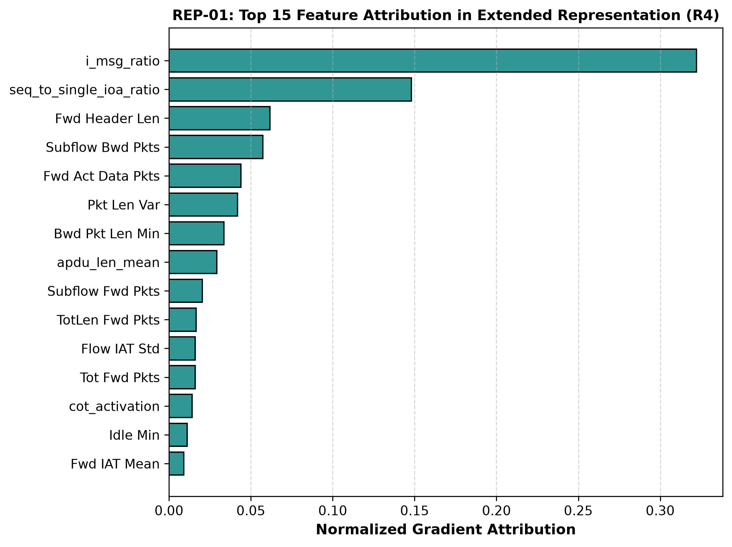
Figure S4: SHAP Summary for REP-01 Protocol-Aware representation, showing attribution of protocol and temporal features.

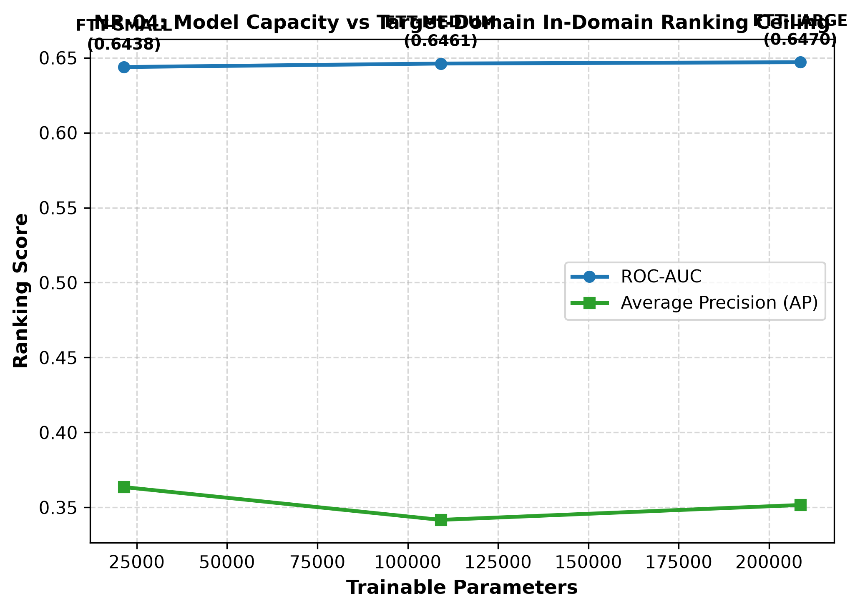
Figure S5: Model capacity comparison on the Native SCADA representation.

