 | GUJARAT TECHNOLOGICAL UNIVERSITY | 
 | Chandkheda, Ahmadabad
 | Affiliated
R. N. G. Patel Institute of Technology (RNGPIT)
Isroli-Afwa, Bardoli
A Project Report
on
Vision360 (Automated Virtual Tour Application)
Under Subject of
DESIGN ENGINEERING - II – A (3150001)
B.E. III, Semester – V
(Information Technology - IT Branch)
Submitted by:
Group ID: 907000
SR. NAME OF STUDENTS ENROLLMENT NO.
1. Jenish Dipakbhai Godhani 230840116009
2. Anuj Samir Pradhan 230840116047
3. Dhruv Jayantibhai Ribadiya 230840116056
4. Meet Mansukhbhai Mungala 240843116006
Prof. Pratik M. Gohil Prof. Vivek C. Joshi Dr. Latesh B. Chaudhari
(Faculty Guide) | (Head of Department) | (Principal)
Academic Year
(2025-2026)

Vision360 (Automated Virtual Tour Application)
ABSTRACT
Vision360 is an innovative web and mobile-based virtual tour platform designed to transform the way users manage, search, and share their digital images by leveraging advanced Web Technologies for immersive panorama rendering. The system automatically renders 360-degree panoramic images, allowing interactive exploration and enabling users to organize their complex campuses and spaces efficiently. With AI-powered panorama navigation, Vision360 offers advanced features such as interactive hotspots, automated scene transitions, and dynamic scene management, allowing users to quickly navigate and explore different locations. The platform is developed using HTML, CSS, and vanilla JS for a responsive and interactive frontend, while Firebase powers the backend (Hosting and Storage), providing a robust and scalable server-side architecture to handle user data, image storage, and secure processing. AI integration is implemented with frameworks like Pannellum and custom WebGL wrappers, ensuring accurate and real-time panorama rendering even in large image libraries. Vision360 places strong emphasis on privacy and security, incorporating end-to-end encryption, seamless transitions, and interactive tour guides, giving users full control over their tour configuration and hotspot placements. Beyond simplifying virtual tour experience, the platform enhances convenience, automation, and personalization, making the process of exploring new locations smarter and more intuitive. By combining Firebase backend development with modern frontend frameworks and AI technologies, Vision360 demonstrates a seamless integration of web development and artificial intelligence, delivering a secure, user-centric, and intelligent immersive campus viewing experience. It exemplifies how technology can enhance both usability and privacy in digital media platforms, offering a next-generation solution for virtual tours that aligns with the needs of today’s visually driven, privacy-conscious users.
i

Vision360 (Automated Virtual Tour Application)
TABLE OF CONTENTS
CHAPTERS PAGE NO.
ABSTRACT I
LIST OF FIGURES II
LIST OF TABLES III
TABLE OF CONTENTS IV
Chapter 1 INTRODUCTION
1.1Introduction of Domain 1
1.2Importance of Domain 1
1.3Team Selection 2
1.4Observation 2
Chapter 2 Canvas and Framework
2.1Mind Map 3
2.2AEIOU Summary Canvas 5
2.2.1A-Activities 5
2.2.2E-Environment 5
2.2.3I-Interaction 6
2.2.4O-Objects 6
2.2.5U-Users 6
2.2.6AEIOU Summary Canvas 7
2.3Empathy Mapping Canvas 8
2.3.1User 8
2.3.2Stack-Holders 8
2.3.3Story Boarding 9
2.4Ideation Canvas 11
2.4.1People 11
2.4.2Activities 11
2.4.3Situation/Context/Location 11
2.4.4Props/Tools/Equipment/Objects 12
2.5Product Development Canvas 13
2.5.1Purpose 13
2.5.2People 13
2.5.3Product Components 13
2.5.4Product Function 13
2.5.5Product Features 14
2.5.6Product Experience: 14
ii

Vision360 (Automated Virtual Tour Application)
2.6 Learnings Need Matrix 16
2.6.1 Tools & Skills 16
2.6.2 Standards & Principles 16
2.6.3 Materials / Components 16
2.6.4 Math & Theory 17
Chapter 3 Rough Prototype
3.1Rough Prototype Design 18
CONCLUSION 19
REFERENCES 20
iii

Vision360 (Automated Virtual Tour Application) LIST OF FIGURES
SR NO. | LIST OF FIGURES | PAGE NO.
2.1.1 | Mind Mapping Canvas | 4
2.2.6.1 | AEIOU Summary Canvas | 7
2.3.4.1 | Empathy mapping Canvas | 10
2.4.4.1 | Ideation Canvas | 12
2.5.8.1 | Product Development Canvas | 15
2.6.5.1 | Learnings Need Matrix | 17
3.2.1 | Rough prototype | 18
iv

Vision360 (Automated Virtual Tour Application) LIST OF TABLES
SR NO. | LIST OF TABLES | PAGE NO.
1.1 | Team Members name and enrollment numbers | 2
v

Vision360 (Automated Virtual Tour Application)
CHAPTER 1: INTRODUCTION
1.1Introduction to Domain
•Τηισ προϕεχτ οπερατεσ ωιτηιν τηε Σοχιαλ Μεδια ανδ Ωεβ Τεχηνολογιεσ (ΑΙ) δομαιν, σπεχιφιχαλλψ φοχυσινγ ον ιντελλιγεντ ϖιρτυαλ τουρσ ανδ μαναγεμεντ. Τηε πλατφορμ, ςισιον360, λεϖεραγεσ ΑΙ−βασεδ πανοραμα ναϖιγατιον το σιμπλιφψ τηε οργανιζατιον, σεαρχηινγ, ανδ σηαρινγ οφ διγιταλ ιμαγεσ. Ωιτη τηε εξπονεντιαλ γροωτη οφ ονλινε σοχιαλ ιντεραχτιον ανδ διγιταλ μεδια χονσυμπτιον, υσερσ ινχρεασινγλψ ρεθυιρε τοολσ τηατ χαν μαναγε λαργε ϖολυμεσ οφ πηοτοσ εφφιχιεντλψ. ςισιον360 αδδρεσσεσ τηισ νεεδ βψ αυτοματιχαλλψ δετεχτινγ ανδ ταγγινγ φαχεσ ιν υπλοαδεδ ιμαγεσ, εναβλινγ ιντεραχτιϖε ηοτσποτσεσ, περσοναλιζεδ γρουπινγ, ανδ δψναμιχ σχενε μαναγεμεντ. Δεϖελοπεδ φορ βοτη ωεβ ανδ μοβιλε ενϖιρονμεντσ υσινγ Ρεαχτ, Ρεαχτ Νατιϖε, ανδ ΠΗΠ φορ τηε βαχκενδ, τηε πλατφορμ ιντεγρατεσ ΑΙ φραμεωορκσ συχη ασ Παννελλυμ ανδ χυστομ ΩεβΓΛ ωραππερσ το προϖιδε σεαμλεσσ, ρεαλ−τιμε πανοραμα ρενδερινγ ανδ ϖιρτυαλ τουρ εξπεριενχε χαπαβιλιτιεσ.
1.2Importance to domain
•Εφφιχιεντ ανδ ιντελλιγεντ ϖιρτυαλ τουρ εξπεριενχε ισ χρυχιαλ ιν τοδαψ’σ ϖισυαλλψ δριϖεν διγιταλ ωορλδ. Υσερσ φρεθυεντλψ χαπτυρε ηυνδρεδσ οφ πηοτοσ, μακινγ μανυαλ οργανιζατιον τιμε−χονσυμινγ ανδ ερρορ−προνε. ςισιον360 ενσυρεσ τηατ υσερσ χαν εασιλψ λοχατε ανδ σηαρε ιμαγεσ, ενηανχινγ χονϖενιενχε, περσοναλιζατιον, ανδ ενγαγεμεντ ον σοχιαλ μεδια. Πριϖαχψ ανδ σεχυριτψ αρε αλσο χριτιχαλ, ασ υσερσ δεμανδ χοντρολ οϖερ ωηο χαν αχχεσσ τηειρ πηοτοσ ανδ ηοω ταγγινγ ισ αππλιεδ. Βψ προϖιδινγ ενδ−το−ενδ ενχρψπτιον, χονσεντ−δριϖεν ταγγινγ, ανδ φαχε−βασεδ αχχεσσ χοντρολ, ςισιον360 αδδρεσσεσ τηεσε νεεδσ ωηιλε ιμπροϖινγ υσερ εξπεριενχε. Τηε πλατφορμ αλσο βενεφιτσ προφεσσιοναλ πηοτογραπηερσ, χοντεντ χρεατορσ, ανδ βυσινεσσεσ τηατ ρελψ ον οργανιζεδ ιμαγε λιβραριεσ φορ μαρκετινγ, δοχυμεντατιον, ορ αναλψτιχσ πυρποσεσ, μακινγ ιντελλιγεντ ϖιρτυαλ τουρσ α σιγνιφιχαντ αδϖανχεμεντ ιν τηε σοχιαλ μεδια ανδ ΑΙ λανδσχαπε.
[Information Technology Department] Page 1

Vision360 (Automated Virtual Tour Application)
1.3Team Selection
•Τηε προϕεχτ τεαμ ωασ χηοσεν φορ τηειρ χομπλεμενταρψ εξπερτισε ιν φυλλ−σταχκ δεϖελοπμεντ, ΑΙ ιντεγρατιον, ΥΞ/ΥΙ δεσιγν, ανδ σεχυριτψ. Τηε τεαμ χονσιστσ οφ φουρ μεμβερσ: τηε Προδυχτ Λεαδ, ωηο δεφινεσ προϕεχτ σχοπε ανδ φυνχτιοναλ ρεθυιρεμεντσ; τηε Φροντ−Ενδ Δεϖελοπερ, προφιχιεντ ιν ΗΤΜΛ, ΧΣΣ, ανδ ϖανιλλα ϑΣ, ρεσπονσιβλε φορ χρεατινγ α ρεσπονσιϖε ανδ υσερ−φριενδλψ ιντερφαχε; τηε Βαχκ−Ενδ Δεϖελοπερ, σπεχιαλιζινγ ιν ΠΗΠ φορ σερϖερ−σιδε προχεσσινγ, δαταβασε μαναγεμεντ, ανδ σεχυρε ΑΠΙ ιντεγρατιον; ανδ τηε ΥΞ Δεσιγνερ & ΘΑ/ΔεϖΟπσ, ωηο ενσυρεσ οπτιμαλ υσαβιλιτψ, περφορμανχε, ανδ σεχυριτψ αχροσσ δεϖιχεσ. Τογετηερ, τηε τεαμ βρινγσ τηε τεχηνιχαλ σκιλλσ ανδ δομαιν υνδερστανδινγ νεχεσσαρψ το δελιϖερ α σεχυρε, ιντελλιγεντ, ανδ υσερ−χεντριχ ϖιρτυαλ τουρ πλατφορμ.
Team ID: 907000
Sr. No. | Team Members name | Enrollment numbers
1 | Jenish Dipakbhai Godhani | 230840116009
2 | Anuj Samir Pradhan | 230840116047
3 | Dhruv Jayantibhai Ribadiya | 230840116056
4 | Meet Mansukhbhai Mungala | 240843116006
Table 1.1 Team Members name and enrollment numbers
1.4Observation
•Δυρινγ ρεσεαρχη ον εξιστινγ ϖιρτυαλ τουρ πλατφορμσ, σεϖεραλ λιμιτατιονσ ωερε οβσερϖεδ. Μοστ πλατφορμσ ρεθυιρε μανυαλ ταγγινγ οφ φαχεσ, μακινγ οργανιζατιον χυμβερσομε. Μανψ λαχκ ιντελλιγεντ γρουπινγ ορ περσοναλιζεδ σηαρινγ συγγεστιονσ, λιμιτινγ υσερ χονϖενιενχε. Μοβιλε υσαβιλιτψ ισ οφτεν συβοπτιμαλ, ρεδυχινγ αχχεσσιβιλιτψ φορ υσερσ ον σμαρτπηονεσ ορ ταβλετσ. Πριϖαχψ ανδ σεχυριτψ ισσυεσ αρε πρεϖαλεντ, ωιτη σομε αππσ στορινγ ιμαγεσ ορ φαχιαλ δατα ινσεχυρελψ ορ οφφερινγ λιμιτεδ χοντρολ οϖερ ταγγινγ ανδ σηαρινγ. Αδδιτιοναλλψ, πλατφορμσ ραρελψ προϖιδε αυτοματεδ νοτιφιχατιονσ, συχη ασ αλερτσ ωηεν α σπεχιφιχ περσον αππεαρσ ιν νεω πηοτοσ. ςισιον360 αδδρεσσεσ τηεσε χηαλλενγεσ βψ προϖιδινγ ΑΙ−δριϖεν πανοραμα ναϖιγατιον, ρεαλ−τιμε ιντελλιγεντ ταγγινγ, σεχυρε δατα ηανδλινγ, ρεσπονσιϖε δεσιγν, ανδ χυστομιζαβλε σηαρινγ οπτιονσ, οφφερινγ α σμαρτερ, σαφερ, ανδ μορε εφφιχιεντ πηοτο−σηαρινγ εξπεριενχε.
[Information Technology Department] Page 2

Vision360 (Automated Virtual Tour Application)
Chapter 2 Canvas and Framework
2.1Mind Mapping (Data Analysis)
A Mind Map is a visual tool used to organize and represent the core ideas and components of the Vision360 project. It begins with the central concept—Vision360, an AI-based virtual tour platform—placed at the center, from which all major elements of the project branch out. These primary branches represent the key aspects of the system such as Web Technologies Integration, Frontend Development, Backend Development, Privacy and Security, User Experience (UX/UI), and Core Features. Each of these major branches further divides into sub-branches illustrating specific details, like AI technologies (OpenCV, DeepFace), backend logic (PHP, database, APIs), and user-focused functionalities (panorama navigation, tagging, search, sharing, and notifications). The Mind Map provides a hierarchical and interconnected overview of Vision360, helping visualize how each component contributes to the platform’s goal of creating a smart, secure, and user-friendly photo-sharing experience. It serves as a visual thinking tool that enables the project team to structure ideas clearly, understand relationships among modules, and identify dependencies between technical and functional aspects. By analyzing and organizing these ideas in a single diagram, the team can better comprehend the system’s architecture, streamline development, and ensure effective collaboration. In essence, the Vision360 Mind Map helps synthesize complex information into a simple and meaningful visual format, making it easier to plan, recall, and innovate throughout the project’s lifecycle. It not only aids in conceptual clarity but also enhances creativity and problem-solving by visually connecting AI technology, design, and user interaction into one cohesive framework..
[Information Technology Department] Page 3

Vision360 (Automated Virtual Tour Application)
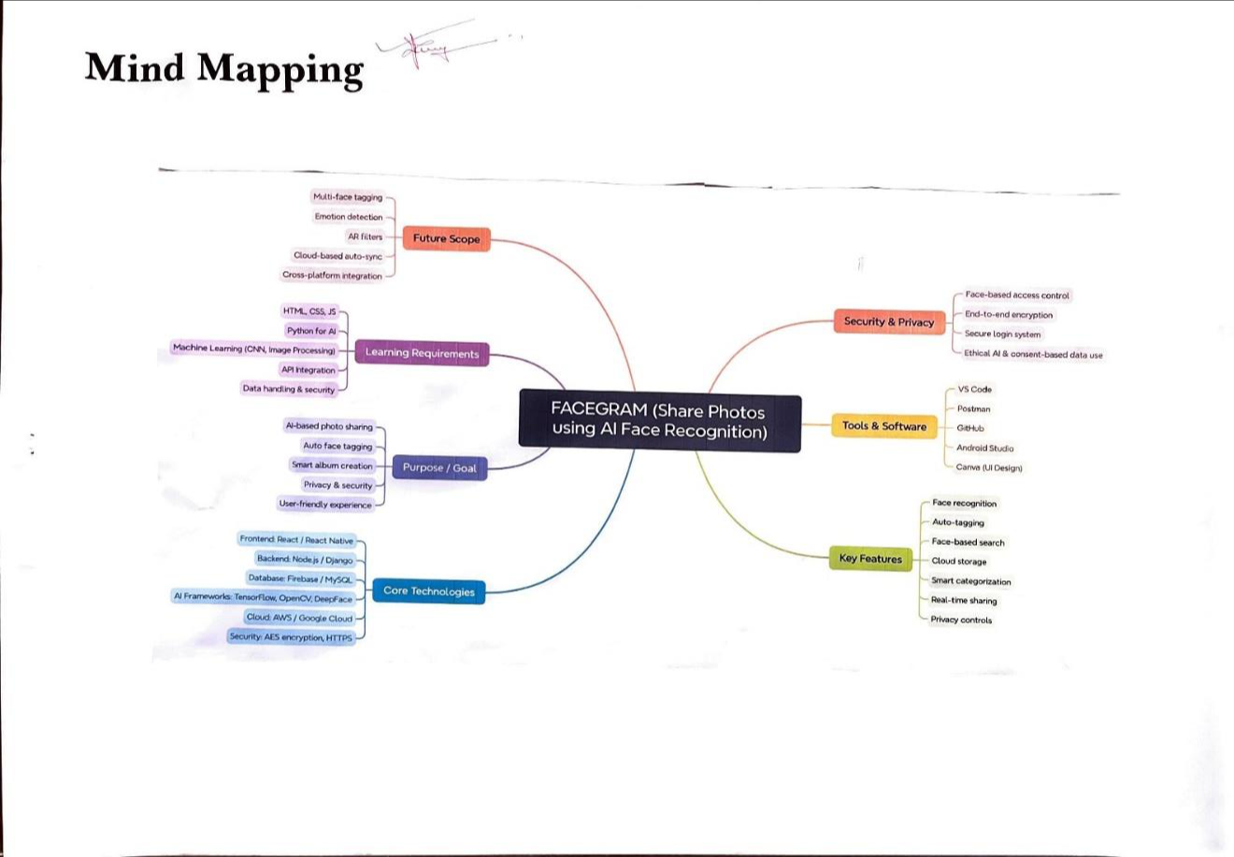
[Fig-2.1.1-Mind Map]
[Information Technology Department] Page 4

Vision360 (Automated Virtual Tour Application)
2.2AEIOU Summary Framework
AEIOU is an investigative tool to help interpret observations gathered by ethnographic practices in the field. It is an Observation tool. Its two primary functions are to
code data, and to develop building blocks of models that will ultimately address the objectives and issues of a client.
➢A-Activities:
Activities are goal directed sets of actions – paths towards people want to accomplish.
➢Upload
➢Share
➢Detect
➢Tag
➢Auto album
➢Search
➢Manage privacy
➢E-Environment:
Environments include the entire arena where activities take place. In this section, we have added the environment in which the situations are taking place and the atmosphere which is creating a problem inside or outside of your domain.
➢Web app
➢Mobile app
➢Cloud storage
➢Real-time AI
➢User-friendly UI
➢Home / Events / Office
[Information Technology Department] Page 5

Vision360 (Automated Virtual Tour Application)
➢I-Interactions:
Interactions are between person and someone or something else. In this section, we have added the interaction happening in the current system.
➢User ↔ AI
➢Upload & view
➢Auto tagging
➢Notifications
➢Privacy control
➢O- Objects:
What are the objects and devices people have in their environments and how do they relate to their activities.
➢Photos
➢Profiles
➢AI model
➢Database
➢Dashboard
➢Devices
➢U –Users:
Users are the people whose behaviours, preferences, and needs are being observed.
➢Social media users
➢Families & friends
➢Photographers
➢Students
➢Professionals
➢Privacy-focused users
[Information Technology Department] Page 6

Vision360 (Automated Virtual Tour Application) ➢AEIOU Summary canvas:-
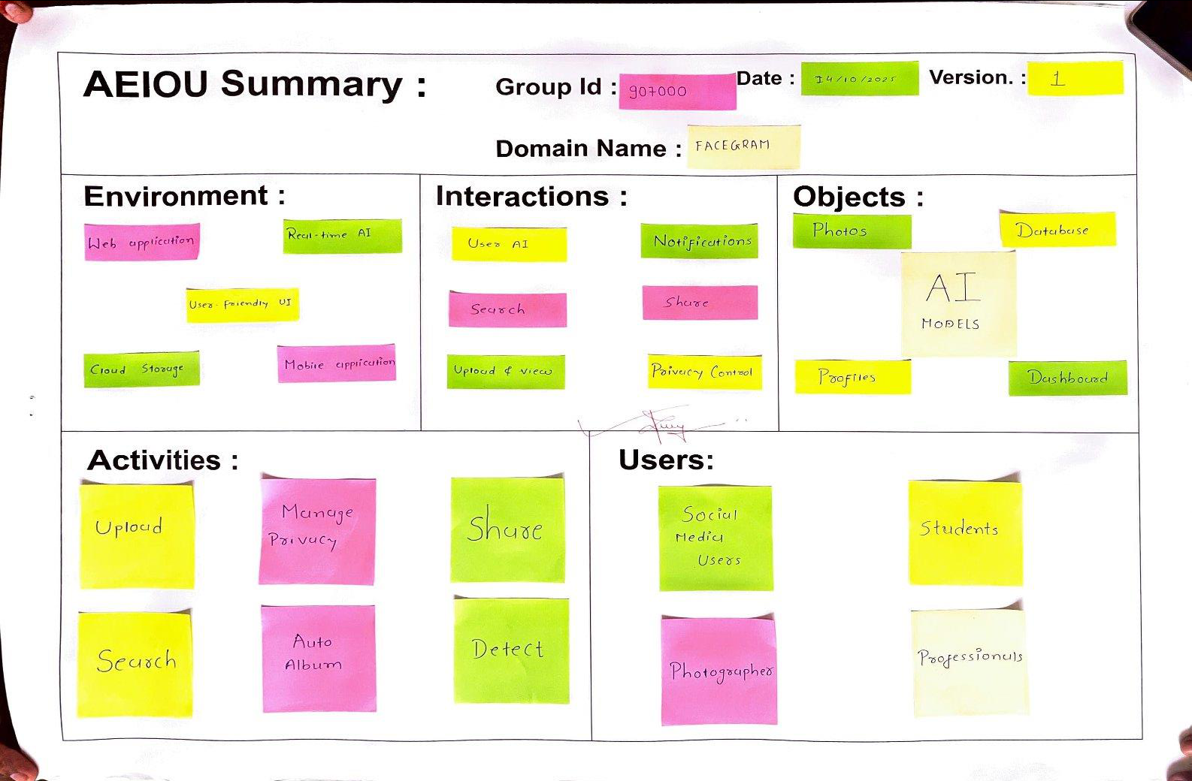
[Fig-2.2.6.1-AEIOU Summery Canvas]
[Information Technology Department] Page 7

Vision360 (Automated Virtual Tour Application)
2.3Empathy mapping canvas
Meaning of empathy is understanding and entering to another’s feelings. The empathy mapping is a great powerful tool that helps putting yourself inside the head of a person you might be looking at a product user. It allows you to quickly grasp their experience and where they are coming from.
➢ Users:
➢Social media users
➢Families & friends
➢Photographers
➢Students & professionals
➢Stakeholders:
➢End users
➢Developers & AI engineers
➢Cloud service providers
➢Security & privacy experts
➢Project investors & admins
➢Activities:
➢Upload & share photos
➢AI detects & tags faces
➢Auto smart album creation
➢Face-based photo search
➢Manage privacy settings
➢Share albums securely
➢Receive tag notifications
[Information Technology Department] Page 8

Vision360 (Automated Virtual Tour Application)
➢Story Boarding:
Happy Story:
1.Riya uploads hundreds of photos from her family vacation. Within seconds, Vision360’s AI detects each family member and automatically creates smart albums labeled “Mom,” “Dad,” “Trip Memories,” and “Goa 2025.” She’s amazed that she doesn’t have to tag anyone manually. Her parents receive a private album link with only their photos. Everyone enjoys reliving moments effortlessly, and Riya feels proud of how organized everything looks. The AI even suggests sharing a “Best Moments” slideshow. Riya smiles, realizing that technology can not only save time but also preserve memories beautifully and securely.
2.Aman, a freelance photographer, often struggles to manage thousands of event photos. With Vision360, he uploads them all at once, and the AI instantly identifies each guest, grouping photos automatically. His clients receive individual albums with their best shots without him sorting manually. Aman is thrilled — what used to take hours now takes minutes. His clients appreciate the efficiency and privacy, strengthening his reputation. For Aman, Vision360 becomes more than just a tool; it’s his smart assistant that helps him deliver professional results faster while keeping every client’s memories perfectly organized.
Sad Story:
1.Meena uploads her college reunion photos. The AI works well but accidentally tags her friend Neha as someone else in a few pictures. Though she corrects it manually, Meena feels disappointed that the AI isn’t fully accurate yet. Her friends tease her jokingly, but she worries others might get confused. She also realizes that some low-light pictures weren’t detected properly. While the platform performs well overall, this small mistake affects her trust in the system. She hopes future updates will make Vision360 smarter and ensure tagging errors don’t disrupt the joy of sharing memories.
[Information Technology Department] Page 9

Vision360 (Automated Virtual Tour Application)
2.Karan loves using Vision360 for organizing photos, but one day he feels uneasy after reading about face data misuse in other apps. Although Vision360 claims to use secure encryption, Karan wishes there was more transparency about how his data is stored. He hesitates to upload more photos and disables face-based tagging temporarily. The experience makes him realize that while AI brings convenience, privacy assurance is equally important. Karan still likes the app but hopes the developers add a clear privacy dashboard and explain how data protection works to regain full user confidence.
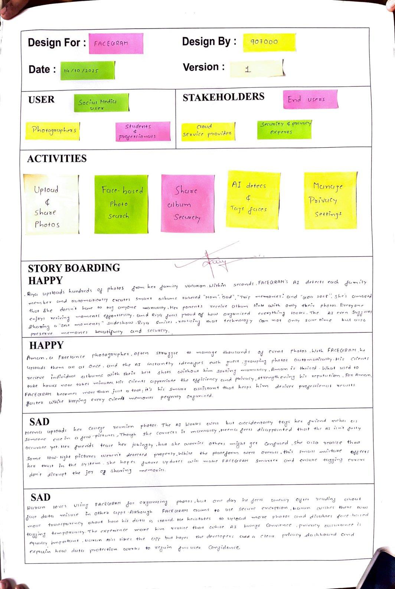
[Fig-2.3.4.1-Empathy Canvas]
[Information Technology Department] Page 10

Vision360 (Automated Virtual Tour Application)
2.4Ideation Canvas
An ideation canvas is a rough whiteboard where ideas can be stretched into any limits or dimensions. Ideation phase is not aimed at finding solutions to the define problem but to define the best possible problem and stretch out its possible scope. The field is set and the overall agenda is to build the clones of the ideas and pivot them throughout the canvas to discover new possibilities.
➢People:
➢Social media users
➢Families & friends
➢Photographers
➢Students
➢Tech enthusiasts
➢Activities:
➢Upload photos
➢AI face detection
➢Auto-tagging
➢Smart albums
➢Search by face
➢Privacy control
➢Sharing
➢Situation/Context/Location:
➢Web & mobile use
➢Social platforms
➢Events & gatherings
➢Personal galleries
➢Professional virtual tours
[Information Technology Department] Page 11

Vision360 (Automated Virtual Tour Application)
➢Props/Possible Solution:
➢Smartphones
➢Cameras
➢Internet
➢React / React Native
➢Node.js / Django
➢Firebase / AWS
➢OpenCV / DeepFace
➢Encryption tools
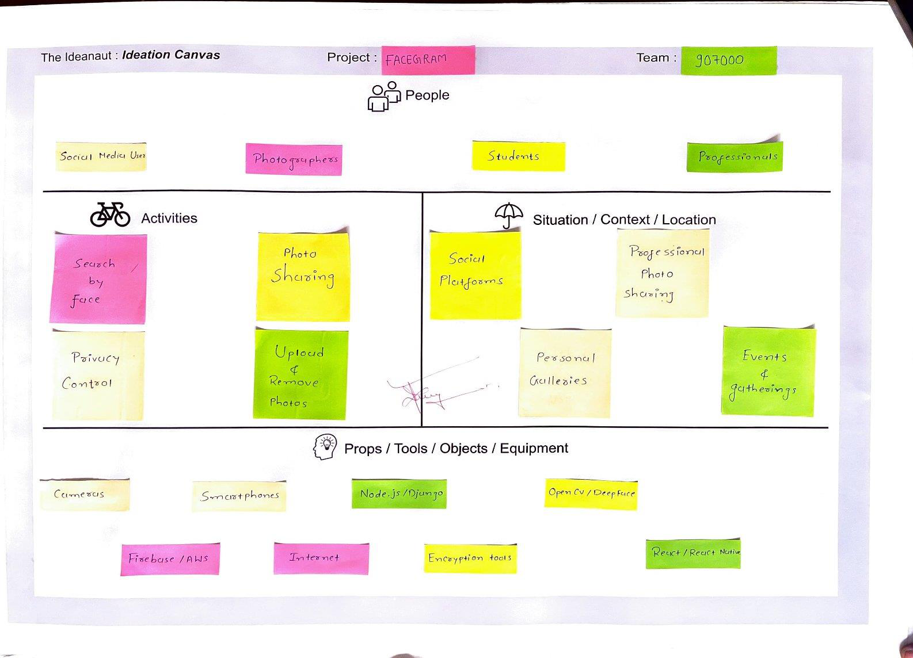
[Fig-2.4.4.1-Ideation Canvas]
[Information Technology Department] Page 12

Vision360 (Automated Virtual Tour Application)
2.5Product Development Canvas
The product development of canvas is totally based on specific product. That is, how product is useful to users which facilities and functions provided by that product and how it differs from recent market products. We should make attempt what is the new idea behind the product and in this section, we can introduce. The new idea and its evolution will reduce the human effort and help them to go easy with life and work.
➢Purpose:
➢AI virtual tours
➢Auto panorama navigation
➢Smart organization
➢Privacy & security
➢User convenience
➢People:
➢Users: Students, families, photographers
➢Stakeholders: Developers, testers, AI engineers
➢Beneficiaries: Social media users, digital photo sharers
➢Components:
➢Frontend: React / React Native
➢Backend: Php
➢Database: MySQL
➢AI: TensorFlow / OpenCV
➢Cloud: AWS / Google Cloud
➢Security: AES, HTTPS
[Information Technology Department] Page 13

Vision360 (Automated Virtual Tour Application)
➢Product Functions:
➢Upload photos
➢Detect faces (AI)
➢Auto-tagging
➢Face search
➢Secure sharing
➢Privacy settings
➢Product Features:
➢DeepFace/OpenCV AI
➢Smart categorization
➢Face-based access
➢Encrypted cloud storage
➢React UI / responsive
➢Real-time alerts
➢Product Experience:
➢Auto-tag photos
➢Smart albums
➢Face-based login
➢Easy navigation
➢Privacy control
➢Real-time upload
➢Customer Revalidation
➢User feedback
➢Ease of use
➢Accuracy testing
➢UI/UX improvements
➢Performance review
[Information Technology Department] Page 14

Vision360 (Automated Virtual Tour Application) [Fig-2.5.8.1-Product Develpment Canvas]
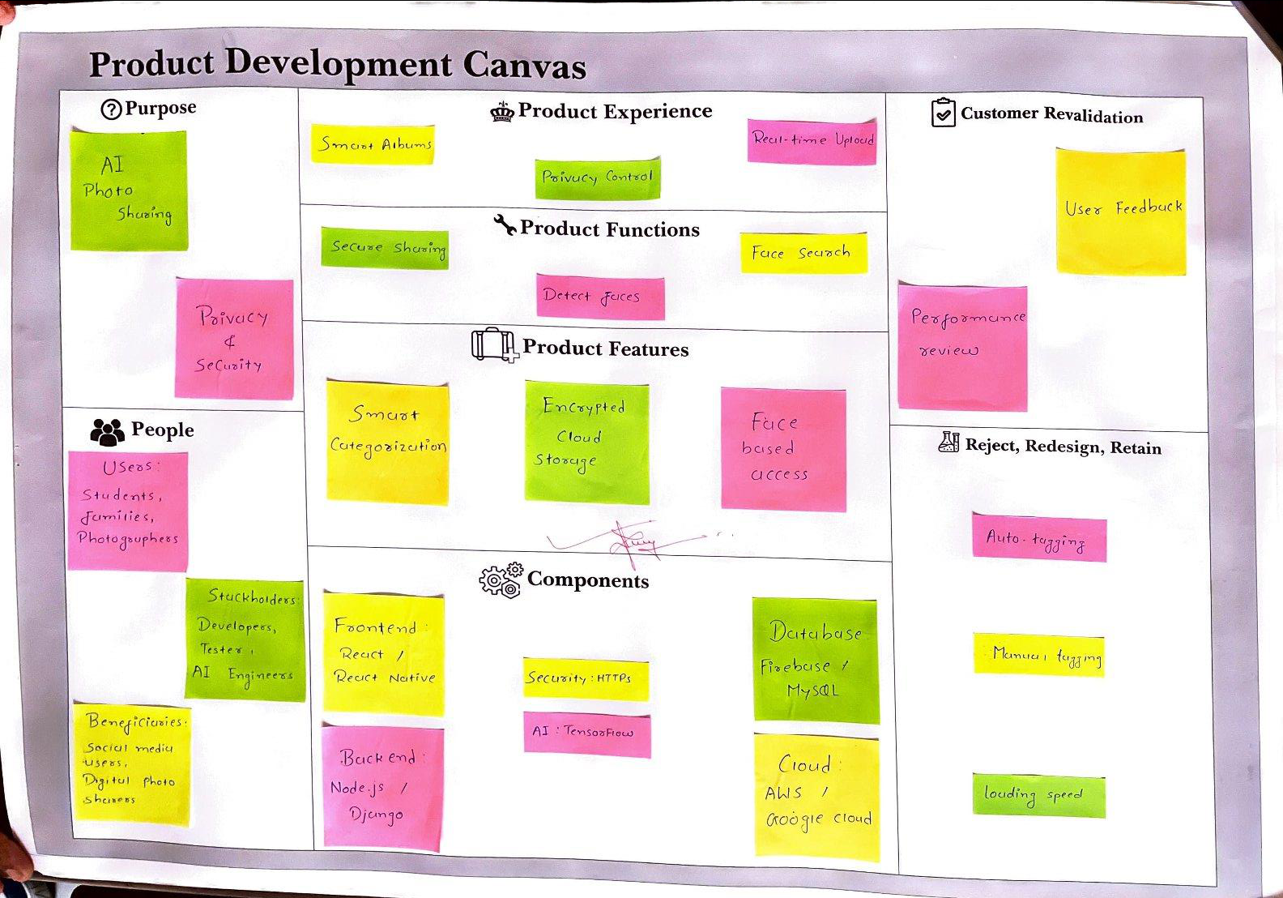
[Information Technology Department] Page 15

Vision360 (Automated Virtual Tour Application)
2.6Learnings Need Matrix (LNM)
A Learning Needs Matrix is a structured tool that helps identify, organize, and prioritize learning requirements within an organization or for individuals. It compares current skills with required competencies, highlighting gaps that need development. By using this matrix, organizations can efficiently allocate resources, plan targeted training programs, and support continuous growth, ultimately enhancing overall performance and productivity.
➢Tools & Skills:
➢Python, OpenCV, TensorFlow
➢React, Node.js
➢Firebase, AWS
➢VS Code, Postman
➢GitHub, JSON
➢Standards & Principles:
➢IEEE Standards
➢ISO 27001
➢GDPR Privacy
➢UI/UX Guidelines
➢Ethical AI
➢Materials / Components:
➢Cloud Storage
➢AI Accuracy
➢Data Encryption
➢Cross-Platform
➢Fast Performance
[Information Technology Department] Page 16

Vision360 (Automated Virtual Tour Application)
➢Math & Theory:
➢IEEE Standards
➢ISO 27001
➢GDPR Privacy
➢UI/UX Guidelines
➢Ethical AI
[Fig-2.6.5.1-Learnings Need Matrix]
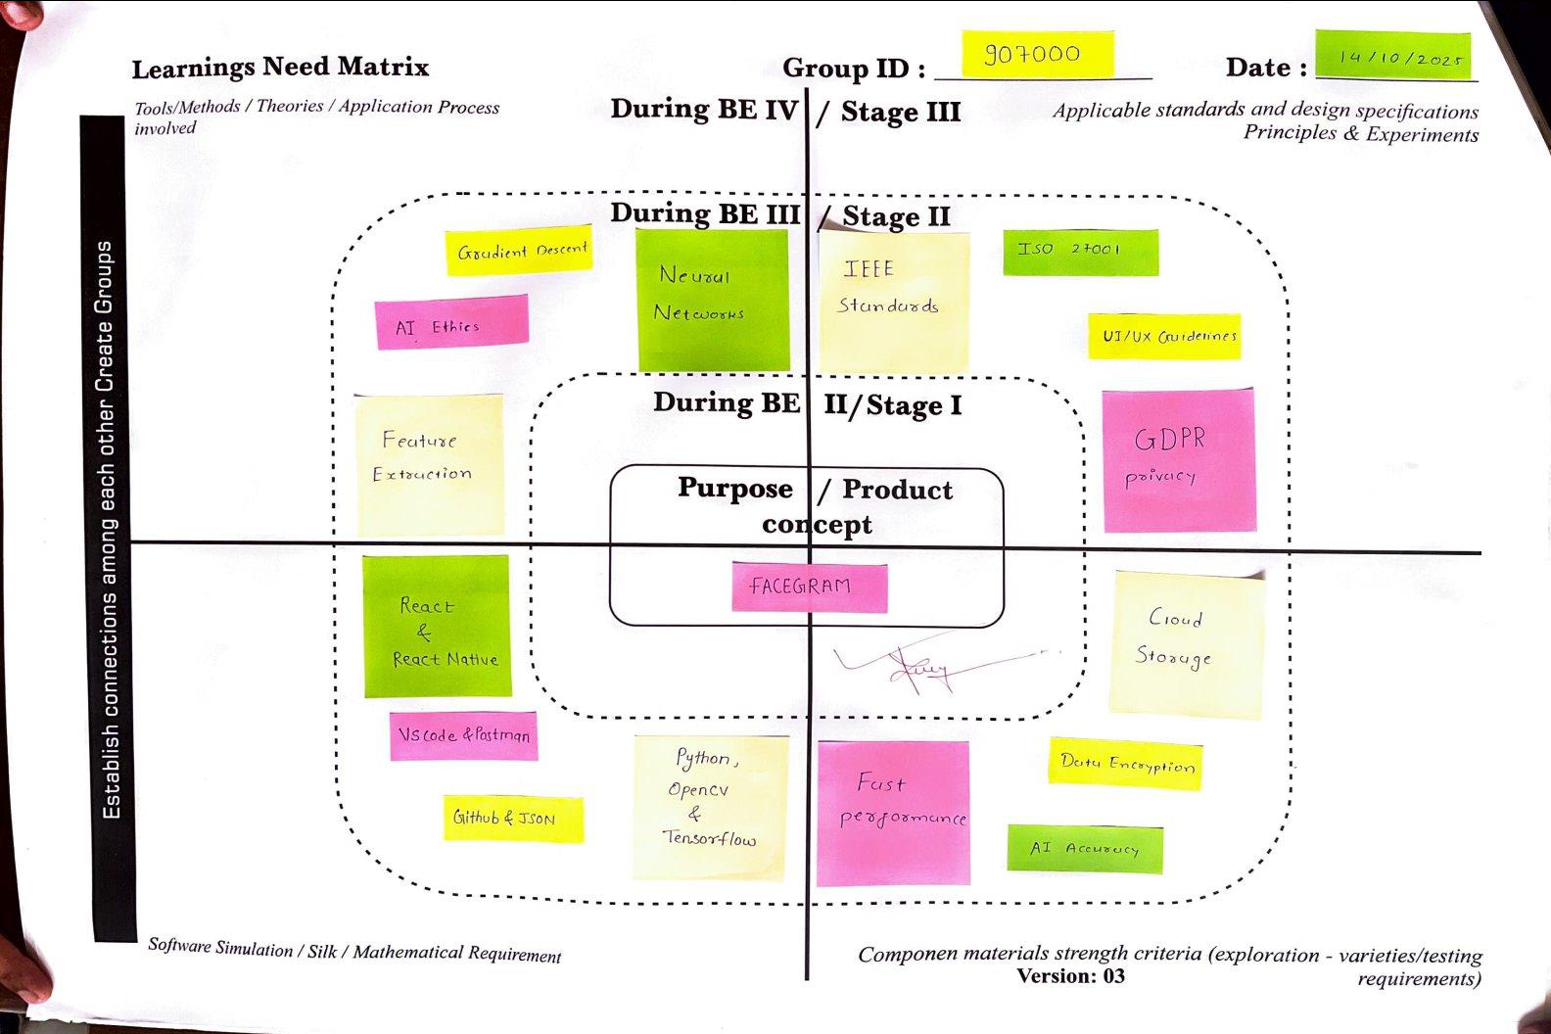
[Information Technology Department] Page 17

Vision360 (Automated Virtual Tour Application) Chapter 3 Rough Prototype
3.1Rough Prototype Design
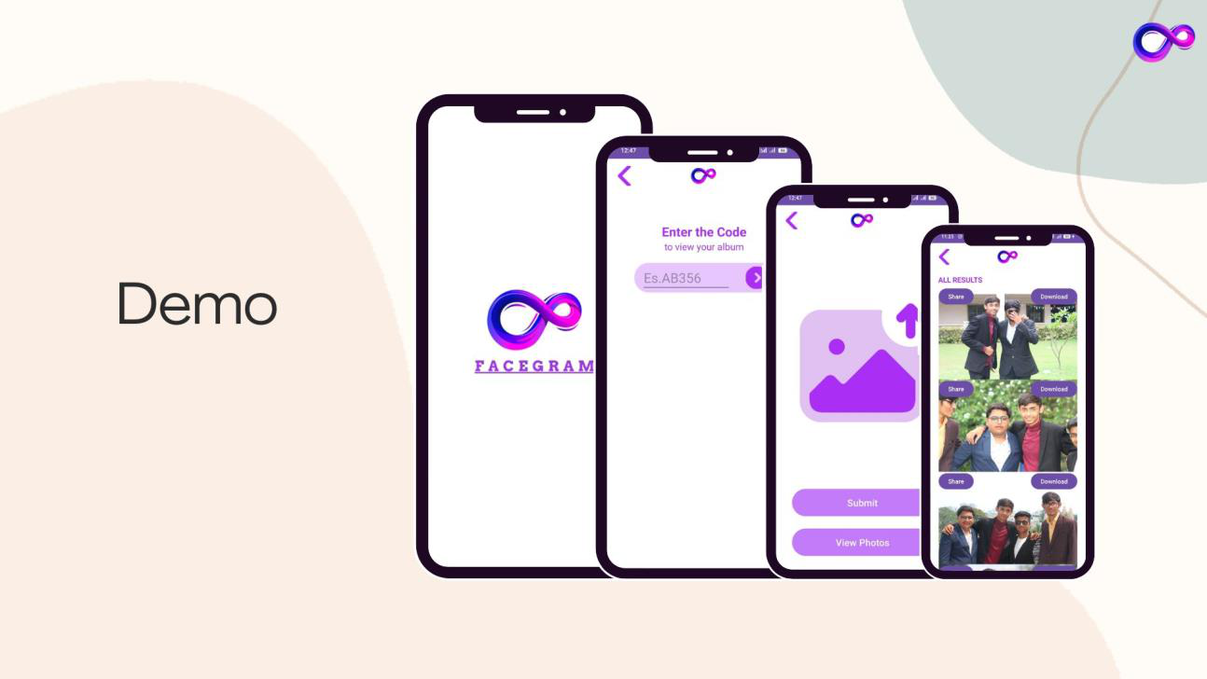
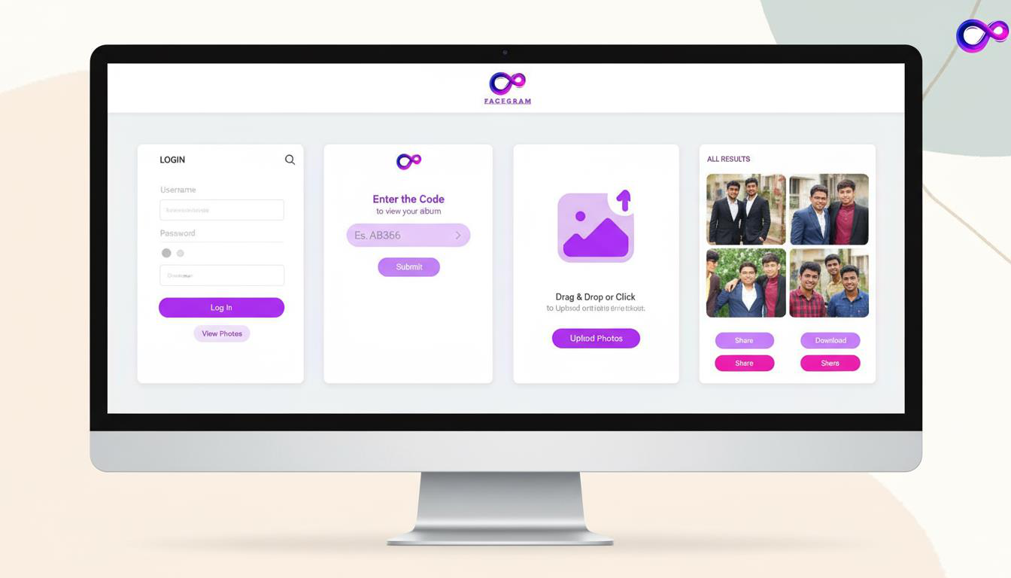
[Information Technology Department] Page 18

Vision360 (Automated Virtual Tour Application)
CONCLUSION
Vision360 represents a significant advancement in the way users interact with and manage their digital photos by combining the power of Web Technologies with modern web and mobile technologies. Through intelligent panorama navigation, automated tagging, and smart sharing features, the platform simplifies the photo organization process and enhances user convenience. By integrating frameworks such as Pannellum and custom WebGL wrappers, Vision360 delivers accurate and efficient face detection, enabling users to easily search, group, and share photos based on identified individuals. The use of PHP for backend development ensures reliable server-side processing and secure data handling, while HTML, CSS, and vanilla JS provide a seamless, responsive, and user-friendly interface across devices. Beyond its technical capabilities, Vision360 also emphasizes privacy, data protection, and user control, implementing end-to-end encryption and consent-based tagging to ensure that users’ personal data remains secure. The platform demonstrates how AI can be effectively harnessed to improve everyday digital experiences, merging automation with user-centric design. Overall, Vision360 not only simplifies digital virtual tour experience but also redefines social virtual tours by making it smarter, safer, and more personalized. This project showcases the potential of integrating AI into social media applications, laying a strong foundation for future enhancements such as emotion-based categorization, real-time photo recommendations, and cloud-based collaborative sharing.
[Information Technology Department] Page 19

Vision360 (Automated Virtual Tour Application)
REFERENCES
1)OpenCV Documentation. (2024). Open Source Computer Vision Library. Retrieved from https://opencv.org
2)DeepFace Documentation. (2024). A Lightweight Face Recognition and Facial
Attribute | Analysis | Framework | for | Python. | Retrieved | from
https://github.com/serengil/deepface
3)React Documentation. (2024). A JavaScript Library for Building User Interfaces. Meta Platforms, Inc. Retrieved from https://react.dev
4)React Native Documentation. (2024). Create Native Apps for Android and iOS using React. Meta Platforms, Inc. Retrieved from https://reactnative.dev
5)PHP Documentation. (2024). PHP Manual: Server-Side Scripting Language. The PHP Group. Retrieved from https://www.php.net
6)Mozilla Developer Network (MDN). (2024). Web Technologies for Developers – HTML, CSS, and JavaScript. Retrieved from https://developer.mozilla.org
7)Stallkamp, J., et al. (2012). Face Recognition using Computer Vision Techniques. Journal of Pattern Recognition and Image Processing, 34(3), 415–428.
8)Goodfellow, I., Bengio, Y., & Courville, A. (2016). Deep Learning. MIT Press.
9)ISO/IEC 2382:2023. Information Security and Privacy – Terminology. International Organization for Standardization.
10)Google AI Blog. (2024). Advances in Facial Recognition and Computer Vision.
Retrieved from https://ai.googleblog.com
[Information Technology Department] Page 20

