COPYRIGHT INFORMATION EXTRACTION FORM
Chitkara University, Rajpura, Punjab

Name | Roll No./Emp Code | Email | Address
Bhumi Garg | 2210990226 | bhumi226.be22@chitkara.edu.in  9530099260 | 701, Station Road, Nasirabad, Rajasthan, 305601
Aastha Gupta | 2210991130 | aastha1130.be22@chitkara.edu.in  7528073185 | 308, Sector-A, Street No.1, Ram Nagar, Sunam, Punjab, 148028
Bhavya Kalra | 2210991440 | bhavya1440.be22@chitkara.edu.in  7015714507 | 1337/11, Model town, Ambala road, Kaithal, Haryana,136027
Dr. S. B. Goyal | CET1003885 | shyam.goyal@chitkara.edu.in | Dean, Department of Computer Science & Engineering, Chitkara University, Punjab, India

TITLE:
Boost: CLI Tool for project optimization
ABSTRACT

1.1 Problem Background
Software projects (mainly production level) don’t remain small. They grow in size because of multiple features, third-party libraries and with a team of developer working on it. During this process, we often end up having empty folders, unused files, unnecessary dependencies, duplicate code and leftover debugging statement. Some security concerns like exposed environment files or hard coded API keys might also remain undetected. It becomes difficult for developer to go through the entire project and look for these things. This may seem like a small task but doing it manually is very time-consuming and reduces efficiency and it may affect maintainability in a group environment.
Although there are tools like ESLint, npm audit, and jscpd that deals with some of these issues but they work independently, so we need to install and run multiple commands and then combine their outputs, so the process still remains time-consuming and does not provide much efficiency. So we need a unified light-weight tool that handles all these issues in a single workflow and make project optimization easier for the developers.

1.2 Objective
The main goal is to design a command-line interface(CLI) tool that can analyze the code quality of a Javascript or Typescript project by:
- Finding unused and large files and assets, duplicate code and leftover debugging statements
- Detecting unused and heavy packages and suggesting the light alternatives
- Removing the empty folders and temporary files
- Auditing security vulnerabilities like exposed .env files, hard-coded API keys
- Rating the code quality of the project based on weighted metrics

The proposed tool provides all these details with just a single npm package, so the developer does not have to install and configure different packages for each concern.

1.3 System Architecture
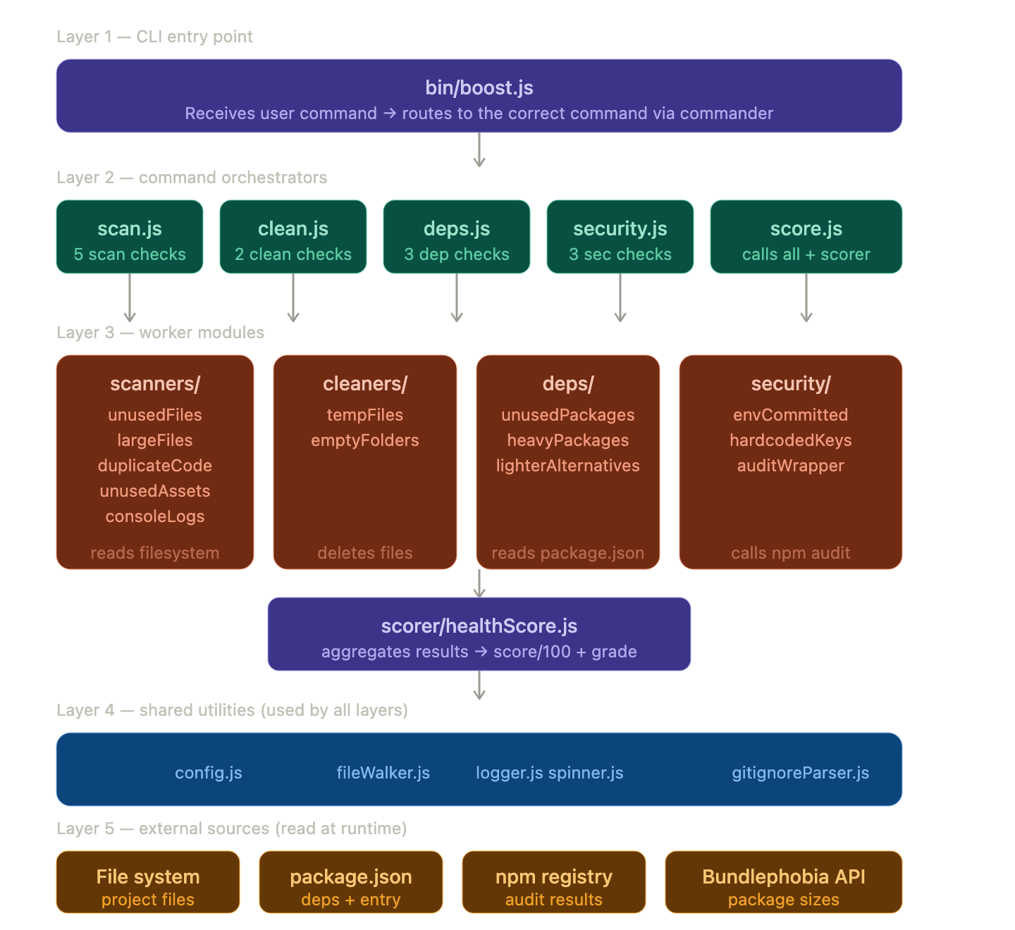

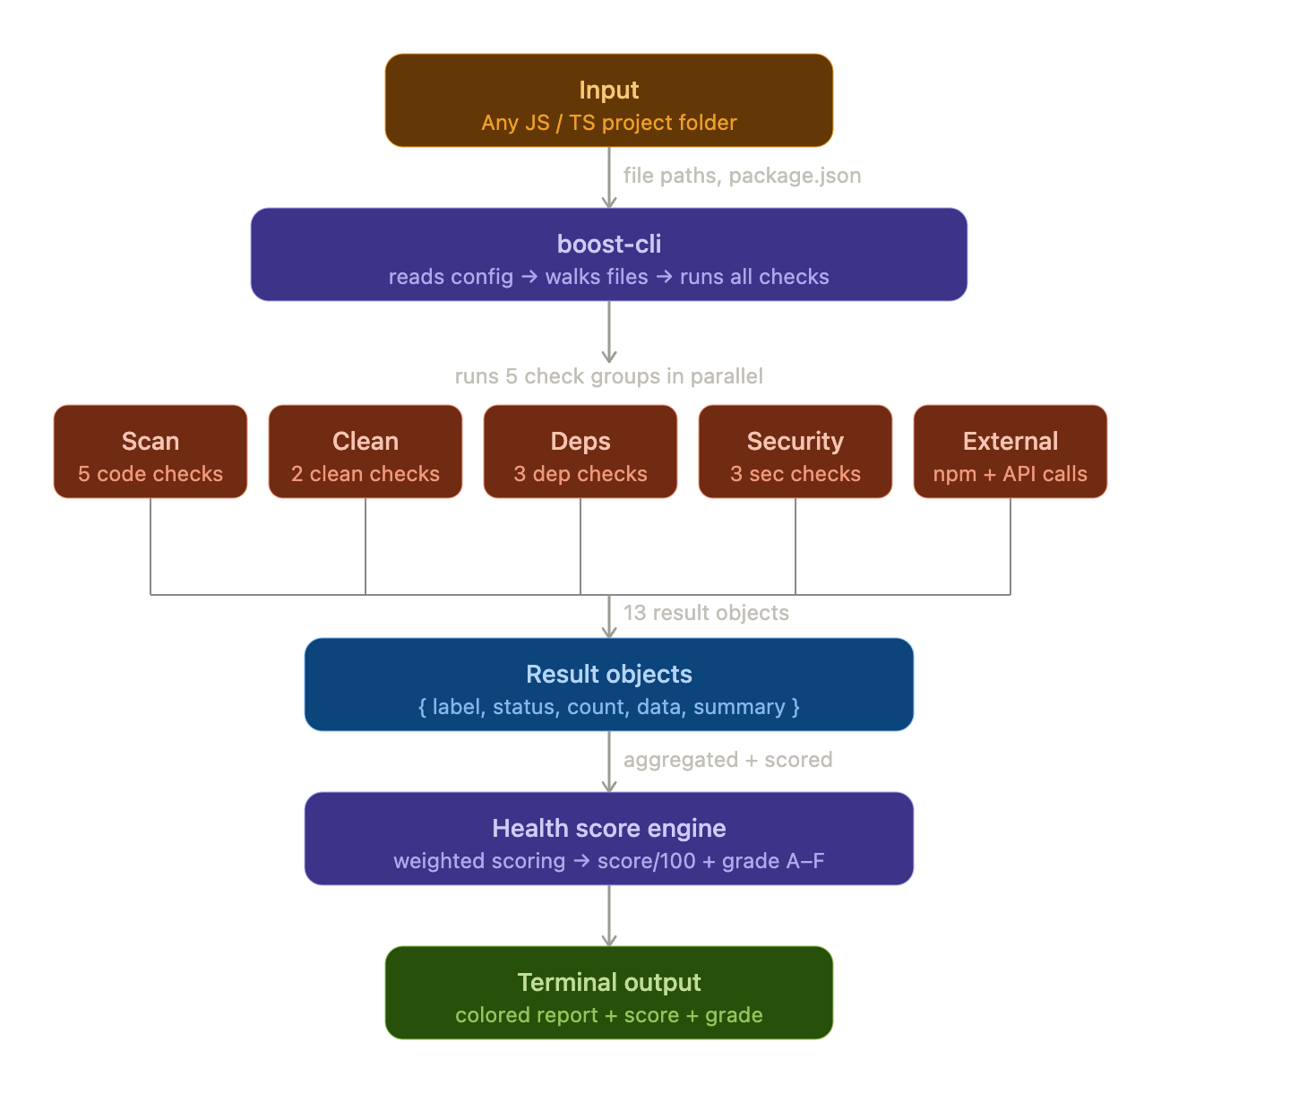
Data Flow:

In simple terms:
Input → Scan → Analyze → Score → Output

1.4 Key Features
The key features of this project are:
  - File Analysis
    - Finds unused files and assets
    - Detects duplicate code
    - Identify large files
    - Locate console logs
  - Dependency Analysis
    - Finds unused packages
    - Detects heavy packages
    - Suggests lighter alternatives

  - Project Cleanup
    - Deletes empty folders
    - Removes temporary files
  - Security Check
    - Checks npm vulnerabilities
    - Identify hard coded secrets
    - Detects exposed(committed) .env files

  - Project Health Score
    - Combines all the above features and gives an overall project health score
    - Gives percentage score for each metric

What’s different?
Unlike tools like ESLint, SonarQube or npm audit, this tool is lightweight and combines multiple checks in one run.

1.5 Technology

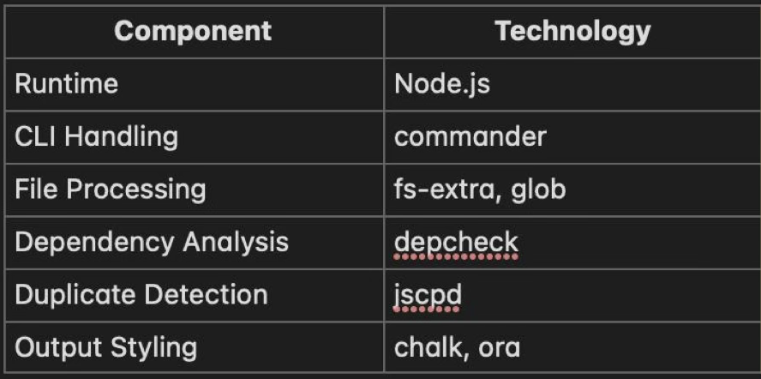
The system is build using Node.js because it works really well for CLI tools. It can handle file operations quickly and also very reliable. Since most of the projects use JS already, it fits in naturally without adding extra complexity.

Why Node.js and a CLI approach?

A CLI tool keeps things simple and practical. It’s easy to run and not very complex. It also doesn’t require an UI. Goes well with existing workflows as well. Another benefits include: faster and efficient file operations, smooth working with JavaScript based projects, can be run on any platform, can be integrated into automation processes as well.

So the flow is very simple. You just run a command, the tool reads the input, loads necessary configurations, scans the project, applies the defined rules and finally gives the output.

System Flow:
Cli Command → Parse Input → Load Config → Scan Files → Apply Rules → Genrate Output

1.6 Expected Outcome and KPIs
These days manually checking everything can be very time consuming and it results in difficult project maintenance. The main goal here is to make this easier and less time consuming.
Basically, it helps catch issues early and keeps the codebase clean.

Major outcomes include:
- This reduces the effort on manually inspecting the codebase
- Helps catch potential issues and risks early
- Keeps a cleaner and structured project directory

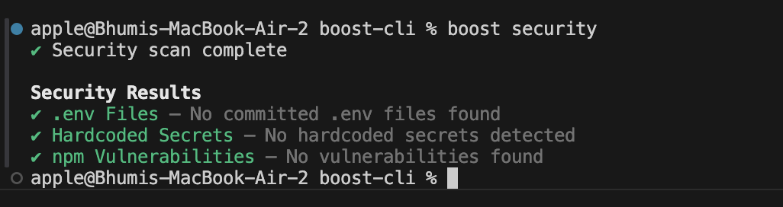
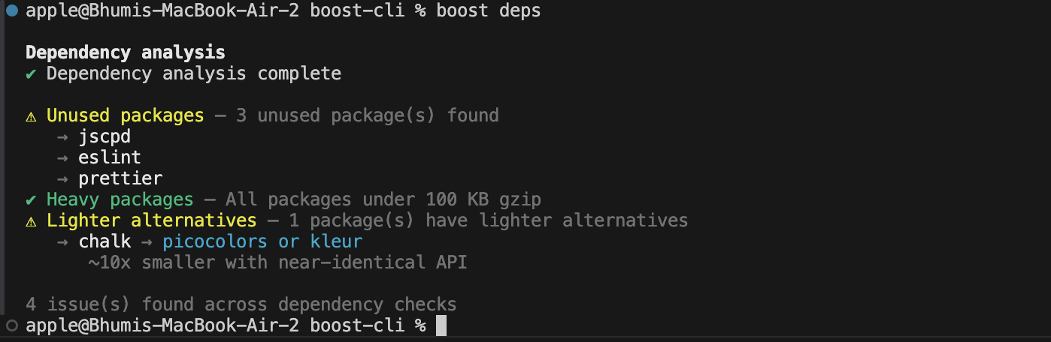

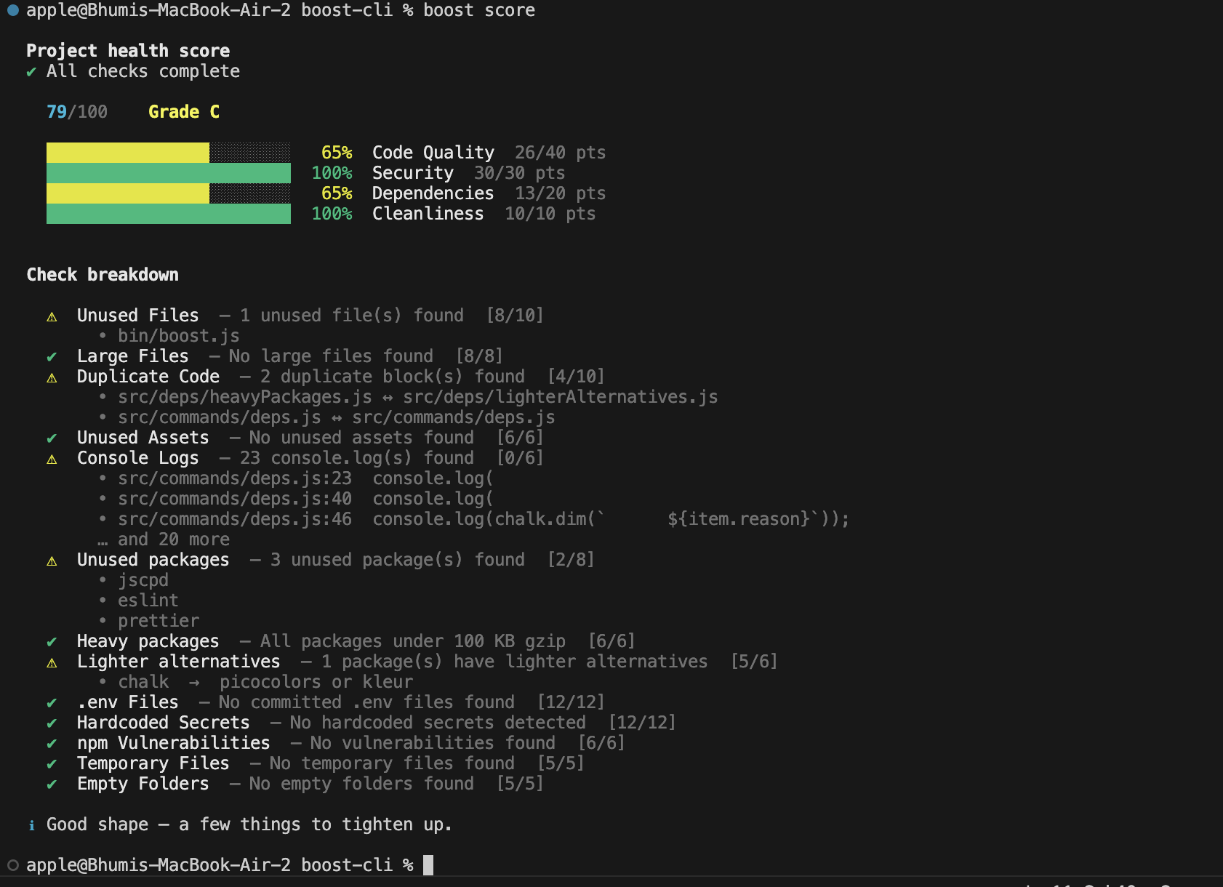

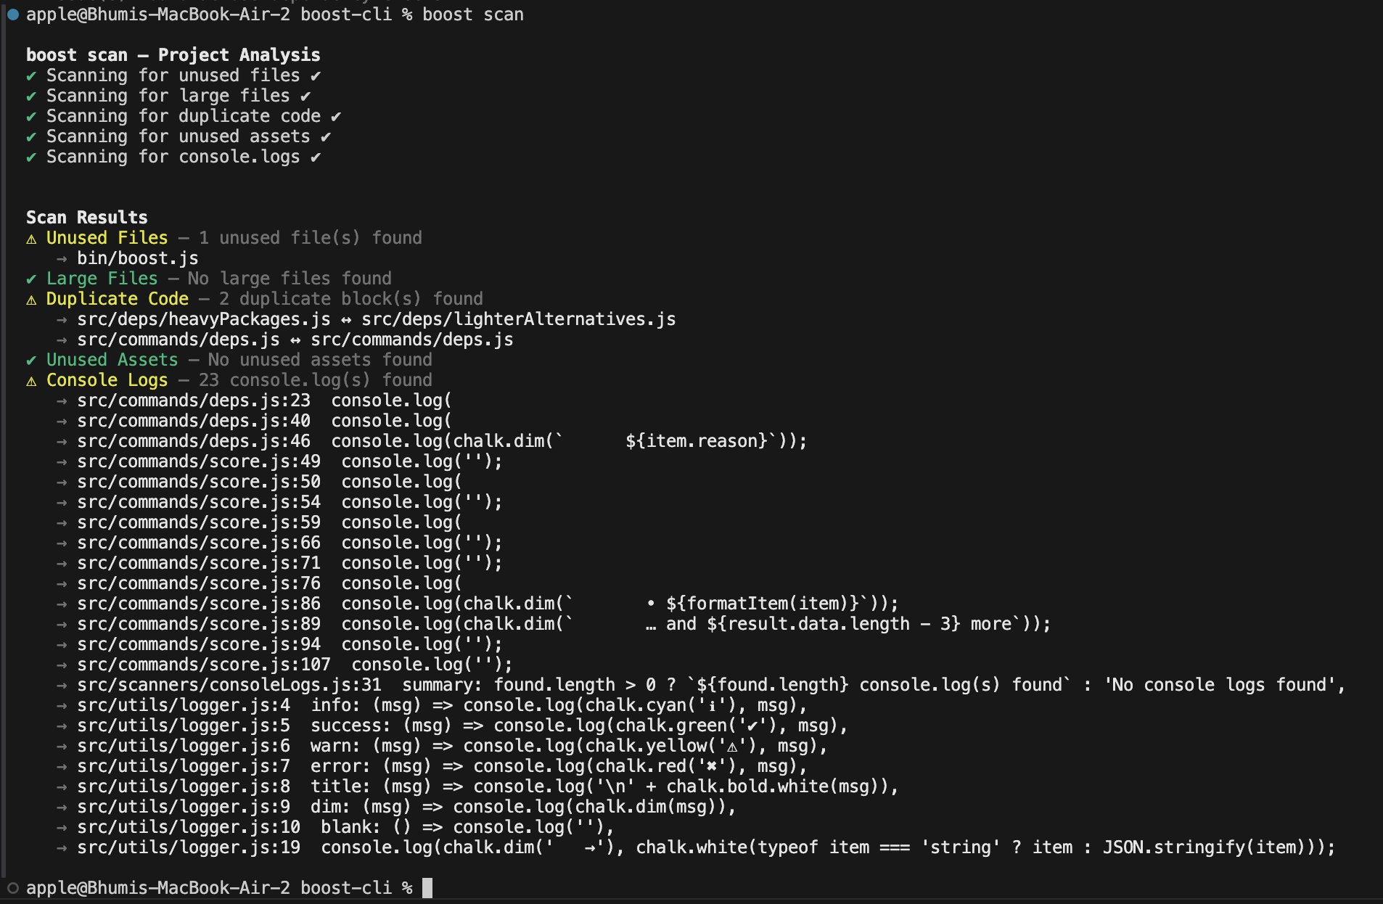

Key Performance Indicators (KPIs):
The actual measure of success should be how useful this tool can be in everyday development. No need to be dependent on AI for the project quality. Instead of numbers, we should see how this tool saves time and reduces the errors which can really help in lifting up the developer productivity.

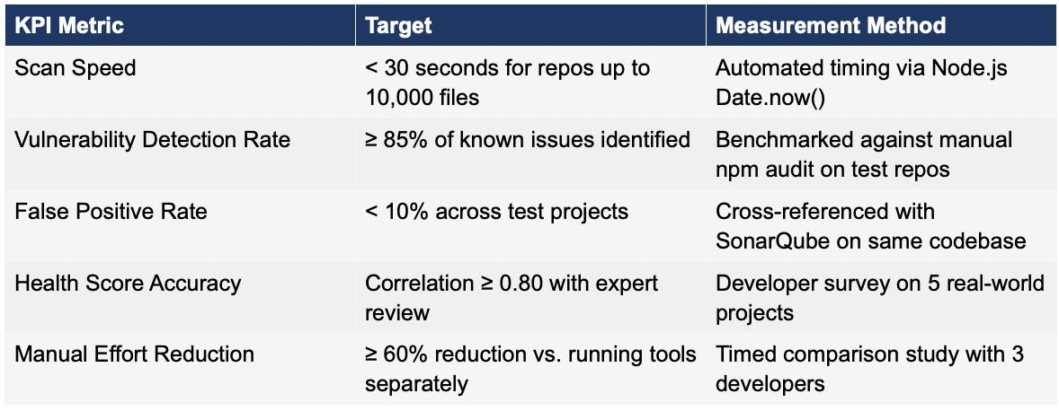

In real life, the tool can be used in 2 ways – either during development or just before the deployment which will help in identifying potential issues early on.

1.7 Original Contribution

We have combined and extended the way existing tools work so the developer just needs one tool for the whole static optimization analysis process of the project.

1. Unified CLI Workflow:

Instead of installing, configuring and running multiple tools, our system provides the developer with just one single command that can tell everything they need to know about the optimization of the project. It can give a combined output of multiple analysis in readable format.

2. Custom Analysis:

The developer can clone the repo and customize the way the analysis is done. For example, he is allowed to change the threshold value for the large files (based on the project needs).

3. Health Scoring:

The system also provides you with the overall health score of the project, which is not provided by any of the existing tools. The health score uses the following metric:

Health Score = w1(Code Quality) + w2(Security) + w3(Dependencies) + w4(Cleanliness)
where, w1 = 40%, w2 = 30%, w3 = 20%, w4 = 10%

4. Cleanup Features:

It has cleanup features like removing the empty folders and temporary files

1.8 Conclusion

The project provides developers with the framework that can scan, analyze, clean, report and score a javascipt/typescript project in a single workflow. Installing multiple tools just for analysis can add redundancy instead of helping in optimization. With this tool, there is no need of installing multiple tools, one lightweight tool does it all.

