Wireshark-traffic-analysis
Bhumi Rana Magar

layer-2 destination Ethernet address of broadcast (not unicast) traffic

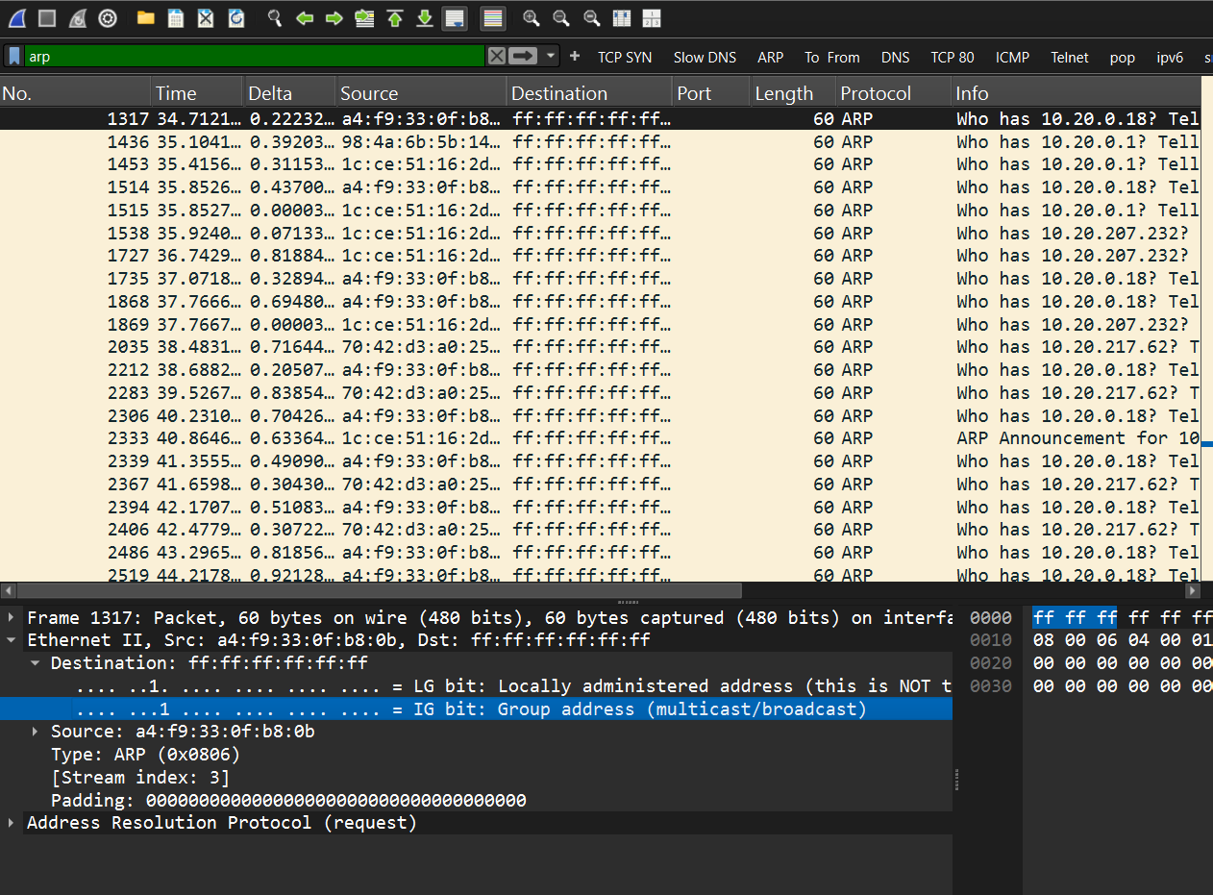
layer-3 destination IP address of broadcast traffic with IP 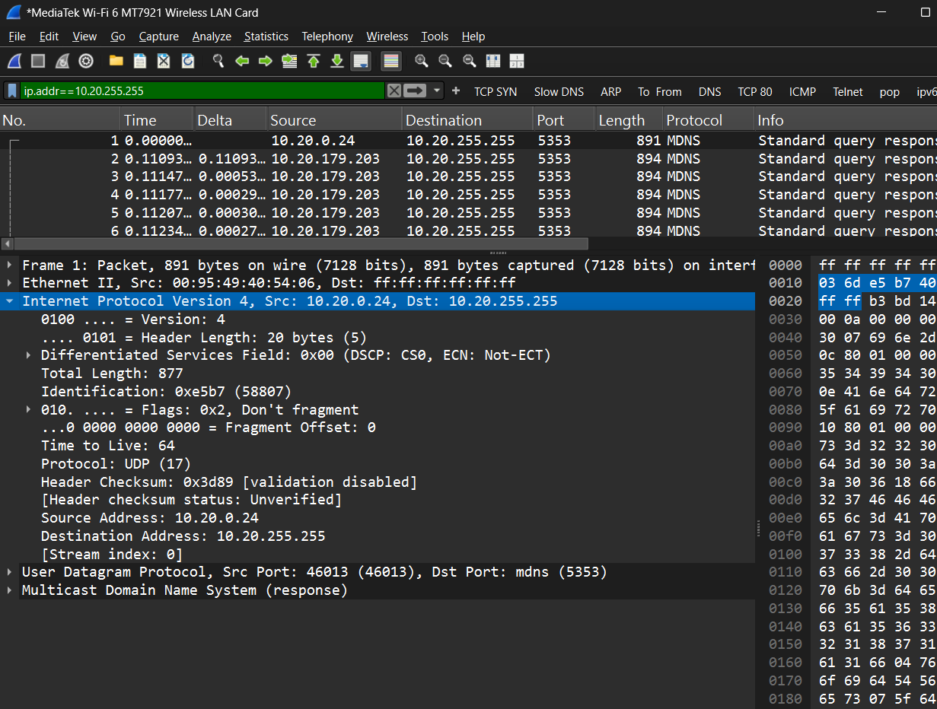

Filtering rule that will display only Ethernet frames that contain my computer’s IP address
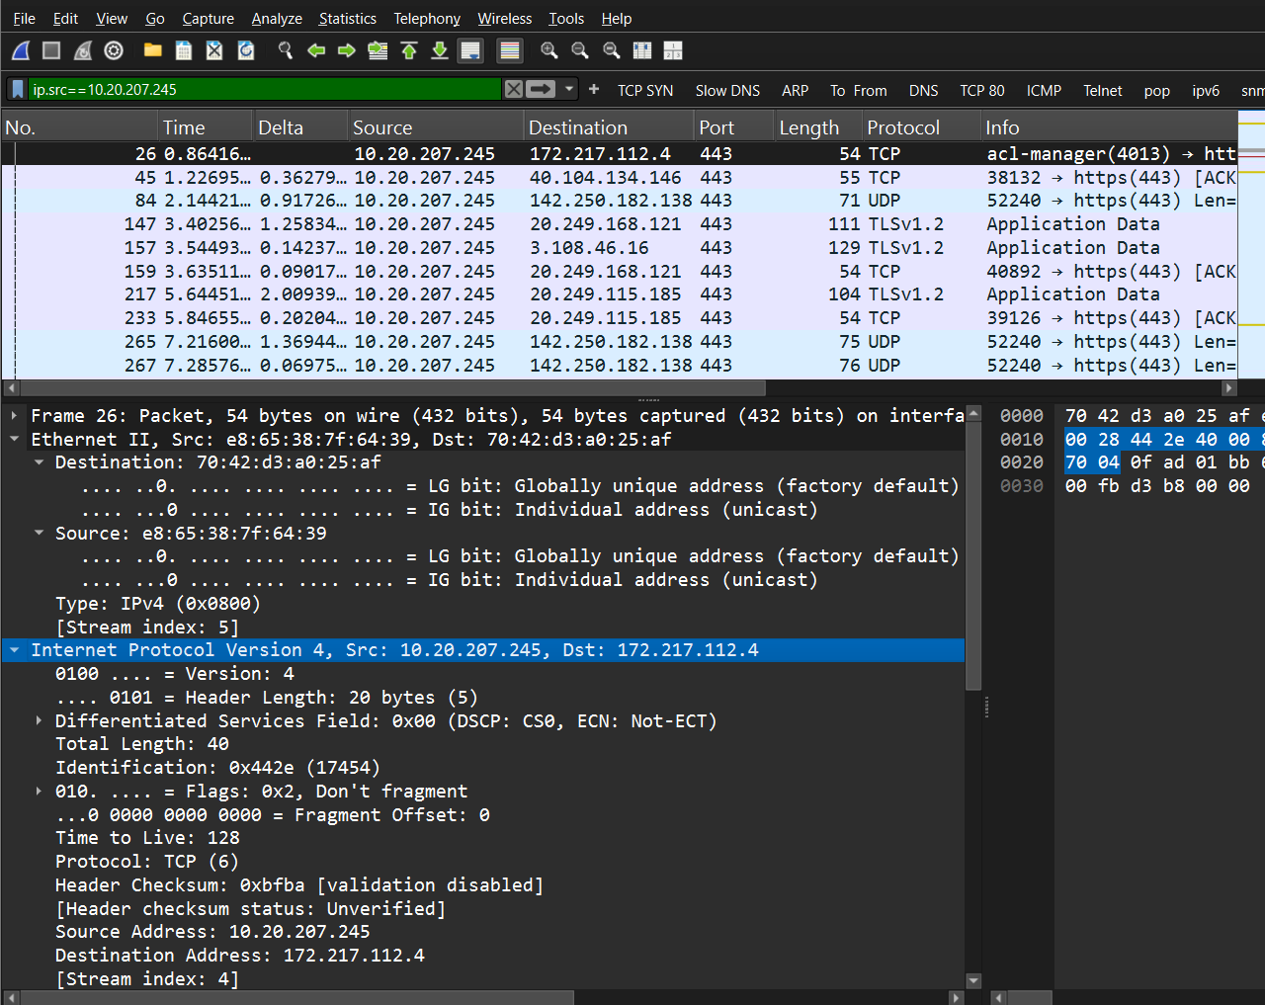

Display only Ethernet frames that contain my computer’s Ethernet address in the Ethernet frame
header
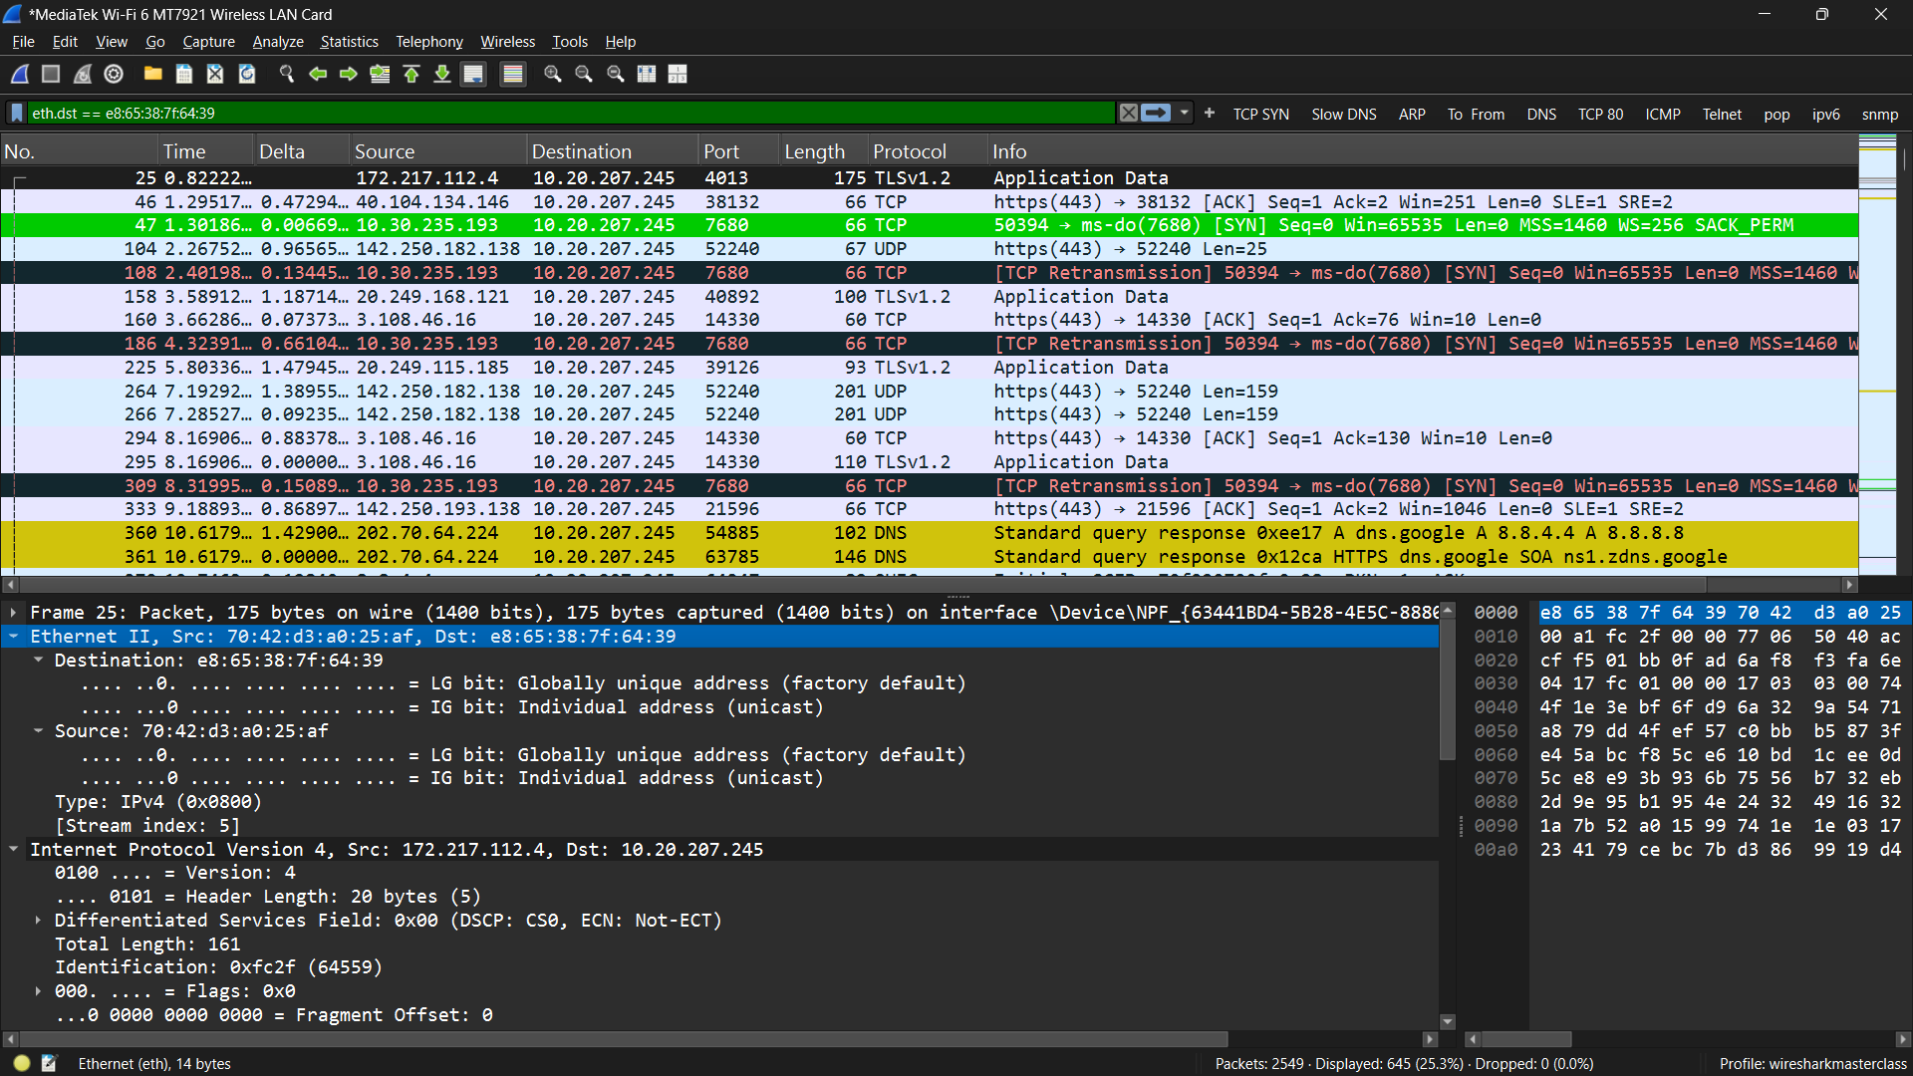

ARP request and the corresponding ARP reply packet
The hexadecimal value the field in Ethernet frame header that is used to identify that the packet is an ARP packet
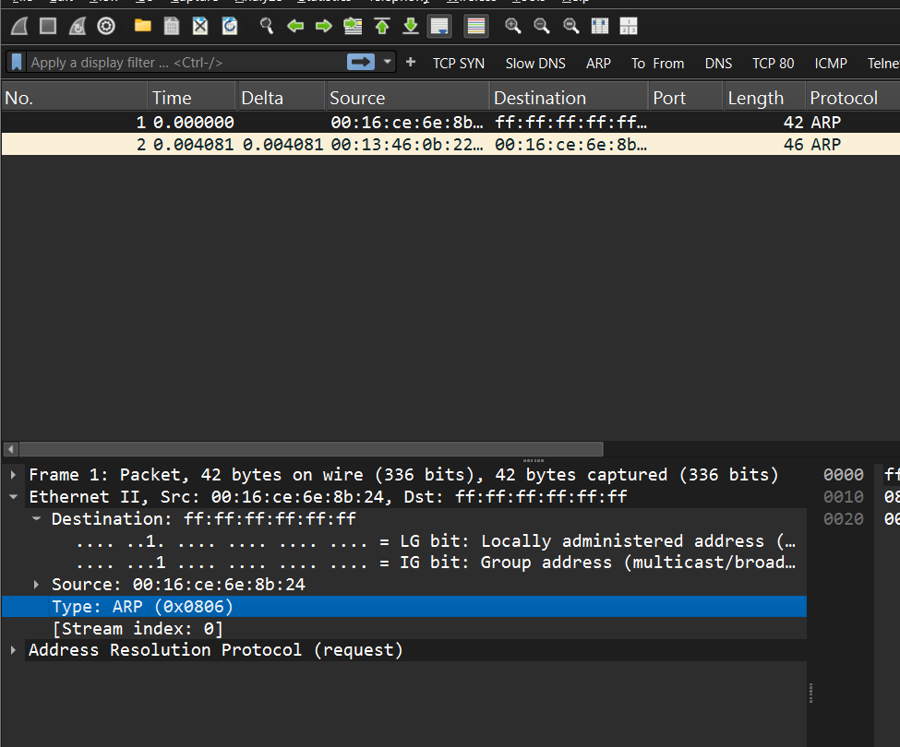

2. The decoded ARP request and ARP reply packets.
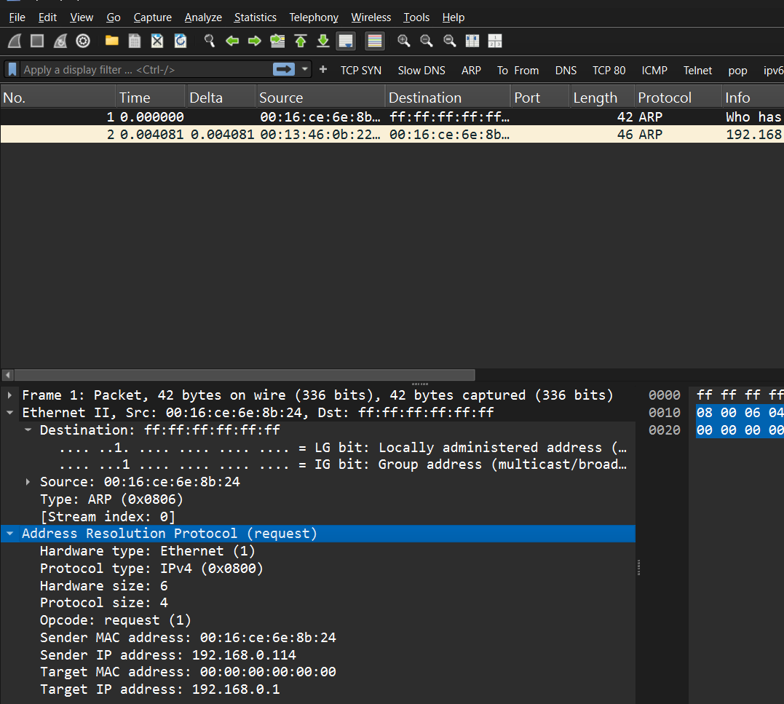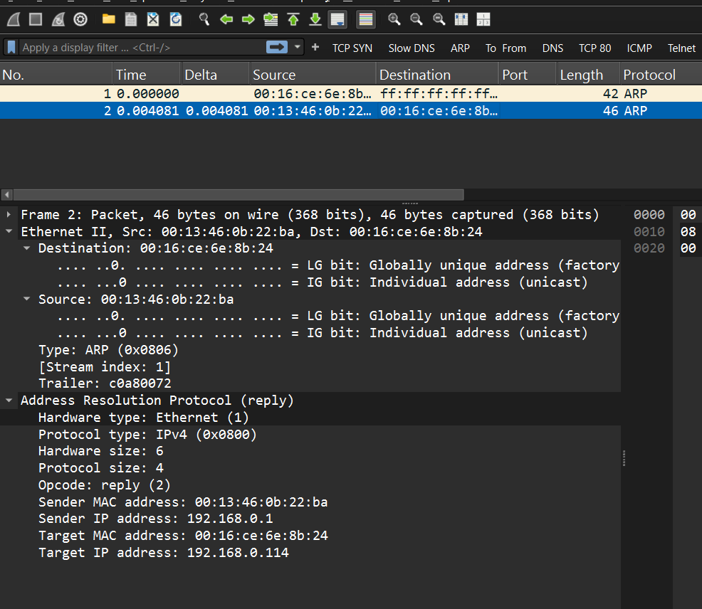

The decimal value of the protocol field in IP header that is used to indicate
that the packet is an ICMP packet
The decoded ICMP echo request and ICMP echo reply packets.
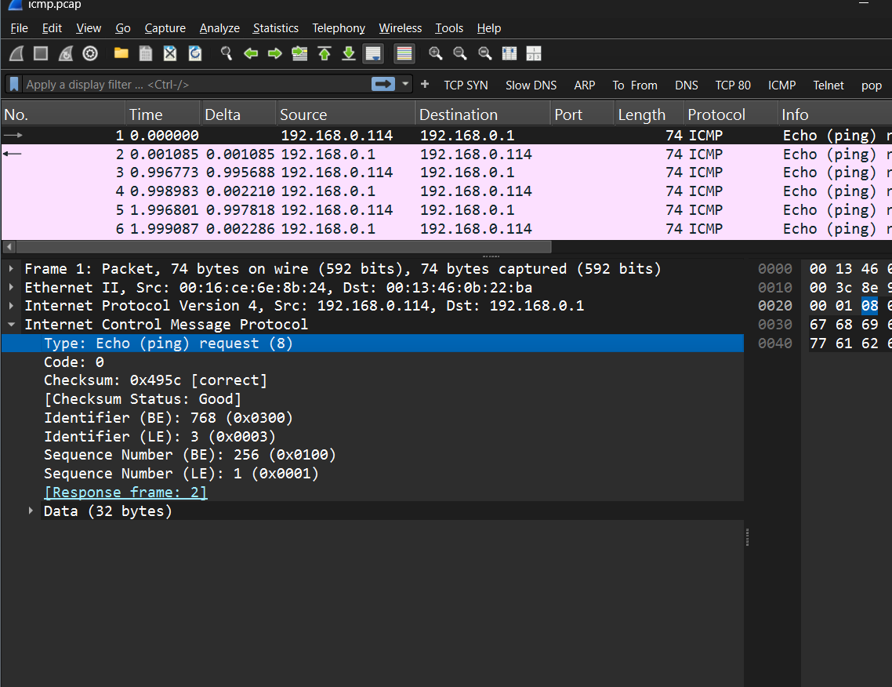
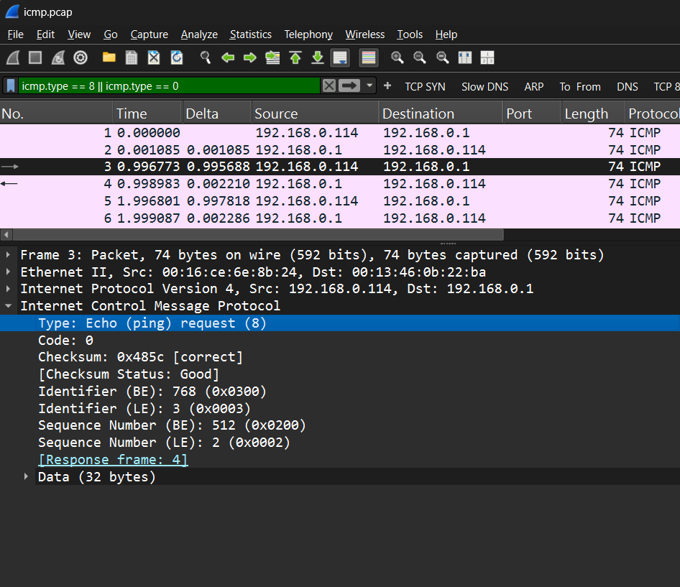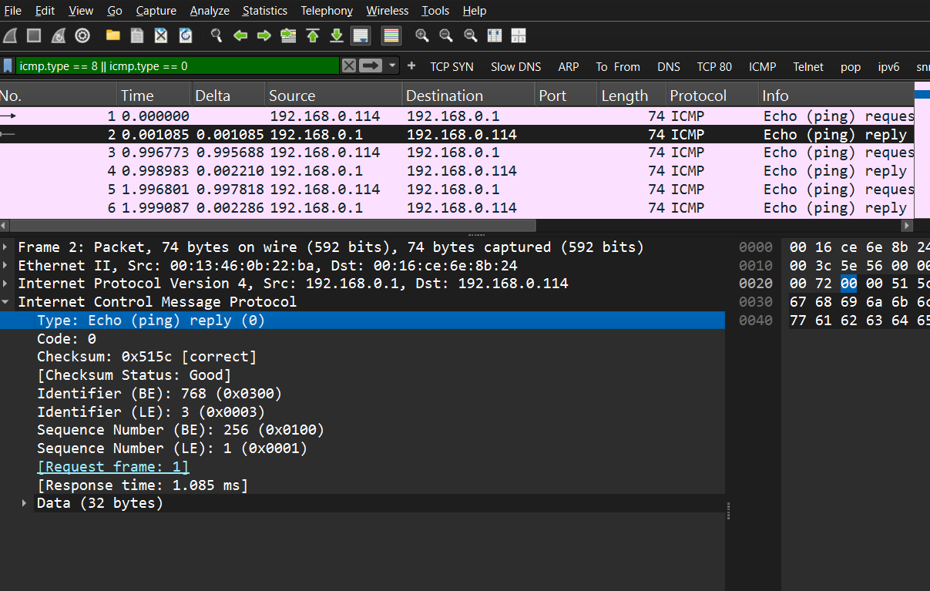

Tracert command
from my computer to www.presidential.edu.np
How does the tracert command running on the Windows client computer modify the value in the TTL field to cause the routers to reply with ICMP messages?
The tracert sends ICMP Echo request by the TTL of 1. When the first router receives that, it decrements the TTL to 0 and drops the packet. Then it returns the ICMP type 11 which is Time to live exceeded message. This identifies as hop 1. Then tracert increases the TTL to 2 then 3,4,5 and so on. This is to discover the routers that are along the path of the target host. Then when the packet is received by the target host it replies with Echo Reply.

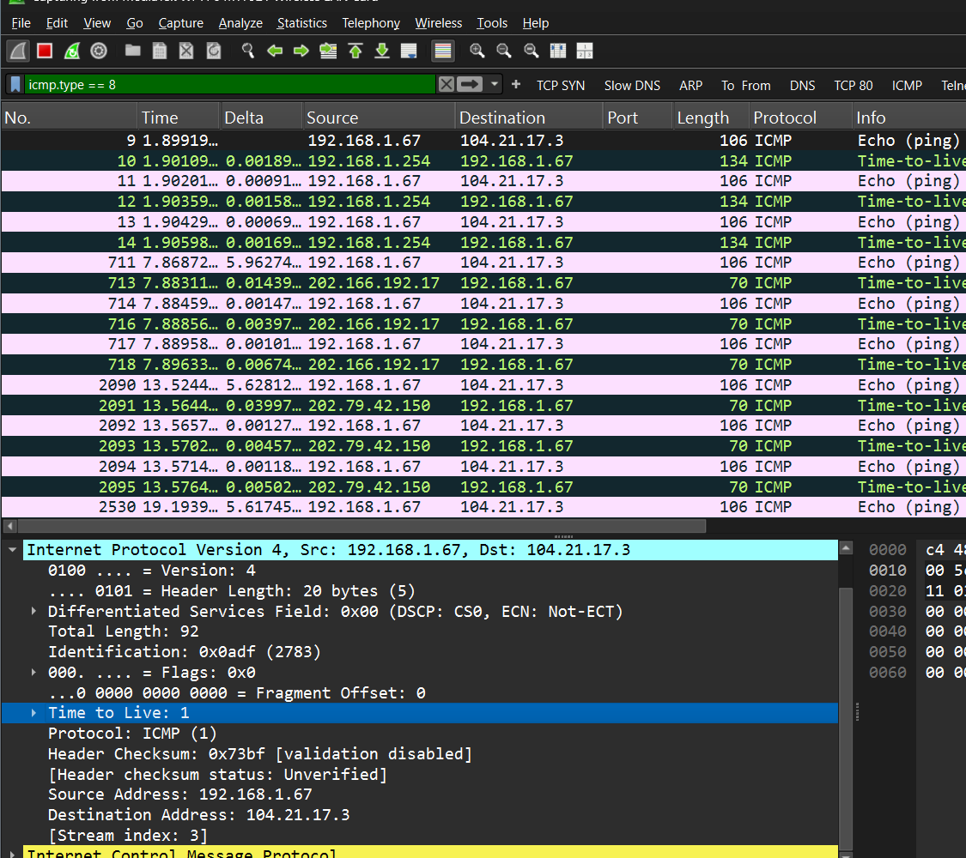

Decoded ICMP TTL exceeded packet that was generated and sent back from a router to my computer.
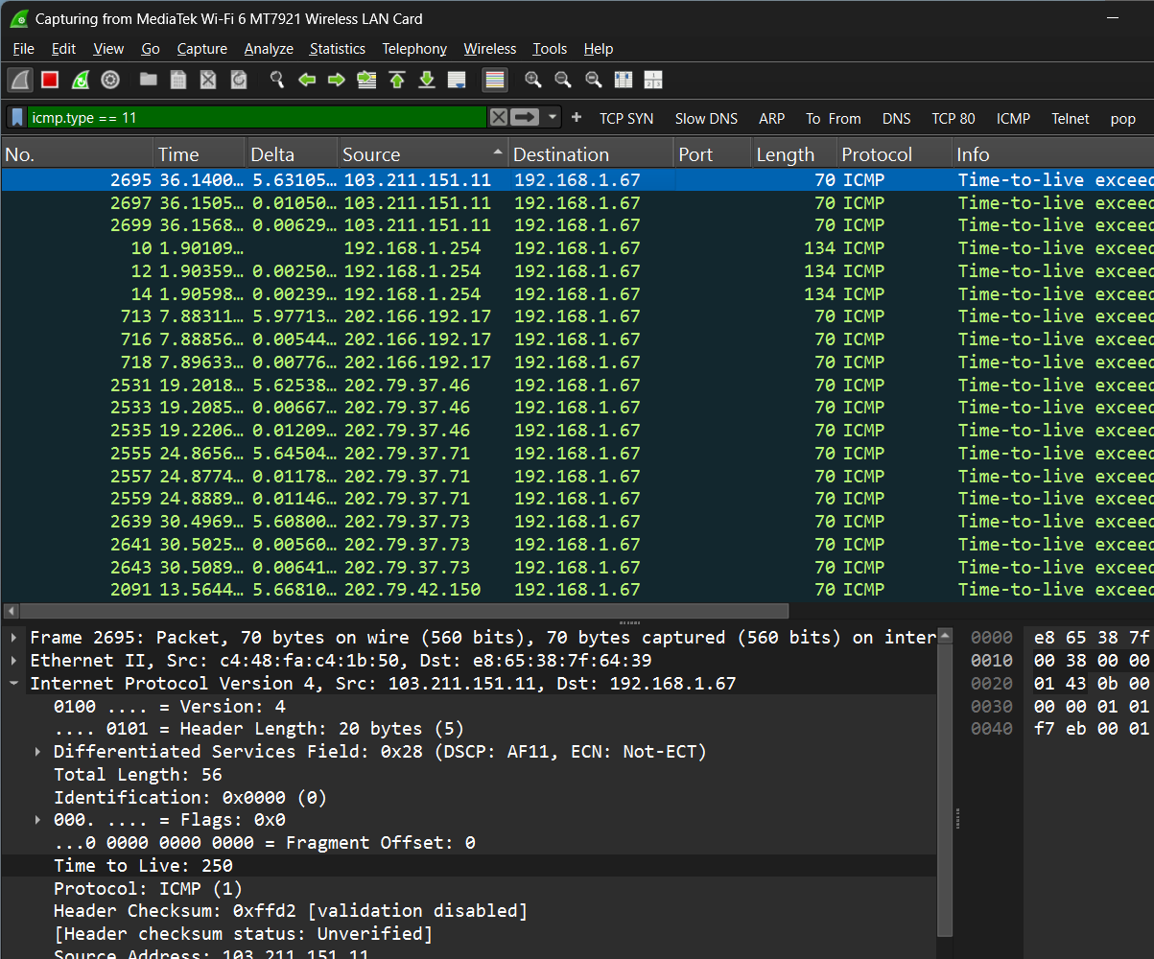

Packets associated with an entire http session.
The 3-way handshake used during startup of the TCP connection. The TCP flags were set
to 1 during the initial 3-way handshake
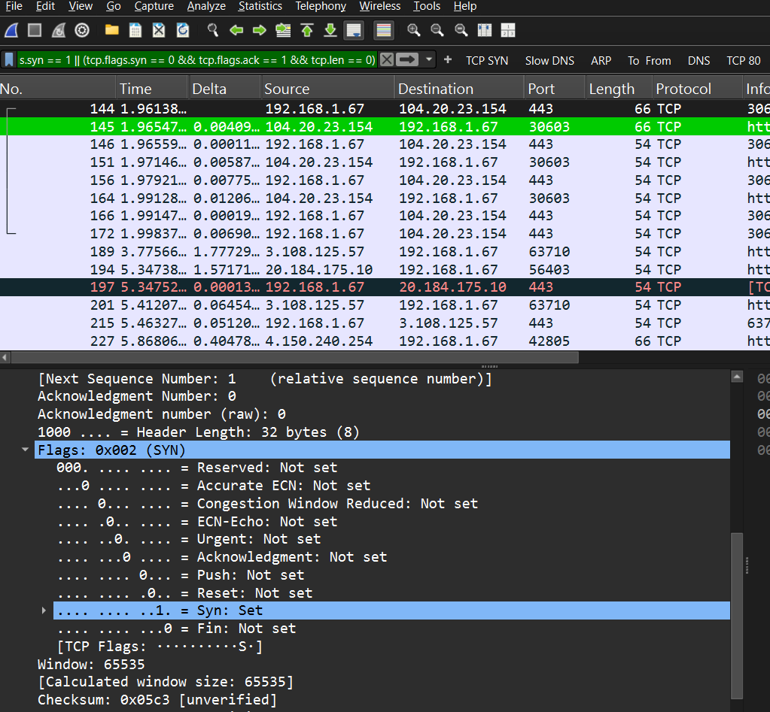

The absolute(raw) and relative values of the initial sequence numbers used by the http client and server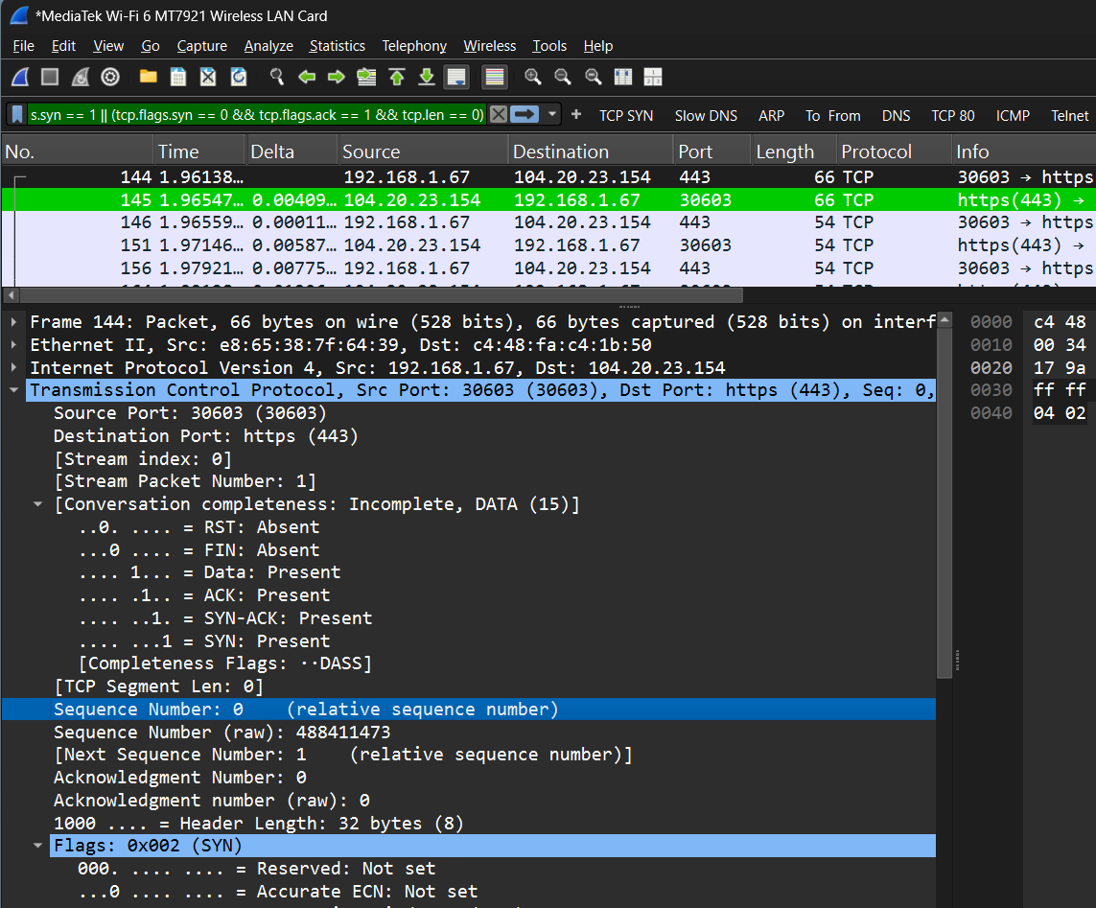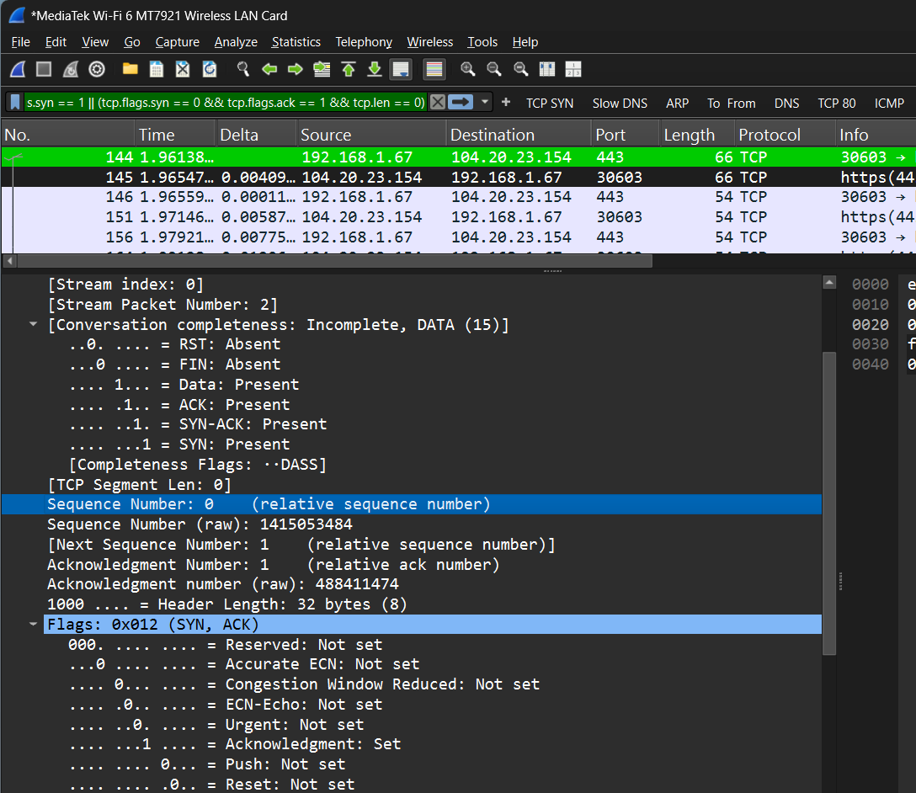

The tcp port numbers the web client and server used
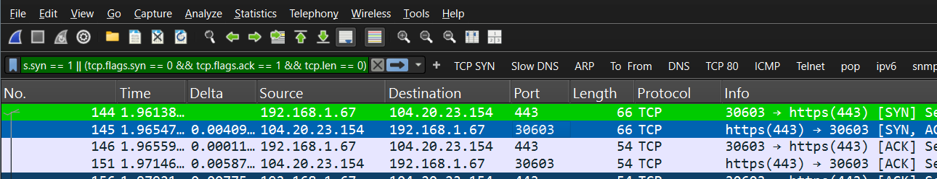

During teardown of the TCP connection the absolute(raw) and relative values of the final acknowledgement numbers sent by the http client and server
