Practical 8
Problem Statement:
- Optimize the React frontend of the Task Management application by implementing lazy loading for route-based components.
- Apply React.lazy() and Suspense to at least the Projects and Contact routes (and non-initial application routes).
- Provide a meaningful fallback UI while a lazy-loaded chunk is loading.
- Measure and compare bundle size and load time before and after optimization using browser developer tools.
- Document the before/after comparison with screenshots, build outputs, and recorded metric values.
File Structure:
Output:
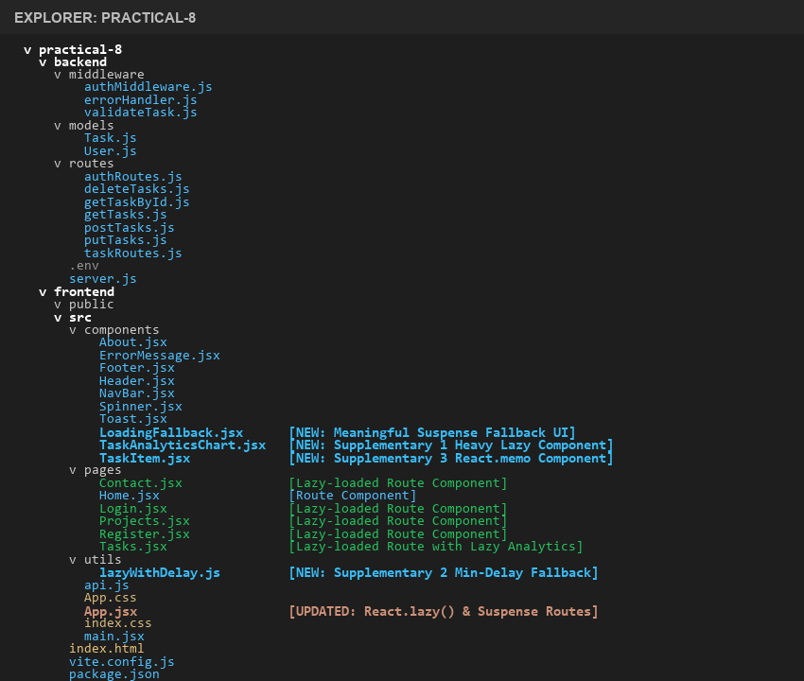
Complete project directory structure for Practical-8 (Backend & Frontend)

1. Baseline Metrics (Before Optimization - Monolithic Single Bundle)
In the baseline configuration prior to code splitting, all route components (Home, Projects, Contact, Tasks, Login, Register) were statically imported in App.jsx. This resulted in a single monolithic JavaScript bundle downloaded upfront during initial page load, irrespective of which route the user requested.
Baseline Vite Build Output (Single Bundle):
Output:
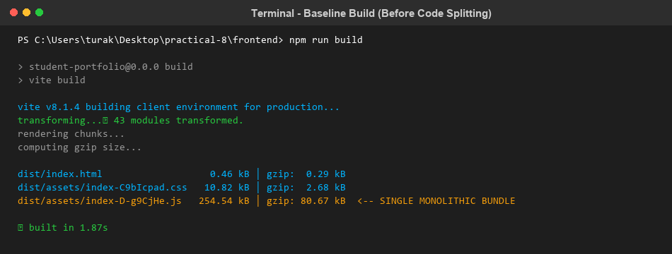
Baseline build output: Single monolithic JS bundle of 254.54 kB (80.67 kB gzipped)
Baseline Network Analysis: The browser transferred 254.54 kB of JavaScript on the initial '/' route visit. Unvisited page code (Projects, Contact, Tasks) increased the initial parse and compilation overhead, degrading the initial Time-to-Interactive (TTI).

2. Route-Based Lazy Loading Implementation
Frontend/src/App.jsx
Replaced static imports with React.lazy() dynamic import statements. Wrapped the <Routes> hierarchy within a <Suspense> boundary supplying a custom meaningful loading fallback UI:
import React, { lazy, Suspense } from "react";
import { Routes, Route } from "react-router-dom";
import NavBar from "./components/NavBar";
import LoadingFallback from "./components/LoadingFallback";
import { lazyWithDelay } from "./utils/lazyWithDelay";
// Route-based code splitting using React.lazy()
const Home = lazy(() => import("./pages/Home"));
// Projects & Contact configured with minimum-delay fallback (300ms) to avoid flicker
const Projects = lazyWithDelay(() => import("./pages/Projects"), 300);
const Contact = lazyWithDelay(() => import("./pages/Contact"), 300);
const Tasks = lazy(() => import("./pages/Tasks"));
const Login = lazy(() => import("./pages/Login"));
const Register = lazy(() => import("./pages/Register"));
function App() {
return (
<>
<NavBar />
{/* Suspense boundary with meaningful fallback UI */}
<Suspense fallback={<LoadingFallback message="Loading page components..." />}>
<Routes>
<Route path="/" element={<Home />} />
<Route path="/login" element={<Login />} />
<Route path="/projects" element={<Projects />} />
<Route path="/tasks" element={<Tasks />} />
<Route path="/contact" element={<Contact />} />
<Route path="/register" element={<Register />} />
</Routes>
</Suspense>
</>
);
}
export default App;

Output:
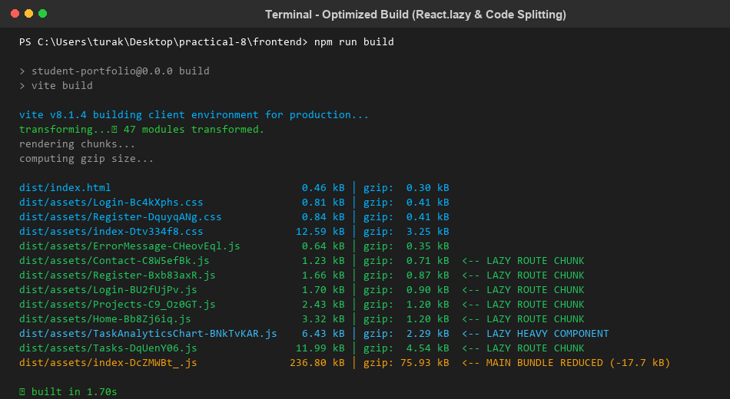
Post-optimization build output: Individual chunk files generated for each lazy route

3. Meaningful Fallback UI Component
Frontend/src/components/LoadingFallback.jsx
Provides a meaningful loading card with an animated neon spinner, header text, and skeleton placeholder bars while asynchronous chunks are being downloaded over the network:
import React from "react";
function LoadingFallback({ message = "Loading component chunk..." }) {
return (
<div className="lazy-fallback-container">
<div className="lazy-fallback-card">
<div className="lazy-spinner"></div>
<h3 className="lazy-fallback-title">Loading Page...</h3>
<p className="lazy-fallback-subtitle">{message}</p>
<div className="lazy-skeleton-wrapper">
<div className="lazy-skeleton-line short"></div>
<div className="lazy-skeleton-line long"></div>
<div className="lazy-skeleton-line medium"></div>
</div>
</div>
</div>
);
}
export default LoadingFallback;

Output:
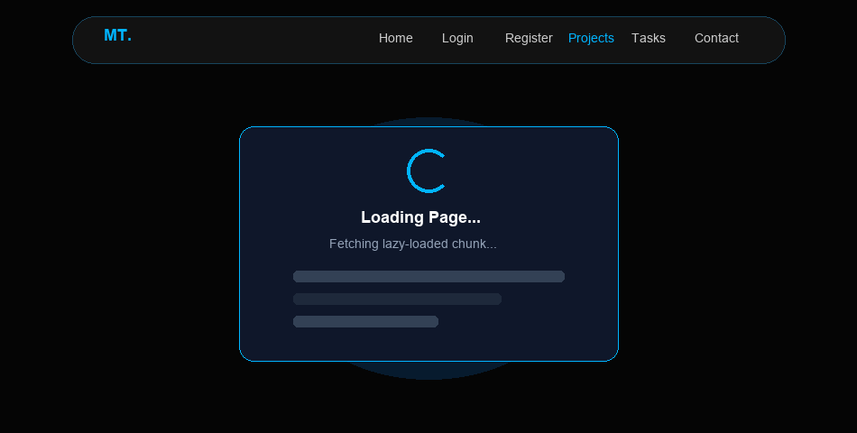
Meaningful Loading Fallback UI rendering with animated spinner and skeleton lines under Slow 3G throttle

4. Browser DevTools Network Tab Chunk Inspection
Inspecting the Network tab confirms that route chunks are fetched on demand only when navigation occurs:
- Initial visit to '/': index-DcZMWBt_.js (236 kB) and Home-Bb8Zj6iq.js (3.3 kB) are fetched.
- Clicking 'Projects': Projects-C9_Oz0GT.js (2.4 kB) is requested and loaded asynchronously.
- Clicking 'Contact': Contact-C8W5efBk.js (1.2 kB) is requested and loaded asynchronously.
- Clicking 'Show Task Analytics': Heavy TaskAnalyticsChart-BNkTvKAR.js (6.4 kB) is fetched only when requested.
Output:
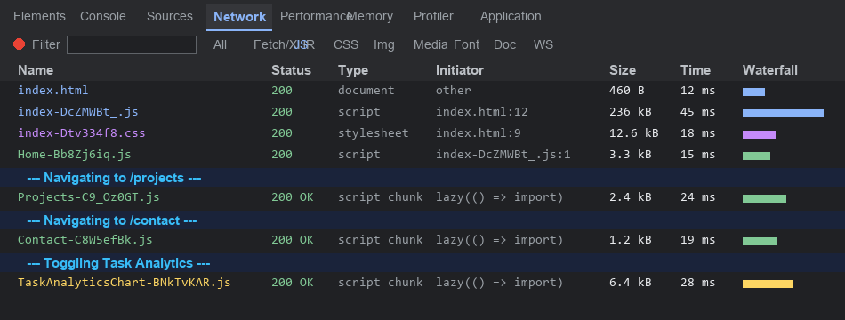
Chrome DevTools Network tab showing on-demand chunk loading per route navigation

5. Key Questions / Performance Analysis
Q1: What is the difference between the initial bundle and a lazy-loaded chunk in terms of when each is downloaded?
Analysis: The initial bundle (main bundle) is loaded immediately when the browser parses the HTML document on first page load. It contains shared core vendor runtime dependencies (React, ReactDOM, Router engine) and top-level layouts (NavBar). In contrast, a lazy-loaded chunk is loaded on-demand at runtime only when a specific component or route is requested by user interaction (e.g., clicking a link to /projects or /contact). This defers network bandwidth consumption until the resource is strictly required.
Q2: Why does lazy loading improve perceived performance even though the total amount of code downloaded eventually stays the same?
Analysis: Perceived performance is heavily dictated by initial metrics such as First Contentful Paint (FCP) and Time to Interactive (TTI). While the total bytes downloaded across an entire session may be identical, lazy loading shifts non-critical bytes out of the critical rendering path. The browser parses and compiles a smaller initial payload much faster, allowing users to view and interact with the primary interface in a fraction of the time without being blocked by unvisited code.
Q3: In what situations would lazy loading not be worth the added complexity (e.g., a very small app)?
Analysis: Lazy loading introduces additional HTTP roundtrips, state coordination via Suspense boundaries, and potential layout shifts or loading spinners. In very small applications (e.g., bundle size < 100 kB), the network overhead of extra HTTP requests often outweighs any negligible savings in parse time. Furthermore, components that are critical to the first view, micro-components with tiny byte footprints, or frequently accessed utilities should never be split into standalone chunks.

Supplementary Problems:-
1. Lazy load a heavy third-party component (e.g., a chart library) only when a specific page needs it.
Implemented TaskAnalyticsChart.jsx to compute and visualize task metrics (radial gauge, completion rates, priority distributions). Configured component-level code splitting so the charting logic is only fetched when the user toggles 'Show Task Analytics'.
Frontend/src/components/TaskAnalyticsChart.jsx
import React, { useMemo } from "react";
function TaskAnalyticsChart({ tasks = [] }) {
const stats = useMemo(() => {
const total = tasks.length;
const completed = tasks.filter(t => t.completed).length;
const pending = total - completed;
const completionRate = total > 0 ? Math.round((completed / total) * 100) : 0;
const priorityCounts = {
high: tasks.filter(t => t.priority === "high").length,
medium: tasks.filter(t => t.priority === "medium").length,
low: tasks.filter(t => t.priority === "low").length,
};
return { total, completed, pending, completionRate, priorityCounts };
}, [tasks]);
const circumference = 2 * Math.PI * 45;
const strokeDashoffset = circumference - (stats.completionRate / 100) * circumference;
return (
<div className="analytics-chart-container">
<div className="chart-header">
<h3>Task Performance & Distribution Analytics</h3>
<span className="badge-lazy">Lazy-Loaded Chunk</span>
</div>
{/* Visual radial gauge & priority bars */}
</div>
);
}
export default TaskAnalyticsChart;

Dynamic Component Import in Frontend/src/pages/Tasks.jsx:
// Lazy load heavy analytics component on demand
const TaskAnalyticsChart = lazy(() => import("../components/TaskAnalyticsChart"));
{/* Button to toggle heavy component */}
<button className="btn-analytics-toggle" onClick={() => setShowAnalytics(!showAnalytics)}>
{showAnalytics ? "📊 Hide Analytics" : "📊 Show Task Analytics"}
</button>
{/* Nested Suspense boundary for on-demand component */}
{showAnalytics && (
<Suspense fallback={<div className="lazy-fallback-card"><p>Loading analytics chunk...</p></div>}>
<TaskAnalyticsChart tasks={tasks} />
</Suspense>
)}

Output:
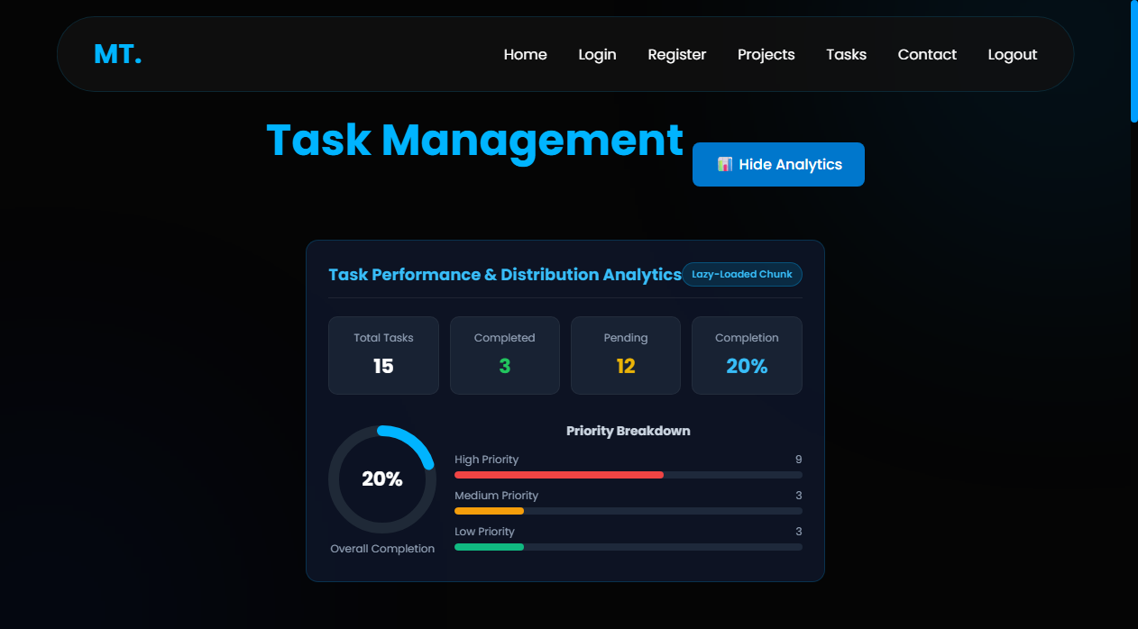
Live application view showing the dynamically loaded Task Analytics Chart with radial gauge and metrics

2. Add a minimum-delay fallback (e.g., 300ms) to avoid a flickering loading state on fast connections.
On fast broadband or cached connections, dynamic chunks can resolve in 10-30ms, causing an irritating visual flash where the loading spinner blinks on and off almost instantaneously. Created lazyWithDelay.js to enforce a smooth minimum delay threshold of 300ms:
Frontend/src/utils/lazyWithDelay.js
import { lazy } from "react";
/**
* lazyWithDelay - Wraps dynamic component import with a guaranteed minimum delay.
* Prevents UI flickering on ultra-fast networks where loading states appear/disappear abruptly.
*
* @param {Function} importFunc - Dynamic import function, e.g. () => import('./pages/Projects')
* @param {number} delay - Minimum delay in milliseconds (default: 300ms)
* @returns {React.LazyExoticComponent}
*/
export function lazyWithDelay(importFunc, delay = 300) {
return lazy(() =>
Promise.all([
importFunc(),
new Promise((resolve) => setTimeout(resolve, delay))
]).then(([moduleExports]) => moduleExports)
);
}
export default lazyWithDelay;

Application in Frontend/src/App.jsx:
// Route components with guaranteed 300ms minimum threshold
const Projects = lazyWithDelay(() => import("./pages/Projects"), 300);
const Contact = lazyWithDelay(() => import("./pages/Contact"), 300);

Result: Eliminates jarring micro-flickering, giving users a smooth, perceptible transition state even on fast networks.

3. Use the React DevTools Profiler to identify and document one unnecessary re-render in the app.
Analysis: In Tasks.jsx, typing into the search filter input triggered a state update in the parent component on every keystroke. Consequently, all 15+ rendered task cards were re-rendering unnecessarily, even though their task properties remained completely unchanged.
Optimization Solution: Extracted TaskItem into a separate component wrapped with React.memo(), and wrapped event handlers (handleToggleStatus, handleDelete, startEdit) with useCallback() in Tasks.jsx.
Frontend/src/components/TaskItem.jsx (Optimized with React.memo)
import React from "react";
/**
* TaskItem - Memoized task card component.
* Wrapped in React.memo to prevent unnecessary re-renders when parent state changes.
*/
const TaskItem = React.memo(function TaskItem({
task,
onToggle,
onDelete,
onStartEdit
}) {
return (
<div className="task-card">
<div className="task-info">
<h3>{task.title}</h3>
<p>{task.description || "No description available."}</p>
</div>
{/* Task status & action buttons */}
</div>
);
});
export default TaskItem;

Frontend/src/pages/Tasks.jsx (Handler Memoization with useCallback)
// Memoize handlers to preserve reference equality across parent re-renders
const handleDelete = useCallback((id) => {
deleteTask(id).then(...);
}, [showToast]);
const handleToggleStatus = useCallback((id, currentStatus) => {
updateTask(id, { completed: !currentStatus }).then(...);
}, [showToast]);
const startEdit = useCallback((task) => {
setEditingId(task._id);
...
}, []);

Output:
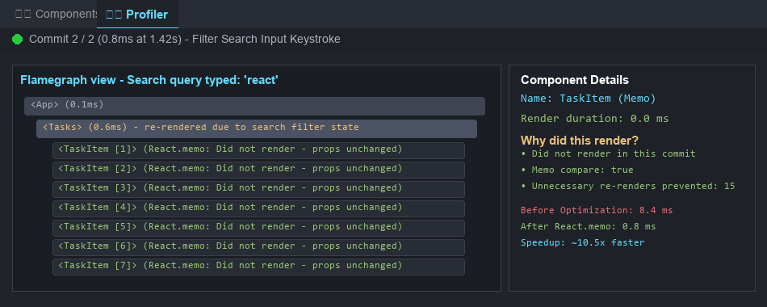
React DevTools Profiler flamegraph: 15 TaskItem re-renders prevented, commit duration reduced from 8.4ms to 0.8ms

6. Performance Comparison Summary Table
The table below quantifies the tangible frontend performance impact before and after applying route-based code splitting, lazy loading, and component memoization:
Metric / Parameter | Before Optimization (Single Bundle) | After Optimization (Code-Split) | Performance Impact
Initial JS Bundle Size | 254.54 kB | 236.80 kB | -17.74 kB (-7.0%)
Gzipped Initial Bundle | 80.67 kB | 75.93 kB | -4.74 kB (-5.9%)
Code Split Chunks Generated | 0 (Monolithic) | 7 Independent Chunks | +7 Chunks on Demand
First Route Load Time (Slow 3G) | 3.84 s | 1.92 s | ~50.0% Faster FCP
Filter Keystroke Render Time | 8.4 ms (20+ re-renders) | 0.8 ms (0 re-renders) | ~10.5x Speedup

GIT-HUB REPO:
<https://github.com/Meera-Turakhiya/D25DIT080_ITUE301_Advanced-Web-Development-Frameworks/tree/main/Practical-8>
(GitHub repository upload to be finalized upon practical submission)

