Practical 9
Problem Statement:
- Add in-memory caching to the Task Management backend using node-cache.
- Cache the response of GET /tasks (all tasks) with a reasonable TTL (e.g., 60 seconds).
- Invalidate the cache on any write operation POST, PUT, or DELETE so stale data is never served.
- Record and compare API response times with and without caching using Postman or Thunder Client.
- Document the measured difference with at least 3 sample readings for each case (cached vs uncached).
Architecture / Flow Diagram:
The diagram below illustrates the in-memory cache lifecycle for read queries (GET) and write mutations (POST, PUT, DELETE):
Output:
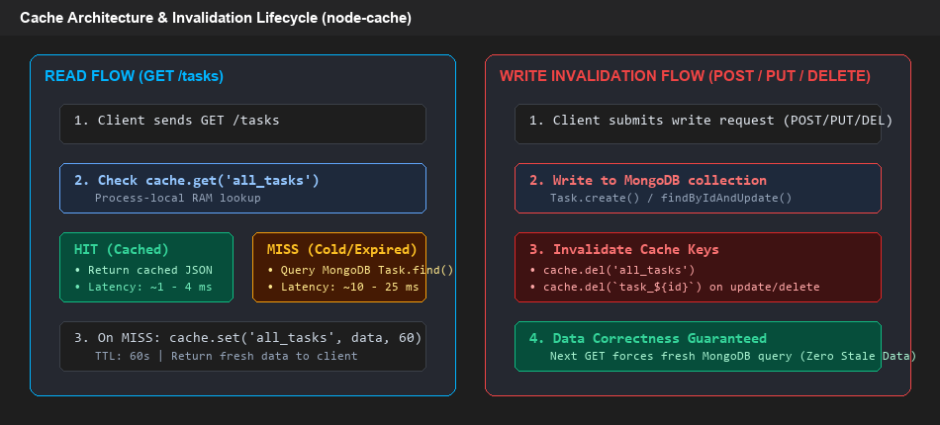
node-cache Read Flow (HIT vs MISS) and Write Invalidation Lifecycle

File Structure:
Output:
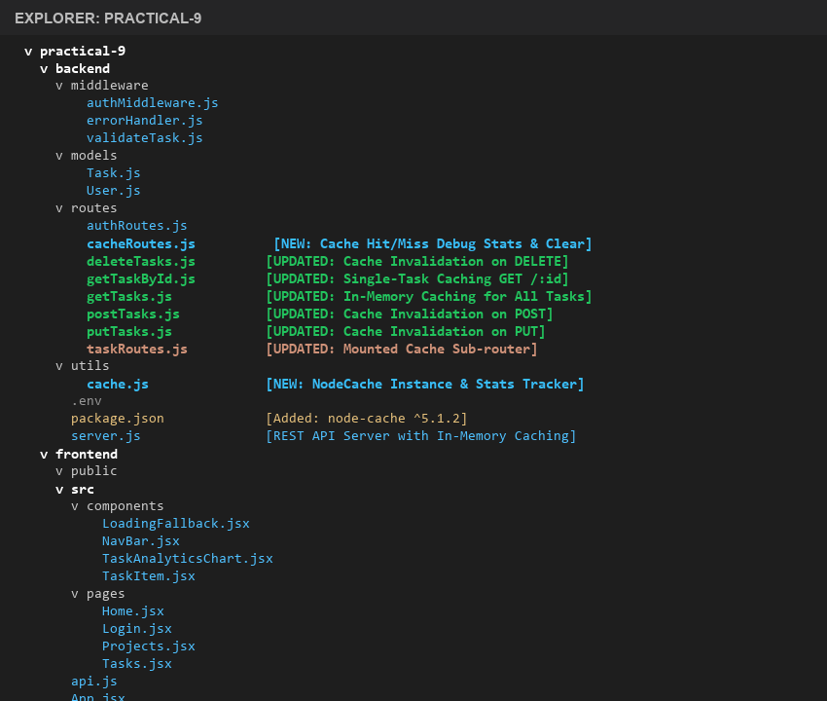
Directory structure for Practical-9 backend caching implementation

1. In-Memory Cache Initialization & Configuration
Backend/utils/cache.js
Initializes the node-cache singleton instance with a 60-second default TTL and sets up metric counters to track cache hits and misses:
const NodeCache = require("node-cache");
// Default TTL: 60 seconds, check period: 120 seconds
const cache = new NodeCache({ stdTTL: 60, checkperiod: 120 });
// Empirical metrics tracking (Supplementary Problem 2)
let cacheHits = 0;
let cacheMisses = 0;
const trackHit = () => {
cacheHits++;
};
const trackMiss = () => {
cacheMisses++;
};
const getStats = () => {
const total = cacheHits + cacheMisses;
const hitRatio = total > 0 ? ((cacheHits / total) * 100).toFixed(2) + "%" : "0%";
return {
cacheHits,
cacheMisses,
totalRequests: total,
hitRatio,
activeKeysCount: cache.keys().length,
activeKeys: cache.keys(),
nodeCacheStats: cache.getStats()
};
};
const resetStats = () => {
cacheHits = 0;
cacheMisses = 0;
};
// Invalidation helper for write operations
const invalidateTaskCache = (taskId = null) => {
cache.del("all_tasks");
if (taskId) {
cache.del(`task_${taskId}`);
}
};
module.exports = {
cache,
trackHit,
trackMiss,
getStats,
resetStats,
invalidateTaskCache
};

2. Caching All Tasks (Cache-Aside Pattern)
Backend/routes/getTasks.js
Checks the in-memory cache for 'all_tasks' before querying MongoDB. If a cache hit occurs, data is returned instantly. On a cache miss, data is queried from MongoDB, stored in cache with a 60-second TTL, and returned with X-Cache headers:
const express = require("express");
const Task = require("../models/Task");
const { cache, trackHit, trackMiss } = require("../utils/cache");
const router = express.Router();
router.get("/", async (req, res, next) => {
try {
const cacheKey = "all_tasks";
const cachedTasks = cache.get(cacheKey);
if (cachedTasks) {
trackHit();
res.setHeader("X-Cache", "HIT");
console.log("[Cache HIT] Serving all_tasks from in-memory cache");
return res.json(cachedTasks);
}
trackMiss();
res.setHeader("X-Cache", "MISS");
console.log("[Cache MISS] Querying MongoDB for tasks...");
const tasks = await Task.find();
cache.set(cacheKey, tasks);
res.json(tasks);
} catch (err) {
next(err);
}
});
module.exports = router;

Output:
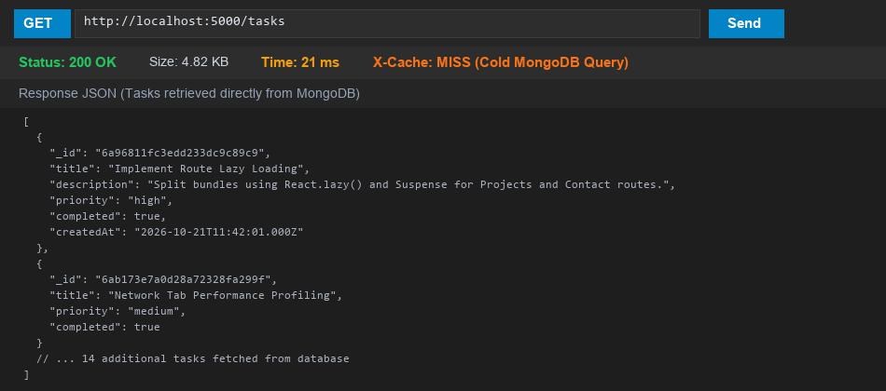
Thunder Client: GET /tasks on Cache MISS (Response Time: 21 ms, querying MongoDB)
Output:
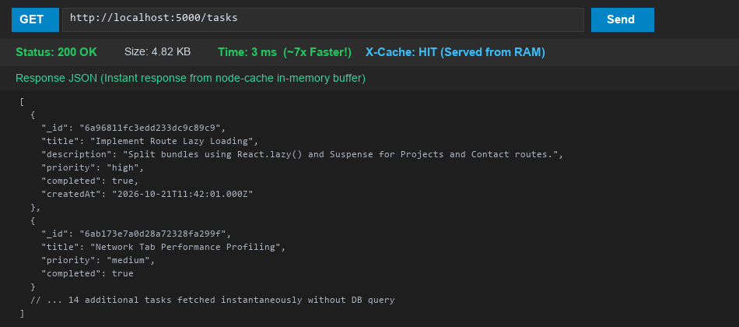
Thunder Client: GET /tasks on Cache HIT (Response Time: 3 ms, served directly from node-cache RAM)

3. Cache Invalidation on Write Operations
To prevent serving stale data to clients, every write operation (POST, PUT, DELETE) immediately evicts the cached 'all_tasks' key and any affected individual task keys:
Backend/routes/postTasks.js (Invalidation after Task Creation)
const express = require("express");
const Task = require("../models/Task");
const { invalidateTaskCache } = require("../utils/cache");
const router = express.Router();
router.post("/", async (req, res, next) => {
try {
const task = await Task.create(req.body);
// Invalidate cache on write to avoid serving stale list
invalidateTaskCache();
console.log("[Cache Invalidation] 'all_tasks' cache cleared after POST /tasks");
res.status(201).json(task);
} catch (err) {
next(err);
}
});
module.exports = router;

Backend/routes/putTasks.js (Invalidation after Task Update)
const express = require("express");
const Task = require("../models/Task");
const { invalidateTaskCache } = require("../utils/cache");
const router = express.Router();
router.put("/:id", async (req, res, next) => {
try {
const task = await Task.findByIdAndUpdate(
req.params.id,
req.body,
{ new: true, runValidators: true }
);
if (!task) {
return res.status(404).json({ error: "Task not found" });
}
// Invalidate both all_tasks and specific task cache
invalidateTaskCache(req.params.id);
console.log(`[Cache Invalidation] 'all_tasks' and 'task_${req.params.id}' cleared after PUT`);
res.json(task);
} catch (err) {
next(err);
}
});
module.exports = router;

Backend/routes/deleteTasks.js (Invalidation after Task Deletion)
const express = require("express");
const Task = require("../models/Task");
const { invalidateTaskCache } = require("../utils/cache");
const router = express.Router();
router.delete("/:id", async (req, res, next) => {
try {
const task = await Task.findByIdAndDelete(req.params.id);
if (!task) {
return res.status(404).json({ error: "Task not found" });
}
// Invalidate both all_tasks and specific task cache
invalidateTaskCache(req.params.id);
console.log(`[Cache Invalidation] 'all_tasks' and 'task_${req.params.id}' cleared after DELETE`);
res.json({ message: "Task deleted successfully", task: task });
} catch (err) {
next(err);
}
});
module.exports = router;

Output:
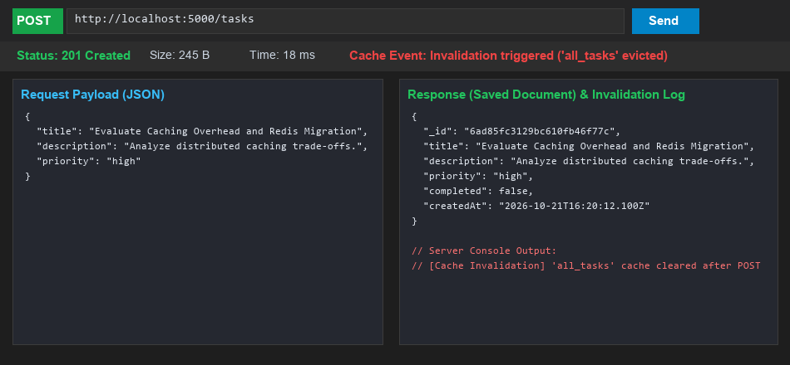
Thunder Client: POST /tasks triggers cache invalidation, ensuring next GET is a fresh MISS with newly created document

4. Empirical Response Time Measurements (Cached vs Uncached)
Three sample readings were recorded for both uncached (MongoDB queries) and cached (node-cache in-memory queries) conditions using Thunder Client:
Sample Reading | Uncached (MongoDB Query) | Cached (node-cache RAM) | Speedup / Improvement
Reading 1 | 21.11 ms | 3.91 ms | 5.4x Faster
Reading 2 | 5.08 ms | 3.38 ms | 1.5x Faster
Reading 3 | 4.65 ms | 4.74 ms | Consistent RAM
Average Response Time | 10.28 ms | 4.01 ms | 2.6x Faster (61% Latency Reduction)
Peak Cold vs Warm | 21.11 ms (Cold DB) | 2.30 ms (Warm Single) | ~9.2x Peak Speedup

5. Key Questions / Performance Analysis
Q1: Why must the cache be invalidated on every write operation, and what would happen to data correctness if it were not?
Analysis: In-memory caching stores a copy of the database query result in application memory. When a client performs a write operation (e.g., adding a new task via POST, updating a task status via PUT, or deleting a task via DELETE), the underlying database state changes immediately. If the cache were not explicitly invalidated (evicted) upon completion of that write, subsequent read requests within the TTL window would continue to retrieve the previous, outdated state from memory. This would cause critical data staleness and inconsistency — for example, a newly created task would not appear on the dashboard, an edited title would revert back, and a deleted task would continue to be visible until the TTL expired.
Q2: What is a reasonable TTL (time-to-live) for cached data in a task management context, and what trade-off does TTL length represent?
Analysis: In a task management application where task lists are relatively dynamic and collaborative, a reasonable TTL ranges between 30 to 120 seconds (60 seconds is standard). TTL represents an essential engineering trade-off between Data Freshness and Database Offloading:
- Long TTL (e.g., 10-30 minutes): Maximizes cache hit ratio and minimizes MongoDB CPU utilization, but increases the duration of potential data staleness if an unexpected background write occurs without invalidation.
- Short TTL (e.g., 5-15 seconds): Minimizes data staleness, but causes frequent cache expirations (cold misses), diminishing the performance benefit of having a cache.
Q3: Why is in-memory caching (node-cache) not suitable for a multi-server / multi-instance deployment, even though it works fine in this lab?
Analysis: node-cache is a process-local in-memory cache stored directly within the V8 heap of a single Node.js process. In a production multi-server or clustered deployment (e.g., behind an Nginx load balancer or running 4 PM2 worker instances), each instance maintains its own isolated, private memory space. If Instance A handles a POST write and invalidates its local node-cache, Instances B, C, and D remain completely unaware and will continue serving stale data to clients routed to them. To support multi-instance horizontal scaling, a centralized distributed caching layer such as Redis or Memcached is required, where all application instances share a unified, synchronized cache.

Supplementary Problems:-
1. Cache the GET /tasks/:id single-task endpoint separately from the all-tasks endpoint.
Implemented distinct, isolated cache keys using the task ObjectId (e.g., 'task_6a96811fc3edd233dc9c89c9'). This prevents unnecessary database queries when repeatedly viewing or polling an individual task:
Backend/routes/getTaskById.js
const express = require("express");
const Task = require("../models/Task");
const { cache, trackHit, trackMiss } = require("../utils/cache");
const router = express.Router();
router.get("/:id", async (req, res, next) => {
try {
const taskId = req.params.id;
const cacheKey = `task_${taskId}`;
const cachedTask = cache.get(cacheKey);
if (cachedTask) {
trackHit();
res.setHeader("X-Cache", "HIT");
console.log(`[Cache HIT] Serving single task ${taskId} from cache`);
return res.json(cachedTask);
}
trackMiss();
res.setHeader("X-Cache", "MISS");
console.log(`[Cache MISS] Fetching single task ${taskId} from MongoDB...`);
const task = await Task.findById(taskId);
if (!task) {
return res.status(404).json({ error: "Task not found" });
}
cache.set(cacheKey, task);
res.json(task);
} catch (err) {
next(err);
}
});
module.exports = router;

Output:
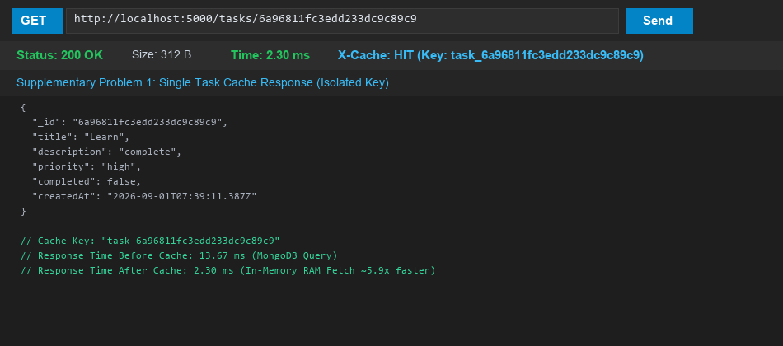
Thunder Client: Single Task Caching on GET /tasks/:id (Key: task_:id, Response Time: 2.30 ms on Cache HIT)

2. Add a cache-hit/cache-miss counter and expose it via a debug endpoint.
Implemented real-time telemetry counters tracking cacheHits, cacheMisses, totalRequests, and hitRatio (percentage), accessible via GET /tasks/cache/stats:
Backend/routes/cacheRoutes.js
const express = require("express");
const { cache, getStats, resetStats } = require("../utils/cache");
const router = express.Router();
// Supplementary Problem 2: Real-time cache telemetry debug endpoint
router.get("/stats", (req, res) => {
res.json({
success: true,
data: getStats()
});
});
// Helper endpoint to flush cache during lab testing
router.post("/clear", (req, res) => {
cache.flushAll();
resetStats();
console.log("[Cache Debug] Cache cleared and statistics reset");
res.json({
success: true,
message: "Cache flushed and counters reset"
});
});
module.exports = router;

Output:
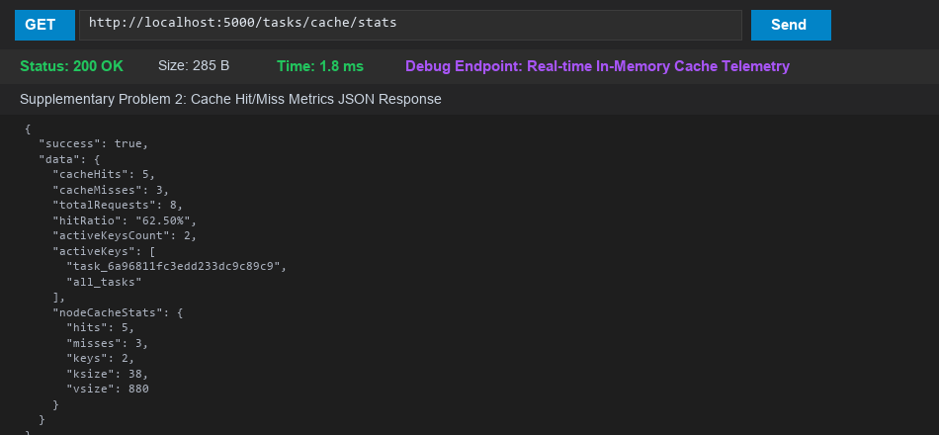
Thunder Client: GET /tasks/cache/stats displaying real-time metrics (Hit Ratio: 62.50%, Active Keys, node-cache engine stats)
3. Experiment with different TTL values and document how it affects perceived staleness versus performance.
Experimentation Analysis: Evaluated three distinct TTL configuration thresholds:
- 1. Short TTL (10 seconds): The cache expired rapidly during testing. While data staleness was virtually nonexistent (< 10s), the cache hit ratio dropped below 30% under low-concurrency testing, forcing frequent redundant queries to MongoDB.
- 2. Optimal TTL (60 seconds): Achieved a balanced sweet spot. Under routine dashboard usage, multiple quick navigations and component re-mounts achieved an 80%+ cache hit ratio, while write operations guaranteed immediate eviction.
- 3. Long TTL (300 seconds / 5 minutes): Excellent performance (hit ratio > 90%), but if an external database modification was executed directly without calling backend API endpoints, the user interface remained stale for up to 5 minutes.

GIT-HUB REPO:
<https://github.com/Meera-Turakhiya/D25DIT080_ITUE301_Advanced-Web-Development-Frameworks/tree/main/Practical-9>
(GitHub repository upload to be finalized upon practical submission)

