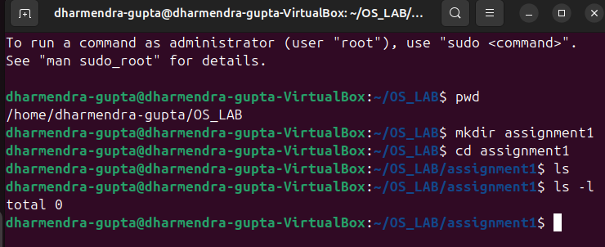
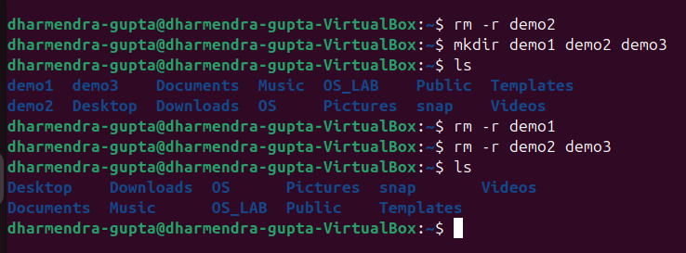
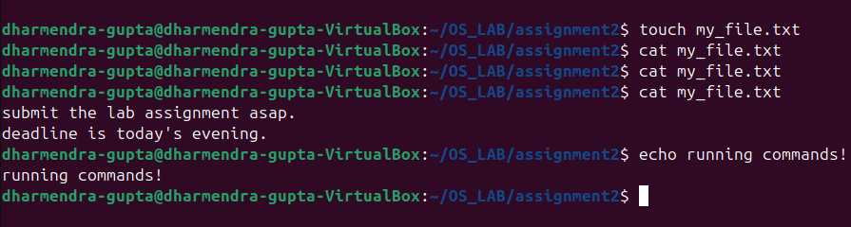
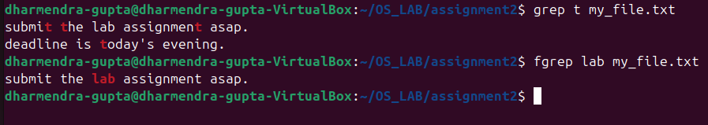
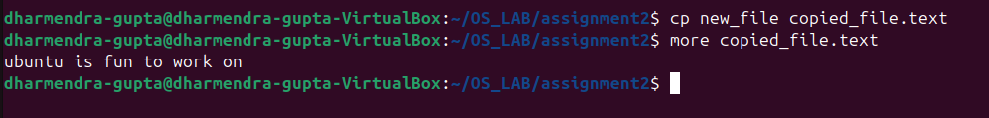
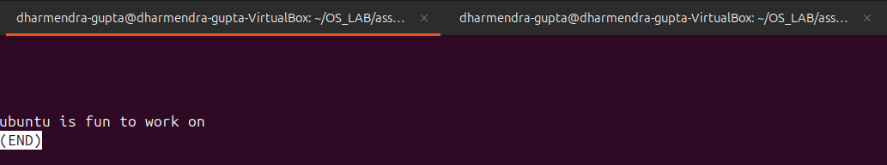
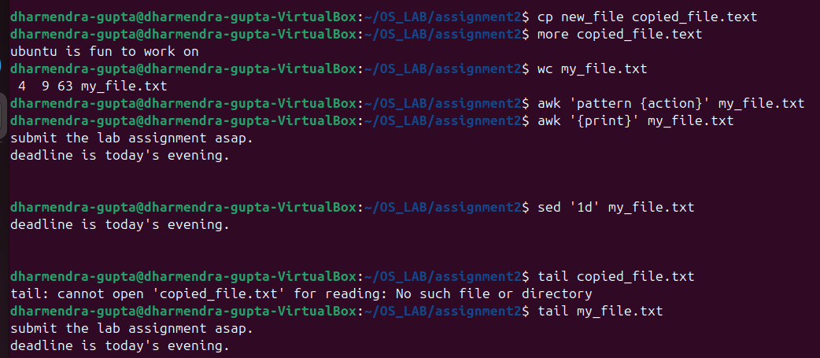
Assignment 02
Part 1:

1. pwd 2. cd 4. mkdir
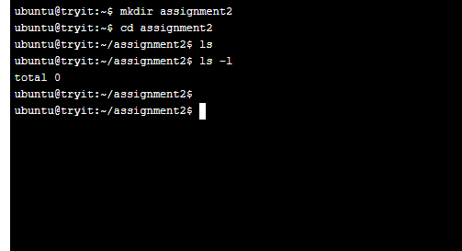

3. ls 5. rm


6. touch 7. hostname 8. Cat 10. echo


11. grep 12. fgrep


Part 2:
- How to navigate to a specific directory?
cd /path/to/directory

- How to see detailed information about files and directories using ls?
ls -l

- How to create multiple directories using mkdir?
mkdir dir1 dir2 dir3
OR create nested directories:
mkdir -p parent/child/grandchild

- How to remove multiple files at once with rm?
rm file1 file2 file3

- Can rm be used to delete directories?
rm -r directory_name

- How do you copy files and directories in Linux?
Copy a file:
cp file1 destination/
Copy a directory:
cp -r dir1 destination/

- How to rename a file in Linux using mv command?
mv old_filename new_filename

- How to move multiple files in Linux using mv command?
mv file1 file2 file3 destination_directory/

- How to create multiple empty files using touch command in Linux?
touch file1 file2 file3

- How to view the content of multiple files in Linux?
cat file1 file2

- How to create a file and add content using cat command in Linux?
cat > filename
Then type the content and press Ctrl + D to save.

- How to append contents of one file to the end of another file using cat command?

cat file1 >> file2
This appends file1 content to file2.

- How to use cat command if the file has a lot of content and can’t fit in terminal?

cat large_file | more
OR
cat large_file | less

- How to merge multiple files using cat command?
cat file1 file2 > merged_file

- How to use cat command to append to an existing file?
cat new_content.txt >> existing_file.txt

- What is “chmod 777” or “chmod 755” and “chmod +x” or “chmod a+x”?

chmod 777 file → Full permissions for everyone.

chmod 755 file → Owner has all permissions, others can read/execute.

chmod +x script.sh → Makes a script executable.

chmod a+x script.sh→ Makes a script executable for all users.

- How to find the number of lines that match a string/pattern?
grep -c "pattern" file.txt

- How to display files that contain a given string/pattern?
grep -l "pattern" *.txt

- How to show the line number of file with the line matched?
grep -n "pattern" file.txt

- How to match lines that start with a string using grep?
grep "^pattern" file.txt

- Can sort command be used to sort files in descending order by default?
sort -r file.txt

- How to sort a file based on a specific column using sort command?
sort -k 2 file.txt
Sorts based on the second column.

