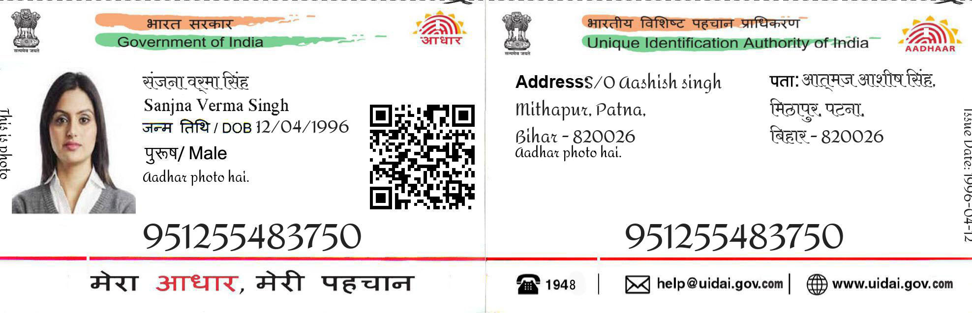

2345 7576 7548

Samarth

16-06-2008

male

2345 7576 7548



**ADDRESS :** S\O Ashok Kumar

Bandra , Mumbai

Maharastra - 110085



 **1948** **|** [**help@uidai.gov.com**](mailto:help@uidai.gov.com) **|** **uidai.gov.com**