Html:

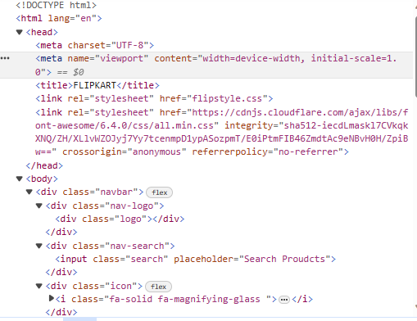

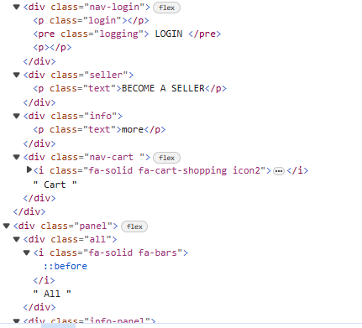

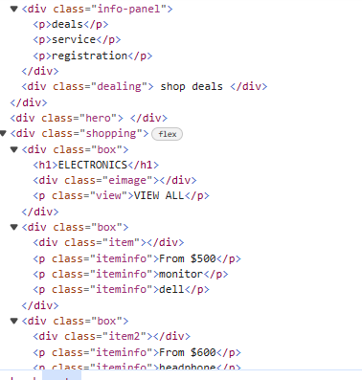

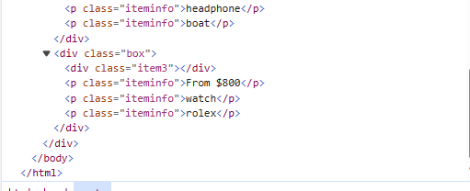

Css:

*{

    margin:0;

    font-family:Arial;

    border:border-box;

}

.navbar{

    height:55px;

    background-color: skyblue;

    display: flex;

    align-items: center;

    justify-content: space-evenly;

}

.nav-logo{

    height:50px;

    width:100px;

}

.logo{

    background-image: url("https://1000logos.net/wp-content/uploads/2021/02/Flipkart-logo.png");

    width:100%;

    height:50px;

    background-size: cover;

}

.search{

    width:560px;

    height:35px;

    text-align: center;

}

.icon{

    border: 2px solid black;

    width:30px;

    height: 27px;

    background-color: white;

    display: flex;

    justify-content: center;

    align-items: center;

}

.nav-login{

    width:100px;

    height:40px;

    background-color: white;

    display: flex;

    text-align: center;

    align-items: center;

    border: 1px solid ;

}

.logging{

    color:#2878f0;

    font-size: 16px;

}

.text{

    color:white;

    font-size: 16px;

}

.icon2{

    width:15px;

    height:15px;

}

.nav-cart{

    display: flex;

    justify-content: center;

    align-items: center;

}

.panel{

    height:40px;

    background-color: aquamarine;

    color: white;

    display: flex;

    justify-content: space-evenly;

    align-items: center;

}

.info-panel{

    width:70%;

}

.info-panel p{

    display: inline;

    margin-left:15px;

}

.hero{

    background-image: url("https://media.istockphoto.com/id/1341621758/vector/shopping-online-on-phone-with-podium-paper-art-modern-background-gifts-box-illustration.jpg?s=612x612&w=0&k=20&c=pcF7zW702nySNfEfiRl1UJ8H5mPc5k7Yr9-NS-mZTIk=");

    height:600px;

    background-size: cover;

}

.box{

    width:23%;

    height:300px;

    border:1px solid black;

}

.shopping{

    display: flex;

    justify-content: space-evenly;

    margin-top:20px;

}

.eimage{

    background-image: url("https://img.freepik.com/free-vector/hand-painted-watercolor-pastel-sky-background_23-2148902771.jpg?w=2000");

    height:260px;

    width:100%;

}

.view{

    background-color: #2878f0;

    border: 1px solid white;

    margin-top: -120px;

    margin-left: 10px;

    width:90px;

    height:40px;

    justify-content: center;

    text-align: center;

    color:white;

}

.item{

    background-image: url("https://rukminim2.flixcart.com/image/200/200/kmp7ngw0/monitor/j/z/h/s2721hn-27-py0df-dell-original-imagfjphuywuh2a7.jpeg?q=70");

    width:100%;

    height:200px;

    background-size: cover;

}

.item2{

    background-image: url("https://rukminim2.flixcart.com/image/200/200/kokdci80/dslr-camera/v/e/x/z-24-200mm-z5-nikon-original-imag2zuekuxgxsgg.jpeg?q=70");

    width:100%;

    height:200px;

    background-size: cover;

}

.item3{

    width:100%;

    height:200px;

    background-size: cover;

    background-image: url("https://rukminim2.flixcart.com/image/200/200/kx50gi80/projector/r/9/p/zeb-pixa-play-12-5-6-dobly-audio-led-projector-zebronics-original-imag9z3yujqmzqt4.jpeg?q=70");

}