**AWS – Level 1**

**Hands-on**

**IAM**

* Create a Free Tier account for AWS console login
* Activate Multi Factor Authentication for that account

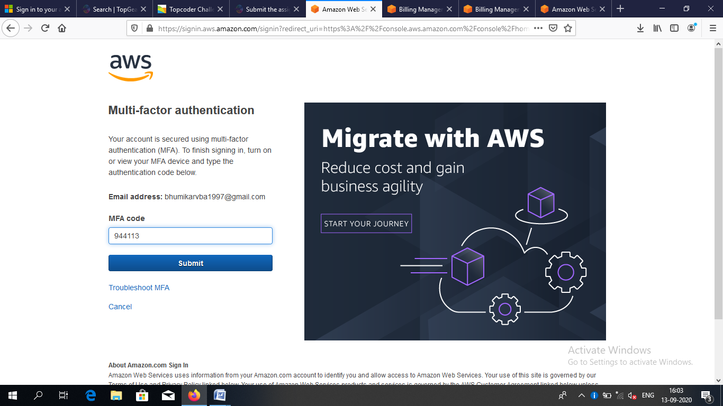

* Create an IAM user called awsadm1, log-in to AWS console using awsadm1 credential

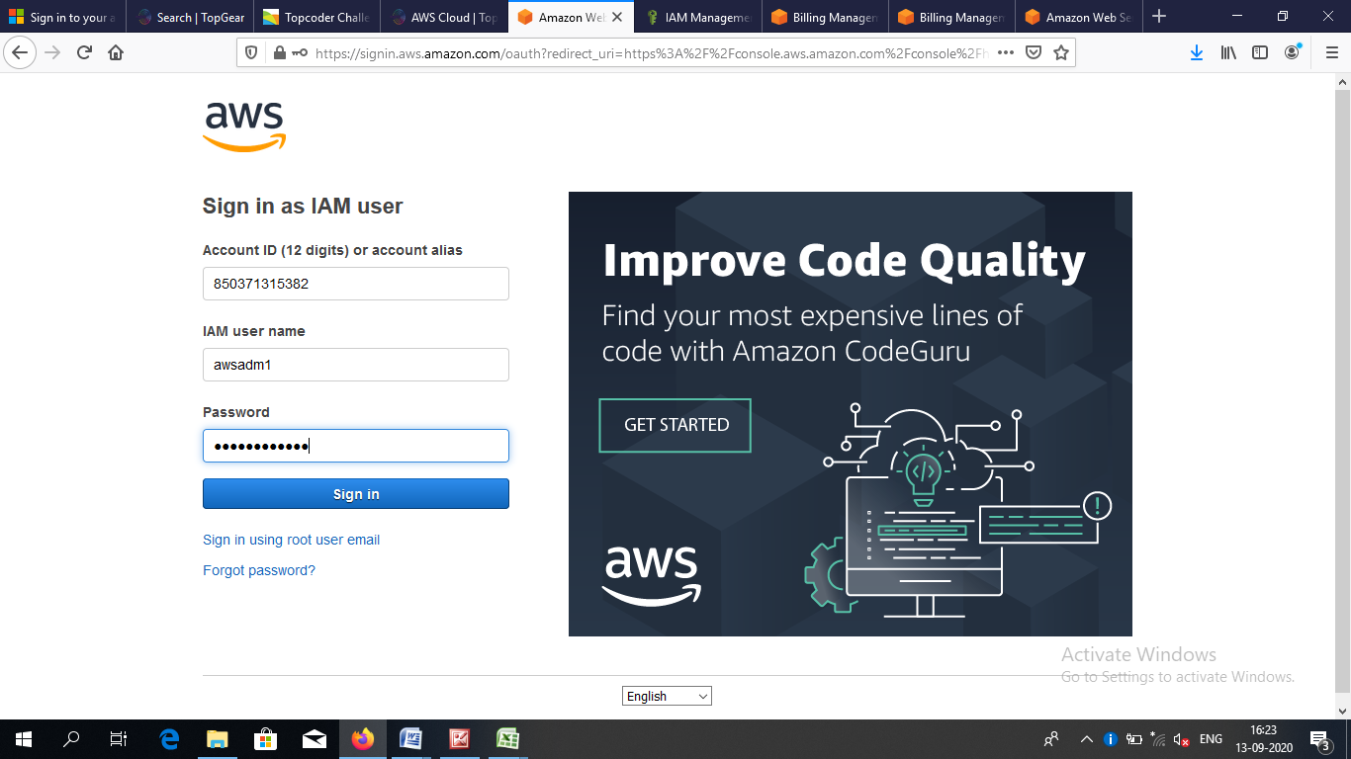

* Create a Group called “s3-group”
* Create 3 users called s3-user1, s3-user2 and s3-user3.
* Provide S3 view privilege to s3-group.
* Provide S3 all privileges to s3-user1

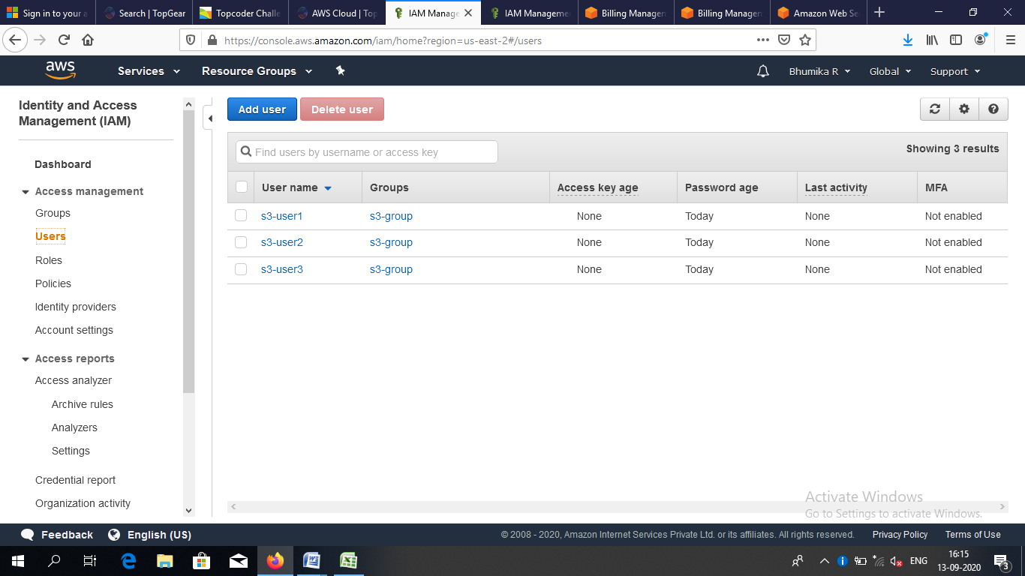

**EC2 and VPC**

* Create two Linux instances on a custom vpc and in the same custom subnet.

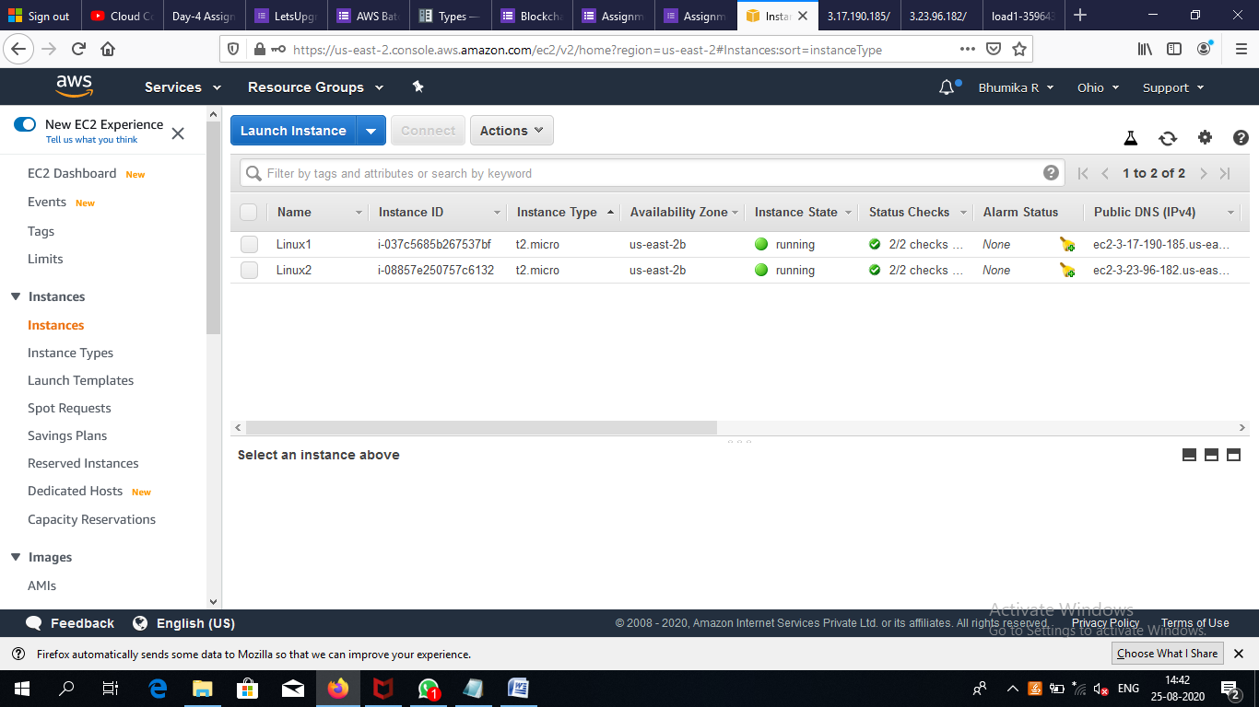

* Enable adequate security to interconnect two instances, and connect those from Putty client

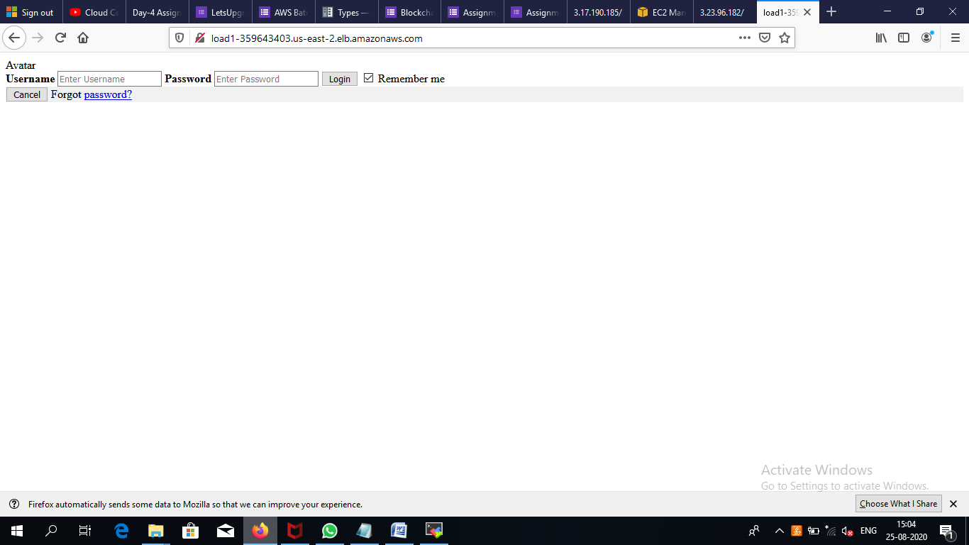

* Create one EC2 instance of Windows, opt any AMI available on Free-Tier. Use default vpc and subnets for that Instance.

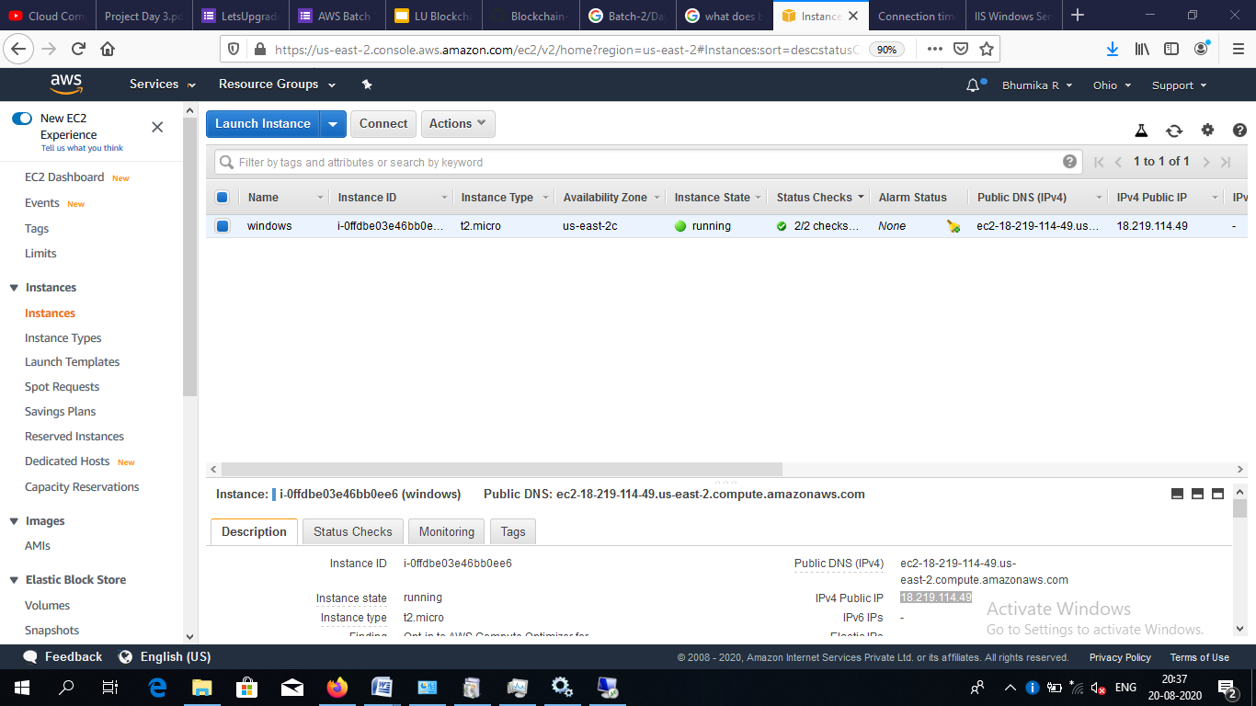

* Connect the Windows instance using remote desktop.

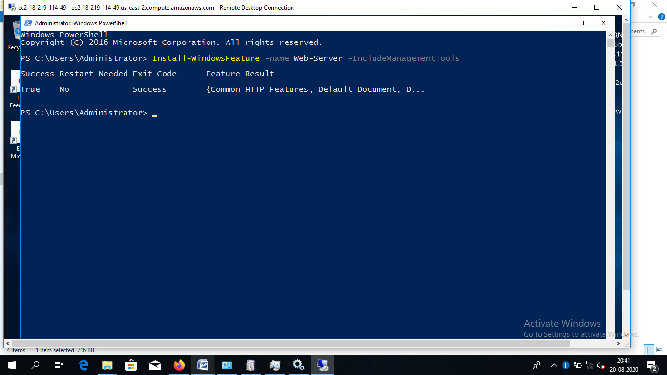

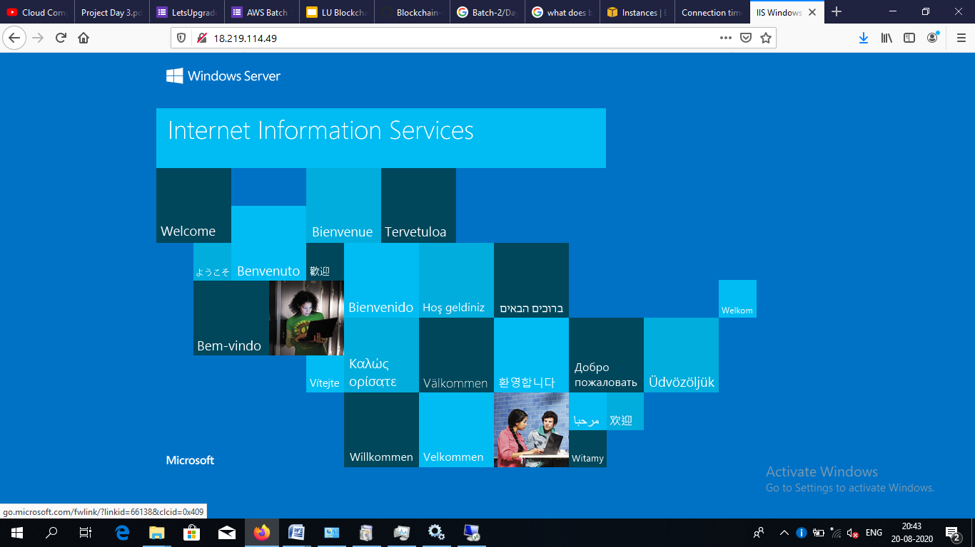

**Object Storage**

* Create a bucket, where the bucket name will be your first name and employee-id combination, Example: shalini123456.
* In that bucket upload 2 .png files and 1 .txt file of your choice

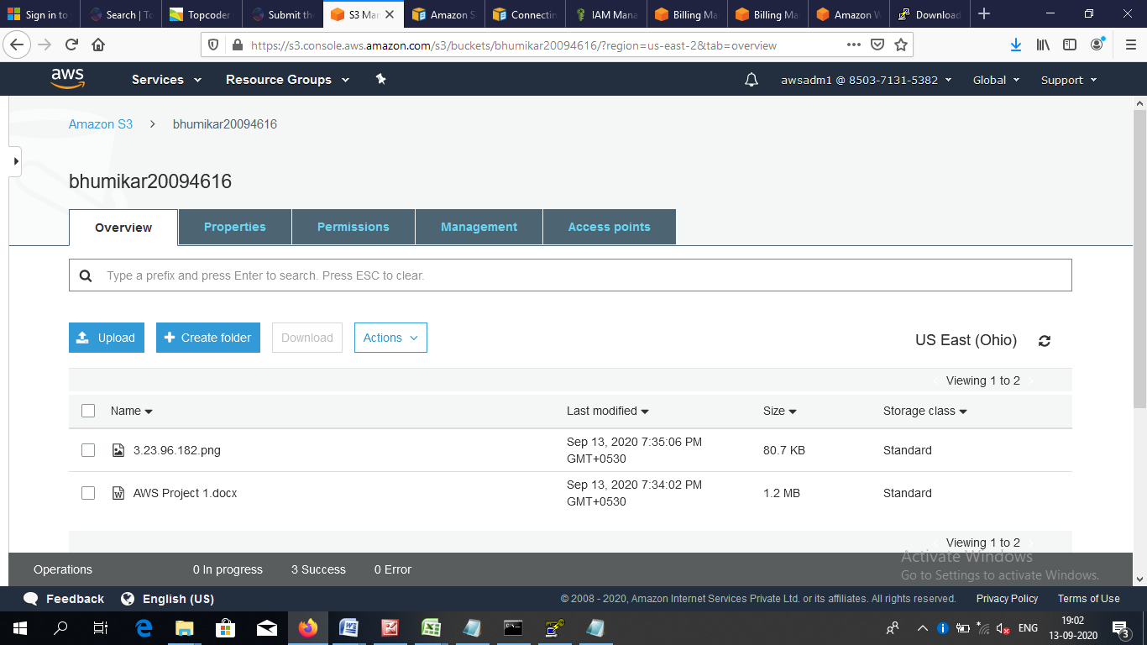

* Provide adequate access to the .png files so that anybody can see the content using web browser but can’t see the .txt file.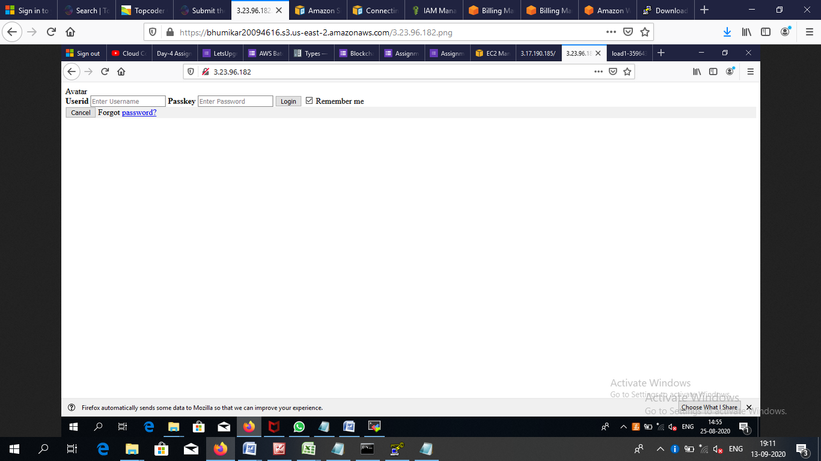
* make sure that after 30 days of creating the current version of all the files are transferred to Glacier and after 400 days those are permanently deleted.

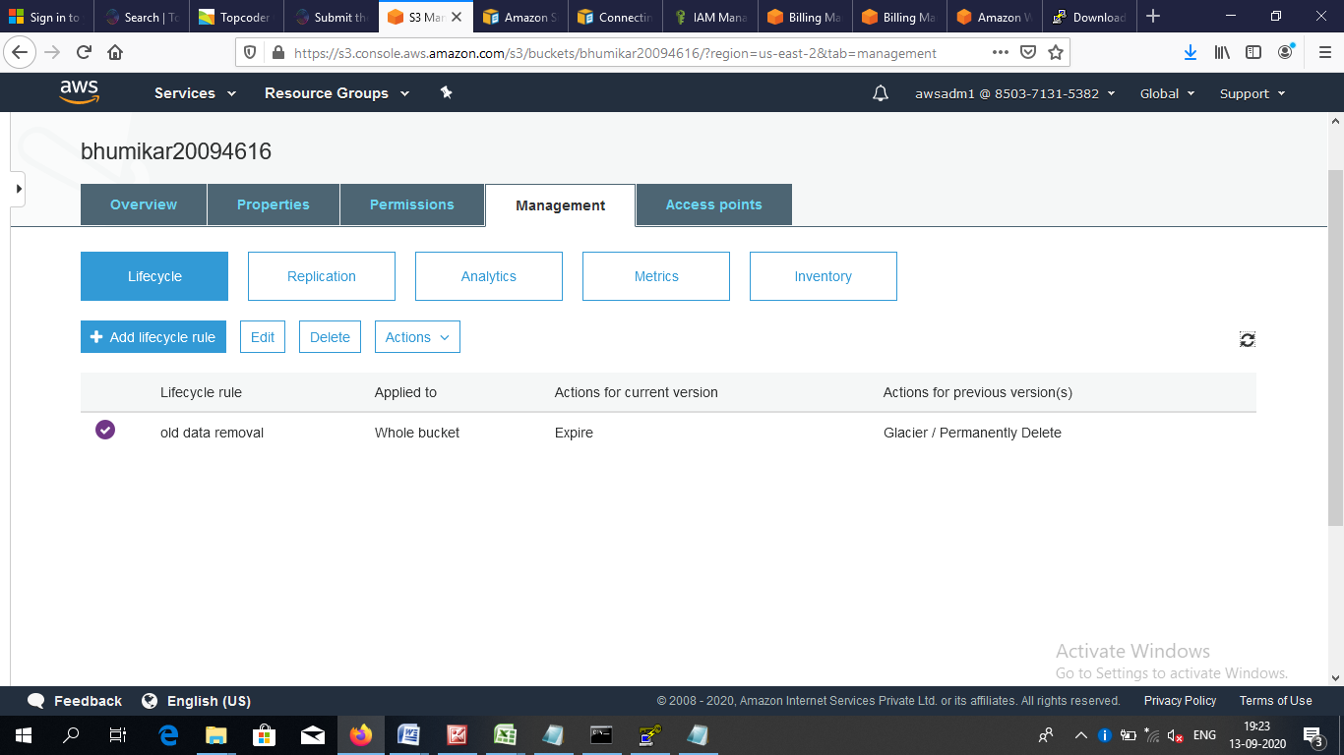

**Capture all the appropriate screenshots, put those in a document file and submit in the appropriate repository of Top Gear along with MS-Team of AWS – L1. The name of the document must be uniquely identified by your first name and employee-id, Example**:

**SHALINI_12345.docx**