EXPERIMENT 6
Execute and display the results for the following commands in Kali Linux Operating Systems:
touch command
Pwd command
Wget command
AIM :To execute and study the touch,Pwd, and Wget commands in the Kali Linux operating system and observe their outputs.
DESCRIPTION:
- touch Command
The touch command is used to create a new empty file. It can also be used to update the date and time of an existing file.
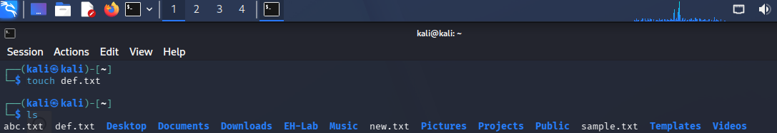
- Pwd Command
The pwd command stands for Print Working Directory. It displays the complete path of the directory in which you are currently working.
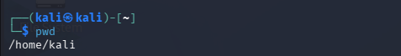
- Wget Command
The wget command is used to download files from the Internet using a URL. It is commonly used to download web pages, documents, images, and other files.
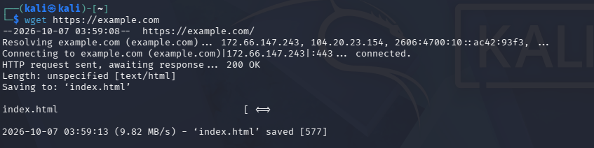
RESULT :The touch, pwd, and wget commands were successfully executed in Kali Linux. The touch command was used to create a new file, the pwd command displayed the current working directory, and the wget command successfully downloaded a file from the Internet.

