EXPERIMENT 2
Execute and display the results for the following commands in Kali Linux Operating Systems:
less command
more command
vi command
AIM :To execute and study the less, more , and vi commands in Kali Linux and observe their results.
DESCRIPTION:
1. less Command :The less command is used to view the contents of a text file one screen at a time. It is useful for reading large files without displaying the entire file at once.
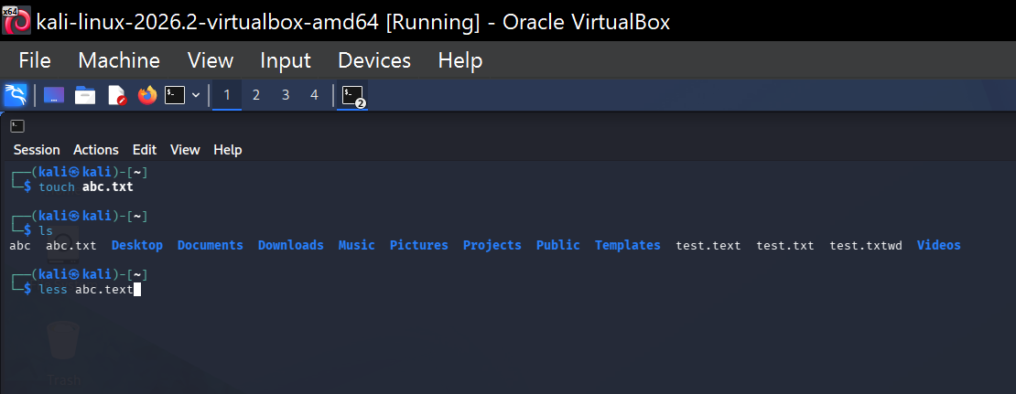
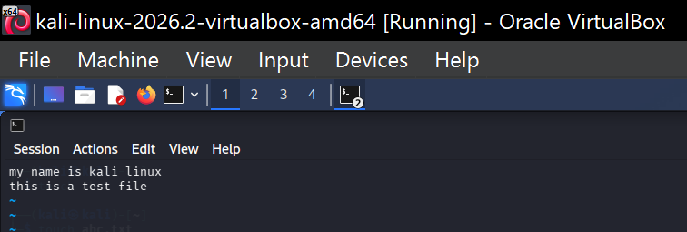
2. more Command : The more command is used to display the contents of a text file page by page. It allows the user to read the file screen by screen.
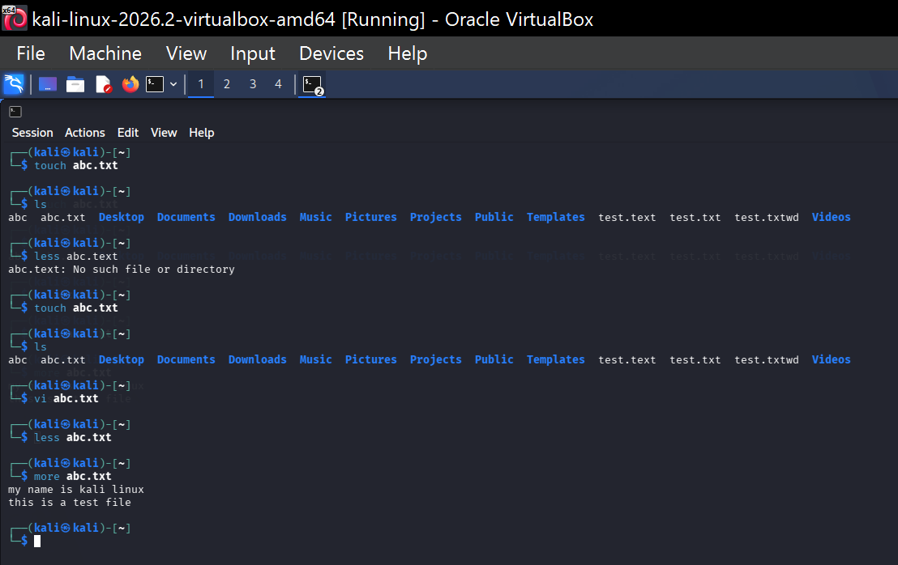
3. vi Command :The vi command is a text editor used to create, edit, save, and modify text files in Linux.
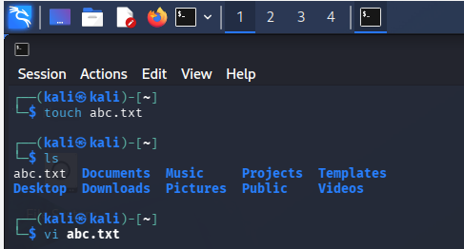
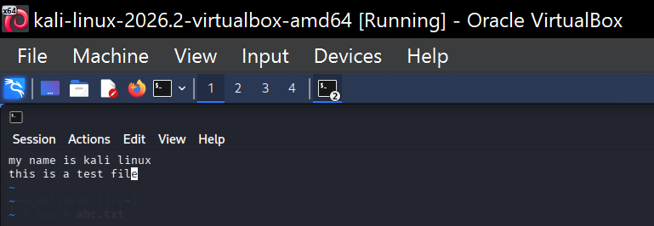
RESULT : The less, more, and vi commands were successfully executed in Kali Linux. The less and more commands were used to view file contents, while the vi command was used to edit and save the file.

