EXPERIMENT 5
Execute and display the results for the following commands in Kali Linux Operating Systems:
uptime command
date command
mv command
AIM :To execute and study the uptime,date, and mv commands in the Kali Linux operating system and observe their outputs.
DESCRIPTION:
- uptime Command
The uptime command displays:
- Current system time
- How long the system has been running
- Number of logged-in users
- System load average
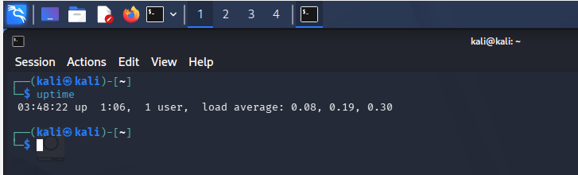
- date Command
The date command displays the current date and time of the system.
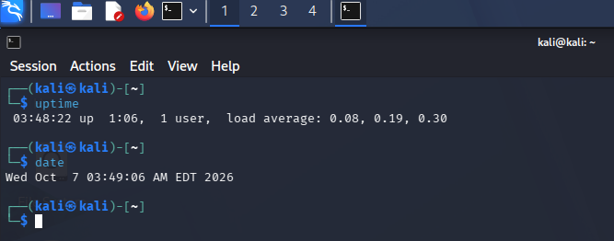
- mv Command
The mv (move) command is used to:
- Move files or directories from one location to another.
- Rename files or directories.
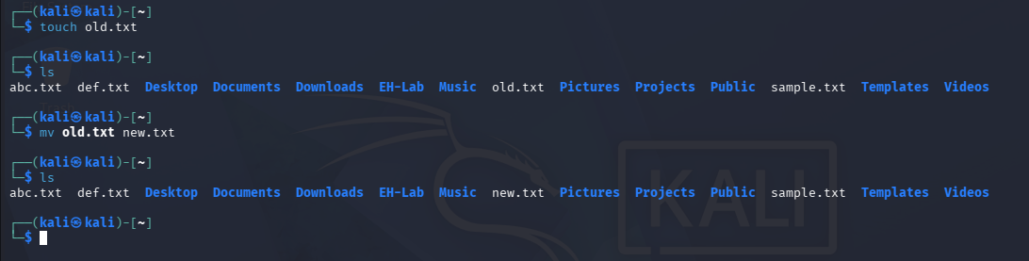

RESULT :The uptime, date, and mv commands were successfully executed in Kali Linux. The uptime command displayed the system running time and load information, the date command displayed the current date and time, and the mv command was used to successfully rename a file.

