EXPERIMENT 7
Execute and display the results for the following commands in Kali Linux Operating Systems:
cd command
cp command
ls command
AIM :To execute and display the results of the cd, cp, and ls commands in the Kali Linux Operating System.
DESCRIPTION:
- cd Command
The cd command stands for Change Directory. It is used to move from one directory to another in the Linux file system.
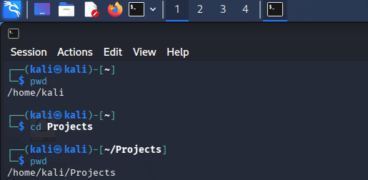
- cp Command
The cp command stands for Copy. It is used to copy files or directories from one location to another.
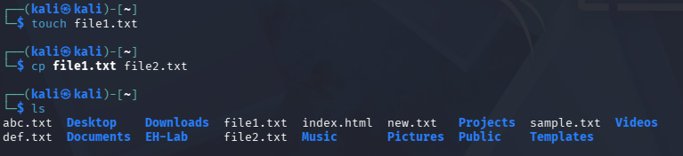
- ls Command
The ls command stands for List. It is used to display the files and directories present in the current working directory.

RESULT :The cd, cp, and ls commands were successfully executed in Kali Linux. The cd command was used to change the current directory, the cp command was used to copy a file, and the ls command was used to display the files and directories in the current working directory.

