EXPERIMENT 1
Execute and display the results for the following commands in Kali Linux Operating
Systems:
rm command
users command
tree command
AIM:
To execute and display the results of the rm, users, and tree commands in the Kali Linux operating system and understand their basic usage.
DESCRIPTION:
rm command: The rm (remove) command is used to delete files and, with suitable options, directories from the file system. In this experiment, a temporary file is created and removed so that the command can be demonstrated safely.
OUTPUT
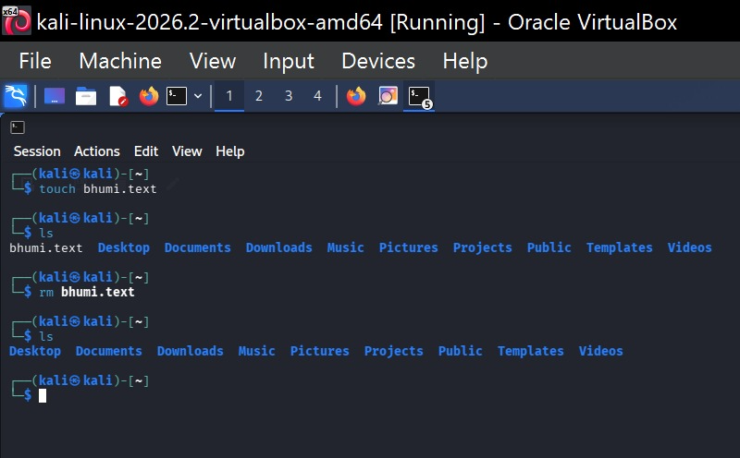

users command: The users command displays the login names of users who are currently logged in to the system.
OUTPUT
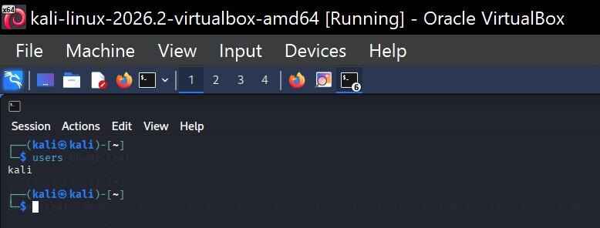

tree command: The tree command displays files and directories in a hierarchical tree-like structure. It is useful for viewing the organization of a directory. The command may need to be installed separately on some Kali Linux systems.
OUTPUT
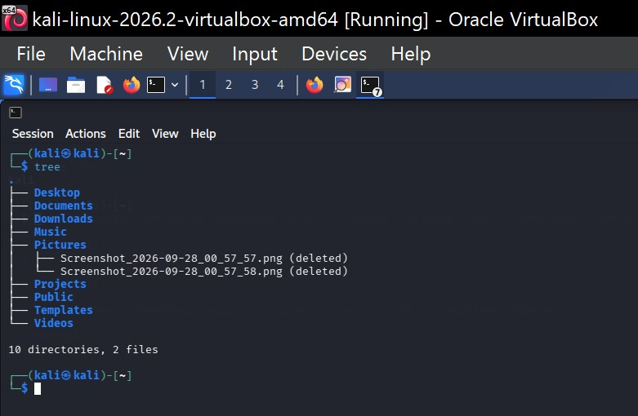

RESULT
Thus, the rm, users, and tree commands were successfully executed in Kali Linux and their outputs were observed.

