Experiment 8
Execute and display the results for the following Nmap service version and OS
detection commands in Kali Linux operating systems:
i) detect the version of services running
ii) aggressive scan
iii) detect operating system of the target
AIM: To execute and study the to detect the version of services running , aggressive scan,and detect operating system of the target commands in the Kali Linux operating system and observe their outputs.
DESCRIPTION:
1.-sV command: Used to detect the versions of services running on the target system.
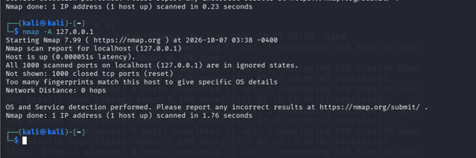
2.-A command: Used to perform an aggressive scan and gather detailed information about the target.
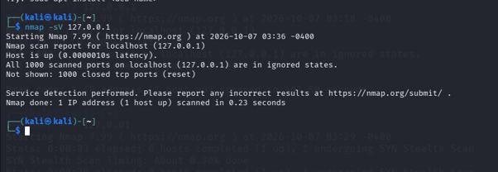
3.-O command: Used to detect the operating system of the target system.
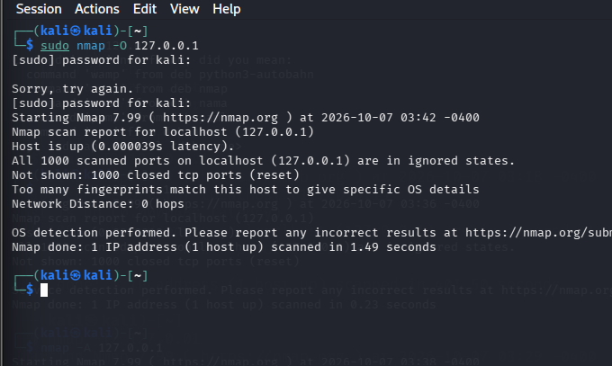

RESULT: we successfully executed and their outputs were observed in the Kali Linux operating system.

