**Sorting an Array Write pseudocode to implement a bubble sort algorithm to arrange a list of integers in ascending order.**

=> Need to create outer loop and inner loop

=> in inner loop using the comparision operator compare less or greater a/c to that swap the element

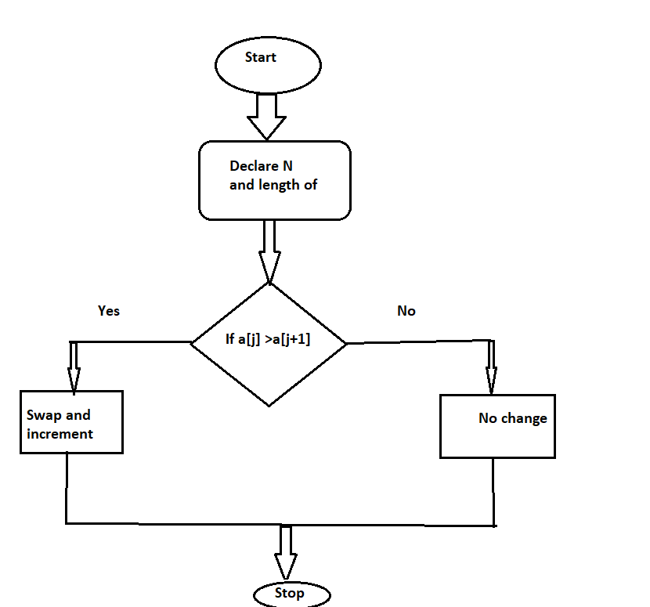

**Find the Largest Number Write pseudocode to find the largest number in an array of integers.**

=> initialize the array and declare the variable named Max

=> use the for loop to iterate each and every element in array

=> inside the for nested if like ===> if (i>max) ;then assign max = i

after the completion of this will get Max in array

=> so return Max

Check for Palindrome Write pseudocode to check whether a given string is a palindrome.

=> Declare a string variable

=> Declare two variable one's for start and and another to the end

=> for ex : madam 1st it starts camparing (start)m == m(end) use while loop until its meets

middle .

=> if statement to be used if all are matches then its "palindrome" else "Not Palindrome"

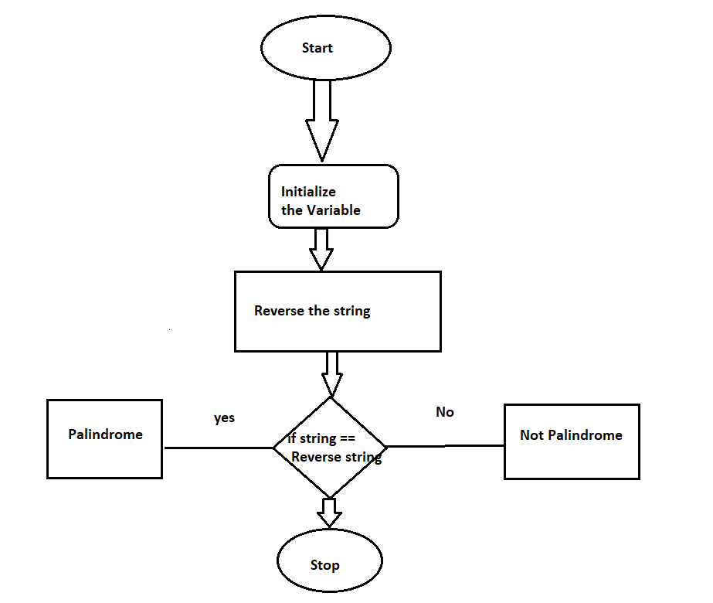

Prime Number Verification Write pseudocode to determine whether a given number is a prime number.

=> Initialize the number

=> check the number is less than or equal to 1 ,if so return Not prime number

=> Iterate from 2

=> check the divisability if so its not prime number

=> if the number is not divided by any other then print "Prime Number".

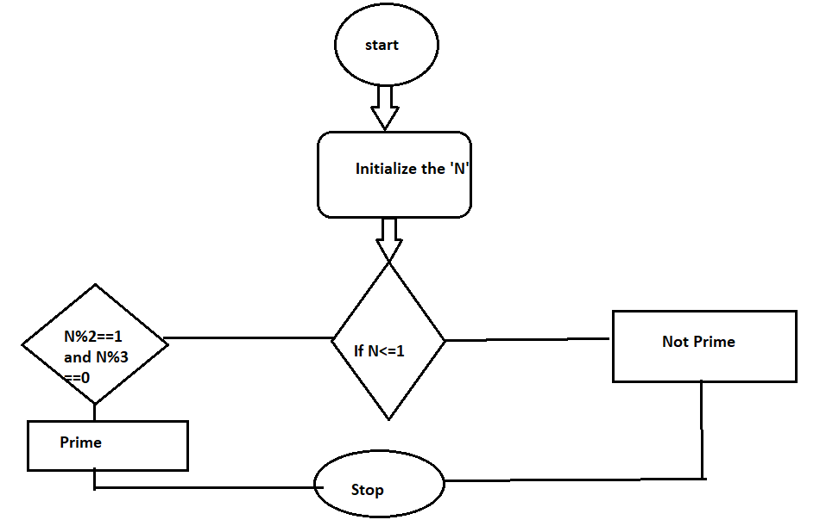

Fibonacci Series Write pseudocode to generate the first N terms of the Fibonacci series.

=> Initialize the int variable n, and int a = 0 and int b = 1

=> for i in range n , delcare variable c = a+b

=> a=b , b=c till its meets range

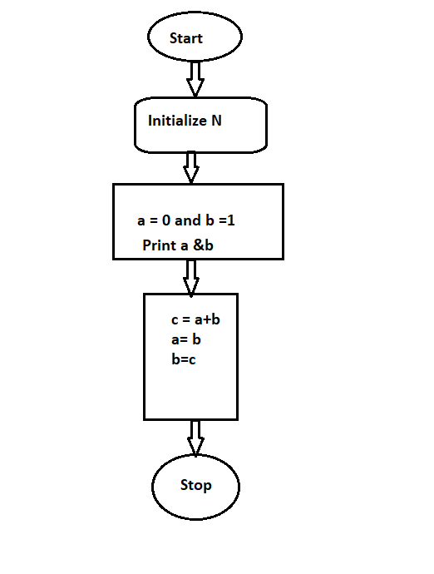

Basic Calculator Write pseudocode to implement a calculator that performs addition, subtraction, multiplication, and division based on user input.

=> initialize the two variables a and b and also c which is equal to +,-,/,*

=> if statement to be used

=> if user type + ,then it need to add a and b ==> a+b // a=10 b = 20 ans = 30

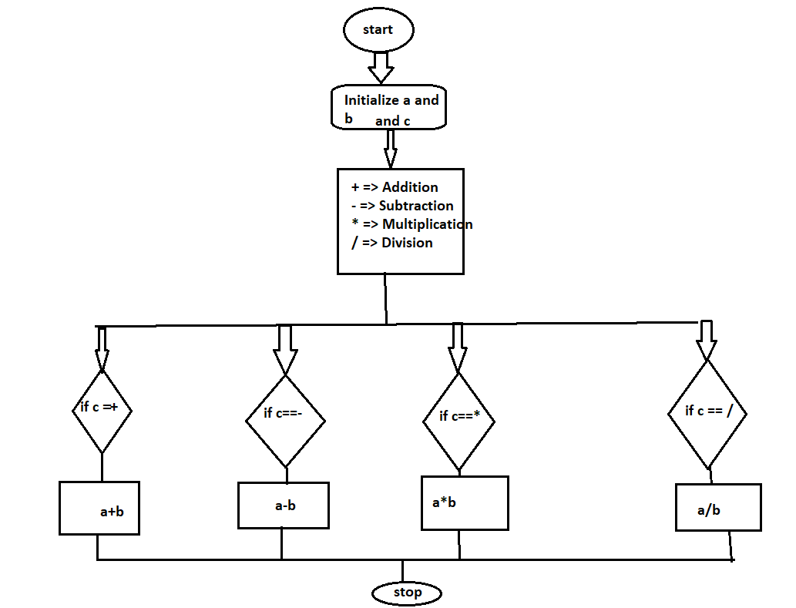

Factorial Calculation Write pseudocode to compute the factorial of a given number using recursion.

=> check the number is equal to 0 or 1 if so return 1

=> else multiply the number with decrease like n * n-1 and store this in variable called factorial

=> return factorial

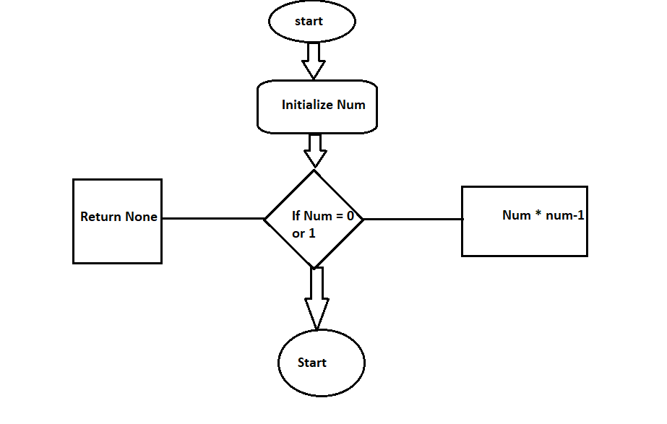

Count Vowels in a String Write pseudocode to count the number of vowels in a given string.

=> declare the variable count =0

=> using for loop iterate if var ='a' or var ='e' or var='i' or var='o' or var = 'u'

=> then count = count +1

=> return count

