To print even numbers from 1 to 100

#include <stdio.h>

int main()

{

int i ,count =0,n;

printf("Enter the Start boundry ");

scanf("%d",&i);

printf("Enter the End boundry ");

scanf("%d",&n);

while(i<=n){

if(i%2 == 0){

printf("%d \n",i);

count++;

}

i++;

}

printf("Out of loop \n");

printf("Total num of count %d",count);

return 0;

}

**While Loop**

1. **Print Natural Numbers:**  
   Write a program to print the first 10 natural numbers using a while loop.

1. **Sum of Digits:**  
   Write a program to calculate the sum of the digits of a given integer using a while loop.

1. **Factorial of a Number:**  
   Write a program to compute the factorial of a number using a while loop.

1. **Reverse a Number:**  
   Write a program to reverse a given number using a while loop.

1. **Count Digits in a Number:**  
   Write a program to count the number of digits in an integer using a while loop.

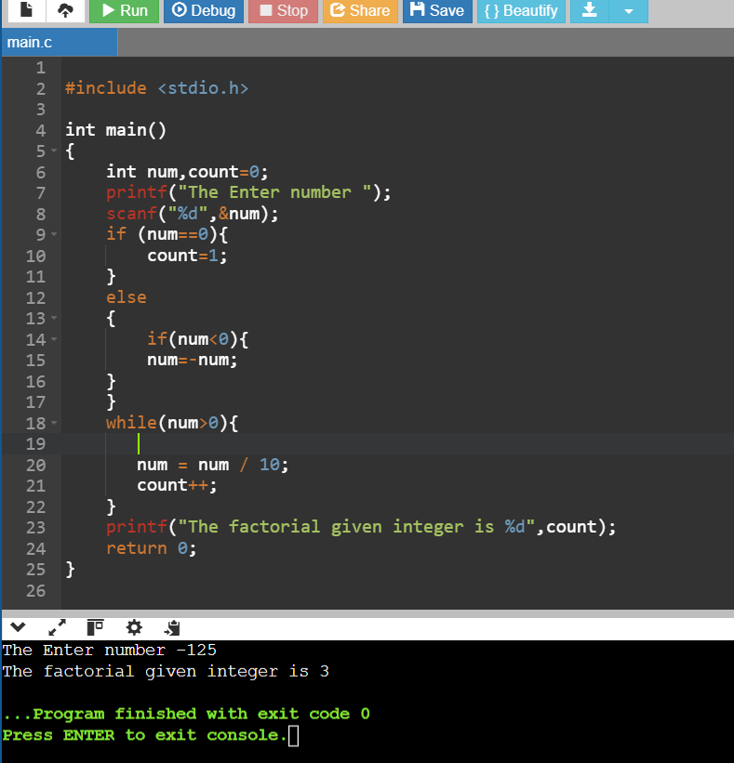

1. **Print Multiplication Table:**  
   Write a program to print the multiplication table of a given number using a while loop.

1. **Check Palindrome Number:**  
   Write a program to check if a number is a palindrome using a while loop.

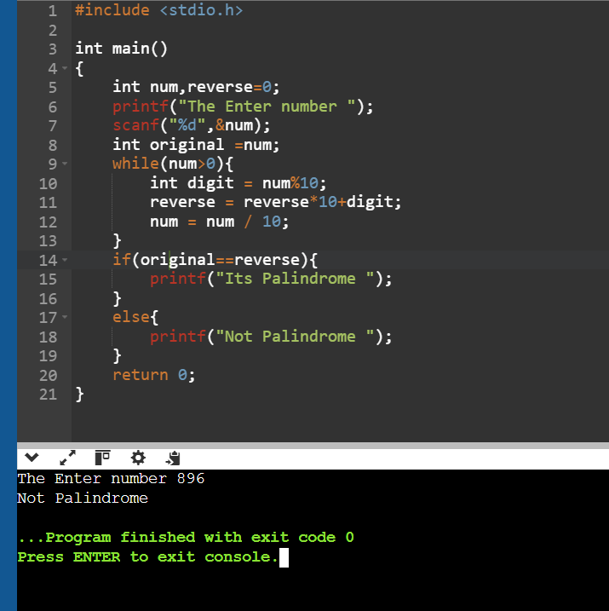

1. **Print Odd Numbers:**  
   Write a program to print all odd numbers between 1 and 50 using a while loop.

1. **Sum of Series:**  
   Write a program to calculate the sum of the series:

S=1+2+3+…+n

using a while loop.

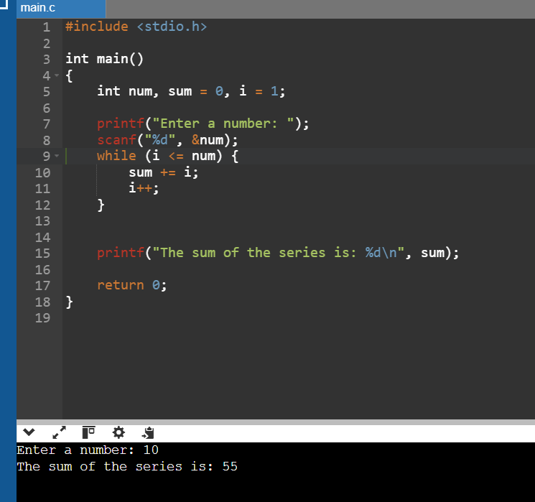

1. **Find GCD of Two Numbers:**  
   Write a program to compute the GCD of two numbers using a while loop.

**For Loop**

1. **Print Even Numbers:**  
   Write a program to print all even numbers between 1 and 100 using a for loop.

1. **Sum of First N Natural Numbers:**  
   Write a program to calculate the sum of the first n natural numbers using a for loop.

1. **Factorial of a Number:**  
   Write a program to calculate the factorial of a given number using a for loop.

1. **Fibonacci Series:**  
   Write a program to generate the first n terms of the Fibonacci series using a for loop.

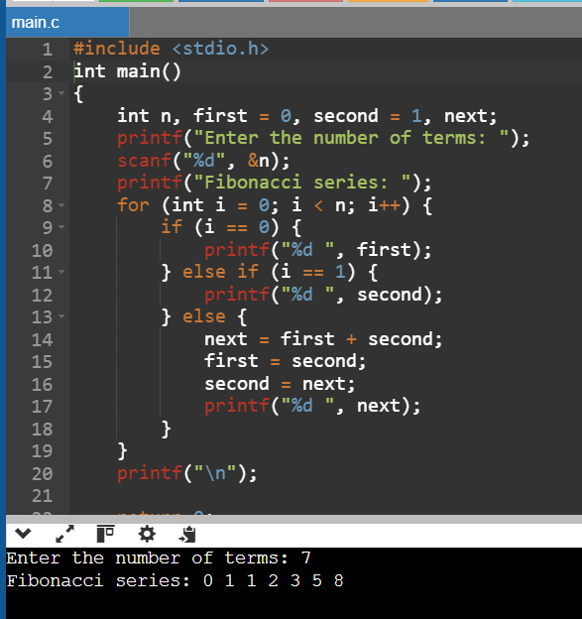

1. **Prime Number Check:**  
   Write a program to check if a given number is prime using a for loop.

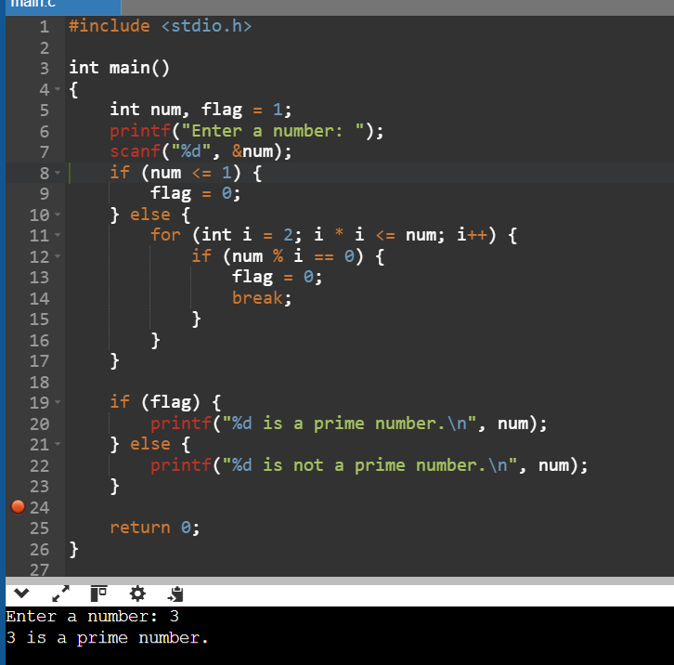

1. **Pattern Printing:**  
   Print the following pattern using a for loop:

*

**

***

****

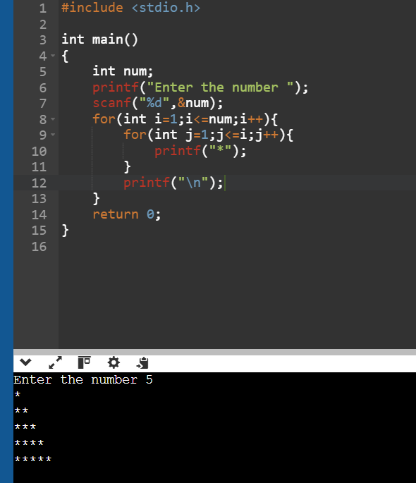

1. **Sum of Squares of Numbers:**  
   Write a program to calculate the sum of squares of the first nnn natural numbers using a for loop.

1. **Power of a Number:**  
   Write a program to compute (x raised to the power y) using a for loop.

1. **Reverse Counting:**  
   Write a program to print numbers from 100 to 1 in reverse order using a for loop.

1. **Count Divisors of a Number:**  
   Write a program to count the divisors of a given number using a for loop.

**Do-While Loop**

1. **Menu-Driven Calculator:**  
   Write a menu-driven calculator using a do-while loop. Continue asking for user input until they choose to exit.

1. **Print Numbers Until Zero:**  
   Write a program to keep accepting numbers from the user and print them until the user enters zero.

1. **Validate Password:**  
   Write a program that asks for a password until the user provides the correct one using a do-while loop.

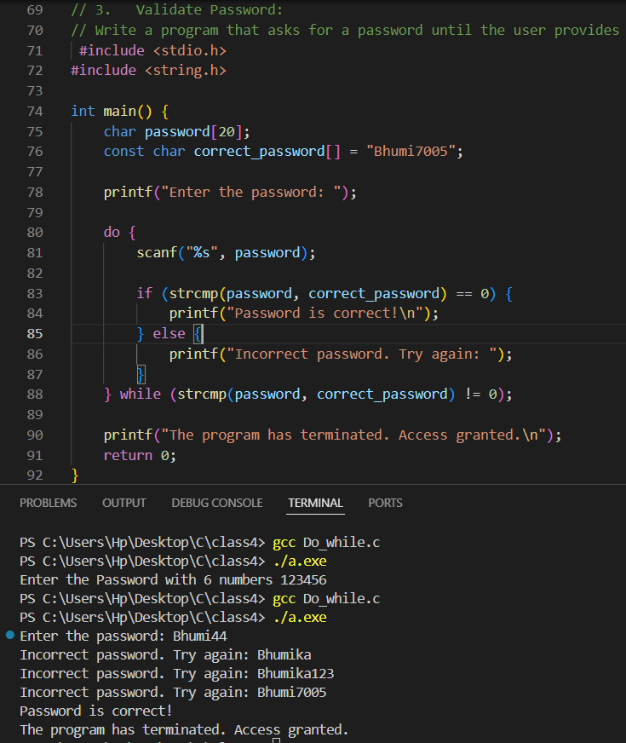

1. **Sum of Positive Numbers:**  
   Write a program to read integers from the user and compute their sum. Stop when the user enters a negative number.

1. **Repeat Multiplication Table:**  
   Write a program to repeatedly display the multiplication table of a number until the user decides to stop.

1. **Guess the Number Game:**  
   Write a program where the user guesses a predefined number. Continue the game until the correct number is guessed.

1. **Input Validation:**  
   Write a program to ensure that the user enters a number between 1 and 10. Prompt until a valid number is provided.

1. **Calculate Average:**  
   Write a program to calculate the average of a series of numbers entered by the user. Stop when the user enters zero.

1. **Print Alphabets:**  
   Write a program to print lowercase alphabets from 'a' to 'z' using a do-while loop.

1. **Count Digits of a Number:**  
   Write a program to count the number of digits in a number entered by the user using a do-while loop.

Problem statements with respect to Pattern printing using For as well as while Loop  
1. Pascal’s Triangle

    1  
   1 1  
  1 2 1  
1 3 3 1  
1 4 6 4 1

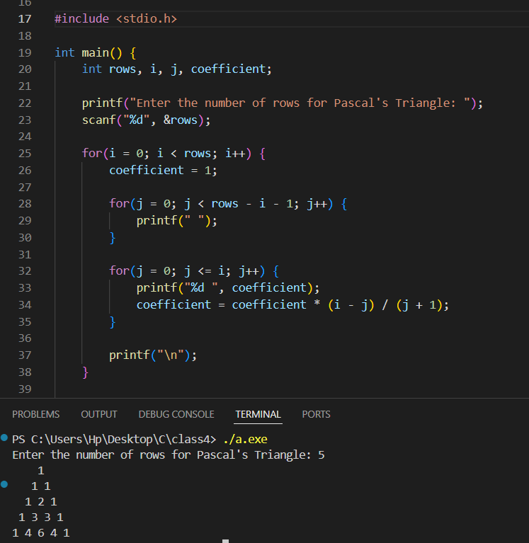

2. Binary Pattern

1  
01  
101  
0101  
10101

3. Floyd’s Triangle (Numbers)

1  
2 3  
4 5 6  
7 8 9 10  
11 12 13 14 15

4. Inverted Right-Angled Triangle (Numbers)

12345  
1234  
123  
12  
1

5. Diamond (Stars)

    *  
   ***  
  *****  
*******  
*********  
*******  
  *****  
   ***  
    *

6. Inverted Pyramid (Stars)

*********  
*******  
  *****  
   ***  
    *

