AML

Jenkins Pipeline configuration

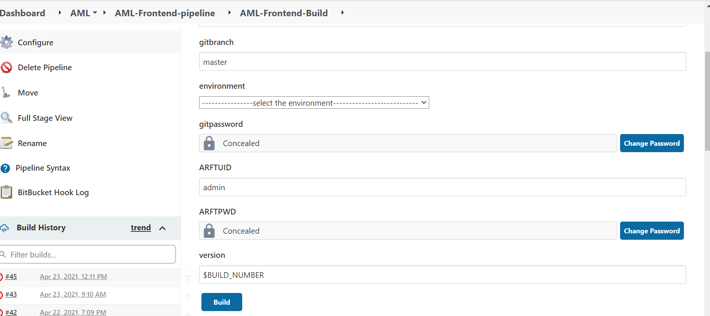

AML slave

this cmd have to run in slave machine after downloading jar

java -jar agent.jar -jnlpUrl http://10.41.63.254:32761/computer/AML%5FSLAVE/jenkins-agent.jnlp -workDir "D:\AML"

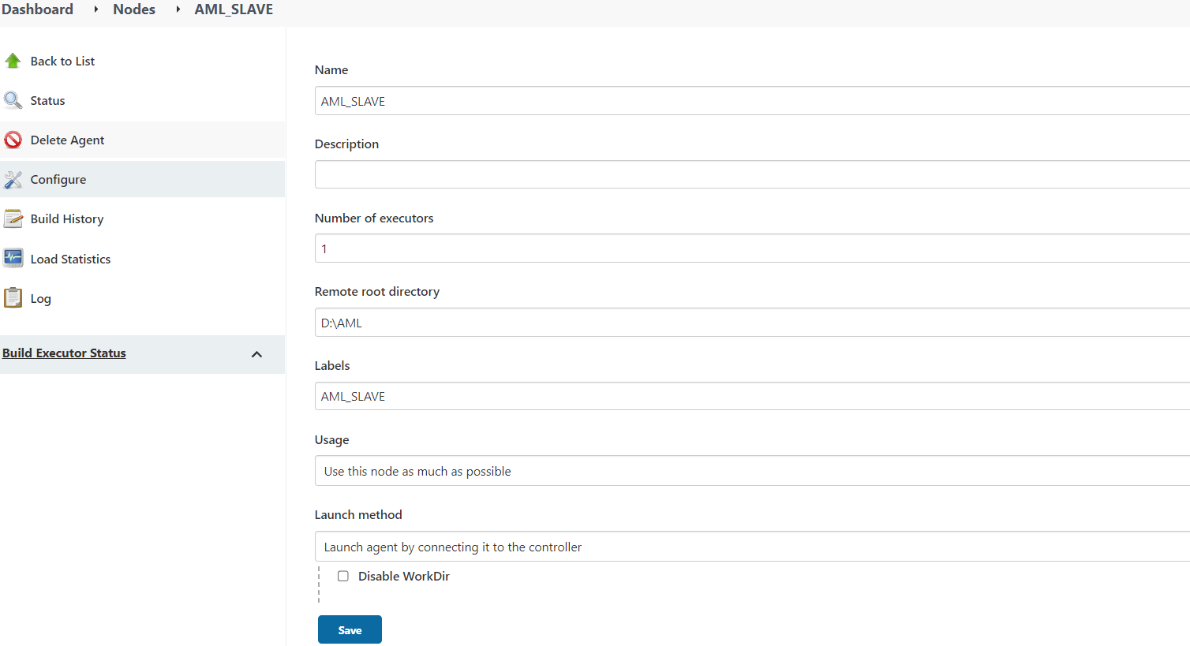

AML deploy Job

Main conf

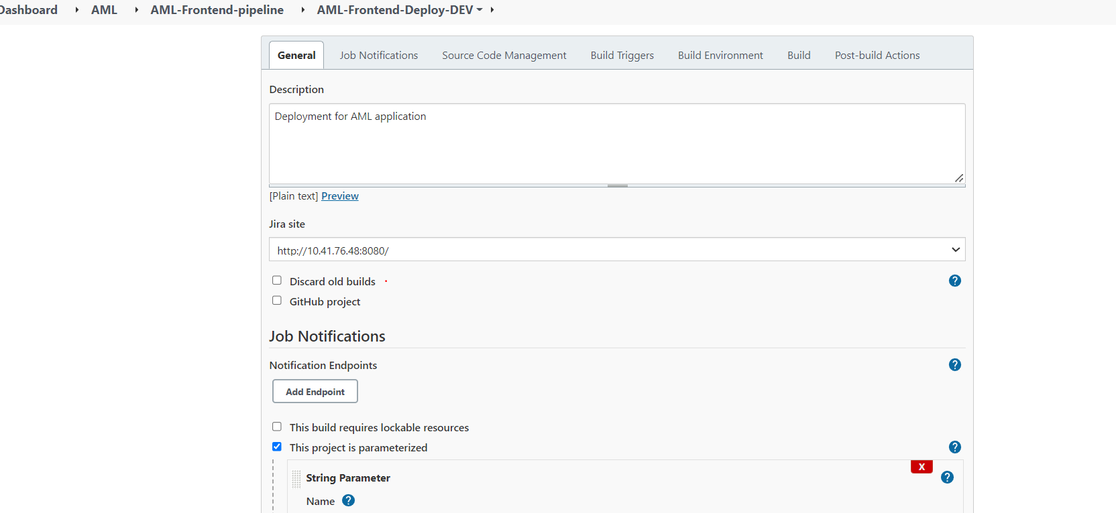

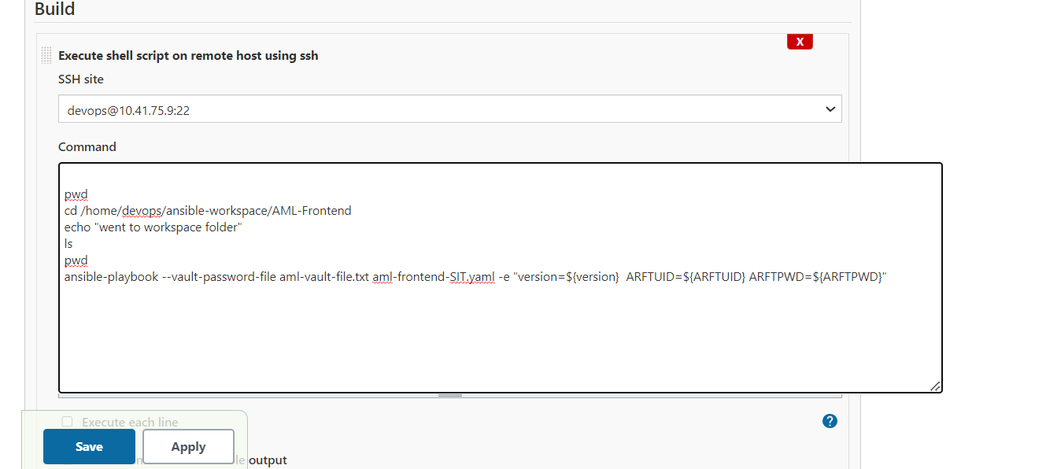

Vault conf

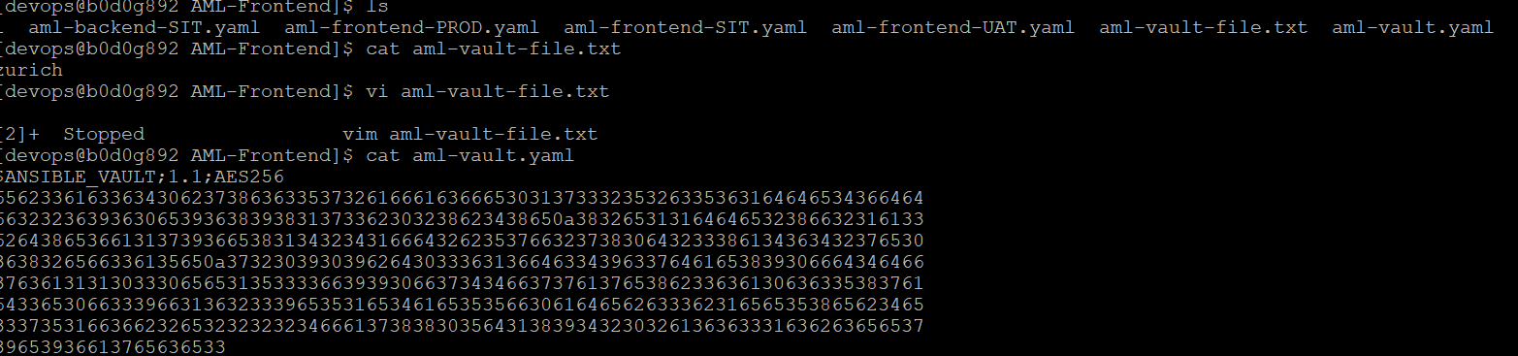

CEC

__________