**New Horizon Awasiya Secondary School**

Tansen-7,Kajipauwa,Palpa



Chemistry Project

A project report on “The different types of dyes”

Submitted by Bhumika Barghare

Class – 12 (science)

Roll no – 10

Under the Guidance of

Mr. Narayan Bashyal

Head of the Department of Chemistry

**Declaration**

I hereby declare that the report presented in the project has been done by myself

under the supervision of Mr. Narayan Bashyal, and hasn’t been submitted

elsewhere for any examination. All sources of information have been specifically

acknowledged by reference to authors and institutions.

Signature:

Name of the student: Bhumika Barghare

Stream: Science

Class: XII

Date: 2/15/2025

**Recommendation letter**

This project entitled “The different types of dyes” carried

out by Mrs. Bhumika Barghare under the supervision of Mr. Narayan Bashyal is here

recommended for the partial fulfillment of project work for grade 12.

..........................

Supervisor

Mr. Narayan Bashyal

Department of Chemistry

New Horizon College

Tansen, Palpa.

**Certificate of Approval**

It is to certify that Mrs. Bhumika Barghare has successfully carried out the project report

entitled “The different types of dyes” under my guidance and

supervision.

I am completely approving the validity of this project.

..........................

Supervisor

Mr. Narayan Bashyal

Department of Chemistry

New Horizon College

Tansen, Palpa.

**Acknowledgement**

Firstly, I would like to express my deep gratitude to my supervisor Mr. Narayan Bashyal

sir for his admirable cooperation, inspirable guidance, caring, continuous support

and valuable suggestions throughout the process of project work. Furthermore, I

would like to express my sincere gratitude to all my teachers, friends, and college staff

who directly or indirectly helped me in completion of the study and skill

development. Specially, I would like to express my gratitude to the chemistry

department for all the support and homely environment throughout the work.

Additionally, I would like to thank all my family members and all my relatives for their

unconditional support.

Bhumika Barghare

Class: 12

Roll no: 10

**Abstract**

Color is one of the elements of nature that makes the human life more aesthetic and fascinating in the world. Plants, animals, and minerals have used as primary sources for colorants, dyes or pigments since ancient times. The first dyes known to be used in prehistoric times consisted of fugitive stains from berries, blossoms, barks, and roots. the dyeing using natural materials is applied as an adjunct for hand spinning knitting and weaving but it has remained as a living craft in many traditional cultures of north America, Africa, Asia and the Scottish Highlands. The new discoveries about the science of color have also led to many industrial innovations and a sharp fashion change. The classification of dyes is approached from multiple perspectives, including chemical structure, application, and source. This holistic approach allows for a through understanding of the relationships between different dye types, facilitating the identification of commonalities and distinctions.

**Table Of Contents**

Cover age and Tittle page

Declaration

Recommendation

Certificate of Approval

Acknowledgement

Abstract

Table of contents

1. Introduction………………………………………………………….8
2. Objectives……………………………………………………………10
3. Literature review…………………………………………………….11
4. Results and discussion………………………………………………12
5. Conclusion…………………………………………………………..16
6. Suggestion for further research……………………………………..17
7. Reference……………………………………………………………18

**Introduction**

A color additive imparts its color to a substrate, such as paint, paper, or cotton. Dyes and pigments, the primary colorants, alter or add color to various materials. Dyes, soluble in the application medium [typically water], exhibit substantivity for the material being dyed and are absorbed from the aqueous solution. In contrast, pigments consist of insoluble particles. These colorants play a vital role in industries like textiles, pharmaceuticals, food, cosmetics, plastics, paint, ink, photography, and paper, with over 10,000 varieties used globally, and an annual production exceeding 7*10^5 tons of synthetic dyes.

Dyes and pigments have been integral to human history, providing color to diverse substances. The key distinction lies in solubility: dyes disperse at a molecular level, providing bright colors but with reduced light stability and permanence, while pigments, insoluble, disperse as particles.

Throughout history, humans have used inorganic salts or natural pigments from vegetable, animal, and mineral sources to color daily objects. These substances, known as dyes, are chemical compounds used in coloring fabrics, leather, plastic, paper, food items, cosmetics, and for producing inks and artistic colors. Dyes are classified as synthetic, derived from petroleum compounds, and natural, obtained from plant, animal, and mineral matter, reflecting their diverse origins and applications.

The global market for pigments and dyes is forecast to reach 9.9 million tons and $26.53 billion by the year 2017, driven by the growth in key end-use industries. Before synthetic dyes and pigments were discovered, limited number of natural colorants has been obtained from plants, animals and minerals. The classification of colorants has become mandatory due to huge increase in kind and number of colorants. For this reason, colorants are classified based on their structure, source, color, solubility and application methods. In this chapter, dyes will be investigated in two different groups as accordance with chemical structures and application methods. The basic classification groups were determined as azo, anthraquinone, indigo, phthalocyanine, sulfur, nitro and nitroso dyes by considering their chemical structures. According to application method, they were groups as reactive, disperse, acid, basic, direct, and vat dyes.

Dyeing is predominantly conducted through continuous or batch processes in modern textile technology. The dyeing process involves multiple stages, each tailored to the specific characteristics of the fiber and the properties of dyes and pigments intended for use in fabrics Various factors, such as the chemical structure, classification, commercia considerations, play a crucial role in determining the suitable dyeing method or techniques. The choice of dyeing method is also influenced by fiber attributes like luster, denier, staple length, texture, and cross-section, as well as the construction of the fabric. These factors collectively impact the final color outcome.

The effects of colorants [dyes and pigments] on the environment and human health are covered by their environmental characteristics. Serious issues arise from aqueous waste effluent that contains dye compounds. As a result, the production and application of synthetic dyes for fabric dyeing have grown to be very popular industries.

Because of this, they are now frequently found in industrial environmental pollutants both during the synthesis process and during the dyeing of fibers. This is the primary prerequisite for both the research into suitable and ecologically friendly treatment technologies as well as for innovations in related process. Artificial coloring has a negative impact on all living things.

The existence of sulfur, naphthol, nitrates, acetic acid, soaps, enzymes, and vat dyes. The textile effluent is extremely toxic due to chromium compounds, heavy metals such as copper, arsenic, lead and cobalt, as well as some auxiliary chemicals. The health effects of dyes on human vary based on where they are used. Some synthetic dyes have been linked to skin irritation and contact dermatitis, and many countries have banned the use of azo dyes from carcinogenic amines due to legal restrictions. The application of biological materials has received particular attention in studies on innovative and alternative wastewater treatment methods.

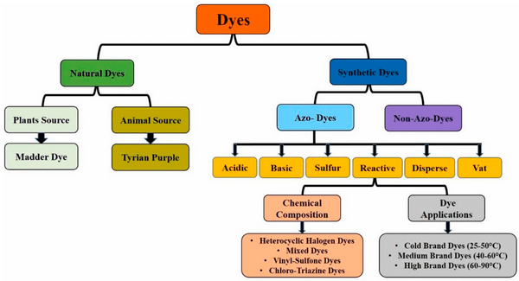

**Objectives**

* To analyze and categorize various types of dyes based on their chemical structure, properties, and applications in textile dyeing.
* To highlight advancements in modern dyeing technologies.
* To analyze the chemical compositions of various dye types and understand their molecular structures.
* To examine the ecological consequences of dye manufacturing, utilization, and disposal.

**Literature Review**

The colorants that impart color such as pigment, dye, ink, and paint are generally derived from plant, mineral or invertebrates. The majority of natural colorant substances are the dyes deriving from plant sources (roots, berries, bark, leaves, and wood) and other organic sources such as fungi and lichens. Archaeological researches have shown that the onset of textile dyeing can be back the Neolithic period. 1.1 Introduction 3 In China. dyeing with plants, barks and insects has been traced back more than 5000 years (Naik et al. 2013)

The chemical analysis that can identify the dyes used in the ancient textiles has rarely been achieved and even if any dye is detected. It has not been possible to determine which of same dye-bearing plants was used. Nevertheless, based on the colors of surviving textile fragments and the evidence of actual dyestuffs found in archaeological sites, it can be claimed that reds, blues, and yellows from plant sources were in common use in the late Bronze Age and Iron Age (Godlove 2011).

Prussian blue can be considered as the first modern, totally synthetic pigment, arising as the result of a deliberate chemical reaction without any natural equivalent. The first product was produced accidentally in 1704, but the pigment has achieved a high production level quite soon afterwards (Kirby and Saunders 2004) The first two synthetic pigments were white lead (basic lead carbonate, (PbCO3)2 Pb (OH)2) and blue frit (Egyptian Blue). White lead is made by combining lead with vinegar (acetic acid, CH3COOH) in the presence of CO2. Blue frit is calcium copper silicate and was made from glass colored with a copper ore, such as malachite (Emeish 2013).

Graebe and Liebermann(1868) achieved the synthesis of alizarin crimson. They utilized anthracene, derived from coal tar, as the initial substance, which underwent oxidation to produce anthraquinone. Employing subsequent chemical processes like condensation and hydrogenation, they effectively created alizarin-a pivotal element responsible for the vivid red hue. This accomplishment marked a significant advancement, enabling the independent production of Alizarin Crimson without relying on the madder plant, which historically served as the natural source of alizarin.

**Result and Discussion**

**Classification of Dyes**

* Occurrence
* Chemical Structures
* Application Methods

**Occurrence**

* **Natural dyes:** They are colorants derived from plant sources, animals, minerals, and other naturally occurring substances. These dyes have been used for thousands of years in various cultures for coloring textiles, clothing, and other materials. Unlike synthetic dyes, which are often derived from petrochemicals, natural dyes are sourced from renewable materials. Advantages of natural dyes include their biodegradability and often lower environmental impact compared to synthetic alternatives. However, they may have limitations in terms of color range, colorfastness, and scalability. Many plant-based materials, such as roots, leaves, bark, and flowers, contain pigments that can be extracted for dyeing. Certain insects, such as cochineal insects, produce vibrant red and pink dyes. Research and interest in natural dyes have seen a resurgence in the context of sustainable and eco-friendly practices within the textile and dyeing industries.
* **Synthetic Dyes:** Synthetic dyes are chemical colorants created through artificial processes, often derived from petrochemical sources. These dyes have been developed since the late 19th century and are widely used in various industries, including textiles, plastics, cosmetics, and food. Unlike natural dyes, synthetic dyes are produced through chemical synthesis, allowing for a broader spectrum of colors and enhanced colorfastness. Here are some key aspects of synthetic dyes. Many synthetic dyes are derived from petroleum-based compounds, such as aromatic hydrocarbons. Synthetic dyes offer a wide and diverse range of colors, including shades that are challenging to achieve with natural dyes. The production and disposal of some synthetic dyes can have environmental implications, including water pollution. Some synthetic dyes have been associated with health concerns, leading to increased interest in natural and safer alternatives. The petrochemical-based nature of many synthetic dyes raises concerns about the sustainability of their production. Synthetic dyes play a crucial role in modern. industries, providing a vast array of colors and functionalities. However, there is also growing interest in developing sustainable and environmentally friendly alternatives to address the environmental and health concerns associated with certain synthetic dyes.

**Chemical Structures**

* **Azo Dye:** Azo dyes stand out as the most widely used, comprising over 60% of the total dye varieties. These dyes contain at least one nitrogen-nitrogen (N-N) double bond, allowing for a multitude of structural possibilities. The azo group is connected to two groups, typically with at least one, but more commonly both. being aromatic. Azo dyes are, due to their relatively simple synthesis and almost unlimited numbers of substituents, most important group of synthetic colorants that are extensively used in textile, pharmaceutical, plastic, leather, paper, and printing industries and they do not occur naturally.

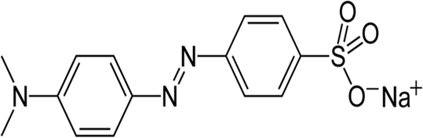

* **Anthraquinone dyes:** They are the second most important class after azo dyes. They are also one of the oldest types of dyes since they have been found in the wrappings of mummies dating back over 4000 years. The anthraquinone dyes have important advantages such as brightness and good fastness properties. In contrast to the azo dyes, which have no natural counterparts, anthraquinones are important natural products found in bacteria, fungi, lichens and plants.

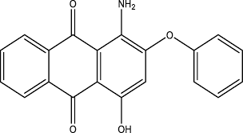

* **Indigo dye:** It is an organic compound with a distinctive blue color and represents one of the oldest organic dyes known. Indigo dye which is firstly extracted from plants has been used for textile dyeing for 5000 years. Indigo is used almost exclusively for dyeing denim jeans and jackets. Until the late 19th century, indigo was obtained from natural sources and, with the advent of the modern chemical industry, became one of the first natural molecules to be synthesized. Synthetically-produced indigo was of superior quality to indigo from plants, and was therefore preferred by dyers. Today, almost all the traded indigo is produced synthetically

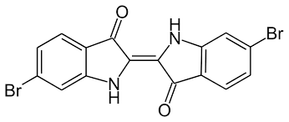

* **Nitro and Nitroso Dyes:** These dyes are now of only minor commercial importance but are of interest for their small molecular structures. The early nitro dyes were acid dyes used for dyeing the natural animal fibers such as wool and silk. These dyes have one or more nitro or nitroso group conjugated with an electron donating group via an aromatic system. The nitroso compounds have not themselves dyeing properties, but are capable of forming metal complexes that are pigments.

1. b.

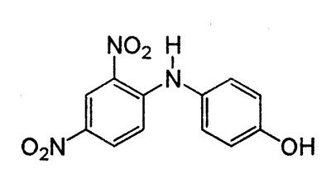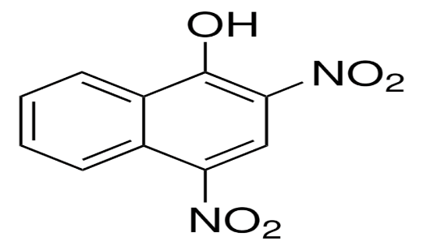

Nitro dyes

**Application Methods**

* **Acid Dyes:** Acid dyes are organic sulfonic acids; the commercially available forms are usually sodium salts, which exhibit good water solubility. In sequence of their importance, acid dyes are mostly used with certain fiber types such as polyamide, wool, silk, modified acrylic, and polypropylene fibers. The most acid dyes are sulfonic acid salts and they contain azo, anthraquinone, triphenylmethane, nitro and nitroso chromophoric groups.
* **Basic Dyes:** Basic or cationic dyes derive their name from the fact that the dye molecules dissociate in water, with the cation being the colored portion of the dye. These water-soluble cationic dyes are applied to paper, polyacrylonitrile, modified nylons, and modified polyesters. Basic dyes are water-soluble and yield colored cations in solution. Generally, these dyes are not applied along with acid or direct dyes because precipitation may occur
* **Disperse dyes:** They generally contain azo, anthraquinone, nitro groups and they are substantially water-insoluble dyes having substantivity for one or more hydrophobic fibers such as nylon, cellulose, cellulose acetate, and acrylic fibers with usually applied from fine aqueous dispersion. During the dyeing process, the dye molecules in solution are attached to the fibers and then dispersed dye molecules transfers to solution despite to their low solubility
* **Direct dyes:** They are water-soluble dyes, easily applied to cellulose fibers, and comprise the largest group of dyes. Direct dyes do not require the use of a mordant and, as their name implies, the dyeing procedure is quite simple. The goods go into the bath followed by the dissolved dyes. The bath is then gradually heated, usually to the boil, and additions of salt that promote dyeing. Compared to other dye classes, direct dyes have a high molecular mass which, as a general rule, promotes dye aggregation and substantivity to the fiber
* **Vat dyes:** They are water-insoluble pigments. Indigo is one of the known oldest dyes and it is a natural vat dye has been used for nearly 4000 years. Vat dyes are colorfast to laundering and have good fastness to light. Most vat dyes are indigoid or anthraquinone and usually have between five and ten aromatic rings

**Conclusion**

In conclusion, the world of colorants, encompassing dyes and pigments, holds a crucial role in various industries, ranging from textiles to food, cosmetics, plastics, and more. This report has explored the historical significance, chemical structures, and application methods of dyes, with a focus on both natural and synthetic varieties.

Natural dyes, derived from plant, animal, and mineral sources, carry historical and cultural importance. They offer biodegradability and are often associated with sustainable practices. However, they may present limitations in terms of color range and stability. On the other hand, synthetic dyes, developed from petrochemical sources, provide a broad spectrum of colors and enhanced colorfastness. Despite their versatility, concerns about environmental impact and health have prompted an interest in more sustainable alternatives.

The classification of dyes based on their chemical structures and application methods has been discussed. Azo dyes, anthraquinone dyes, indigo, nitro, nitroso, and vat dyes represent different chemical structures, each with specific characteristics. The application methods, including acid, basic, disperse, direct, and vat dyeing, are tailored to diverse fibers and materials.

The report also highlighted the global significance of the pigment and dye market. exceeding 10,000 varieties globally, with an annual production exceeding 7 x 10^5 tons of synthetic dyes. The growth in key end-use industries is expected to drive the market further.

However, the environmental impact of dye production, application, and disposal cannot be overlooked. The release of dye compounds in aqueous waste effluents poses serious environmental challenges, emphasizing the need for research into ecologically friendly treatment technologies.

The effects of dyes on human health and the environment, especially in the textile industry, are critical concems. Wastewater from dye processing, containing various chemicals, contributes significantly to industrial water pollution. Therefore, exploring innovative and alternative wastewater treatment methods is imperative for minimizing the negative impact on public health and the environment.

The objectives of this report, including the analysis and categorization of various types of dyes, exploration of modern dyeing technologies, and examination of the chemical compositions of different dye types, have been addressed. The comprehensive literature review delved into the historical roots of dyeing, showcasing the evolution from natural sources to the synthesis of modern pigments like Prussian blue and alizarin crimson.

In the ever-evolving landscape of colorants, the importance of sustainable practices, regulatory considerations, and advancements in technology have become paramount. Future research and development in this field will likely focus on creating colorants that balance vibrant aesthetics with minimal environmental and health impacts. As industries continue to grow, the responsible use and disposal of color additives will remain a key challenge, urging stakeholders to collaborate in developing eco-friendly solutions.

**Suggestion For Further Research**

Further exploration into the study of various dye types has the potential to make valuable contributions in mitigating the adverse effects associated with the dye industry. This research could significantly enhance our comprehension of the subject, tackle existing challenges, and propel advancements in the field. Here are several recommendations for additional research efforts:

**1.** **Health Effects of Colors:** Investigate how colors in makeup and clothing, whether natural or synthetic, may impact our skin and overall health. Explore potential issues like irritation, allergies, and long-term consequences.

**2.** **Coloring Advanced Materials:** Examine the methods of coloring advanced materials such as nanofibers and graphene-based materials. Explore challenges and opportunities in achieving consistent and durable coloration for these materials.

**3. Exploring Natural Color Alternatives:** Research and understand alternatives to synthetic dyes derived from natural sources, including plant extracts and microbial pigments. Evaluate the range of colors, stability, and practicality of these alternatives.

**4.** **Integration of Digital Technologies in Dyeing:** Investigate the incorporation of digital technologies, such as Al and machine learning, into dyeing processes. Explore how these technologies can improve color matching, reduce waste, and enhance efficiency in the dyeing industry.

**5. Green and Sustainable Dyeing Processes:** Explore and develop eco-friendly dyeing processes that minimize water consumption, energy usage, and chemical waste. Assess the viability of alternative solvents and environmentally friendly dye carriers in dyeing applications.