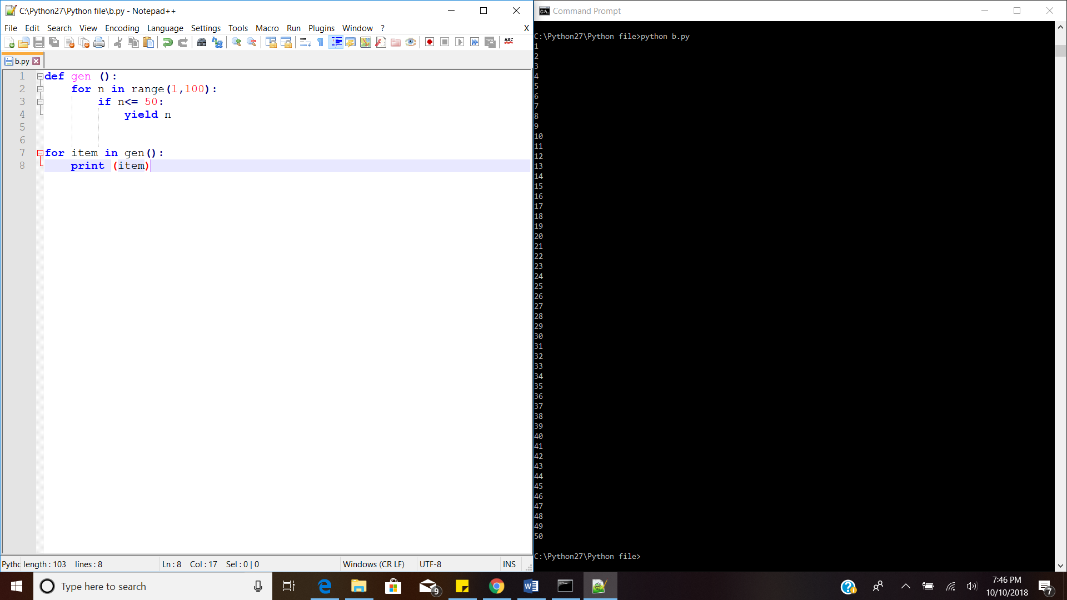

1. Encapsulation

The restriction to access to methods and variables to prevent them to be modified by accident is known as encapsulation.

This restriction is possible through the class variable.

Python does not have private keyword.

There are different types of encapsulation in python,

|  |  |
| --- | --- |
| Type | Description |
| Public method | Accessible from anywhere |
| Private method | Accessible only in their own class. It starts with two underscores |
| Public variable | Accessible from anywhere |
| Private variable | Accessible only in their class or methods if defined. Starts with two underscores. |

An object holds the data that you may not want to get changed from anywhere in the code.

class books(objects):

def __int__(self):

self.a=123

self._b=123

obj=books()

print (obj.a)

print(obj._b)

Reference:

1. <https://pythonspot.com/encapsulation/>
2. <https://pythonprogramminglanguage.com/encapsulation/>