**Assignment Oct 2**

1. Use the split () function to remove the space.

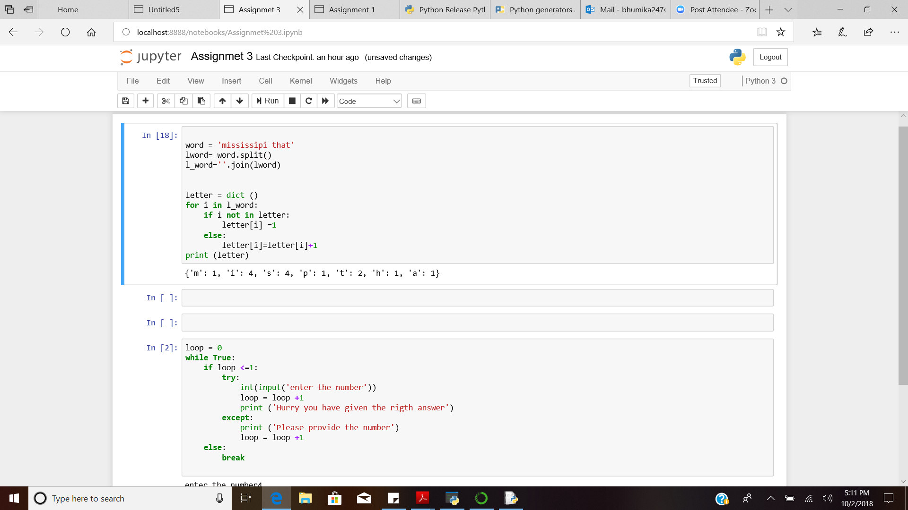

In the above code, the split and the join functions are used together in order to remove the space from the dictionary.

1. Exception handling: Using while loop and break.

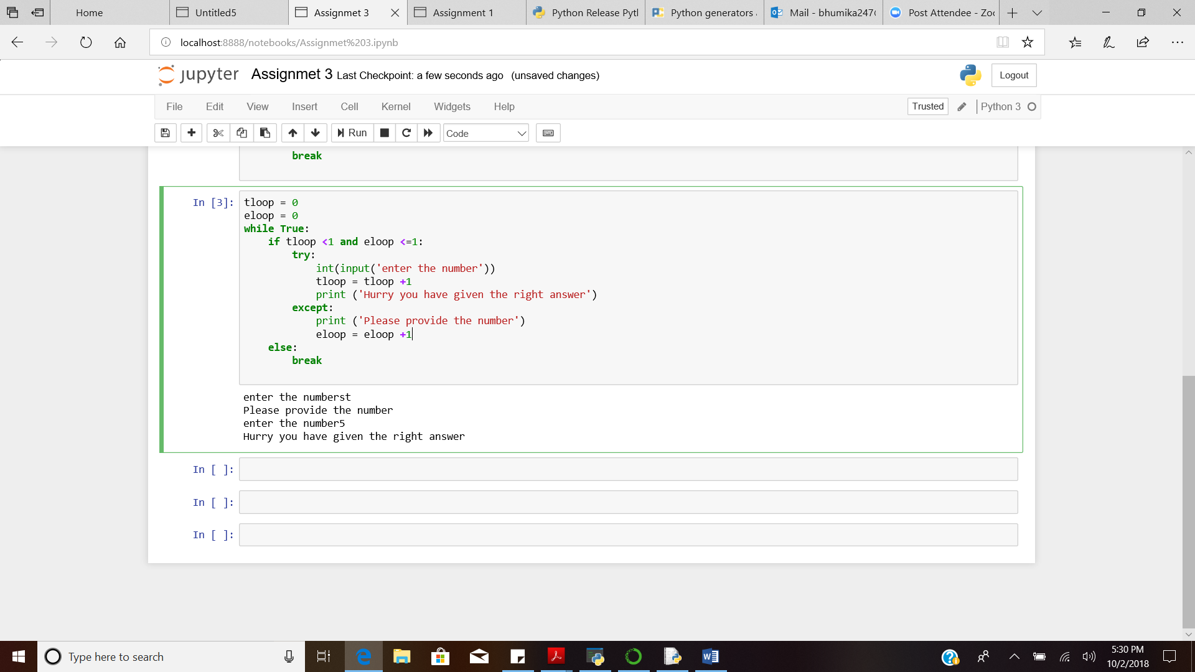

In the above code,

1. if the number is entered, the loop breaks.
2. if the number is not entered it ask for the number for the second time and then breaks.
3. Code for 4 functions (Add, Sub, Multi and Expo). Use arguments and return statement. Import the Add and Sub.

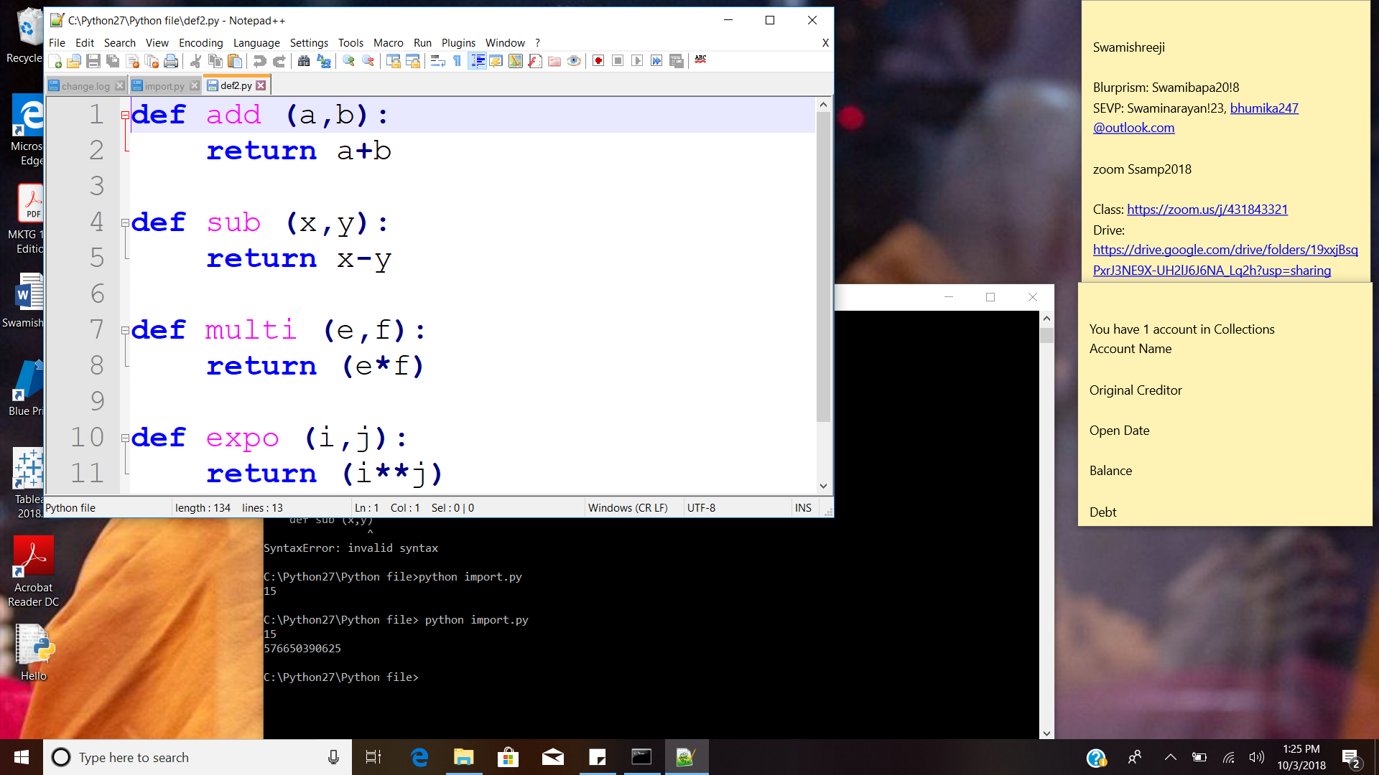

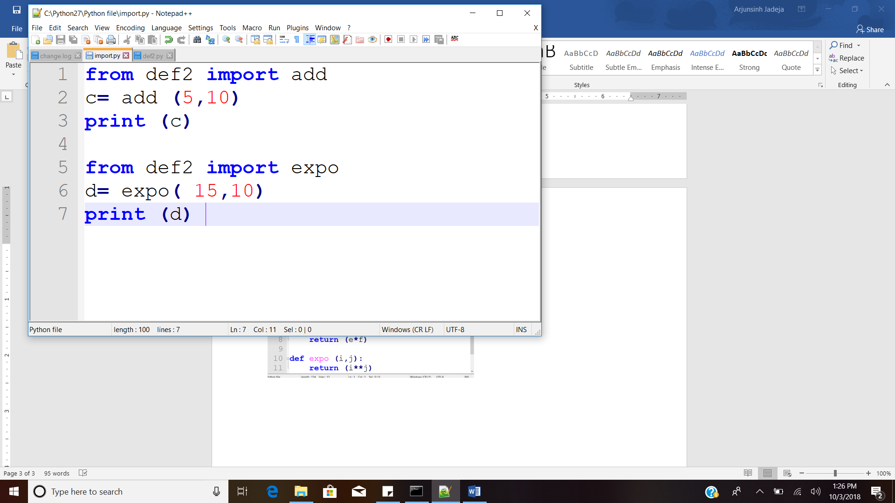

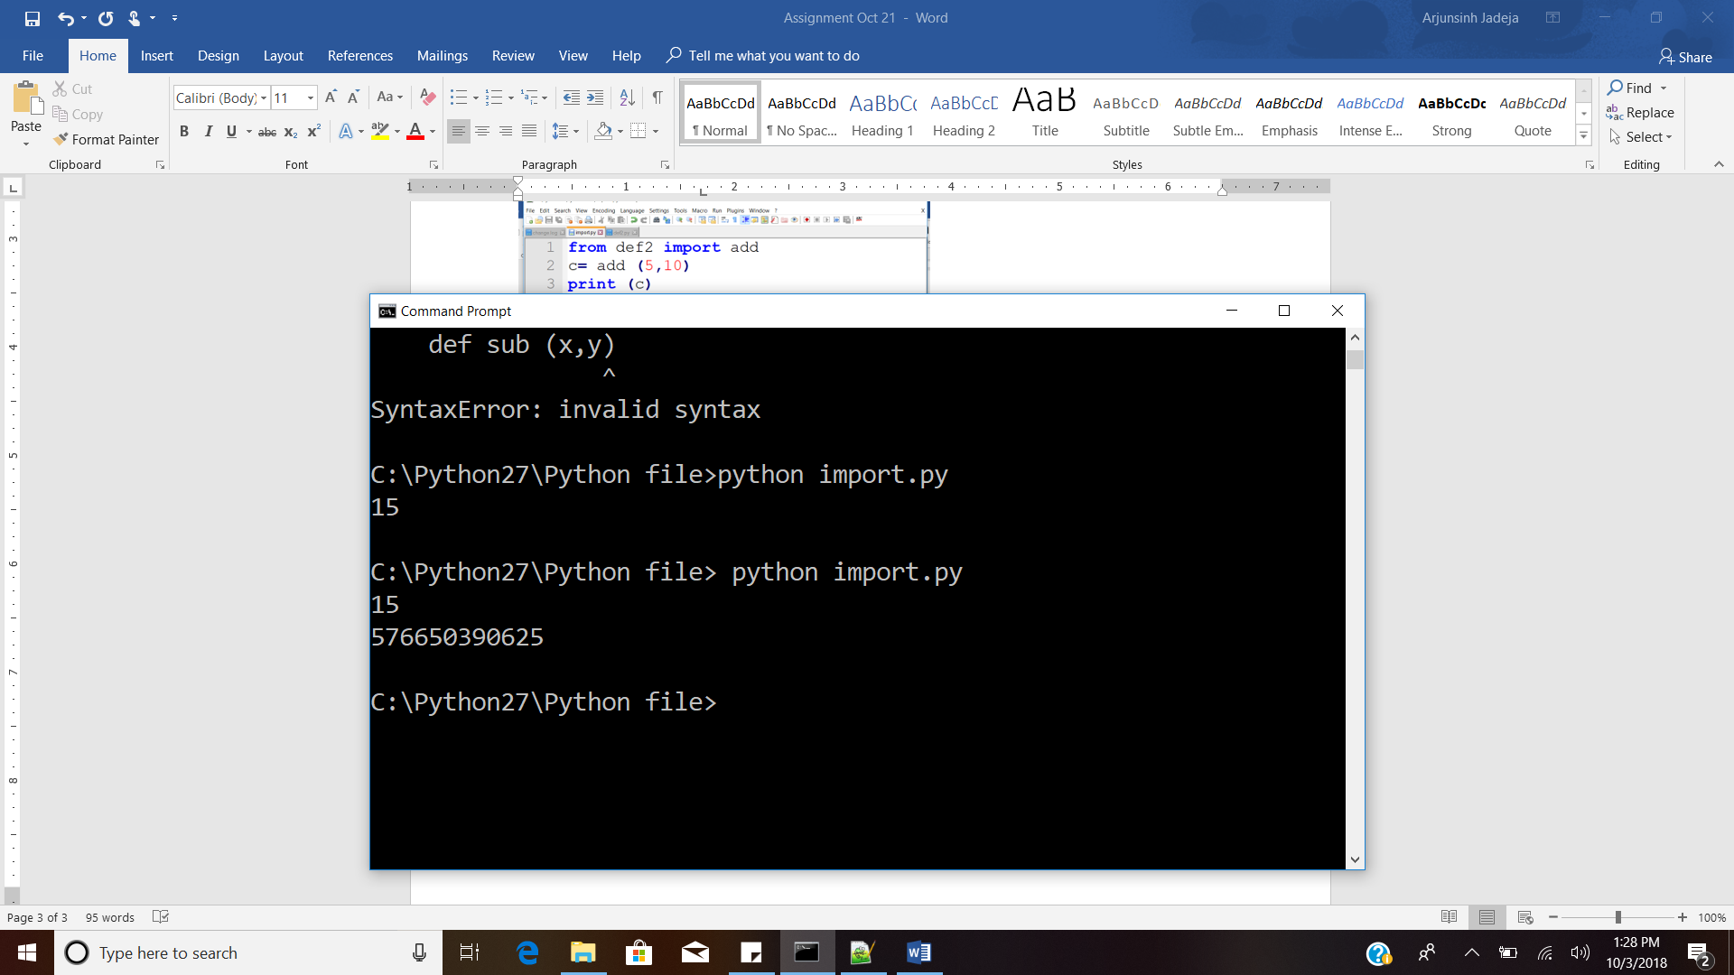

The function was defined in one file called def2.py. The function was used in the other file import.py, with the help of the input function. The result of successful import can be seen in the command prompt.

1. Combination and commutation/permutation in Python

* Combination and commutation are itertools.
* They both give the list of tuples as output.
* Combination (): r-length tuples, in sorted order, no repeated elements.
* Permutation (): r-length tuples, all possible orderings, no repeated elements.

Reference:

<https://docs.python.org/2/library/itertools.html>