**Assignment Oct 3**

1. What is the difference between sort () and sorted ()?

The sort () and the sorted () function both help to get the sequence sorted.

1. Sort ():

* The original sequence order is gone once, the sequence is saved in the system.
* Sort function works sequence_name.sort(), e.g. x.sort().

1. Sorted ()

* The original sequence remains the same. The copy of the sorted sequence is in the output.
* Sorted function works sorted(sequence_name). e.g. sorted(x)

1. Writing the text to the file without opening in write-mode. Is it possible?

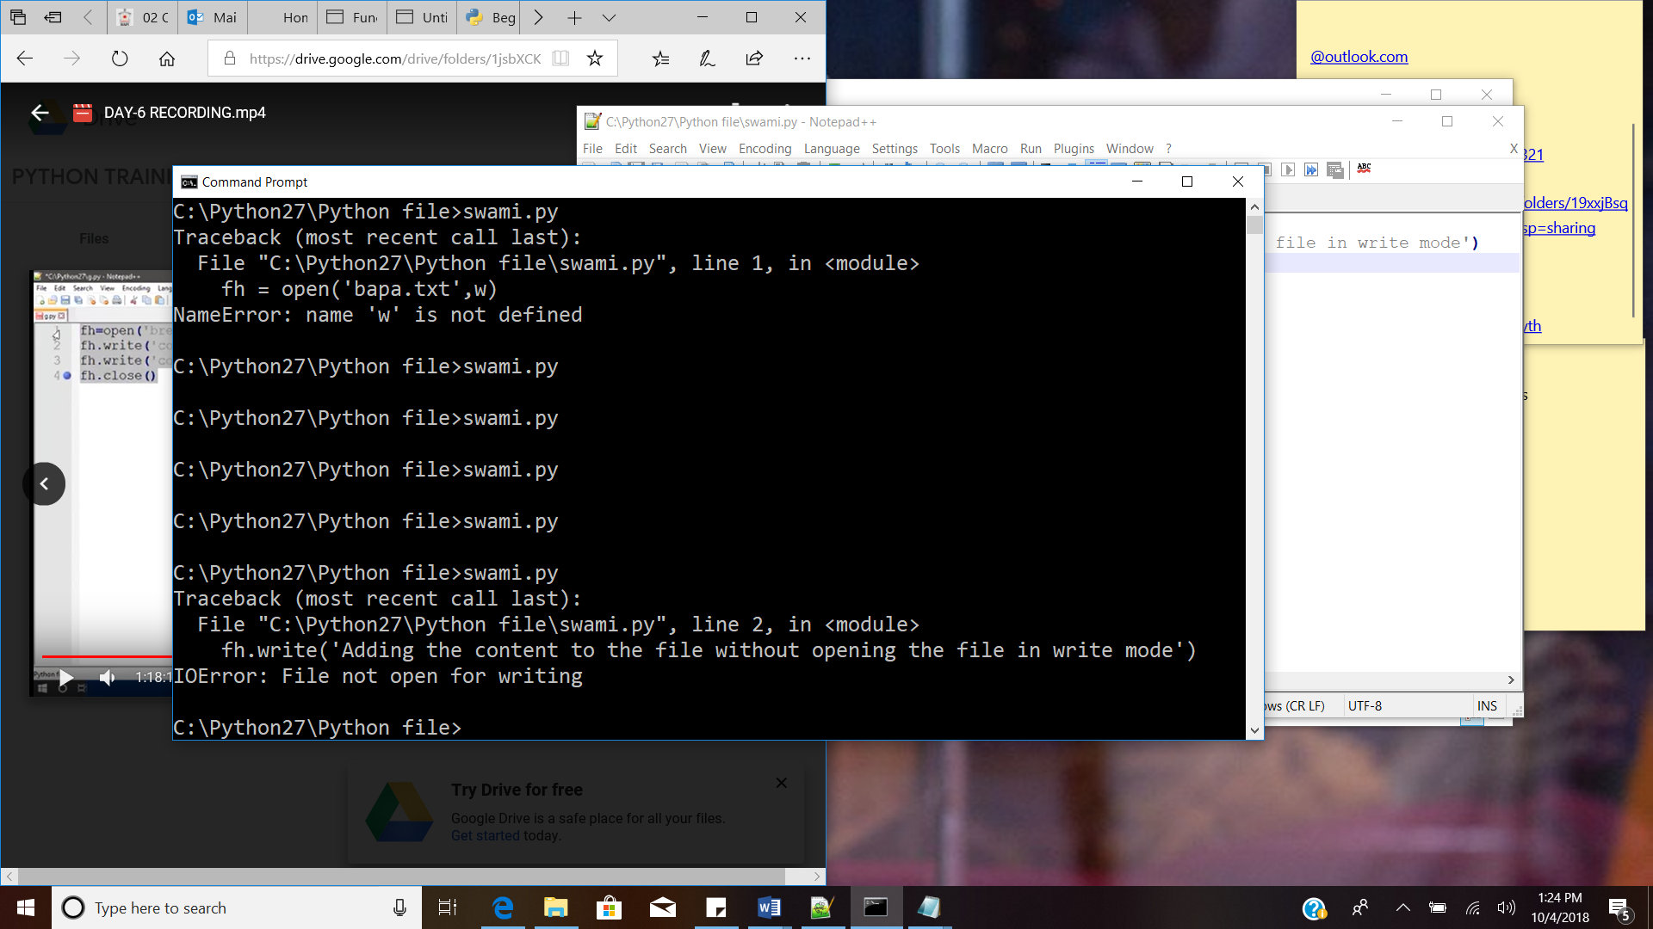

It is giving error, stating that it is not open for writing.