1. Define a function max() that takes two numbers as arguments and returns the largest of them. Use the if-then-else construct available in Python.

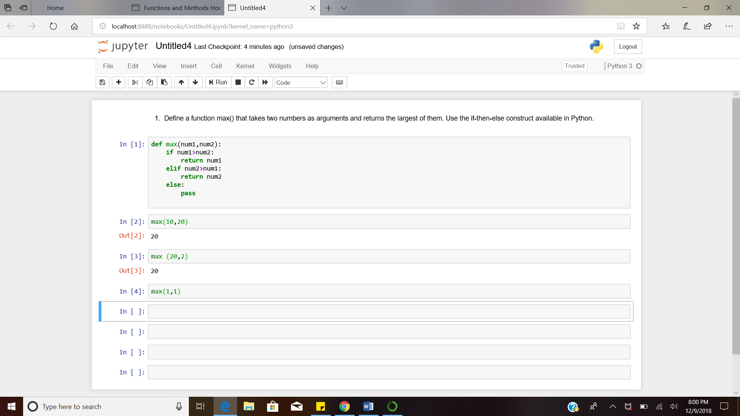

2. Define a function that computes the length of a given list or string.

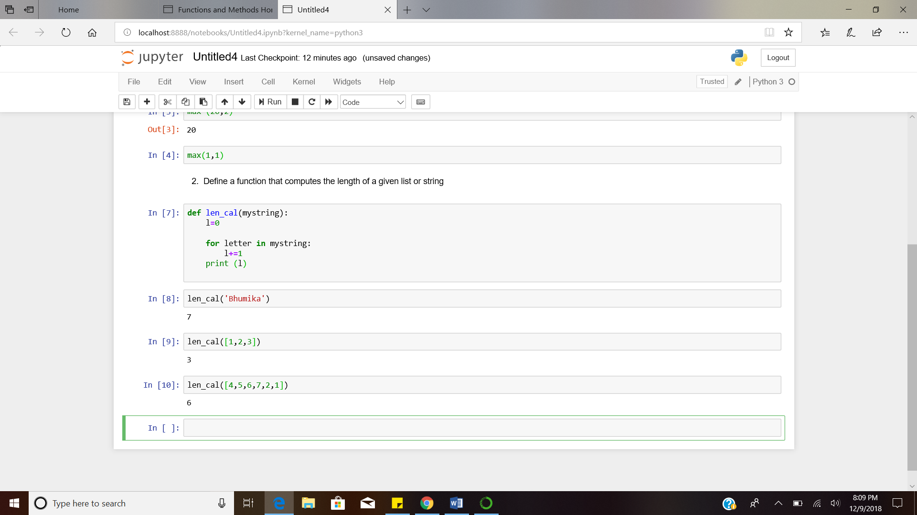

3. Write a function that takes a character (i.e. a string of length 1) and returns True if it is a vowel, False otherwise.

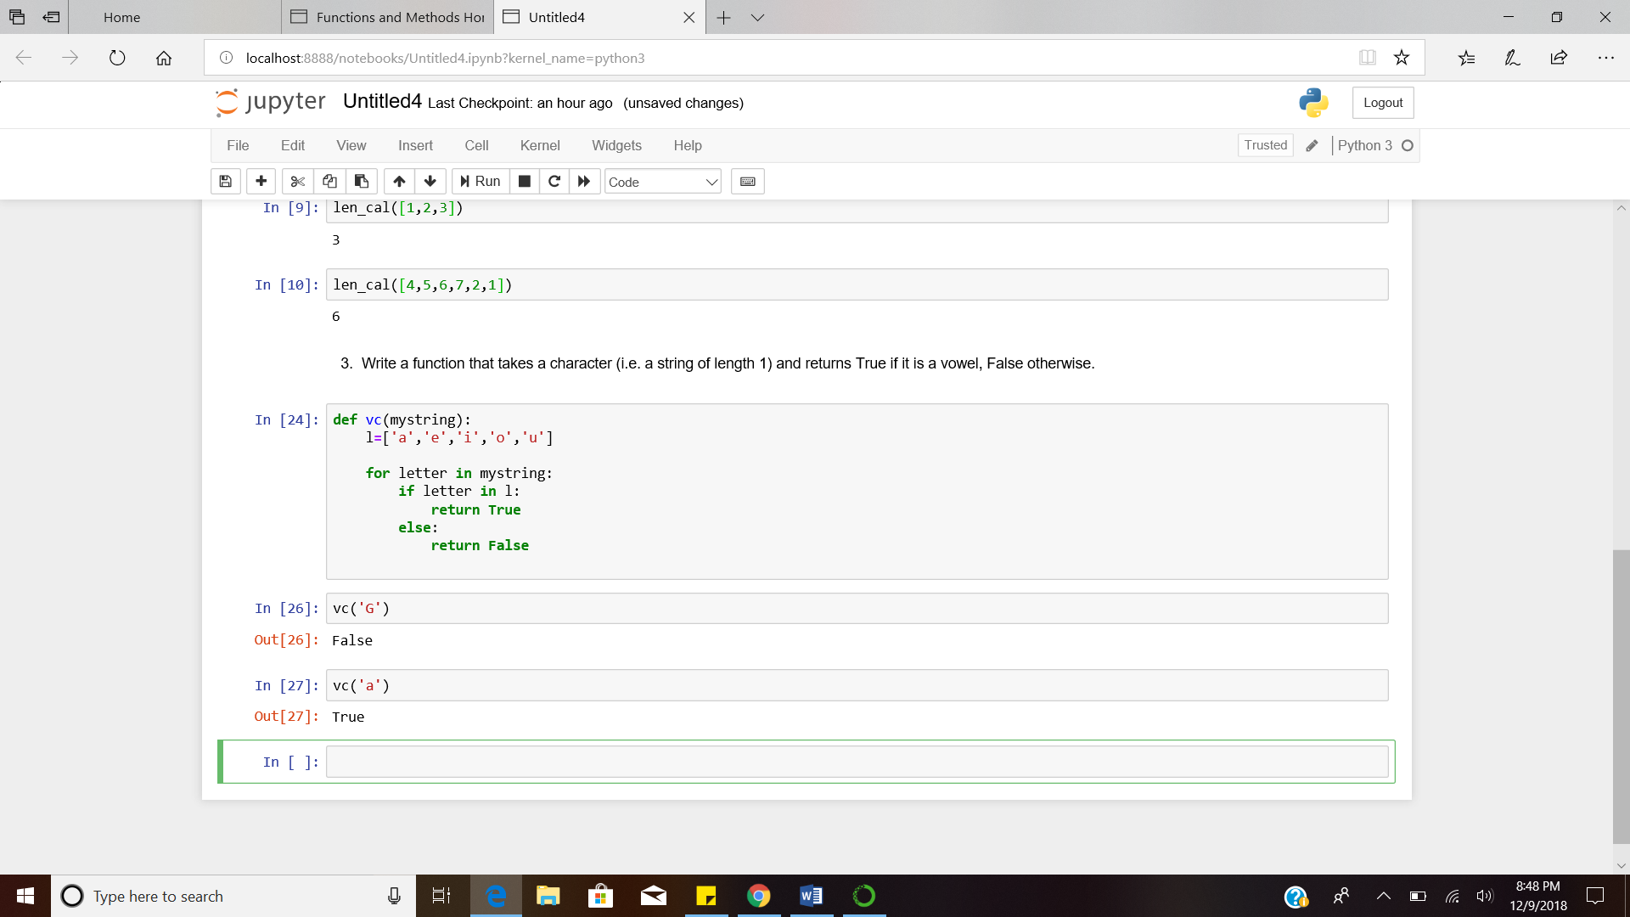

4. Define a function sum() and a function multiply() that sums and multiplies (respectively) all the numbers in a list of numbers. For example, sum([1, 2, 3, 4]) should return 10, and multiply([1, 2, 3, 4]) should return 24.

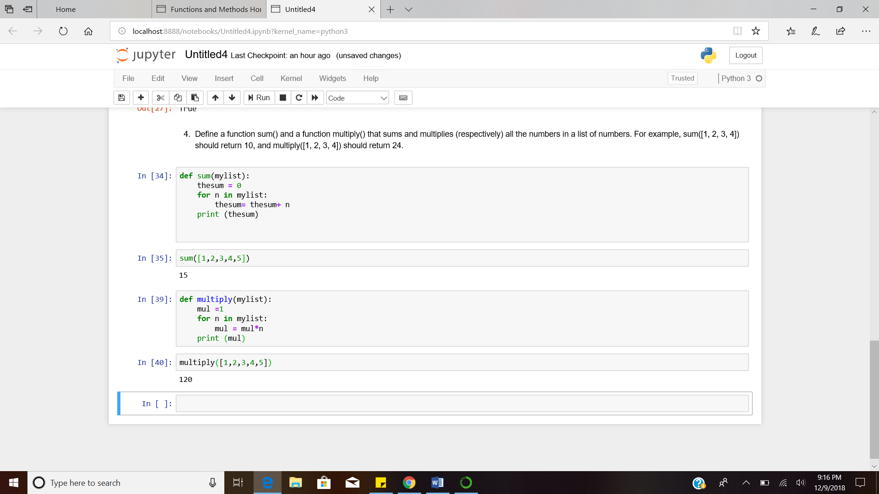

5. Define a function is_palindrome() that recognizes palindromes (i.e. words that look the same written backwards). For example, is_palindrome("radar") should return True.

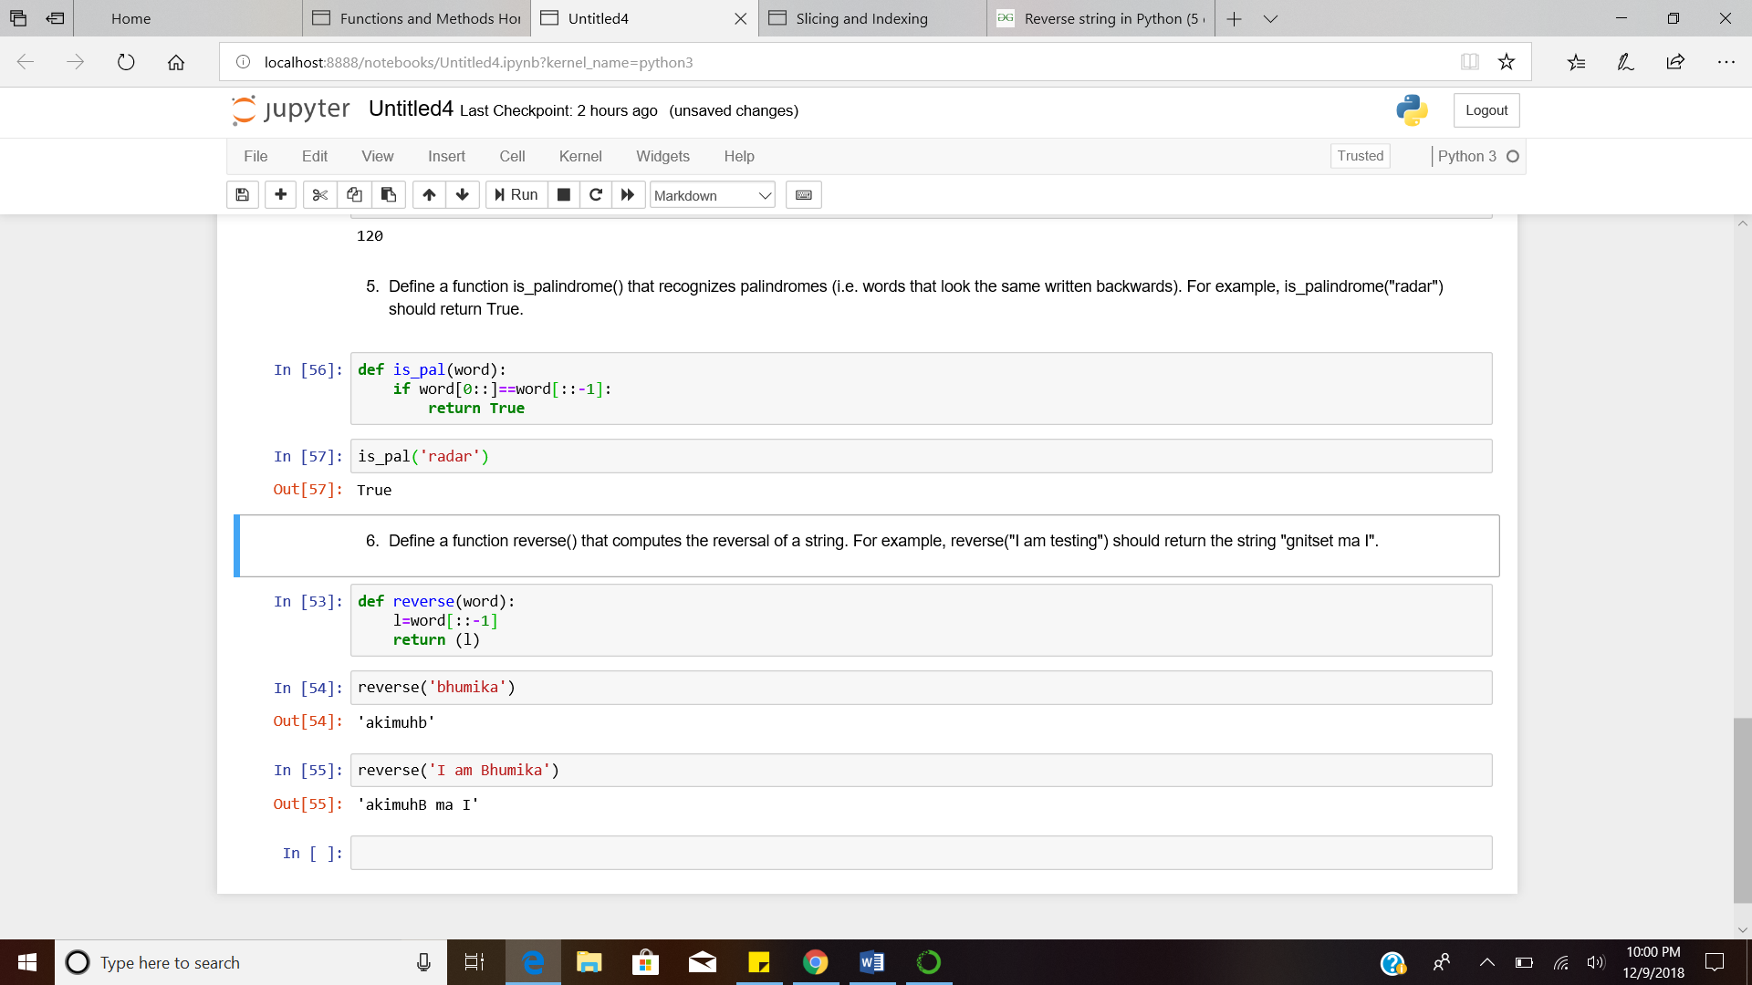

6. Define a function reverse() that computes the reversal of a string. For example, reverse("I am testing") should return the string "gnitset ma I".

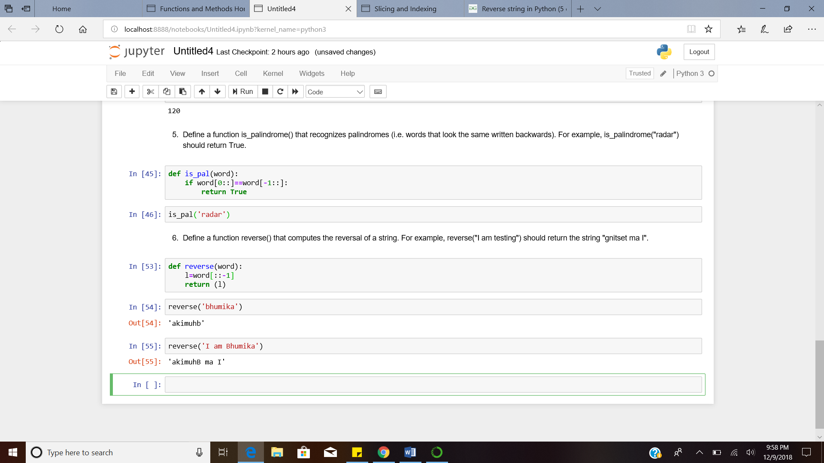

7. Define a procedure histogram() that takes a list of integers and prints a histogram to the screen. For example, histogram([4, 9, 7]) should print the following:

****

*********

*******

8. Write a function find_longest_word() that takes a list of words and returns the length of the longest one.

